Principals Pursuing Excellence is a two-year program aimed at leveraging the expertise of New Mexico’s educational leaders to support and empower New Mexico’s school leaders as they work to dramatically improve student achievement in their schools.

PPE is…
- Focused on building leadership capacity in New Mexico’s schools and districts
- Multilayered professional development and mentorship to mentee school leaders

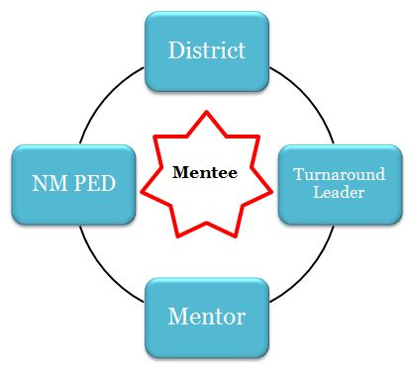

Project Structure:
With the support of the district, mentor, and turnaround leader, each mentee works with their core team to assess school needs and establish an Annual and 90-day Plan containing effective turnaround strategies (e.g. data-driven instruction, school culture of achievement, observation and feedback).

To support successful implementation and monitoring of the school’s 90-day Plan, each mentee principal receives ongoing coaching and mentoring during monthly onsite visits and frequent check-ins.

All roles, including superintendents and district leadership, participate in cohort convenings to further cultivate the competencies and skills of turnaround leaders.

The Theory of Action that underpins Principals Pursuing Excellence follows:

If we strengthen the competencies of leaders to transform districts and schools, then they will have the capacity to take bold and purposeful action.

If leaders take bold and purposeful action, then they establish the conditions for effective teaching and learning.

If the conditions for effective teaching and learning are established, then teachers will have the opportunity to improve instructional practice.

If teachers improve instructional practice, then student learning will increase.

Selection Process:
  - By close of business on Monday, February 26, 2018: Potential participants complete role-specific applications available on the Priority School Bureau’s PPE webpage.

    - Note: School leaders of struggling schools are eligible to participate as mentees.

  - In March (date TBD): For districts that have a leader apply for Cohort 6, the superintendent and a designated PPE team of 2-3 (e.g. Associate Superintendent, Director of Curriculum and Instruction, Elementary Schools, district-level coach) must attend PPE District Orientation.

  - During April: Selected applicants participate in a Behavioral Event Interview (BEI). The BEI is a two-hour process that delves deeper than traditional interviews to identify the underlying competencies that are predictors of success for school turnaround leaders.

  - In early May: New turnaround leaders, mentors, and mentees are notified of selection.

  - Wednesday, June 13 through Friday, June 15, 2018: New turnaround leaders, mentors, mentees, and district leaders must attend Cohort 6 Induction in Albuquerque.
Cohorts 1-5 Participating Districts
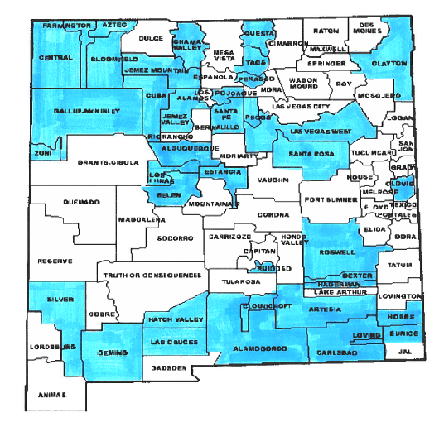

“Exceptional school leaders succeed because of how they use their time:
what they do, and how and when they do it.”
-Paul Bambrick-Santoyo, Leverage Leadership
NM PED Contact Information:
Hannah Peria
Priority Schools Bureau, NM PED
(505) 827-8005
hannah.peria@state.nm.us

