Flowthrough BAR Process Flow from Creation to Submission to PED

The processes of creation and order execution and user roles that are allowed to do the process are explained below.

The status of a BAR changes as the user moves through the process. Statuses are bolded in the descriptions below for clarity.

The user’s options change as the BAR moves through its process. User options are represented as buttons in the application, and are italicized in the descriptions below for clarity.

User Roles
BA | Budget Analyst
SD | School District
CS | Charter School
FM | Fund Manager
PM | Program Manager
BS | Budget Supervisor
BD | Budget Director
DS | Deputy Secretary for Finance Admin
SA | System Administrator
FS | Fund Supervisor
PS | Program Supervisor
SE | Secretary of Education
DP | Deputy Secretary for Programs
FD | Fiscal Director
PD | Program Director
SP | Superintendent
VW | View Only
BM | Business Manager

Creation of a Flowthrough BAR

- The SD, CS, SP or BM (Business Manager Role) user must first login to the PED OBMS application from the login page (see Figure 1.0).

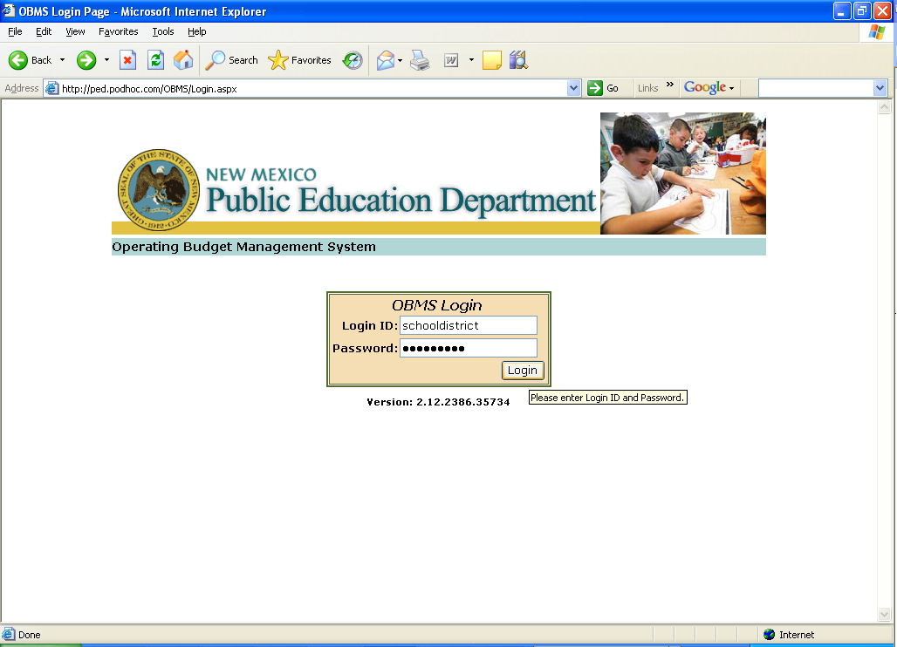
Figure 1.0

- Next the user selects the BAR link in the header bar (see Figure 2.0).

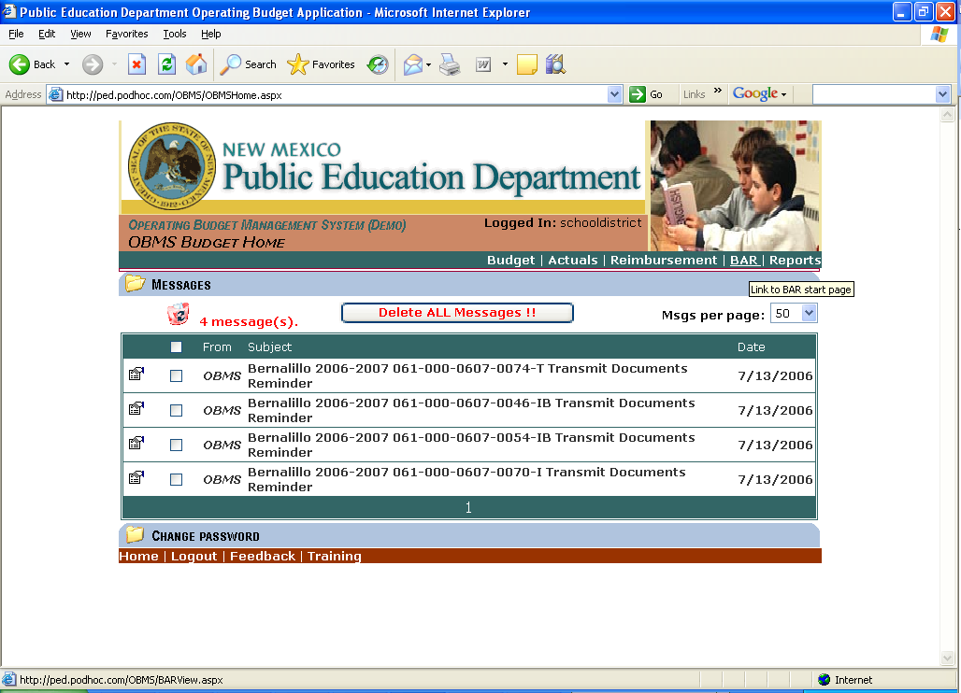
Figure 2.0

- Then the user selects the BAR Actions link in the header bar (see Figure 3.0).

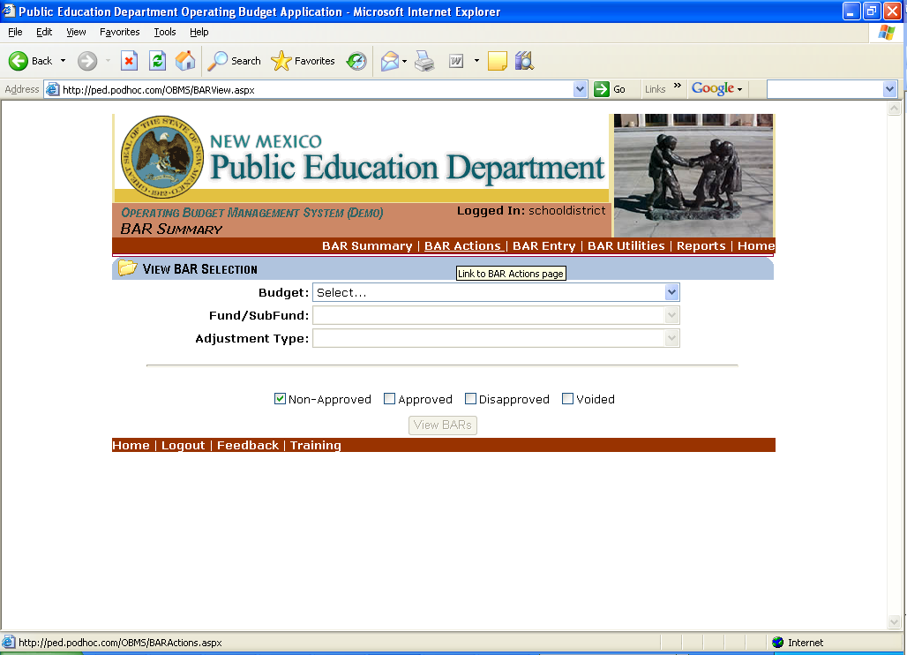
Figure 3.0

- The user must first select a budget from the budget dropdown. Then the user must select the adjustment type from the adjustment dropdown. And, finally the user must select a fund/subfund from the fund/subfund dropdown. If a flowthrough fund/subfund segment is selected (e.g. 24101) a Flowthrough BAR will be created (see Figure 4.0). The Create button will then become active (see Figure 5.0).

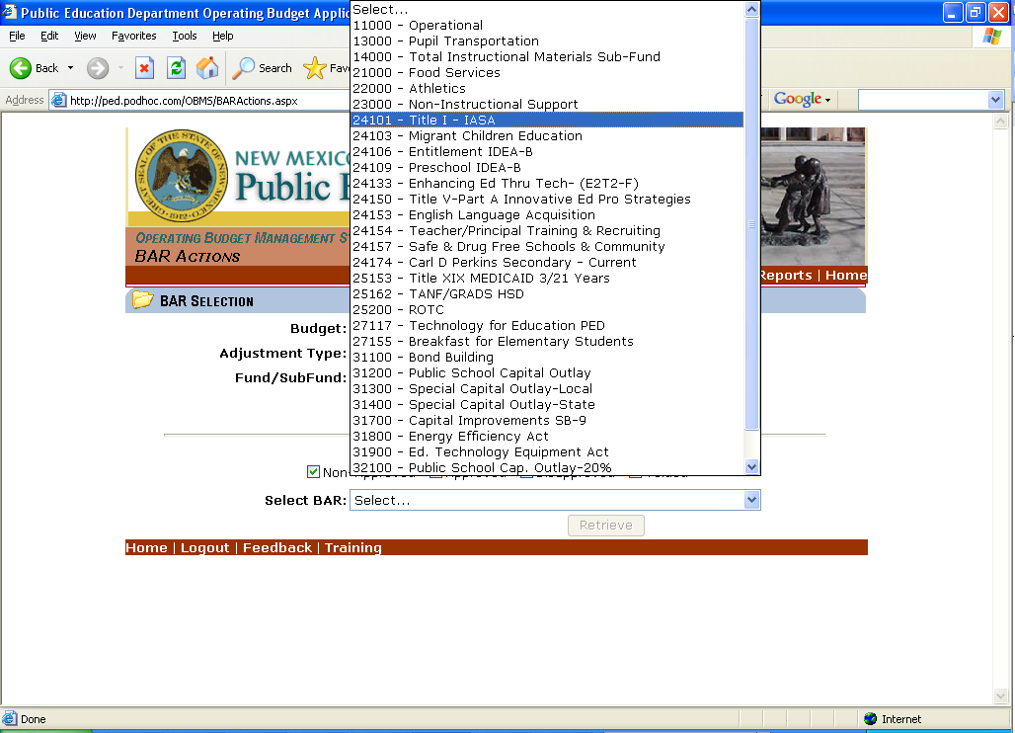
Figure 4.0

- When user clicks Create (see Figure 5.0):
  - The status of the created BAR becomes Flowthrough BAR Number Generated (see Figure 5.a).

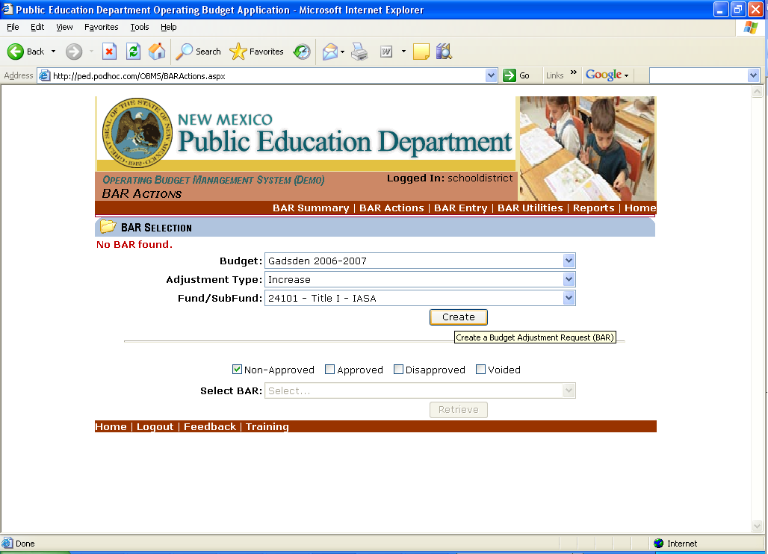
Figure 5.0

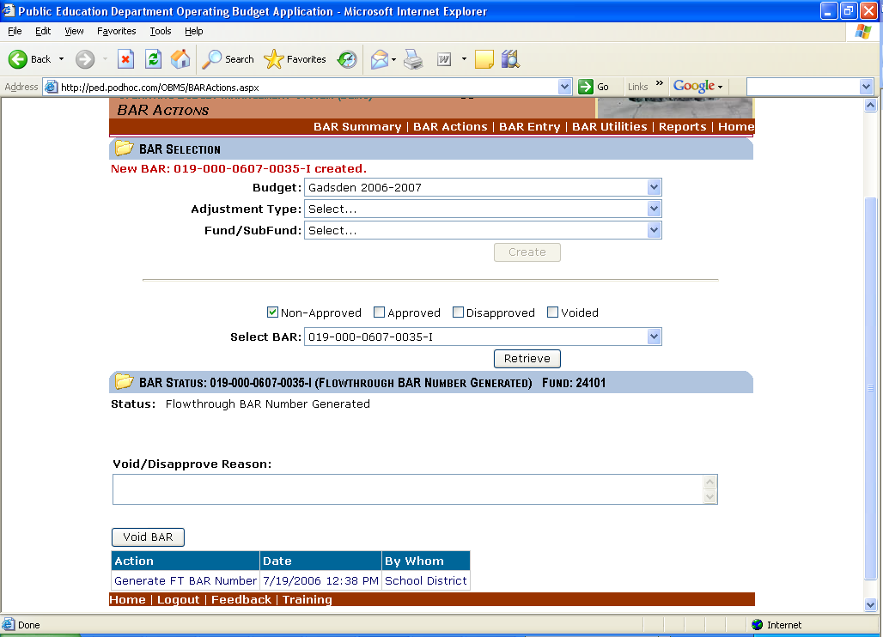
Figure 5.a

- Next the user selects the BAR Entry link in the header bar (see Figure 6).

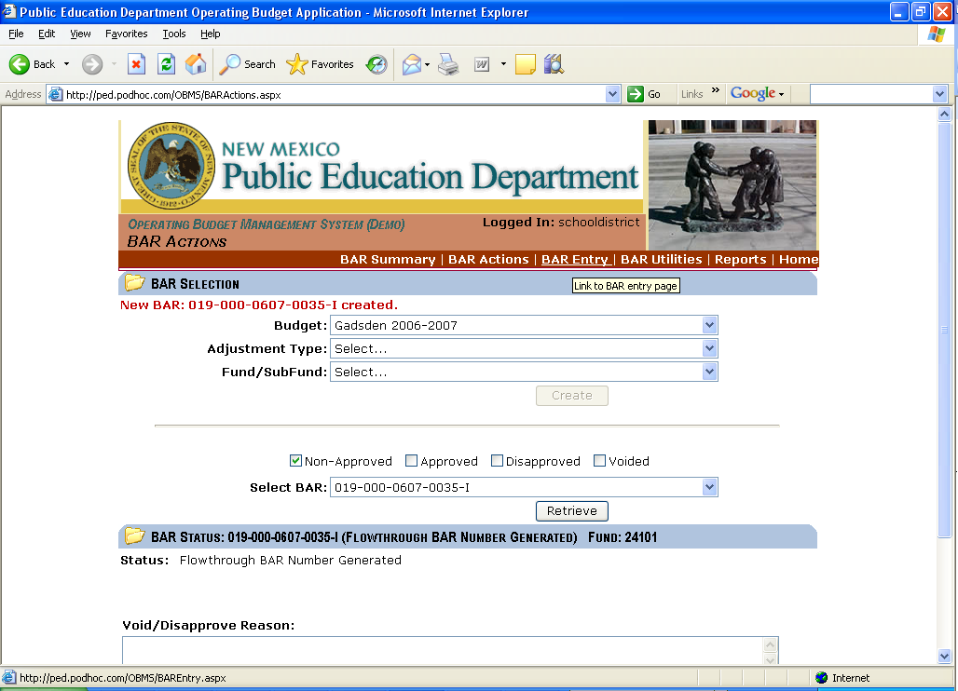
Figure 6.0

- This will open the BAR Header control for the newly created BAR (see Figure 7.0).

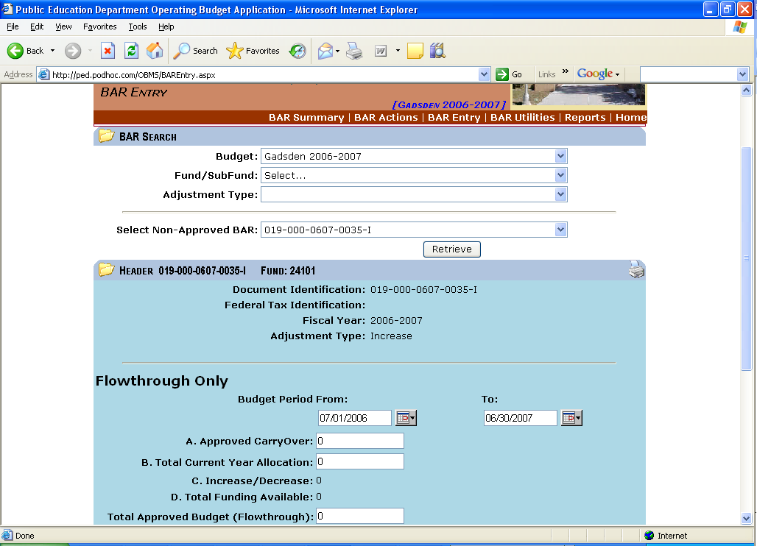
Figure 7.0

- The user selects a Budget Period From: and To: date or accepts the preset dates. Then the user must enter an amount in the textboxes labeled “A. Approved CarryOver:”, “B. Total Current Year Allocation:”, and “Total Approved Budget (Flowthrough):”. The user selects yes or no to Adjustment Changes Intent/Scope of Program. The user selects a contact for the particular entity from a dropdown, then enters a justification in the justification textbox (see Figures 8.0 and 8.1).

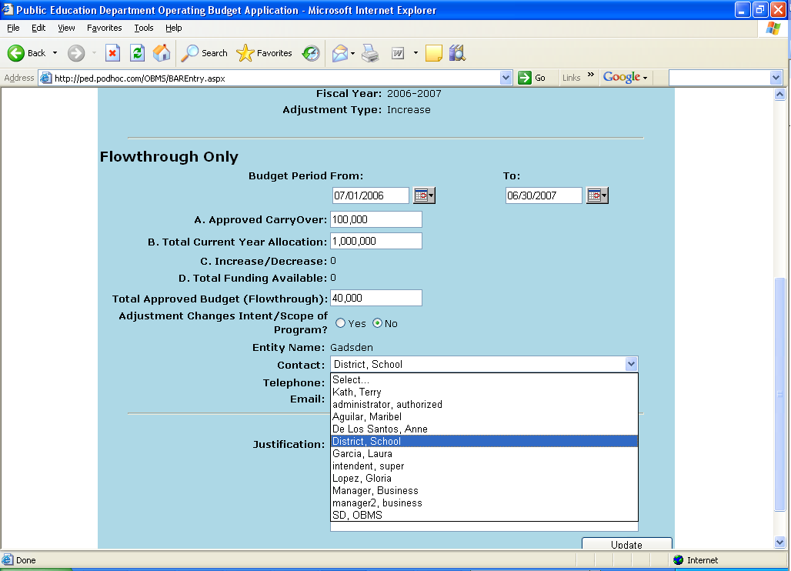
Figure 8.0

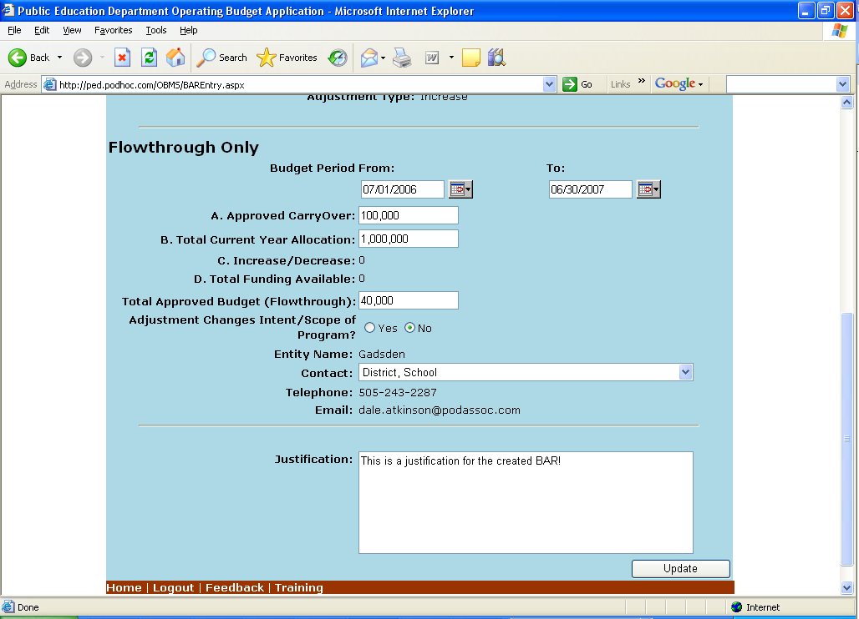
Figure 8.1

- The user clicks Update (see Figure 9.0):
  - The status of the BAR becomes Pending Flowthrough BAR (this status can be viewed in the BAR Status control in the BAR Actions area).

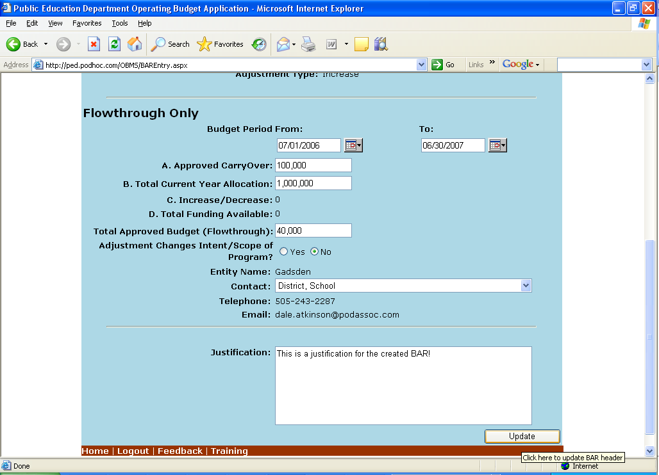
Figure 9.0

- Now the user selects functions, objects, programs and job classes for the particular Source and Destination from various dropdowns as applicable and then an adjustment amount and FTE adjustment if applicable. After the selections and monies are entered the user clicks Enter for both Revenues and Expenditures (see Figure 10.0).
  - This creates BAR lines (see Figure 10.a).
  - Attachment can be added (See Figure 10.b).
  - The user must ensure that the Adjusted Amount of Revenue is equal to the Adjusted Amount of Expenditure (See Figure 10.c).

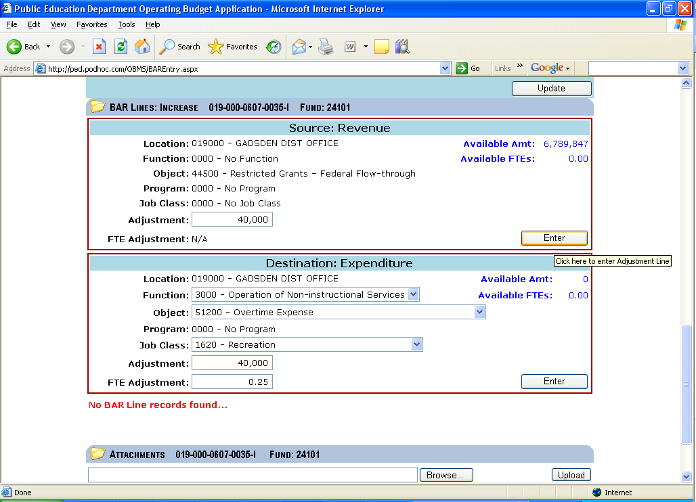
Figure 10.0

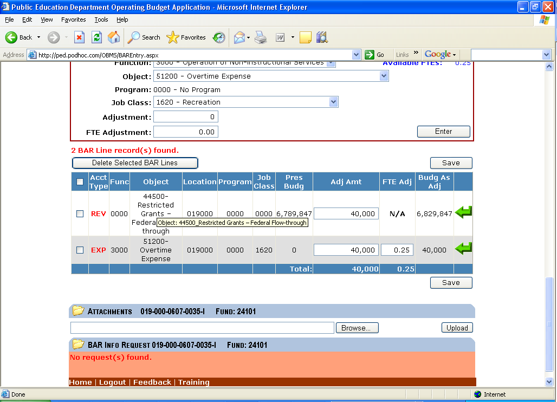
Figure 10.a

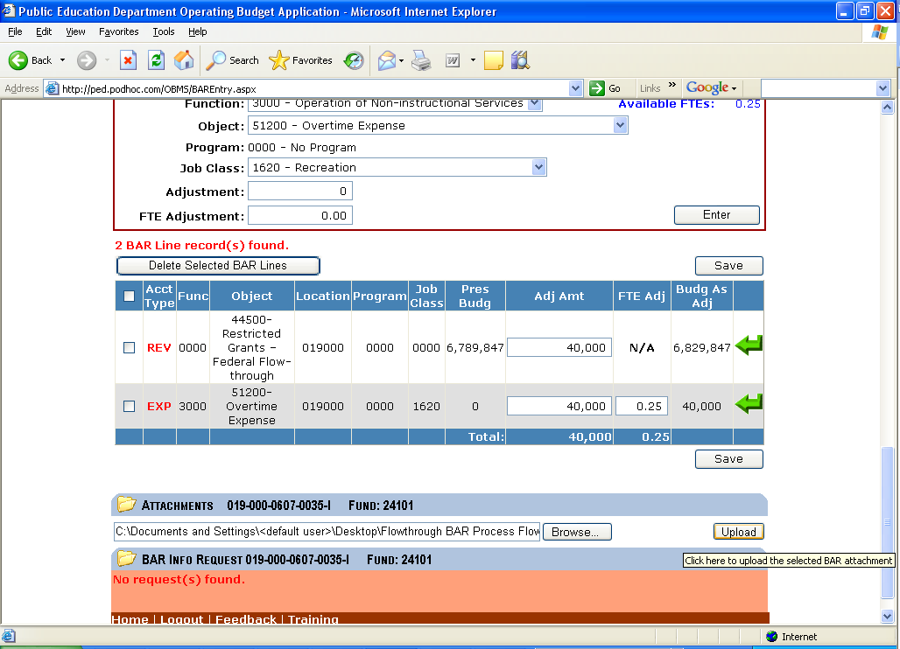
Figure 10.b

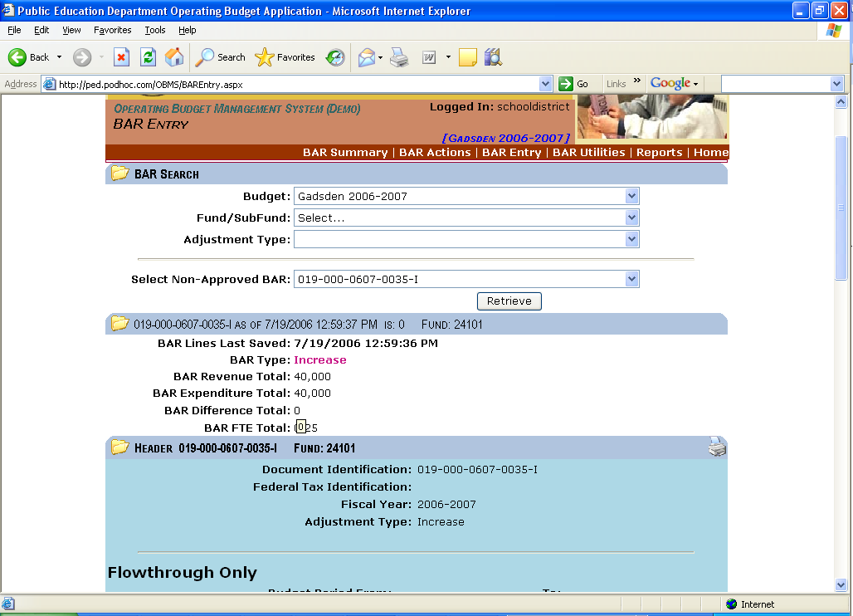
Figure 10.c

- Once the Adjusted Amount of Revenue is equal to the Adjusted Amount of Expenditure, the user selects BAR Actions link in the header bar (see Figure 11.0).
  - The Submit BAR to BM button should now be visible (see Figure 11.a).
  - Note that the user should be able to click Void BAR to void out the BAR (see Figure 11.a).

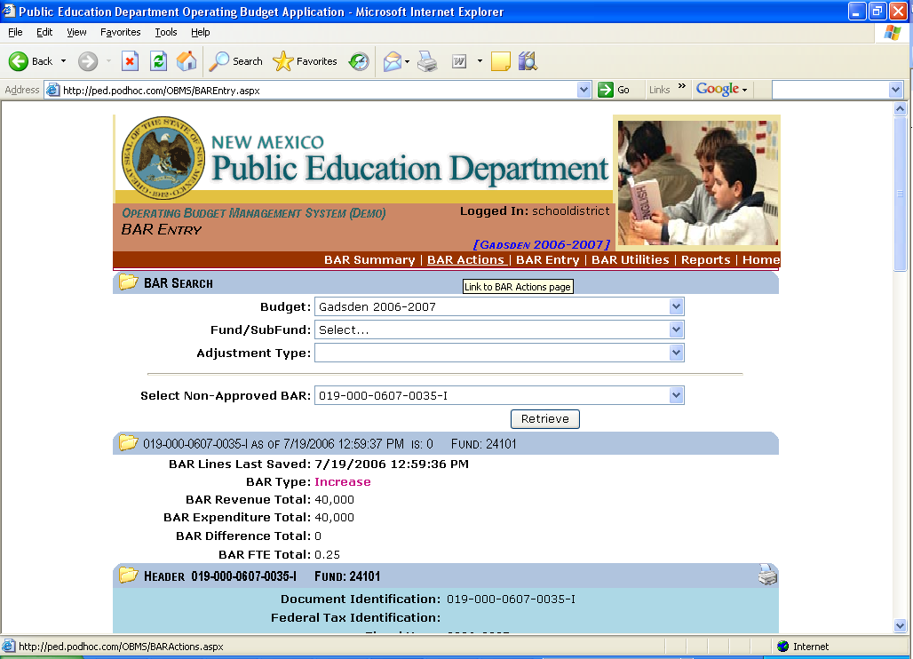
Figure 11.0

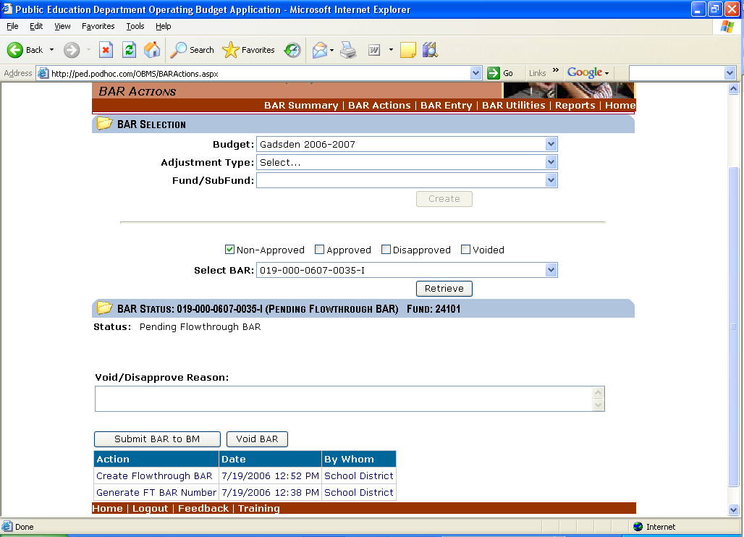
Figure 11.a

- The user clicks Submit BAR to BM (see Figure 12.0):
  - The status of the BAR becomes Flowthrough BAR Submit to BM (see Figure 14.0).

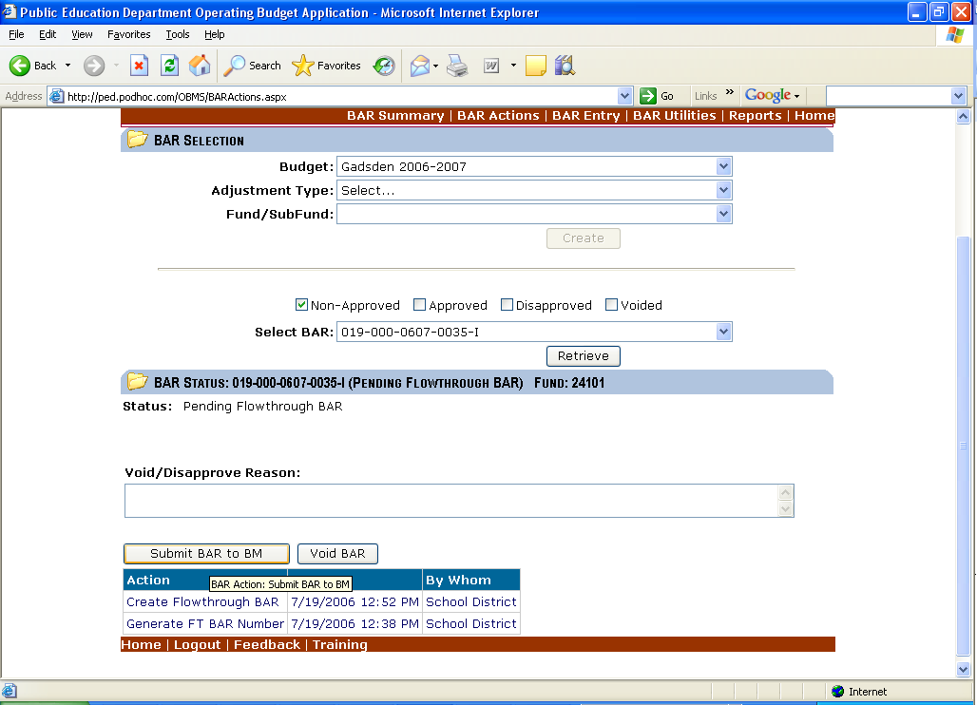
Figure 12.0

- The BM user reviews the BAR.
- The user clicks BM Approve BAR (see Figure 14.0):
  - The status of the BAR becomes BM Approved FT BAR – Submitted to SP (see Figure 16.0).

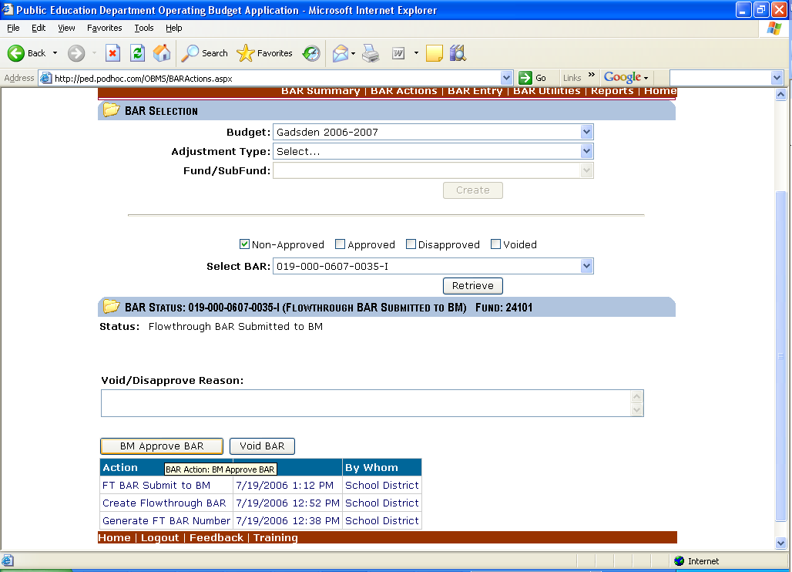
Figure 14.0

- The SP user reviews the BAR.
- The user clicks SP Approve BAR (see Figure 16.0):
  - The status of the BAR becomes SP Approved FT BAR – Ready to submit to PED (see Figure 18.0).

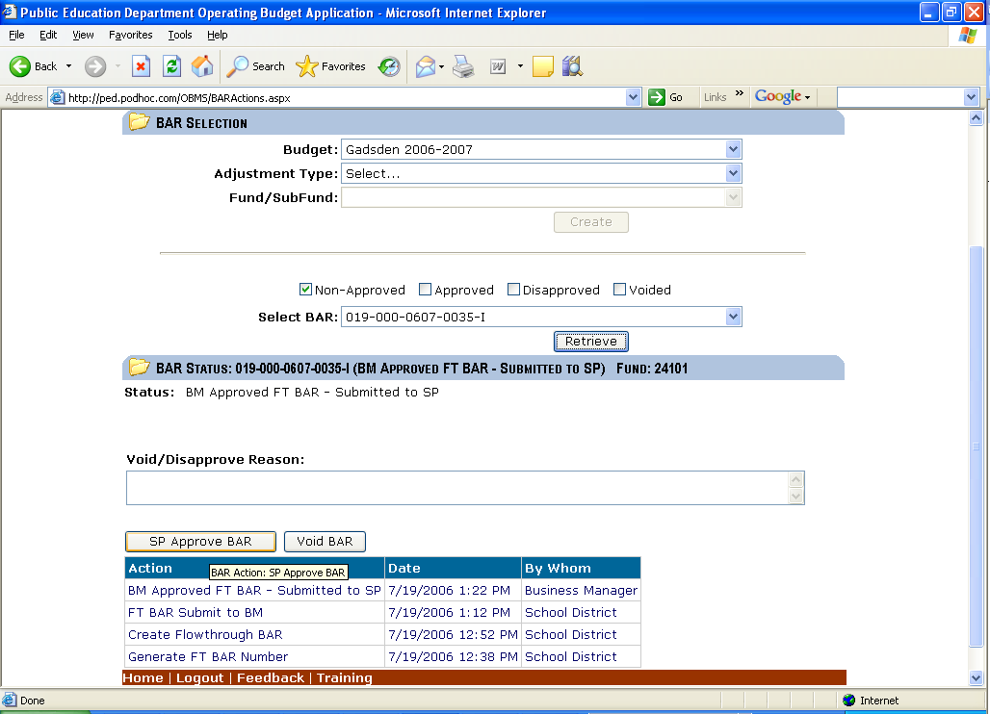
Figure 16.0

- The BM user reviews the BAR once more.
- The user enters an approval date in the textbox labeled “The requested budget/changes were authorized at a scheduled Board of Education or Governance Council meeting open to the public on: “ (see Figure 18.0).

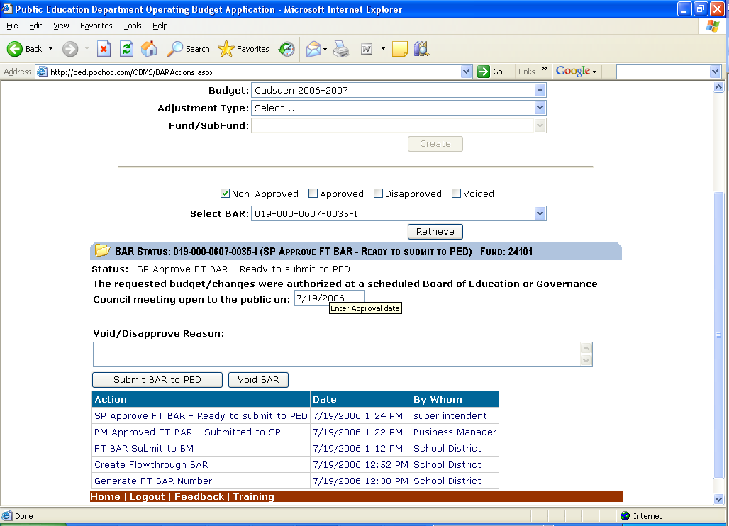
Figure 18.0

- The user clicks Submit BAR to PED (see Figure 19.0):
  - The status of the BAR becomes BM submitted FT BAR to PED (see Figure 19.a).

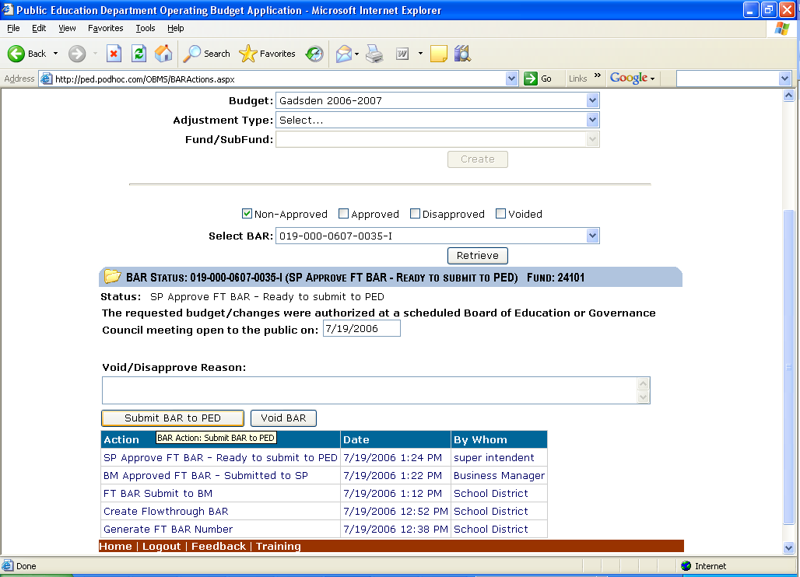
Figure 19.0

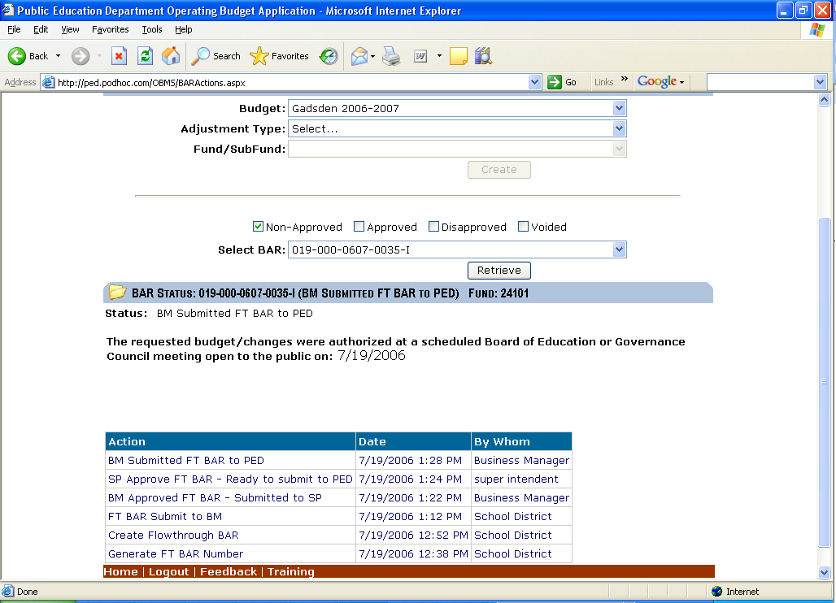
Figure 19.a

- The BAR has been submitted to PED!

