SAT Action/Intervention Plan Overview

Student Information
Student Name: | Student ID:
DOB: | Date:
School: | Teacher:
Grade:

Supporting Information
Overall Hypothesis:
Area(s) of Concern:

SAT Action/Interventions
Area of Concern: _________________
Note: The SAT will need to duplicate this section for each area of concern)

Goal

Accommodations/Actions
Accommodations, activities, assessments and/or modifications necessary to address the area(s) of concern without changing the nature or integrity of instruction.
Accommodation(s)* | Person Responsible | Begin Date | Desired Outcome | Progress Measure/Product

Action(s)** | Person Responsible | Begin Date | Desired Outcome | Progress Measure/Product

* An Accommodation is an instructional adaptation or support that assists the student in their learning such as providing preferential seating and frequent feedback.
** An Action is a specific tasks that the SAT has determined necessary as part of the SAT process such as completing a vision/hearing screening.

Accommodations and Actions may be critical in order to meet the student’s needs, however, they are not considered an intervention.
Interventions
Approaches that change the nature or intensity of instruction.
Name of Strategy/Intervention:
Person(s) Responsible:
Start Date: |  | End Date:
Size of Group: | Session Length: | Frequency:

Progress Monitoring
Start Date: | End Date: | Schedule: | Required Number of Data Points:
Evaluation Tool: | Unit of Measurement: | Baseline Data Point: | Targeted End Point:

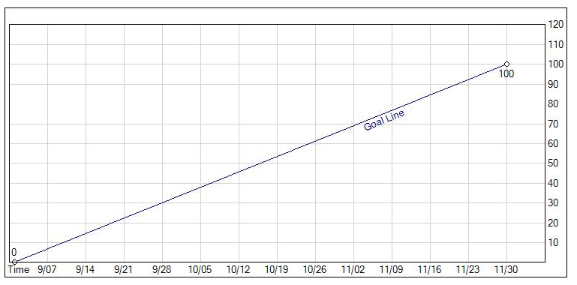
SAT may insert their own progress monitoring graph, as appropriate. However, data are a critical aspect of an effective SAT Action/Intervention Plan.

SAT Meeting Signature
Initial Meeting Date:
SAT Meeting Participant(s)
Position |  | Name |  | Agree/Disagree
Parent/Guardian __________________________________ Yes No
Parent/Guardian __________________________________ Yes No
Student __________________________________ Yes No
Administrator __________________________________ Yes No
Classroom Teacher __________________________________ Yes No
SAT Coordinator __________________________________ Yes No
Other: __________________________________ Yes No
Other: __________________________________ Yes No
Other: __________________________________ Yes No

