2010

NEW MEXICO

CHARTER SCHOOL APPLICATION

FOR

SPORTS AND ENTERTAINMENT MARKETING ACADEMY

(SEMA)

Charter Schools Division
New Mexico Public Education Department
CNM Workforce Training Center
5600 Eagle Rock Avenue, Room 227
Albuquerque, NM 87113
(505) 222-4762

DR. VERONICA C. GARCÍA  secretary of education | BILL RICHARDSON  Governor
Dear Prospective Charter School Applicants,

Congratulations on your decision to pursue your dreams of creating a charter school in the state of New Mexico!

This letter serves to introduce you to the process that a charter school applicant must complete before being considered for approval and is designed to provide some general guidance. In the state of New Mexico, the Charter Schools Act [22-8B-1 et. seq. NMSA 1978] and administrative rule at 6.80.4.1 et. seq. NMAC, govern the application and review process for start-up charter schools. I recommend that you familiarize yourself with the law and rule as they should guide your preparation and ultimate submission of your application.

The Charter Schools Act [22-8B-1 NMSA 1978] is enacted to enable individual schools to structure their educational curriculum to encourage the use of different and innovative teaching methods that are based on reliable research and effective practices or have been replicated successfully in schools with diverse characteristics; to allow the development of different and innovative forms of measuring student learning and achievement; to address the needs of all students including those determined to be at risk; to create new professional opportunities for teachers, including the opportunity to be responsible for the learning program at the school site; to improve student achievement; to provide parents and students with an educational alternative to create new, innovative and more flexible ways of educating children within the public school system; to encourage parental and community involvement in the public school system; to develop and use site-based budgeting; and to hold charter schools accountable for meeting the department’s educational standards and fiscal requirements. (22-8B-3 NMSA 1978)

On behalf of the New Mexico Public Education Commission and the Charter Schools Division, I wish you well in your endeavors; and I believe that the process that we have produced to review and evaluate charter school applications will continue to validate the public trust that we have been given.

Sincerely,

Don Duran, Ed.D.
Assistant Secretary, Charter Schools Division
New Mexico Public Education Department

STATE OF NEW MEXICO
PUBLIC EDUCATION COMMISSION
300 DON GASPAR
SANTA FE, NEW MEXICO 87501-2786
Telephone (505) 827-5800
www.ped.state.nm.us

DR. VERONICA C. GARCÍA  secretary of education | CATHERINE SMITH  chair



New Mexico Public Education Commission

The Charter Application Process and Review Stages - 2010
Instructions | All submissions should be prepared utilizing the New Mexico Charter School Application. Brevity, specificity, and clarity are strongly encouraged. Any questions regarding the application and the review process must be directed to Sam Obenshain, Review Coordinator, at sam.obenshain@state.nm.us or (505) 795-2374. During this process, applicants are discouraged from contacting Charter Schools Division (CSD) staff, Public Education Department (PED) staff, or Public Education Commission (PEC) members unless specifically authorized by the Review Coordinator.
Deadlines | The deadline for receipt of all materials by the New Mexico Public Education Charter Schools Division (CSD) is 5:00 PM on the due date indicated:  • Notice of Intent……..……….January 12, 2010  • Charter Application………….July 1, 2010  Charter Applications may be submitted between June 1, 2010 and July 1, 2010, but no later than 5:00 pm on July 1, 2010. Applications will also be considered timely if they are postmarked four (4) calendar days prior to July 1, regardless of the date on which they are received. Facsimiles (FAXes) are not accepted.
Format | - All applications must be submitted to the Department on 8 ½ by 11-inch paper with one-inch margins, and the type font must be 12-point font or larger. Your application must include the Table of Contents. Include page numbers in the bottom right hand corner of each page. Include the proposed school name in the footer of each page of the application that you submit.  - Each of the nine “main” sections of the application must be separated by labeled, tabbed dividers. Appendices must also include a Table of Contents and tabbed, labeled dividers.  - Applications must be no more than 200 pages of text. References cited within the text should be listed in a bibliography using APA format as an appendix to the text. An alphabetical listing of all acronyms used in your application must be included in the Appendices, if applicable. (Example: CSD – Charter Schools Division)  - The required appendices will not count against the overall page limit for the application.  - Submit two (2) paper copies with original signatures to the Charter Schools Division. Each copy should be submitted in a three-ring binder that includes a label on the spine. In addition, submit two (2) CDROMs with the application in electronic format (Word-compatible and Excel-compatible). The electronic version must be an exact copy of the paper version.
Where to Mail or Drop-off Notice  of Intent  and the Application | Dr. Don Duran, Assistant Secretary of Education  Charter Schools Division  New Mexico Public Education Department  CNM Workforce Training Center, Room 227  5600 Eagle Rock Avenue, Albuquerque, NM 87113  (505) 222-4762
Technical Assistance Workshops  (January – June) | Technical Assistance Workshops will be provided by the Charter Schools Division beginning in January 2010. Interested applicants will be provided with information related to:  - relevant materials and supports that may be of use in developing and completing the charter school application process;  - overview information about applicable laws, regulations, and rules governing the process and content of the application;  - contact information for key Division staff;  - relevant documents, resources and guidance, and contact information for state and local charter school advocacy and support groups.  A Charter School Application Kit will be provided during the first information session and available for pick-up in the Charter Schools Division, as well as online: (http://www.ped.state.nm.us/charter/index.html/).
Submission of the Application  (June 1 - July 1) | The completed application may be submitted between June 1, 2010 and July1, 2010; however, the application must be received by the Charter Schools Division no later than 5:00 PM on July 1, 2010, in order to be considered for approval in 2010 and to open in the fall of 2011. Applications will also be considered timely if they are postmarked four (4) calendar days prior to July 1, regardless of the date on which they are received. Charter Applications will be date stamped by CSD staff at the time of submission. The submission of the application materials will initiate the process of Charter Application review.
Written Application Analysis  (July 5-August 6) | A review team made up of Charter School Division staff, PED staff, and external reviewers will be convened to thoroughly read and analyze the application. Expertise within this review team will be focused on key areas and/or unique aspects of the application. A tool developed in collaboration with the National Association of Charter School Authorizers (NACSA) and in accordance with the New Mexico Charter Schools Act and its applicable laws and regulations will be used to analyze the charter application. During this component of the review process, questions may be generated that will seek to better clarify aspects of the application.
Applicant Interview  (July 26-July 30) | Applicants will be invited to present a summary of their charter school applications to the Assistant Secretary. During this interview, the Assistant Secretary will provide information about the remaining steps in the application review process and applicants will be afforded the opportunity to ask questions regarding these next steps.
Charter School Division Staff Preliminary Analysis  (August 10) | The Charter Schools Division staff will complete a preliminary analysis based on an initial application review team analysis. This analysis will be sent to the Public Education Commission and to the applicants on August 10, 2010.
Public Hearing to Obtain Community Input  (August 16-20) | As provided by the New Mexico Charter Schools Act, a public hearing will be held by the Public Education Commission to allow the community the opportunity to provide comments on the application, as well as a chance for the applicant to clarify and verify information identified in the preliminary analysis from the Charter Schools Division.  The purpose of this hearing will be for The Public Education Commission to obtain information and community input to assist in its decision whether to approve a charter school application.  Community input may include written or oral comments in favor of or in opposition to the application from the applicant, the local community and, for state-chartered schools, the local school board and school district in whose geographic boundaries the charter school is proposed to be located.  Written comments must be received by the Public Education Commission on or before 5:00 p.m. at the end of the third calendar day after each applicant’s Community Input Hearing. Written comments must be submitted directly to the Public Education Commission at the following addresses:  Public Education Commission  300 Don Gaspar  Santa Fe, NM 87501  or  Bev.Friedman@state.nm.us
CSD Assistant Secretary’s Final Recommendation  (September 3) | The Assistant Secretary of Education, Charter Schools Division, will make a final recommendation. This recommendation will be made to the Public Education Commission with respect to approval or denial of the charter application.
Public Education Commission Decision-making Meeting  (September 9-10) | The Public Education Commission holds a public decision-making meeting to approve, approve with conditions, or deny the charter application. The applicants will have an additional opportunity prior to the decision to address the PEC and answer questions from the Commission.

GLOSSARY OF TERMS
USED IN THE APPLICATION

Alignment of Curriculum: The curriculum of all public schools must be aligned with the New Mexico Content Standards, Benchmarks and Performance Standards. The alignment process includes: (1) A systematic comparison of the charter school curricula with the NM Standards; (2) Identification of gaps between the NM Standards and the charter school curricula; and (3) Writing additional curricula to address the identified gaps. (NM State Board of Education Policy on Educational Standards, October 1999)

Assessment: A method, tool or system to evaluate and demonstrate student progress toward – or mastery of – a particular learning standard or goal. (Examples: A standardized test, short-cycle tests, teacher-developed tests, a portfolio-judging system, etc.)

Class Size, Projected: Number of students per grade level.

Corrective Action: Corrective action, for purposes of this application, refers to adjustments a school will make as a result of periodic grade-level or school-wide data analysis to ensure the school meeting the NM Standards or other student performance expectations.

Curriculum in Charter Schools: The content of a charter school curriculum must ultimately align with the New Mexico Content Standards, Benchmarks and Performance Standards; however, charter schools may develop alternative and innovative ways of structuring and delivering their educational curriculum to meet the NM Standards. The choice of an alternative curricular approach requires that a scope and sequence be included in the Charter School application to demonstrate what will be taught at what grades levels, grade spans, age levels or sequence based on the alternative curriculum format. Examples of alternative curricular approaches include but are not limited to: Expeditionary Learning; Montessori; International Baccalaureate; thematic instruction; Waldorf; experienced-based curriculum; and digital curriculum.

Goals: (Refer to SMART Goals definition.)

Instructional Hours: Hours in which regular students are in school-directed programs, exclusive of lunch. [22-2-8.1 NMSA 1978]

New Mexico Content Standards, Benchmarks and Performance Standards: The State of New Mexico has established the Content Standards with Benchmarks and Performance Standards to be used by all public schools, including charter schools, and state supported educational institutions to develop, deliver, and assess curriculum. The NM Standards may be accessed at http://www.ped.state.nm.us/nmStandards.html .

NM Standards: (refers to New Mexico Content Standards, Benchmarks and Performance Standards)

Partnership: a partner organization that is essential to the existence of the charter school, its governance, key instructional and/or management functions.
Policy: A policy, for purposes of this application, is a guiding statement that reflects the principles, rules and/or guidelines set forth by a governing body.

Procedure: A procedure, for purposes of this application, is a statement of the specific methods to be used or course of action that will be taken to implement a policy in the day-to-day operation of the school.

Remediation for students not achieving standards: Remediation, for purposes of this application, refers to a process, procedure, plan or a variety of instructional support opportunities to assist individual students who are not achieving proficiency in the NM standards or other student performance expectations.

Organizational Goals: Organizational goals are goals that: 1) support the Mission Statement; 2) target what the organization/school will do; and 3) are written in a SMART format. (Refer to SMART Goals definition.)

Scope and Sequence: A scope and sequence should include the following components:
- Grade levels, grade spans, age spans and/or other sequence;
- The knowledge, content areas and/or organizing themes within the grades levels, grade spans, age spans and/or other sequence.

SMART Goals: Student Performance Expectations must be written as SMART Goals. The criteria for SMART Goals are as follows:
- Specific. A well-defined goal must be specific, clearly and concisely stated, and easily understood. Educational goals should be tied to learning standards that specify what students should know and be able to do, for each subject or content area and for each grade, age, or other grouping level.
- Measurable. A goal should be tied to measurable results to be achieved. Measurement is then simply an assessment of success or failure in achieving the goal.
- Ambitious and Attainable. A goal should be challenging yet attainable and realistic.
- Reflective of the School’s Mission. A goal should be a natural outgrowth of the school’s mission, reflecting the school’s values and aspirations.
- Time-Specific with Target Dates. A well-conceived goal should specify a timeframe or target date for achievement.

Special Populations: Special populations may include students who have been identified with special needs that require an Individualized Education Plan, a 504 plan, English as a Second Language (ESL) Instruction, Gifted education, or who require access to ancillary services including, but not limited to, counseling and health.

Student Performance Expectations: Student-centered goals that: 1) support the Mission Statement; 2) target what the students in the school will do; and 3) are written in a SMART format. (Refer to SMART Goals definition.)

NEW MEXICO CHARTER SCHOOL APPLICATION 2010

APPLICATION INSTRUCTIONS

The application has nine sections – please complete all sections:

- Table of Contents
- Application Cover Sheet, Notice of Intent, Abstract
- Statements of Assurances/Assurance That All Governing Body Members have Read the Completed Application
- Charter School Mission and Statement of Need
- Educational Plan
- Financial Plan
- Governance/Management Plan
- Requirements
- Appendices

Each part is divided into sections addressing key provisions of the New Mexico Charter Schools Act (22-8B-1 et.seq. NMSA 1978).

IMPORTANT:
- Read the entire charter application before you begin to prepare your written document. Please answer each prompt completely. In an effort to help you understand the requirements articulated in the application, the Charter Schools Division will hold Technical Assistance Workshops (January-June) in partnership with the New Mexico Coalition for Charter Schools. Dates, times and locations of workshops will be posted on the Charter Schools Division website at http://www.ped.state.nm.us/charter/index.html
- Any questions regarding the application and the review process must be directed to Sam Obenshain, Review Coordinator, at sam.obenshain@state.nm.us or (505) 795-2374. During the application review and evaluation process, applicants are discouraged from contacting Charter Schools Division (CSD) staff, Public Education Department (PED) staff, or Public Education Commission (PEC) members unless specifically authorized by the Review Coordinator.
- All applications must be submitted to the Department on 8 ½ by 11-inch paper with one-inch margins, and the type font must be 12-point font or larger. Your application must include the Table of Contents. Include page numbers in the bottom right hand corner of each page. Include the proposed school name in the footer of each page of the application that you submit.
- Each of the nine “main” sections of the application must be separated by labeled, tabbed dividers. Appendices must also include a Table of Contents and tabbed, labeled dividers.
- Applications must be no more than 200 pages of text. References cited within the text should be listed in a bibliography using APA format as an appendix to the text. An alphabetical listing of all acronyms used in your application must be included in the Appendices, if applicable. (Example: CSD – Charter Schools Division)
- The required appendices will not count against the overall page limit for the application. Submit two (2) paper copies with original signatures to the Charter Schools Division. Each copy should be submitted in a three-ring binder that includes a label on the spine. In addition, submit two (2) CDROMs with the application in electronic format (Word-compatible and Excel-compatible). The electronic version must be an exact copy of the paper version.
- The deadline for receipt of all materials by the Charter Schools Division of the New Mexico Public Education Department is 5:00 PM on July 1, 2010. (Charter Applications may be submitted between June 1, 2010 and July 1, 2010, but no later than 5:00 pm on July 1, 2010. Applications will also be considered timely if they are postmarked four (4) calendar days prior to July 1, regardless of the date on which they are received.)
- Facsimiles (FAXes) are not accepted.
- Submit all application materials to:

Dr. Don Duran, Assistant Secretary of Education
Charter Schools Division
New Mexico Public Education Department
CNM Workforce Training Center
5600 Eagle Rock Avenue,
Albuquerque, NM 87113

APPLICATION REVIEW CRITERIA

The Assistant Secretary will use the following criteria to evaluate the quality of each section in your application:

- Inadequate: The section lacks significant detail; demonstrates lack of preparation; or otherwise raises substantial concerns about the applicant’s understanding of the issue in concept and/or ability to meet the requirement in practice.

- Approaches: The section addresses some of the criteria, but lacks meaningful detail and requires important additional information in order to be reasonably comprehensive.

- Meets: The section indicates solid preparation and grasp of key issues that would be considered reasonably comprehensive. It contains many of the characteristics of a response that exceeds even though it may require additional specificity, support, or elaboration in places.

- Exceeds: The section reflects a thorough understanding of key issues and indicates capacity to open and operate a quality charter school. It addresses the topic with specific and accurate information that shows thorough preparation and presents a clear, realistic picture of how the school expects to operate.

- TABLE OF CONTENTS

Section Titles and Subsection Items | Page Number(s)
I. TABLE OF CONTENTS | 4-5
II. Application Cover Sheet/notice of intent/Abstract | 6 -9
III. StatementS of Assurances/ASSURANCE THAT ALL GOVERNING BODY MEMBERS HAVE READ THE COMPLETED APPLICATION | 10-18
IV. Charter School Mission and Statement of need | 19-24
V. EDUCATIONAL PLAN | 24-46
- CURRICULUM FRAMEWORK | 25
- EDUCATIONAL PROGRAM | 34
- STUDENT PERFORMANCE EXPECTATIONS | 36
- PLAN FOR EVALUATING STUDENT PERFORMANCE | 38
- SPECIAL POPULATIONS | 40
VI. FINANCIAL PLAN | 46-50
- BUDGET | 46
- FISCAL MANAGEMENT | 49
VII. GOVERNANCE/MANAGEMENT PLAN | 51-72
- GOVERNANCE/MANAGEMENT STRUCTURE | 51
- DESCRIPTION OF THE GOVERNING BODY | 53
- PARTNERSHIPS (IF applicable) | 58
- SCHOOL ORGANIZATIONAL STRUCTURE | 58
- EMPLOYEE RELATIONS | 63
- STUDENT ENROLLMENT PROCEDURES AND DISCIPLINE POLICY | 69
- FACILITIES | 71
- OTHER STUDENT SERVICES | 72
VIII. REQUIREMENTS | 73
- LEGAL LIABILITY AND INSURANCE COVERAGE | 73
- WAIVERS | 73
IX. APPENDICES (include Table of Contents for Appendices)  A. SEMA’s proposed personnel policies;  B. SEMA’s proposed student discipline procedures;  C. Completed Form 910B5;  D. Completed 5-Year Budget Plan;  E. Bibliography of citations  F. Acronyms list  E. Resumes | 74-113  75  79  83  93  97  9/  100

- APPLICATION COVER SHEET/ NOTICE OF INTENT/ABSTRACT

School Information:
Name of Proposed Charter School: Sports and Entertainment Marketing Academy

School Address (if known) N/A
School Location (City/Town) Albuquerque North-West Side or the city of Rio Rancho
School District within which the school will be located: SEMA will be an APS
Charter-Charter School; however, it will service students from Albuquerque Public Schools and/or Rio Rancho Public Schools

Contact Information:
Primary Contact Person: Eric Strauss

Address: 1211 El Portal

City: Los Ranchos State: NM Zip: 87107
Daytime Tel: (505) 459-7412 Fax (505) ______________________
Alternate Tel: (505) 332-7875 E-mail: boostrauss@hotmail.com
Secondary Contact Person : Sherry Lober

Address : PO Box 10397

City: Albuquerque State: NM Zip: 87184
Daytime Tel (505) 350-9947 Fax N/A
Alternate Tel (505) 345-7202 E-mail sherrylober@hotmail.com

Partner Organizations (if applicable):

____________________________________________________________________________________

Enrollment Information:
NOTE: If the charter school will be located in a school district that has a total enrollment of not more than one thousand three hundred (1,300) students, the charter school’s proposed enrollment for all grades, in combination with any other charter school’s enrollment for all grades, will neither equal nor exceed ten (10) percent of the total MEM of that school district [6.80.4.9.C.6 NMAC]

Grade span at full enrollment 9-12 Total number of students at full enrollment 350
Complete the chart. Indicate phase-in grades if applicable.
School Year | Grade Levels | Total Projected Student Enrollment
First Year 2011-12 | 9-12 | 150
Second Year 2012-13 | 9-12 | 150
Third Year 2013-14 | 9-12 | 200
Fourth Year 2014-15 | 9-12 | 350
Fifth Year 2015-16 | 9-12 | 350

Notice of Intent:

Provide a copy of the notice of intent that was submitted on or before January 12, 2010 to both the district superintendent where the charter school is proposed to be located and to the Public Education Commission.

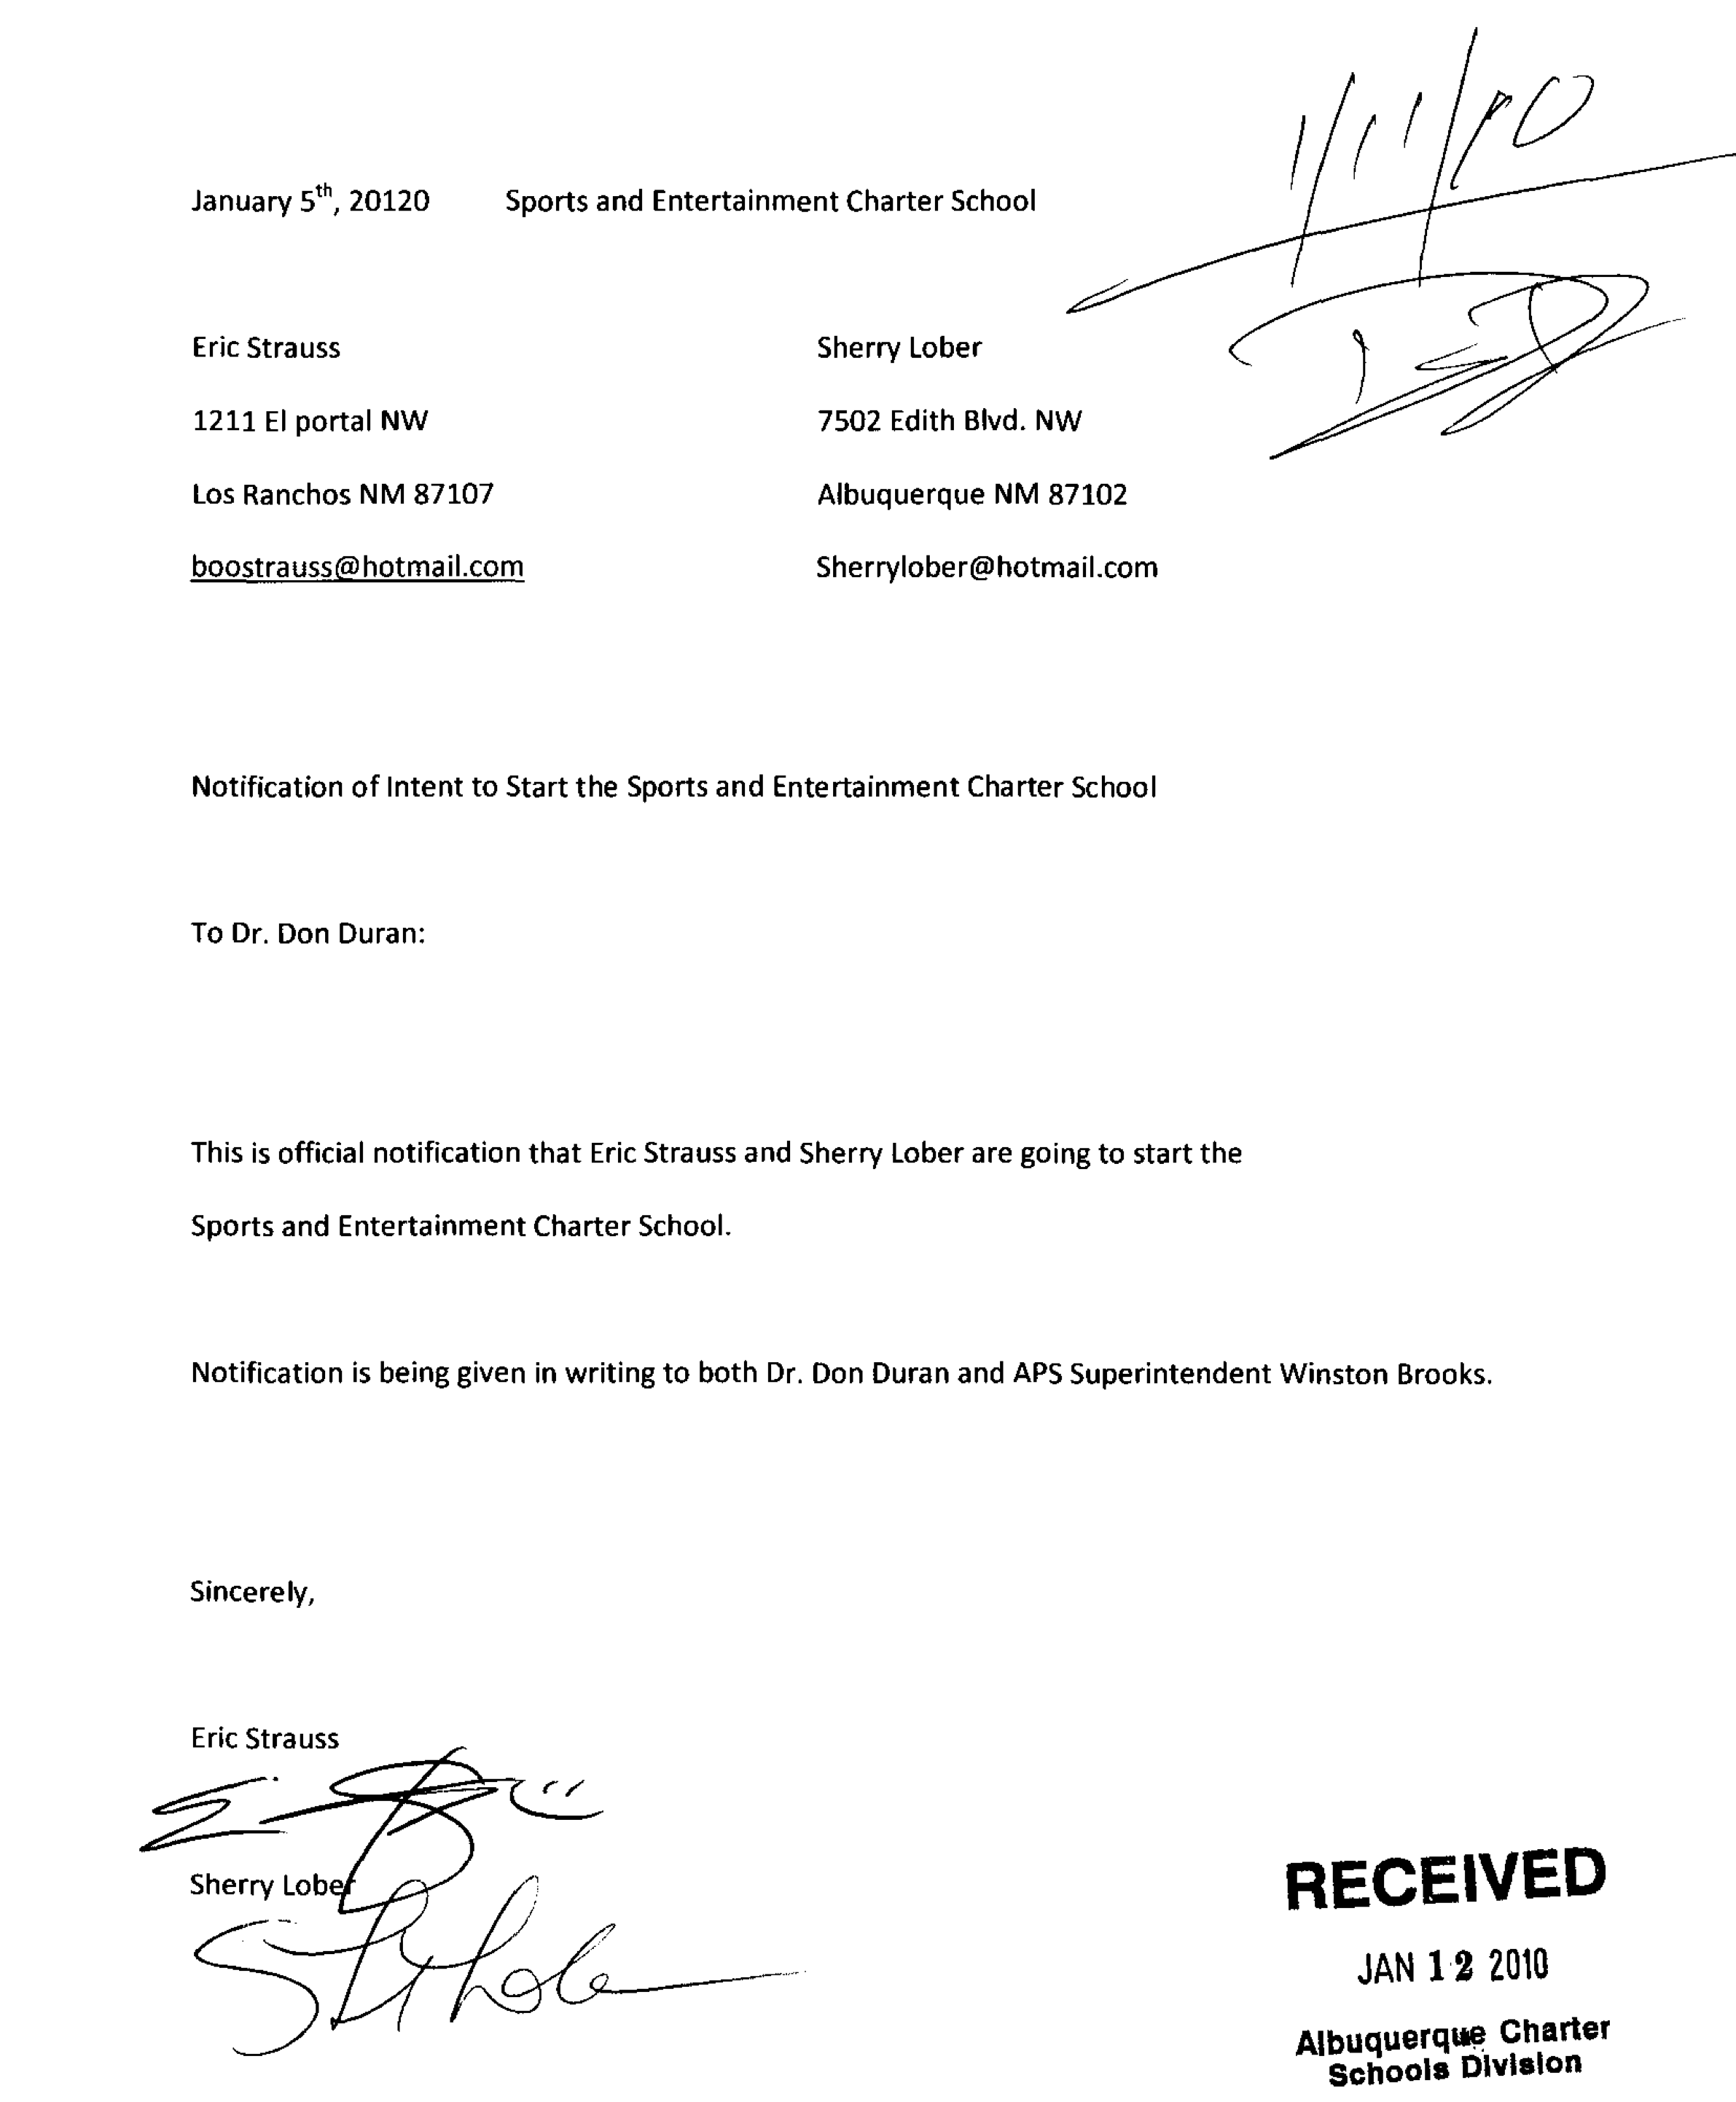

Abstract of Proposed Charter School:

The Mission of Sports and Entertainment Marketing Academy, SEMA, is to educate high-performing, entrepreneurial students who are trained in sports and entertainment marketing, teamwork, leadership and responsibility using cross-curricular integration strategies, culminating projects and real world activities that gives them a competitive advantage in college, career and community. Our school will combine challenging academics with creative use of technology and real-world experience to prepare a diverse student body for post secondary success and productive citizenship. Two School-Based-Enterprises, SBEs, will be opened within the school selling food and beverages to the student body. These SBEs will be working laboratories to connect curriculum to real world experience. SEMA students will be excellent problem solvers and communicators who contribute to their community through internships, service learning projects, and other field experiences. SEMA will offer specialized attention to student-athletes who need extra-personalized help in order to remain academically eligible to participate at their home school in athletics and extra-curricular activities. SEMA students will receive guidance and training to navigate the NCAA clearinghouse process, ACT and SAT test preparation, as well as financial aide assistance and college application requirements.

The Sports and Entertainment Marketing Academy is a 9-12 grade school serving the Albuquerque and Rio Rancho communities. Total enrollment will reach 350 students. Students will have rigorous academic and co-curricular requirements including: leadership development, service learning projects, internships and extra-curricular requirements. Students will earn college credits while in high school. SEMA students will also receive industry-recognized certifications in Final Cut Pro, IRS certification in Tax Preparation, Association for Retail Industry, ASK, Certification and Microsoft Office Suite Certifications. These certifications, combined with direct Internship opportunities, will allow SEMA students to outpace other students in this highly competitive job market.

All students will take a fully integrated core program, including: mathematics, science, English, social studies, Spanish, business and marketing classes. They will participate in regular advisory and weekly Vocational Student Organizational meetings, scheduled opportunities for personal or educational support, enrichment or business electives and a cooperative education internship in the community. SEMA emphasizes several interrelated instructional approaches supported by a flexible technology infrastructure: differentiated instruction, project-based learning, cooperative learning, curriculum integration and presentations of learning, field studies and direct instruction. All of these strategies will be employed in a context of team teaching. Each interdisciplinary team of teachers will teach and advise a particular cohort of students over a two year period starting with the IMPACT TEAM A, 9th and 10th grade, and moving to IMPACT TEAM B, 11th and 12th grade, based on demonstrated mastery of requisite skill set and knowledge.

Partnering with organizations such as: DECA, BPA and VICA, People to People, and Educational tours, SEMA will create professional development, competitive, leadership and travel opportunities. SEMA will partner with higher educational institutions including: Central New Mexico College, New Mexico Highlands University and The University of New Mexico to provide pathways for our students to earn college credit and develop a seamless transition to post secondary educational opportunities. The goal of SEMA is to articulate students to post secondary education and high paying, challenging, fun and exciting careers.

- STATEMENTS OF ASSURANCES / ASSURANCE THAT ALL GOVERNING BODY MEMBERS HAVE READ THE COMPLETED APPLICATION
These forms must be signed by a duly-authorized representative of the governing body of the proposed charter school and submitted with the final application. An application will be considered incomplete if it is not accompanied by the Statements of Assurances and an assurance from each governing body member that they have read the completed application and agree to its submission.

STATE OF NEW MEXICO )
)
COUNTY OF )

I, Sherry Lober, after being duly sworn, state as follows:
1. My name is Sherry Lober and I reside in Albuquerque, NM.
2. I am the authorized representative of the governing body of the proposed Sports and Entertainment Marketing Academy(name of school) to be located at to be determined later , I certify that, if awarded a charter:
- The CHARTER SCHOOL’s admission process shall not discriminate against anyone regarding race, gender, national origin, color, ability level, or age.
- If more students apply than can be accommodated, The CHARTER SCHOOL shall admit students on the basis of a lottery.
- The CHARTER SCHOOL’s admission processes shall be in compliance with Section 22-8B-4.1 NMSA 1978.
- The CHARTER SCHOOL shall be a nonsectarian, non-religious, and non-home-based public school.
- Except as otherwise provided in the Public School Code, the CHARTER SCHOOL shall not charge tuition or have admission requirements.
- The CHARTER SCHOOL shall comply with all state and federal health and safety requirements applicable to public schools, including those health and safety codes relating to educational building occupancy.
- The governing body shall not contract with a for-profit entity for the management of the CHARTER SCHOOL.
- The CHARTER SCHOOL shall comply with all applicable state and federal laws and rules related to providing special education services.
- The CHARTER SCHOOL shall avoid apparent and actual conflicts of interest when administering grants and entering into contracts for equipment and services.
- The CHARTER SCHOOL shall comply with conflict of interest provisions identified in the New Mexico Procurement Code, Section 13-1-128 et seq. NMSA 1978 and the Prohibited Sales Act, Section 22-21-1 et seq. NMSA 1978; and the federal regulations at 34 CFR 75.525 and 80.36.
- The CHARTER SCHOOL shall ensure that criminal background checks are conducted on all employees in accordance with Section 22-10A-5 NMSA 1978.
- The CHARTER SCHOOL shall develop written procurement procedures and conduct all procurement transactions in a manner that provides open and fair competition.

(Statements of Assurances page 2 of 4)

- The CHARTER SCHOOL shall comply with the Age Discrimination Act of 1975, Title VI
- of the Civil Rights Act of 1964, Title IX of the Education Amendments of 1972, Section 504 of the Rehabilitation Act of 1973, and part B of the Individuals with Disabilities Education Act;
- The CHARTER SCHOOL shall provide equitable access to and participation in its federally assisted program for students, teachers, and other program beneficiaries with special needs.
- The CHARTER SCHOOL shall be economically sound and the fiscal management shall comply with all applicable federal and state laws, regulations and rules relative to fiscal procedures.
- The CHARTER SCHOOL shall provide to the Public Education Commission by the sooner of the end of the planning year or within ten (10) days of receipt of any federal or state stimulus funds a detailed plan indicating how the CHARTER SCHOOL will manage its fiscal responsibilities, the plan will include a description of the internal control procedures that the charter school will utilize to safeguard assets, segregate its payroll and other check disbursement duties, provide reliable financial information, promote operational efficiency, and ensure compliance with all applicable federal statutes and regulations and state statutes and rules relative to fiscal procedures.
- Meetings of the CHARTER SCHOOL Governing Body shall comply with the New Mexico Open Meetings Act, Sections 10-15-1 et seq., NMSA 1978.
- The CHARTER SCHOOL shall adopt policies and procedures of the governing body, that address governance, relationship to staff, professional development, the role of the governing body in policy-making, personnel decisions, budgeting, and operation of the school, including how decisions will be made.
- The Governing Body or head administrator of the CHARTER SCHOOL shall recognize and work with employee labor representatives, if any.
- The CHARTER SCHOOL shall produce a certificate of occupancy prior to opening a facility for use as a school; the facility shall meet all applicable federal and state health, safety and code requirements and be suitable for use as a school.
- The CHARTER SCHOOL shall develop and maintain a plan for addressing code, accessibility, health and safety requirements as well as operation, maintenance and repair of any facility it seeks to use as a school.
- The CHARTER SCHOOL shall develop personnel policies that comply with all applicable federal and state labor laws, regulations and rules implementing them and shall submit the policies to the Public Education Department for comment prior to the hiring of any employees.

I hereby certify that the information submitted in this application for a charter is true to the best of my knowledge and belief. I understand that I am the authorized representative of the governing body of this proposed charter school.

[Signatures required on next page]

(Statements of Assurances page 3 of 4)

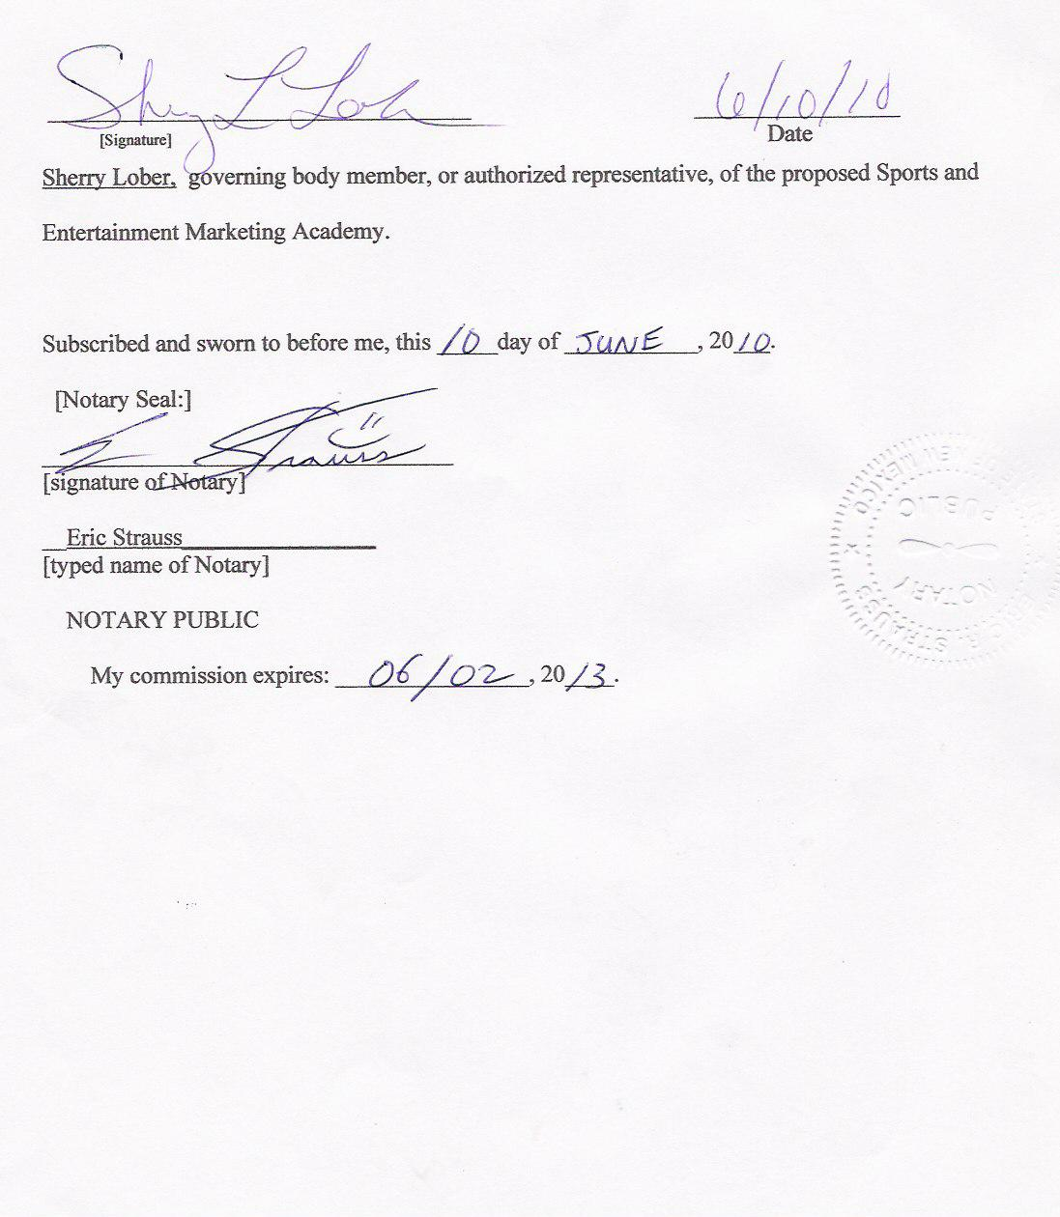

(Statements of Assurances page 4 of 4)

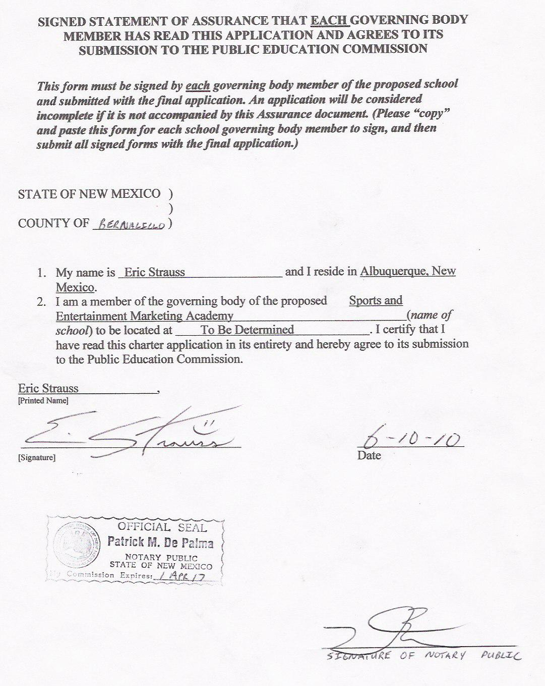
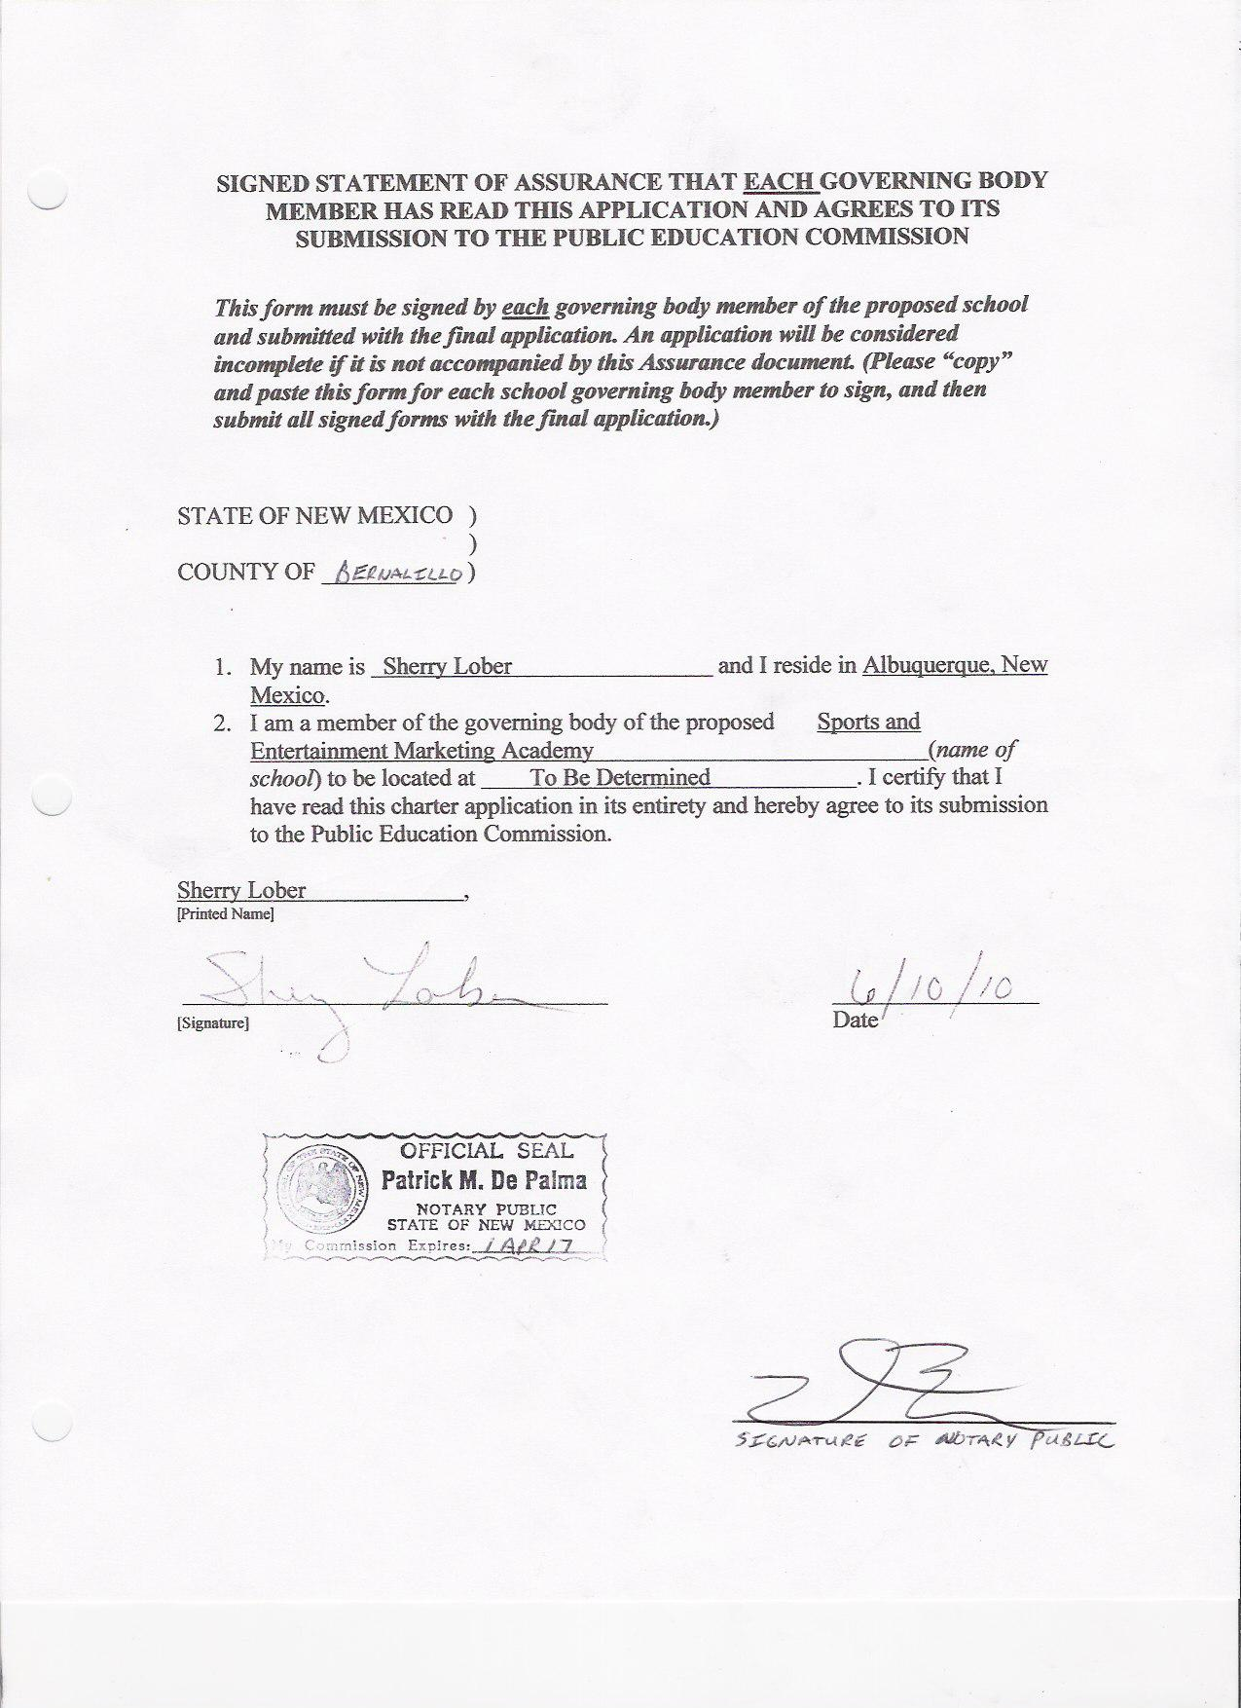
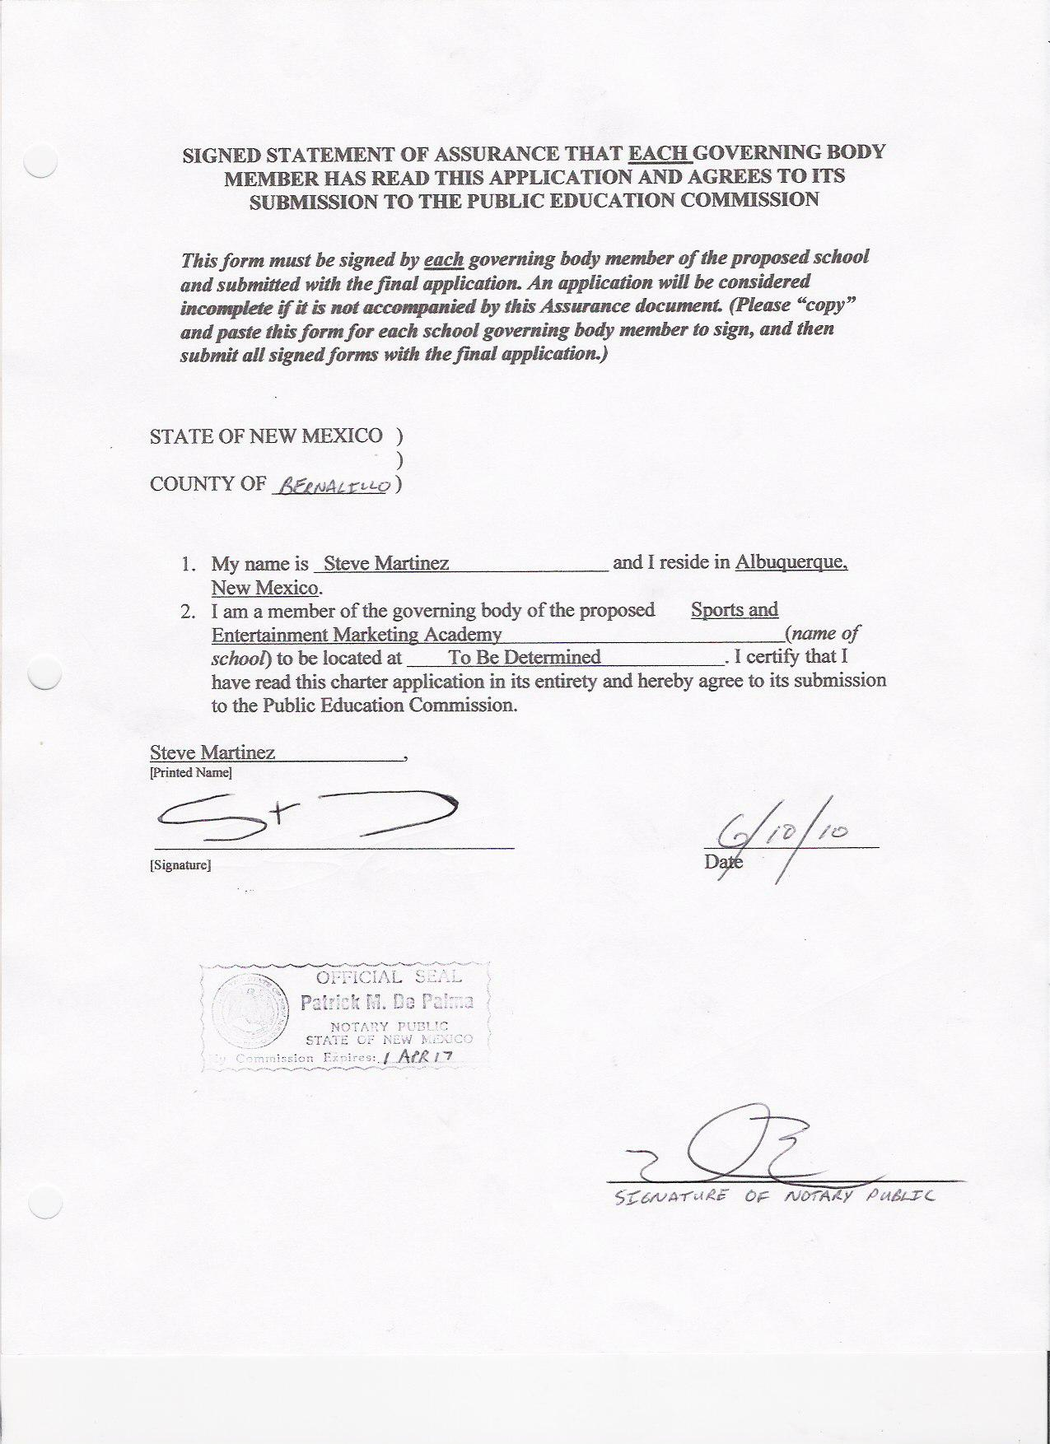
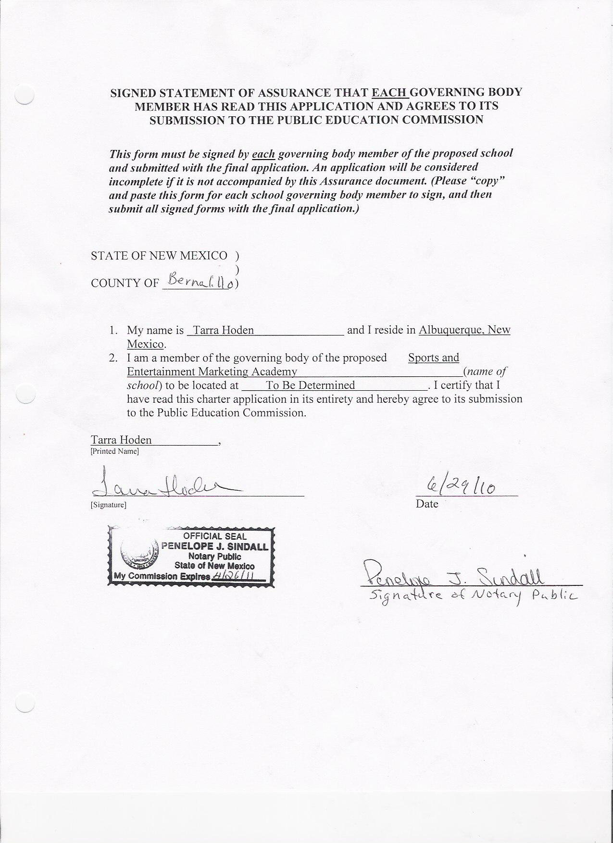
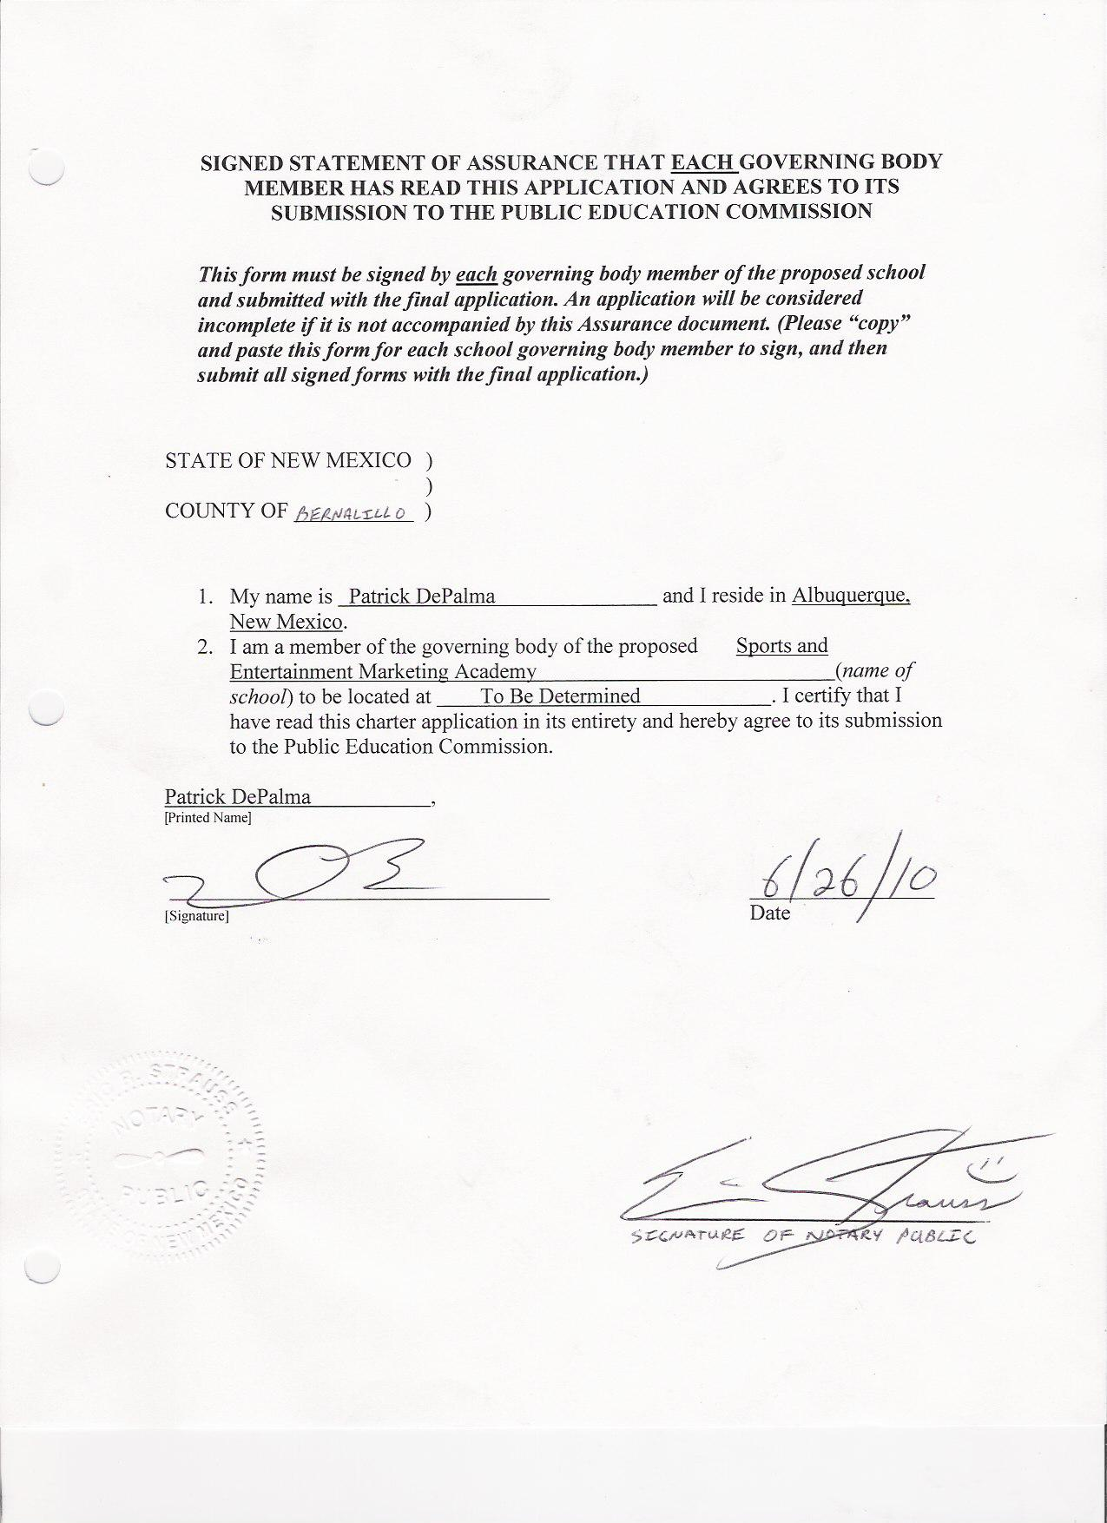
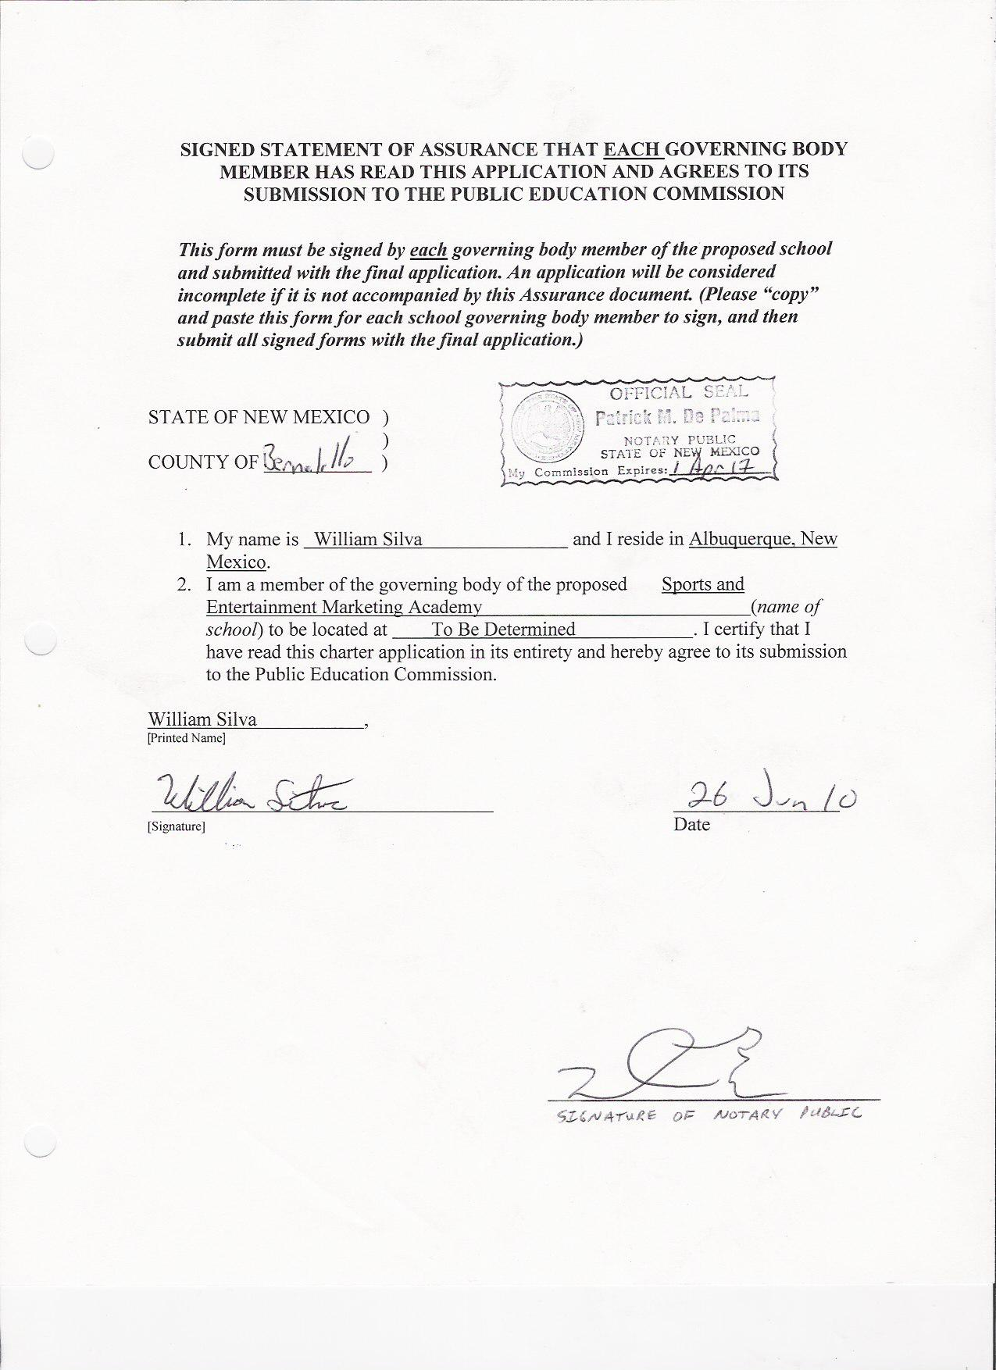

- CHARTER SCHOOL MISSION AND STATEMENT OF NEED

The Charter School Mission Statement should communicate the essence of the school to stakeholders and to the public and should provide the focal point to which all other sections of the school’s plans align. In addition, the proposed charter school and its mission must be in the best interest of the students and community that it proposes to serve.

Mission Statement: To educate high-performing, entrepreneurial students who are trained in sports and entertainment marketing, teamwork, leadership and responsibility using cross-curricular integration strategies, culminating projects and real world activities that will provide them a competitive advantage in college, career and community.

  - Who the school seeks to serve
- Students grades 9-12 in the Albuquerque and surrounding areas
- Students who have an entrepreneurial spirit and who want to pursue a college degree, owning their own business or entering the industry of sports and entertainment marketing.
- Students who desire a more focused and accelerated learning curriculum and intellectual growth
- Students who need specialized attention in order to remain academically eligible to participate at their home school in athletics and extra-curricular activities.
- Students “at risk” who may be challenged by low income, English language learning, special education needs, immigration status, truancy, lack of parental support, gifted students and those that do not fit in a larger school traditional learning environment.
- Students who have dropped out and want to rejoin a high school program to prepare for a career or college.
- Students who wish to discontinue their home school studies
- Student athletes who desire and/or require a more flexible school schedule

  - What the school seeks to accomplish.
  - Students to graduate with college credits completed in BA 1101 Introduction to business, BA 1100 College Preparation and Accounting 1101 preparing them for Associates of Business Management and subsequently transitioning to UNM Anderson School of Management for Bachelors of Business Associates
  - Industry certifications for students in areas such as: Final Cut Pro, Assessment of Skills and Knowledge Marketing, New Mexico Tax Help, Microsoft Office Suite and National Retail Association Professional Certifications in Customer Service, Sales and Management which can be used for transition into a career field or Secondary Education
  - A successful “Cooperative Education” (to be used interchangeably with “Internships”) requirements to be completed by senior year providing real-world work experience with local businesses such as the Albuquerque Isotopes and UNM Athletics as well as Tingley Coliseum or a new downtown event center
  - A successful athletic assistance program that will help students remain eligible through high school and to help them navigate the NCAA clearinghouse eligibility process so they can continue their athletic interests in college
  - Partnerships with multiple Vocational Student Organizations such as DECA to provide unique competitive, professional development opportunities for our students.
  - Annual portfolio presentations and a final Senior Exit Portfolio to be presented to Impact Teams for Graduation Certification
  - Preparing students to be successful in their lives and careers and to become productive members of society by integrating character education, project citizen curriculum, leadership and teamwork training into a rigorous core academic and career education curriculum
  - Bilingual and Dual Language Opportunities for International Marketing
  - Travel Opportunities for students to professional conferences and competitions connecting curriculum to the real-world expanding the students worldly experience and professional and social network

  - What methods the school will use.

Our integrated approach to teaching for meaning and understanding includes:

- A rigorous and relevant curriculum that infuses the challenging mathematics, language art, history, business marketing/economics, technical and communication skills required by postsecondary education and a sophisticated workplace.
- A focused vision owned by the stakeholders, for students to achieve and produce high-quality intellectual work, with significant support from school and community leaders.
- The continuous use of instructional approaches and designs that fully engage students in developing a thorough understanding of lessons and activities; manipulating information and ideas; solving authentic problems and creating products, projects, services, and new knowledge that all have value in the workplace.
- Ensuring rigorous, relevant academic and technical courses in which students are expected to think logically, solve problems creatively, plan strategically, engage in research, synthesize, organize, and present information using a multi-media approach as they complete complex tasks.
- Use of clear, standards-based authentic assessments requiring students to utilize and apply their prior knowledge and know-how in new ways that are challenging and meaningful.
- Create a flexible design structure that enables teachers to: (1) plan and work collaboratively in teams (Impact teams), and (2) develop meaningful and engaging integrated lessons, activities, relationships, and experiences that serve as a springboard for students to demonstrate higher performance and achievement levels.
- Create support for the success of all students by connecting school and the outside world through strong parent, business and community involvement in student learning and character development.
- Implement small learning communities (Impact teams) within our school structure that create a sense of belonging and responsibility by all students, faculty and staff.
- Dual credit courses taught by Central New Mexico Community College faculty pursuant to the Statewide Dual Credit Master Agreement as approved by NMPED
- High school credit courses benchmarked to NM PED Standards taught by
NM certified teachers following the Advanced Placement curricula, where available
- High school and AP distance learning courses available through IDEAL-
NM
- Memberships in Vocational Student Organizations such as DECA, An Association of Marketing students, to help students develop skills for successful business careers, build self–esteem, experience leadership and practice community service. Members of Vocational Student Organization’s, VSO’s, create networks with like–minded people from all over the world at career and leadership conferences and build resumes that move them to the top of the job and college application list.
- SEMA students will be required to demonstrate growth in their chosen career competencies by maintaining a portfolio documenting their development and assessment of their soft skills that complement hard skills, which are the technical requirements necessary of their Cooperative Education experiences including wage and hour reports and supervisor evaluations.
- Students will acquire skills and experiences valued by college, which are not easily measured with traditional grades or standardized tests. These skills and experiences will be demonstrated in Senior Graduation Exit Portfolio Presentations.
- SEMA will integrate Character Education, Project Citizen and Leadership training curriculum into every core academic class.

  - Provide a response to the following question: How will the school know if it is achieving its mission as stated above? The response must include school level or organizational goals that are measurable and directly support the Mission Statement. The school level or organizational goals must be stated using the SMART Goal
(NOTE: Specific measurable student performance expectations [student goals] should be addressed in section IV, Educational Plan.)

To educate high-performing, entrepreneurial students who are trained in sports and entertainment marketing, teamwork, leadership and responsibility using cross-curricular integration strategies, culminating projects and real world activities that gives them a competitive advantage SEMA will apply the following SMART goals:

- SEMA will use a continuous cycle of improvement to guide the school and assess the data that the school collects. Following a model of Plan, Do, Study and Act all decisions will be based on constant evaluation for efficacy.
- SEMA will track the actual number of Certifications in Final Cut Pro, ASK, Retail certification, IRS certification and Microsoft Office Suite to determine actual industry preparation.
- Every student will be required to participate in concurrent enrollment classes earning college credit in coordination with high school credit. The number of students completing these courses will provide data to post secondary connections.
- All participants in the Cooperative Education program will do ongoing evaluations of the students and the experiences. These evaluations will be collected and analyzed to improve the experience of the students and industry partners.
- SEMA’s cooperative partnerships with post-secondary institutions and the business industry will provide unparalleled opportunities for our students to have well-paid and enriching careers. Therefore, the school will track the comparative earnings of its graduates and their job satisfaction to determine whether they are more satisfied in their jobs than their peers from other schools.
- SEMA students will be academically eligible to participate in athletics and extra-curricular programs at their home school.
- SEMA students will complete a yearly evaluation of the school and instructors consisting of quality of instruction, curriculum and school operations. This data will be collected and presented to board and impact teams for disaggregation and implementation for improvement.
- We believe that relevant instruction, teamed with high levels of care and concern, will produce exemplary graduation rates and ultimately an efficient use of public funds. In order to demonstrate our success, the school will compare its cost per-graduate to other schools in New Mexico. We also intend to disaggregate this data and provide analysis by subgroups of the student population (English language learners, special education, income, etc.)

- Explanation of need that describes how the proposed charter school is in the best interest of the students and community that it proposes to serve. Include a demographic description of the student and community population within which the school will be located.

High student achievement does not happen by accident. It is the result of careful planning, involvement of the students in their own learning processes, employing varied and effective instructional practices, and analyzing student achievement and abilities data to drive instruction. SEMA’s integration plan promotes all four principles through collaborative cross-curricular planning, rigorous and relevant instructional practices incorporating the students’ academic needs. The foundation of this instruction is cemented in State instructional standards and graduation requirements. SEMA will be located in Albuquerque, New Mexico and will serve students on the West Side including Rio Rancho High School Students. SEMA seeks to serve the 52.8 percent of Hispanics, 35.4 percent of Caucasians, 4.2 percent of African-American, 2.5 percent of Asian/Pacific and 5.1 percent of Native Americans that APS is currently educating. SEMA will seek diversity of its students embracing all cultures and ethnicities interested in Sports Entertainment and Marketing. SEMA will operate two School-Based-Enterprises, SBEs, selling food and beverages to the student population. These SBEs will provide work and leadership opportunities. Students who are involved are more academically successful. Of the 60 students listed in the May 14, 1998, USA Today's All-USA High School Academic First, Second and Third Teams and the 51 who earned honorable mention, 75 percent were involved in sports, or extra curricular clubs. According to career clusters organization, the employment outlook for 2009 states that nearly half of all jobs are in managerial and professional occupations, and nearly one-fourth of all workers are self-employed. Half of every dollar spent by a business is spent on marketing. The business management and administration services industry is one of the highest-paying industries. In the next few years, many new jobs will be added and many openings will result from the need to replace experienced workers who leave jobs. There are career opportunities available in every sector of the economy that requires skills in organization, time management, customer service and communication. In a survey of 4,800 high school students in March 1995, the Minnesota State High School League found that 91 percent of them said students who participate in school activities tend to be school leaders and role models; 92 percent said that participation in school activities provides an opportunity not found in a regular classroom setting to develop self-discipline. Vocational programs such as SEMA offers, fulfill this requirement by combining academics, career awareness and employability skills and producing high-performing, entrepreneurial students who are trained in sports and entertainment marketing, teamwork, leadership and responsibility. These students have industry certifications and college credits already completed by the time they leave the Sports and Entertainment Marketing Academy. SEMA is not only needed, but it can be a valued school in the Albuquerque community which is actively seeking more tourism, entertainment and sports venues to increase revenues of the city. SEMA will help students to enter this huge and growing industry.

When the Albuquerque Public Schools Graduation rate is 46.2%, there is a need for a new and unique approach for our students. Statistics show students who are involved in their school and community show a higher retention rate. School involvement in extra-curricular clubs and teams is a requirement of SEMA. Merely graduating is not enough, students need to become educated and career ready, not just earn a diploma. There are many public high schools facing corrective action. These high schools have lagging standardized test scores and an inability to make meaningful use of the abundant resources within the local community. SEMA plans on utilizing the abundance of resources available in Albuquerque to provide unique learning situations for our students. Through the structuring of small learning Impact teams, students can receive the individualized attention necessary to help close the achievement gaps. These gaps have been identified in APS between students of different races and incomes. Poorer and Hispanic, Native American and Black students have lower reading scores, math scores and graduation rates. Students graduating from APS are ill prepared for either post secondary education or the demands of a career. “In 2007, only 46 percent of CNM's degree-seeking freshmen returned the next year,” stated Katherine Bercaw, vice president of the college's Planning and Budget department. “Students who attend the University of New Mexico have a 43 percent chance of graduating,” stated UNM President David Schmidly.

SEMA’s approach to facilitating an increased level of student learning and performance is rooted in the core belief that all children can learn more, retain more and perform at higher levels if we teach for meaning and understanding through integration of academic and technical curricula. The world is an independent environment, and our approach is to find the natural connections where independent disciplines connect and mesh with one another, and to use those natural connections to develop relevant learning experiences that have meaning beyond what a student can achieve at a traditional public high school.

- EDUCATIONAL PLAN

The educational plan should describe who the school expects to serve; what the students will achieve; how they will achieve it; and how the school will evaluate performance. It should provide a clear picture of what a student who attends the school will experience in terms of educational climate, structure, materials, schedule, assessment and outcomes.

- CURRICULUM FRAMEWORK

The New Mexico Content Standards, Benchmarks and Performance Standards provide the content requirements and expectations for students in all public schools. The description of the curriculum should provide a sense not only of what the school will teach but also of how and why. (NOTE: Refer to the Glossary of Terms Used in the Application, page v, to assist in the completion of this section.) The following components of the curriculum framework must be addressed:

1. Philosophy and Approach to Instruction

- Describe the educational philosophy and curricular approach of the proposed school.
- Describe why the particular educational philosophy and/or approach was selected.
- Provide documentation, research, and/or a rationale that supports the educational philosophy and curricular approach.
- Explain why the educational philosophy and/or approach is/are likely to result in improved educational performance of students.
- Describe how the educational philosophy and/or approach aligns with the school’s mission and student needs.

The educational philosophy and curricular approach of SEMA is the total integration of Core Academia and Cooperative Education. Academic and workforce development integration directly follows our mission To educate high-performing, entrepreneurial students who are trained in sports and entertainment marketing, teamwork, leadership and responsibility using cross-curricular integration strategies, culminating projects and real world activities that gives them a competitive advantage in college, career and community. SEMA will also follow the objectives of the State Department of Education, “To establish challenging academic and technical standards with benchmarks and performance standards for students in grades 7-12 and to assist students in meeting such standards, including preparation for high-skill, high-wage or high-demand occupations in current or emerging professions, as defined in the scope of this regulation.”[6.29.3.6 NMAC – N, 6-30-2009]

SEMA has chosen an academic and workforce development integration philosophy for the following reasons:
- Integration is how people learn in the real world. Students learn more quickly and easily if information is given in context. Brain research suggests what teachers have long expected—that the brain is a pattern seeker. When teachers assign isolated skills, they deprive students of the opportunity to make the types of connections that nourish the brain and foster learning.
- Integrated learning helps academic and workforce development teachers expand their repertoire of teaching strategies. It enables teachers to move beyond lecturing and asking students to fill out worksheets. It allows students to construct new knowledge by working on problems, projects and products that relate academic knowledge to the work environment. Traditional instruction requires students to learn by listening and watching; it excludes those who learn best by doing. Recognizing and teaching to multiple learning styles and multiple intelligences reduces students’ fears of failure that often impedes learning. In this process, workforce development education is more rigorous and academic learning and more relevant.
- Integrated studies can cultivate a “yearning for learning” among youth. Integration answers the fundamental questions, “Why do I need to know this?” and “How and when will I use it?”
- Academic and workforce development integration improves the academic achievement of more students. Brain research endorses integrated learning. When teachers teach concepts apart from students’ experiences, they are setting many students up for failure and a sense of hopelessness, producing physiological barriers to student achievement. Thus, when academic concepts are coordinated with experiential learning in workforce development studies, many students “anchor” their learning and achievement increases. To have more high-performing students, teachers need to use instructional strategies linking symbolic school-based learning and real-life experiences.
- Integrated learning helps students make education and career plans. Students who use academic knowledge and skills in the content of broad career fields begin to recognize their aptitudes and interests and to formulate individual tentative career goals.
- Integrated learning promotes professionalism among teachers as they work together to raise student achievement. Teachers are often subjected to top-down instructional mandates and are left to implement them in the isolation of their classrooms. In integrated learning, teachers collaborate in developing engaging and meaningful lessons, activities, and experiences for their specific students. Acting as decision-makers rather than conduits for prepackaged curricula, these teachers combine their knowledge and expertise with best teaching practices to create 21st century learners.

2. Description of the Curriculum

- If the curriculum has already been selected/developed: Provide a detailed description of the curriculum that includes a scope and sequence.

- If the curriculum has yet to be developed: Provide a description of the proposed curriculum and a specific plan for its development that will include a scope and sequence. The development plan should include a description of the process, a timeline, and resources (including staffing) to be utilized.

3. Alignment with NM Standards

- The curriculum selected/developed must align to the New Mexico Content Standards, Benchmarks and Performance Standards. Provide a copy of the alignment document if it was completed, OR, if the alignment has not been completed, describe the process and a specific timeline to be used for aligning the curriculum with the New Mexico Standards.
4. Strategies and Methods:

- Provide a description of the strategies and methods to be used in delivering the curriculum.
- Provide an explanation of how the curriculum will address students’ needs and assist students in reaching the NM Standards. (NOTE: Students with special needs, including students who require bilingual education, special education or are limited English proficient, should be addressed in Subsection D: Special Populations)
- Provide a descriptive example of the curricular strategies and methods in action in the classroom.
- Provide a description of professional development that may be necessary for implementation of the strategies and methods to be used in delivering the curriculum.

(Please note that section 2, 3, and 4 are combined under this section).

SEMA’s comprehensive curriculum will be written and aligned with New Mexico content standards by a group of hired curriculum experts. The curriculum experts will be hired within one month right after the charter approval date. Approved curriculum will be aligned and ready to be deployed three months before the first day of school. The New Mexico State Department of Education Benchmarks and Standards will be the foundation of the curriculum at SEMA. Curriculum will also be linked to industry certifications in order for students to achieve the requirements of the certifications as they move through instruction.

High student achievement is the common goal that drives day-to-day instruction of SEMA. Attaining high achievement promotes the growth of the individual students, our schools’ programs, and our student body as a whole. The faculty of SEMA believes in continuous improvement for all students in all curricular areas. Themes will be developed and consequently integrated lesson plans will be completed based on research, best teaching practices and teacher and student input. SEMA will be a place for students to experience and participate in their learning. Each student will actively experience learning as a meaningful, transformative experience that creates opportunity and enables success. By helping students maintain eligibility according to New Mexico Activities Association for athletics or extra-curricular participation, students will be more inclined to achieve academic excellence. Impoverished and at risk students will be mentored and actively engaged in the learning process. Students will be proficient in core subject areas and be ready for post secondary educational success.

SEMA will provide a safe, supportive learning environment that offers challenging work to all students. The school will look and function like a high performance workplace. Students will move easily through their educational journey because of the total integration of academic, career awareness and employability curriculum and skills. They will be able to transition seamlessly to either post secondary education or a career. Each student will have an advisor who will help the student pursue interests through projects, electives and cooperative education. All students will complete next step plans, maintain a digital portfolio and a cooperative education journal to document and reflect on their learning. Teachers will work in impact teams and serve on evaluation panels for student presentations. The school will offer opportunities for parent learning and will forge partnerships with local businesses and social service agencies to provide learning opportunities for students and community members.

High expectations, integration, project-based learning, personal support and community involvement form the foundation of SEMA’s educational philosophy; they are embedded in our mission, our learning goals and our curriculum. They will result in producing high-performing, entrepreneurial students who will become successful, contributing members of our community.

SEMA emphasizes several instructional approaches: differentiated instruction, project-based learning, cooperative learning, curriculum integration, presentations of learning and field studies as well as traditional direct instruction. All of these strategies will be employed in a context of team teaching, where interdisciplinary teams of teachers, Impact Teams, are responsible for the academic and personal growth of small teams of students. For example, Impact Team A will be responsible for all the 9th and 10th graders and Impact Team B will be responsible for the 11th and 12th graders. The strategies fit together easily to enhance student performance. Project-based learning, for example, provides an excellent way to differentiate instruction and integrate the curriculum. It employs cooperative learning techniques and culminates in presentations of learning.

Curriculum Integration – Teachers will work in teams, Impact Teams, to develop an integrated curriculum in which students investigate engaging, overarching questions through a variety of disciplinary lenses. The “answers” to these questions require significant investigation, critical thinking, and the application of skills across the subject areas. As students study the core subjects of English, History, Mathematics and Science, students will create multidisciplinary projects that reinforce the connections among disciplines. They will put into practice Bruner’s notion that “grasping the structure of a subject is understanding it in a way that permits many other things to be related to it meaningfully.” The notion of curriculum integration is supported by a substantial body of research in how children learn, particularly in the tendency of the brain to seek meaningful, connected patterns (Cromwell, 1989, Caine and Caine, 1991).

Project-Based Learning – SEMA’s commitment to active, applied learning will find its day-to-day application in project-based learning. “A model for teaching and learning that focuses on the central concepts and principle of a discipline, involves students in problem-solving and other meaningful tasks, allows students to wok autonomously to construct their own learning, and culminated in realistic, student-generated products.” (Tucker and Codding 1998, pp. 175-190). They describe the dramatic impact of integrated, project-based learning on student achievement in a case study of the Aalborg Technical College, Denmark. Simply stated, students learn more effectively when information is connected in context. At SEMA, students can also enter their finished products for competition via Vocational Student Organizations providing them opportunities for national recognition as well as scholarships.

Presentations of Learning – In a study of 24 schools in 16 states, found that in schools where student achievement is high, students are engaged in regular presentations of their work (Newman 1996). SEMA will require all students to demonstrate publicly their skills and knowledge each term in a “presentation of learning.” More than a means of assessment, these presentations become an instructional strategy in day-to-day practices. As students regularly share their work, they learn to ask questions of each other and use feedback to improve their performance. Students begin to contemplate, “What is “good enough? What is missing from this particular science lab report? What questions are left unanswered?” Student presentations will also provide an occasion for mastery of digital technology, as students will be required to employ a variety of digital media in their presentations. Tucker and Codding, in Standards for our Schools, point to the dramatic impact of student exhibitions, collaborative projects and the integration of technology on student achievement. Students achieve better, increase confidence and read and write more effectively (pp 94-99).

Differentiated Instruction – While all students will be expected to reach the same performance standards, they may follow different paths to success. Teachers will plan together daily and will consider multiple ways of engaging their students. As they get to know their students in their impact teams and in the classrooms, they will adjust instruction to meet the varied needs of their students. They will incorporate strategies that cater to visual and auditory learners, providing a variety of prompts and entry points that enable a full range of students to grasp fundamental concepts and connect to the important themes, questions and skills in a unit of study. All teachers will be trained to employ well-designed, research-based differentiated strategies for group work as a means for providing “simultaneous opportunities for all class members.” Tomlinson describes differentiated instruction, “as a complex process that includes both group work and curriculum integration” (1999, pp.68-71). Differentiated instruction raises the standard of instruction for all students and demands the creation of multiple responses and the use of multiple intelligences.

Cooperative Learning – When appropriate, students will work in small peer-groups. Students gain confidence and skills through collaborative work by learning how to engage in “collegial problem solving” (Newman, 1995). Numerous research studies in K-12 classrooms, in very diverse school settings and across a wide range of content areas, have revealed that students completing cooperative learning group tasks tend to have higher academic test scores, higher self-esteem, greater numbers of positive social skills, fewer stereotypes of individuals of other races or ethnic groups and greater comprehension of the content and skills they are studying (Stahl, 1994; Johnson, Johnson, and Holubec, 1993; Slavin, 1991; Stahl and VanSickle 1992). Cooperative learning at SEMA will emphasize delegating authority, teaching students to take responsibility for particular pieces of their work and co-reliance, effective communication and interaction in order to accomplish a shared goal (Cohen, 1994).

Digital Portfolios – Students will keep and maintain a digital portfolio that reflects their academic progress throughout their time at SEMA. Arter. J. et. Al. (1995) point out that the perceived benefit for instruction is that assembling a portfolio fosters student self-reflection, critical thinking, responsibility for learning and content area skills and knowledge. The advantage of the digital portfolio is that it permits variety of uses and purposes: archiving work samples and reflections on learning, documenting development, demonstrating proficiency, and exhibiting one’s best work and resume on a personal website. The digital portfolio at SEMA will be a key component of students’ transition from Impact Team A to Impact Team B and will ultimately provide evidence of readiness to graduate.

Field Work and Cooperative Education/Internships – Key to SEMA’s commitment to real world connections is the requirement that each student will complete at least one substantial, minimum 10 hours per week, academically connected Cooperative Education class in the junior and senior year. This requirement has implications for instruction as early as the 9th grade year, as teachers help students consider the real-world applications of their learning. Early on, SEMA students will learn how to navigate the larger community of Albuquerque through field-work and community-oriented projects. This approach is supported by the National Association of Colleges and Employers (NACE). Katharine Hansen, Ph.D., creative director and associate publisher of Quintessential Careers, cites the top 13 reasons for students to complete Cooperative Educations:
1. Employers increasingly want to see experience in the new college grads they hire. A staggering 95% of employers said candidate experience is a factor in hiring decisions, according to an annual survey by the National Association of Colleges and Employers (NACE) Nearly half of surveyed employers wanted new-grad experience to come from internships or co-op programs. If you have completed Cooperative Educations, you will clearly have an edge over your classmates who haven't. In an Associated Press article, reporter Emily Fredrix quotes Philip D. Gardner, research director of the Collegiate Employment Research Institute, as saying that internship experience is, "just one of those things you have to have before employers will even consider looking at your resume.”
2. Employers increasingly see their internship programs as the best path for hiring entry-level candidates. "Not only does participation in an internship make the student a more attractive candidate," says NACE Executive Director Marilyn Macke, "but it can also be an avenue to a job." NACE's 2008 Experiential Education Survey shows that hiring from the intern program is growing. Employers reported that nearly 36 percent of the new college graduates they hired from the Class of 2007 came from their own internship programs, up from 30 percent from the Class of 2005. Matthew Zinman of the Internship Institute reports that IBM hires up to 2,000 interns annually and converts more than half of them to full-time hires. Recruiting guru Dr. John Sullivan writes on the Electronic Recruiting Exchange, “the most effective sources I have worked with have consistently found that quality internship programs produce the highest quality candidates, the most productive hires, and the hires with the highest retention rates."
3. Students may get paid more when they graduate if they have done one or more internships. Even back in 2005, NACE reported that surveyed employers that hired entry-level candidates with internship/co-op experience paid them 6.5 percent more than those without the experience.
4. Students could earn both high school and college credit that can be applied toward graduation and their degree. SEMA will offer practical arts credit and many if not most colleges provide credit for eligible internships.
5. Internships enable students to take their career plans for a test drive. They might discover by interning in their planned career field that it is not what they thought it would be like. Or one niche of their field is a better fit for them than another. For example, if a student is a marketing major, and they complete an internship in marketing research, they may discover they hate it. Before giving up on marketing, they may do an internship in public relations and find it is a perfect fit for them. Early internships can help students to solidify their career choice. Students can also test out a variety of career paths. Finally, students can test out creative ways to combine their interests, for example; a student might be wavering between med school and a marketing career and did internships that combined medicine and marketing they could ultimately pursue grad school in health-care policy.
6. Students will gain valuable understanding of their major field and be better able to grasp how their coursework is preparing them to enter their chosen career. Students may also discover gaps between their classroom learning and what they need to know in the real world and can strategize how they will fill those gaps. Some employers will even suggest additional courses they should consider.
7. Students will develop skills galore. An internship can help sharpen interpersonal skills employers seek by interacting with people on a professional level and in a way that they would never have the opportunity to do in the classroom. The same goes for the teamwork, communication, leadership and problem-solving skills that employer’s lust.
8. Students will gain confidence. If they are afraid of facing the work world when they graduate, an internship will teach them that they can do it.
9. Students will build motivation and work habits. There is nothing like an internship, where students cannot slack off if they want to succeed, to instill in them the workplace characteristics they will need after they graduate.
10. Students will build their network. Everyone they meet in an internship is a potential contact for their network and someone they can call upon for advice and referrals when they are job-hunting closer to graduation time.
11. Students will build their resume. Any kind of experience on their resume is helpful, but career-relevant internship experience will make a better impression on employers.
12. Growing numbers of colleges require internships, reports Zinman. If they are requiring them, they must be convinced that internships are important. Similarly, studies show increasing numbers of students are completing internships. Presumably these students know that internships are valuable for all the reasons listed here.
13. Students might make money. Not all internships are paid, of course, but those that do pay can yield pretty decent salaries. Employers queried in NACE's 2008 Experiential Education Survey reported offering their undergraduate interns an average of $16.33 per hour.

SEMA’s program is designed to meet the needs of a diverse student population by offering multiple ways to engage in the curriculum, opportunities for personal expression and teamwork, real-world applications, and regular presentations of learning. To be successful, these approaches need structural support in the form of significant team planning time for teachers, a strong advisory program that ensures students are known well, and partnerships with community organizations in the world beyond school. SEMA will provide all of these elements.

Technology at SEMA is not just a subject, but is a vehicle for engaging and empowering students in a variety of pursuits: scientific, mathematical, historical, literary, vocational, and aesthetic. Every student will create a web-based digital portfolio that includes a resume, work samples, and reflections on learning. Students will use a variety of applications in their work, including word processing, Internet search engines, email and other social media communications, multimedia and web tools. SEMA students will utilize Microsoft PowerPoint, Dreamweaver, Flash, photo and video tools, digital still and video cameras, Adobe Photoshop, Final Cut Pro video-editing software and computer illustration and design tools. All of these technological tools will also lead to certifications for industry ready jobs.

All SEMA students will take the following core academic classes: math, science, social studies/history, English and Spanish. Additionally, students will take vocational courses such as Marketing Business and Finance and health/wellness courses with a physical fitness component. Content and skills for math, science, social studies/history and English core classes for Impact Team A and Impact Team B will be developed in the planning year. Each group will have a thematic question, a question that spans the curriculum across all disciplines and provides the basis for interdisciplinary projects.

SEMA students will have access to a range of support and elective options. These will be offered in block schedule format, which will include career connection classes. Block classes are non-core, vocational classes within students’ weekly schedule that will offer opportunities for enrichment and support. All students, regardless of academic and career goals will receive support when it comes to preparation for their future. From 9th grade on, all students will take part in various student leadership and career development opportunities. Membership in a co-curricular vocational student organization will be required as well as service learning activities.

The Dean of Curriculum will work with SEMA faculty under the supervision of the Principal to align curriculum with the NM State Content Standards, Benchmarks and Performance Standards and ensure it is taught effectively to students. The diagram below shows the process by which the Standards-Based Instruction will inform the curriculum, and how curriculum and instruction are driven by SEMA student outcomes as well as student achievement data.

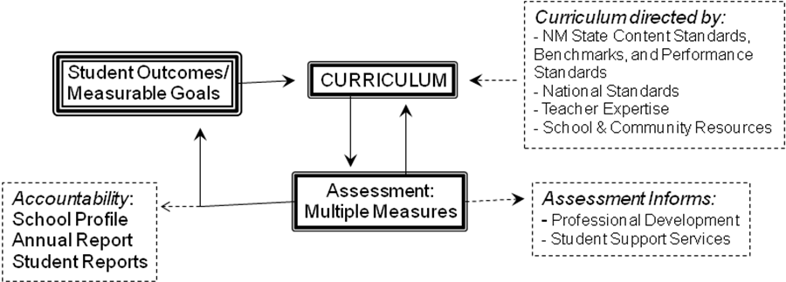

The curriculum of SEMA will also benefit limited English learners, disabled students and students who enter the school below grade level. Utilizing differentiated instructional techniques; our Dean of Curriculum and teachers will develop appropriately challenging curriculum that is beneficial to all students, regardless of disability or cultural or linguistic difference. A Special Education teacher, part of the instructional FTE, will work within each Impact team and will be able to provide additional assistance to ensure that students are engaged and benefiting from the curriculum. The Special Education teachers on each team will work closely with the school’s learning Specialist and fellow faculty to provide appropriate services for every student with and Individualized Education Plan (IEP) as well as for ESL students and students entering the school below grade level. In order to provide access to the curriculum, the following strategies will be employed across the school:
  - Professional development for faculty focusing on instructional techniques and student learning and development.
  - Co-teaching (when feasible) that allows for small groups, individualized instruction, and peer tutoring
  - Multiple forms of student assessment including differentiated projects and portfolio assessments
  - Personal learning Plans for all students that highlight strengths, areas of need, interests, accommodations and modifications.
  - Use of block schedule and vocational classes for academic support.

SEMA will encourage students to set non-academic goals and will develop a process for measuring progress toward their attainment. A context where students can set and work toward personal goals is vital for their socio-emotional development and well-being. The SEMA Advisory program will provide such a context, as well as a structure and process for monitoring and measuring student progress toward both personal and academic goals. An advisory program will be an evolving program in response to students needs. Some goals might include:
  - To advise students about academic decisions and monitor academic achievement
  - To provide developmental guidance
  - To foster communication between the home and school and among members of the school community
  - To encourage supportive peer relationships and practice conflict resolution
  - To promote an awareness of diversity and tolerance
  - To undertake community service both within and outside the school
  - To facilitate community governance and conversations
  - To prepare students for life transitions including career development and post-secondary opportunities
  - To promote character development, explore moral dilemmas
  - To explore the process of group development and have fun

Personal learning plans (PLP’s) developed through the Impact Team Advisory program (ITAP), provide each student with an opportunity to articulate specific academic and personal goals for each school year. The student, his/her advisor, and parent/guardian meet together to draft the PLP and to ensure that there are concrete avenues in place that will allow the student to make progress towards the stated goals. The PLP is revisited on a regular basis by the student and the advisor and is an important document in any team meeting about the student. Ideally, the PLP is drafted in October of each year and is reviewed again by the parent/guardian, student and advisor in a second meeting in the spring that same academic year. Advisors use the PLP’s of their students to help craft the specific activities of Advisory to determine, each semester, with their students how to make best use of their class schedule, Dual Enrollment, Internship and co/extra-curricular activities.

Measuring student progress towards the advisory goals is critical to remaining informed about the socio-emotional development of individual students as well as maintaining an indicator of the school climate and success of the Impact Team Advisory program, including surveys and questionnaires, observations, interviews and self-checklists. SEMA will develop an Advisory Goals Rubric for assessing the success of the Impact Team Advisory program. (Schurr, 1992, pp. 16-19)

SEMA must have highly trained and creative teachers. The SEMA budget has professional development and staff travel built-in to insure constant professional growth. Staff Professional development and ongoing training is vital to keep curriculum relevant and dynamic. Teachers will be actively involved in district professional development workshops and the following professional development opportunities:

- Sports and Entertainment Marketing Conference
- Differentiated Instruction Training
- National Board Certification Training
- Career and Technical Education National Conference
- Western Region Leadership Conference

- EDUCATIONAL PROGRAM

1. Length of School Day and School Year:

- State the proposed length of the school day, including the number of instructional hours;
- State the proposed length of the school year, including number of days and total number of instructional hours.
- Describe how the proposed length of the school day and school year support the Educational Plan.

The proposed length of the school day will be at approximately seven instructional hours each day for grades nine through twelve including career/work and community service hours. Students will be provided with a lunch break. The schedule will follow a block format with an Impact Team Advisory period once a month.

The proposed length of the school year will be either 180 days (5 days per week) or 160 days (4 days per week) and total number of instructional hours will be approximately one thousand eighty hours per year for grades nine through twelve.

The board of directors along with input from the impact teams and parents will determine the exact final schedule for SEMA. The SEMA schedule will take into consideration the strategy of Cooperative Education, which is a requirement at SEMA.
- “Cooperative education” means a method of education for individuals who, through written cooperative arrangements between a school and employers, receive instruction, including required rigorous and challenging academic courses and related career and technical education instruction, by alternation of study in school with a job in any occupational field, which alternation:
(1) shall be planned and supervised by the school and employer so that each contributes to the education and employability of the individual;
(2) may include an arrangement in which work periods and school attendance may be on alternate half days, full days, week or other periods of time in fulfilling the cooperative program.

SEMA’s proposed schedule will also support the educational plan in the following ways:
- Giving students choices and flexibility in scheduling classes to accommodate: personal responsibilities, financial responsibilities, and the ability to perform Community Service and/or Cooperative Education requirements.
- Maintain students and teacher morale
- A schedule that will allow for extra and co-curricular activities, tutoring and mentoring
- Allow time for professional development and Impact Team planning
- Allow for curriculum integration and team teaching

2. Grade Levels, Class Size and Projected Enrollment:

  - State the grade levels the charter school proposes to serve.
  - If a phase-in of grade levels is proposed, indicate plans for the phase in by year and grade levels, and provide a rationale for the phase-in plan.
  - State the total projected student enrollment (at full enrollment for the school).
  - State the projected class size.

School Year | Grade Levels | Total Projected Student Enrollment
First Year 2011-12 | 9-12 | 150
Second Year 2012-13 | 9-12 | 150
Third Year 2013-14 | 9-12 | 200
Fourth Year 2014-15 | 9-12 | 350
Fifth Year 2015-16 | 9-12 | 350
Total enrollment will be 350 students grade 9-12. Class size will be kept small, 20:1, to accommodate the demands of project based learning.

3. Graduation Requirements (if applicable):

  - Describe the proposed credits and requirements for graduation.
  - Describe how any proposed requirements that differ from the New Mexico Graduation Requirements [22-13-1.1.] support the school’s educational plan.

Successful completion of the requirements of the New Mexico Diploma of Excellence shall be required for graduation for students entering the ninth grade beginning in the 2009-2010 school year. Successful completion of a minimum of twenty-four units aligned to the state academic content and performance standards shall be required to earn a New Mexico diploma of excellence and may be adjusted as the state requirements are adjusted. Students will be required to complete an internship, cooperative education, and senior exit portfolio. These classes provide real world experiences that are aligned with SEMA’s mission.

These units shall be as follows:
1. Four units in English
2. Four units in mathematics
3. Three units in science
4. Three and one-half units in social science
5. One unit in physical education
6. Two units of Spanish
7. One-half elective units that meet department content and performance standards
8. Three units of Career and Technical Education classes
9. Four units Cooperative Education
10. One unit AP/Dual Credit enrollment
11. Student service learning projects
12. Senior Portfolio Presentation
13. Financial literacy shall be offered

- STUDENT PERFORMANCE EXPECTATIONS

Student academic performance is central to a school’s existence. Student performance expectations must be aligned with the mission and the educational plan. The student performance expectations will:

- Provide student-centered goals that are SMART:
  - Specific;
  - Measurable;
  - Ambitious and Attainable
  - Reflective of the school’s mission;
  - Time-Specific with Target Dates
- Provide student-centered goals that are aligned with the school’s mission and the educational plan.

SEMA has established the following SMART goals to measure and assess students’ academic performance. Impact teams will use the following performance standards scales where applicable:

Performance Standards
Performance Standard | Description | Traditional Grade Equivalency
Exceeds | Student exceeds expectations in the skill/subject area | A+
Meets | Student met expectations in the skill/subject area | A-B range
Approaches | Student is approaching expectations in the particular skill/subject area | C-D range
Just Beginning | Student is in the process of beginning to meet expectations in the skill/subject area | D-F range

Goal: Upon graduation students will have completed a journal of their required Cooperative Education/Internship Experience
Measurement:
- Will be measured and assessed using a rubric for their written reflections, employer evaluations, and wage and hour reports.

Goal: Students will meet or exceed the New Mexico and National Standards and Benchmarks for all grades in all subject areas annually
Measurement:
- As measured by SBA scores and other required indicators.

Goal: Students will graduate with college credits
Measurement:
- All students must complete the CNM Accuplacer to be eligible for college credits
- Completed concurrent enrolment in BA 1101, BA 1100 College Preparation and Accounting 1101 preparing them for Associates of Business Management and seamlessly transitioning to UNM for Bachelors of Business Associates
- High school transcripts

Goal: All students will earn an Industry Certification
Measurement:
- As measured by students including proof of industry certification in their Senior Exit Portfolio.

Goal: All students will gain work experience for their resume
Measurement:
- All students will work in the School-Based-Enterprises at SEMA their freshman and Sophomore year

Goal: Senior Exit Portfolio to be presented to Impact Team for Graduation Certification
Measurement:
- The Impact team will develop a rubric with a list of requirements and skills using the performance standards scale.

Goal: Bilingual and Dual Language Opportunities for International Marketing
Measurement:
- High school transcripts and graduation data of SEMA students who receive bi-lingual seal for diploma as outlined by APS.

Goal: Travel Opportunities for students to professional conferences and competitions connecting curriculum to the real-world, expanding the students worldly experience and social connections
- Students will submit a travel journal documenting their experiences outside the classroom that will be evaluated by the Impact teams annually using a rubric and the above performance standards scale.
Goal: To increase student eligibility and participation in athletics and extra-curricular activities.
- Students will be mentored and strongly encouraged to participate in either athletics or extra-curricular activities. Documentation of their experience will be a requirement for their Senior Exit Portfolio.

- PLAN FOR EVALUATING STUDENT PERFORMANCE

A Plan for Evaluating Student Performance must address the following components:

- the types of assessments that will be used to measure student progress toward achievement of the NM Standards and the school’s student performance expectations;
- the timeline for achievement of the NM Standards and/or the school’s student performance expectations;
- the procedures for taking corrective action in the event that student performance falls below the NM Standards and/or the school’s student performance expectations;
- remediation for students not achieving standards, including a timeline for implementation of the remediation plan;
- assessments that might be considered in addition to the statewide-mandated testing;
- documentation and reporting of student data to students and parents.

The Impact Teams and Leadership of SEMA will develop and administer instruments to assess the mission-based student performance expectations. Students are expected to achieve academic success continually. In order to measure progress and mastery, the Impact Teams and teachers at the school will conduct assessments. These assessments will also be at the classroom level as well as for individual students (aligned with their PLP and Next Step plans and Individualized Education Plans for students receiving special education services) using the following matrix and the aforementioned performance standards scale:

Expected Student Performance Outcomes | Measurable Evidence
Students are well-prepared for success in post-secondary education and a career | - Students meet internally developed academic and work-related requirements for each Impact Team and for SEMA’s graduation. Criteria involve demonstration of academic knowledge, literacy, numeracy, and fluency in technology.  - Students meet or exceed proficiency levels on standardized exams.  - College, university, post-secondary education acceptance data (external validation of student preparedness and high school achievement such as the CNM Accuplacer).
Students are literate and skilled users of technology | - Students meet “technology fluency” criteria for proficient use of digital and information technology. Criteria include successful and appropriate integration of technology into presentations that are written, oral and Mutli-Media projects.  - Students demonstrate technological fluency in their Digital Portfolio, culminating in Senior Exit Portfolio, as measured by an internally developed technology rubric.
Students can work well in diverse groups to solve authentic, complex problems | - Students demonstrate ability to work in diverse groups by meeting internally developed criteria for group projects.  - Students demonstrate ability to solve complex problems on externally validated exams such as PSAT, SAT, ACT ect.  - Students demonstrate ability to solve authentic, complex problems by meeting internally developed criteria for individual work, projects and presentations

Classroom and student data will be regularly collected. Teachers and students will analyze and track data using Baldridge methods. Data from all assessments will be disaggregated to show a trend analysis for each student and to be used to modify instruction. Statistical methods will be used, when applicable, to streamline the data collection and analysis processes. Comparative measures will be used to assess SEMA’s performance as compared to other New Mexico Charter Schools and other High Schools in New Mexico and Nationally. SEMA will practice a continuous process and school improvement policy using the Malcom Baldridge Criteria for Performance Excellence and the EPSS (Educational Plan for Student Success).

In addition to summative assessments, formative assessments will be conducted in each classroom to determine student progress toward mastery and to drive instructional practices. The formative assessments will inform both teachers and students about students’ understanding at a point when timely adjustments can be made. These adjustments help to ensure students achieve targeted standards-based learning goals within a set time frame.

Evidence that assessments will be valid and reliable measures of student progress toward achieving the identified student performance standards shall be through grading and ongoing student performance evaluations as follows:

Grading: SEMA will utilize an alphabetic grading system using a standard 4.0 grading scale to evaluate student performance. While preparing integration plans to meet course requirements and NM Standards, SEMA Impact teams will develop a set of performance expectations that demonstrates critical thinking capabilities, subject matter expertise and mastery of basic skills associated with the course requirements that evaluate whether or not students will receive a “C” or better for a final grade and become eligible to move to the next level of instruction. This structure requires students to master the learning objectives in each content area before moving on. Students will receive progress reports on a quarterly basis.

The following corrective action plan is being used by other New Mexico Charter Schools and has been adopted by SEMA:
• Self-analysis of inquiry methodologies and implementation of said methodologies
• Analysis of schedule to determine if there is a better one to meet our mission
• Analysis of alignment of tools and curriculum with New Mexico State Standards
• Analysis of the implementation of the short cycle assessment program
• Analysis of professional development plan and its effectiveness to meet the Academy’s mission
• Student mentoring program where upper classmen can tutor lower classmen for service learning hours
• Classroom teacher
• Study groups
• Tutoring services
For additional assessments, SEMA will use short cycle and long cycle assessments in a differentiated model following our curriculum framework.

Annual Student Performance Evaluation: Student performance will be assessed on an ongoing basis through teacher, counselor and self-assessment. The New Mexico Standards Based Assessment and the ACT/SAT in year 11 and 12 will be administered to ensure that student performance is meeting school goals. Prior to graduation all SEMA students will surpass the graduation cut scores of the New Mexico High School Assessment.

SEMA will be using the Sustainability Tracking, Assessment & Rating System (STARS) system for documentation of students and reporting of data. SEMA will also be using the PED website with the reporting and accountability forms to keep and track data. The Sports Entertainment and Marketing Academy will also be utilizing Baldridge techniques to continually collect, evaluate and improve student and school performance.

- SPECIAL POPULATIONS

A plan must provide a description of the how the charter’s school educational program will meet the individual needs of Special Populations, which addresses the following components:

- Suggested modifications to the proposed educational program to meet individual student needs, such as bilingual, limited English proficient, and special education;
- An outline of a special education plan (the final plan of which must be completed and submitted to the charter authorizer by the end of the planning year) that demonstrates understanding of state and federal special education requirements including the fundamental obligation to provide a free, appropriate education to students identified with disabilities;
- How the charter school will provide access to ancillary services for these special populations, when necessary.

English proficiency is a goal for all students, regardless of linguistic background. In order to best serve the needs of our Limited English Proficient (LEP) students and comply with federal statutes and regulations defined by the US Department of Education’s Office of Civil Rights (OCR); SEMA will follow a five-step language support system described below. To assist with the implementation of this plan, SEMA will hire a full time Learning Specialist with experience in both LEP instruction as well as Special Education as part of the FTE. All LEP students will be fully integrated into core classes and required activities and will receive one-on-one or small group coaching based on their language needs.
Identification – All students, regardless of racial or ethnic background will need to complete a Home language Survey. The purpose of the survey is to identify students who come from homes in which a language other than English is spoken.
Assessment – If the Home Language Survey indicates that a language other than English is spoken at home, SEMA is responsible for assessing the student’s English language proficiency in the areas of speaking, reading, writing, and comprehension of English. The assessment results will be placed in students’ school records.
Placement and Services – All districts and schools are obligated to provide language support to students qualifying as LEP. The Learning Specialist will work individually with each LEP student and his/her family to decide on the most appropriate educational service.
Transitioning/Exiting – While LEP students will be working on gaining English proficiency, they will still be expected to practice and learn the skills and content outlined in the Student Performance Expectations. Specific skills for transitioning from ESL services will be created by the Learning Specialist so that the students and the school have a clear sense of goals and accomplishment.
Monitoring – Students who no longer need ESL services will be monitored by the Learning Specialist, a liaison, or their Impact Team to make sure they are performing adequately across their classes.

SEMA understands that it has a duty under federal and state law to provide a free and appropriate public education to children with disabilities that require special education and related services. During its planning year SEMA will hire appropriately licensed and knowledgeable special education consultants to assure the school adheres to and addresses all federal and state laws and regulations pertaining to special education students. SEMA will comply with all state and federal laws to ensure that all its enrolled students with special needs are properly identified, and that appropriate services are delivered pursuant to Section 504 of the Rehabilitation Act of 1973, Title II of the American With Disabilities Act of 1990 (ADA), and the Individuals with Disabilities Education Improvement Act of 2004 (IDEA), as amended and the IDEA implementing regulations, found in 34 CFR Part 300 (December 1, 2008).

Students enrolled at SEMA and previously identified as qualifying for special education services will receive the special education services outlined in their current IEP, which will be reviewed annually, or sooner if requested by school staff or the parents. The student’s eligibility will be reevaluated every three years or sooner if requested.

Section 504, the Americans with Disabilities Act, requires students with disabilities be provided with a free appropriate public education (FAPE). SEMA agrees to provide the full range of accommodations and services necessary for students with disabilities to participate in and benefit from public education programs and activities.

The school plans to use the Student Assistance Team (SAT) process as outlined in the NMPED Student Assistance Team manual and NMPED Response to Intervention guidance document for general education students who are struggling. This process includes forming a SAT team representative of members, including the student’s teachers, who can work together to form an intervention plan to assist the student. This includes documenting a student’s response to interventions tried and monitoring by general education staff to address academic and other needs that are impacting the student’s ability to appropriately access the general education curriculum. The school will set up systems and methodologies to address student needs that include data-based goals, reflection and review of instruction and methodology, differentiation of the instruction and targeted interventions as well as formal and informal assessments. As recommended in the Response to Intervention Manual, the three-tiered approach will be implemented.

TIER I
If a teacher recognizes that a student is either struggling to learn the standard curriculum, working beyond the standard curriculum, or having difficulty maintaining appropriate behavior in the general education classroom, the teacher will implement appropriate standards-based instruction including any grade-level or school-wide interventions such as monitoring and general screenings. Tier I interventions are provided in the general education classrooms and may consist of programs that have different levels of instruction (mild to intense). Student progress is monitored.

TIER II
Students who have not responded significantly to Tier I programs/interventions will be referred to the SEMA Student Assistance Team (SAT), where they may receive a written, individual SAT Intervention Plan or a Section 504 plan. Based upon data that indicates that the student has shown over time a significant deviation from their grade-level peers and/or persistent behavioral problems, a plan can be developed that includes more intense instruction that is provided individually or in small groups and occurs in addition to the general education curriculum. In the area of behavior, a Functional Behavior Assessment and a Behavior Intervention Plan can be developed. Students with disabilities who do not qualify for special education services can be served at this tier through a Section 504 accommodation plan. The SEMA SAT will be the Section 504 Team as well. The student’s progress is monitored to see if the intervention(s) are effective on a more consistent basis than in Tier 1.

TIER III Special education referral process
If the student does not respond adequately to significant Tier II interventions, the student will be referred for a Multidisciplinary Evaluation to determine their need for special education services. SEMA will follow the rule that informed parental consent must precede the initial evaluation, and the parent's consent to the initial evaluation will not be construed as consent for special education services. The initial evaluation will be completed within 60 days from the date of parental consent, as per IDEA 2004.

If the student qualifies for special education services under the IDEA or the state criteria for gifted, specially designed instruction and related services will be provided through an Individualized Education Program (IEP). If the student does not qualify for special education services, they can return to the SAT team and continue to receive Tier II interventions or a Section 504 accommodation plan if appropriate.

Determination of eligibility and educational need
Upon completion of the initial evaluation, a Multidisciplinary Team Meeting (MDT) will be scheduled. A written notice to parents will be sent to inform them of, and invite them to, the meeting. Parents will be afforded sufficient time for response and opportunity to request another time in order to accommodate their schedules. The MDT team is composed of the child’s parents and educational professionals such as general and special education teachers, a diagnostician, related service providers if they conducted an evaluation, and the Local Education Agency (LEA) representative. The purpose of the meeting is to review the evaluation with the parents and determine if the student is eligible to receive special education services. If so, an Individualized Education Plan (IEP) is developed which will provide specially designed instruction that is tailored to fit the learning strengths and needs of the student. Determination, or the re-evaluation, of eligibility through the Multi-disciplinary Team occurs every three years unless an early re-evaluation is warranted.

Individualized Education Plan
SEMA will be responsible for developing, implementing, reviewing, and revising an IEP program in compliance with all applicable regulations and standards for each child with exceptionalities served by the school. At an IEP meeting, the individualized education plan for a student will be developed by a team including the student, parents, general education and special education teachers, appropriate ancillary staff, and a Local Education Agency representative. The IEP will focus on academic, behavioral, and/or social competence and will include therapies necessary to both help the student overcome difficulties in these areas and have as much access to the general education curriculum as possible. The services, as required by IDEA, will be delivered in the least restrictive environment. The IEP will be reviewed annually or sooner if requested by school staff or the parents.

Student Discipline
IDEA 2004 states that school personnel may consider any unique circumstances on a case- by- case basis when determining whether to order a change in placement for a student with a disability who violated a code of student conduct, Section 615(k)(1)(A). Therefore, the Principal will consider each set of unique circumstances in deciding whether to seek a long- term disciplinary removal of a student with a disability.

Manifestation Determination
Should the school recommend a change in the student's placement due to a disciplinary offense, the school, parents, and relevant members of the IEP will review all information in the student's file, including the child's IEP, any teacher observation and any relevant information provided by the parents to determine if the conduct in question was caused by, or had a direct and substantial relationship to the child's disability, or if the conduct in question was the direct result of the school's failure to implement the IEP.

Should the manifestation determination conclude that the conduct in question was not caused by the child's disability, the IEP team is charged with determining an interim alternative education setting for the student Section 615 (k)(2). If it was determined that the child's behavior was related to the disability, the IEP team is to return the child to the placement from which the child was removed, unless the parent and the school agree to a change of placement as part of the modification of the Behavioral Intervention Plan. Section 615(k)(l)(F)(iii).

Functional Behavioral Assessment (FBA) & Behavioral Intervention Plan (BIP)
A functional behavioral assessment is done when a student's behavior interferes with his or her learning or the learning of others. SEMA will use the FBA and BIP forms provided by the NM PED Special Education Bureau. If a manifestation determination finding shows that a student's behavior was related to his/her disability, then the IEP team will conduct a functional behavioral assessment and implement a behavioral intervention plan for the child, unless an FBA was already conducted prior to the behavior in question. [Section 615(k)(l)(iii).] If the school already has developed and implemented a BIP for the student, the IEP team will review the plan and modify it to address the behavior in question.

Least Restrictive Environment
To the maximum extent appropriate, students who qualify for special education services will be educated with their non-disabled peers. Segregation or other removal of children with disabilities from the regular educational environment will occur only when the nature or severity of the disability is such that their needs in general education classes, even with modifications, accommodations, and the use of supplementary aids and services, cannot be satisfactorily met. The IEP Team will determine what services are needed, the level of service and where the service will occur for each student. SEMA will offer a continuum of services as required. The number of special education staff will meet or exceed requirements for caseloads. This includes special education teachers and any ancillary staff needed to implement a student’s IEP. Special education staff and service providers will be hired as employees or contracted with privately or through agencies. Special education teachers and ancillary staff will work closely with SEMA general education teachers to provide services and support in the general education classrooms. SEMA special education staff will provide direct support to students who are taking IDEAL-NM courses as needed. They will also work collaboratively with the Special Services for Students with Disabilities Department to provide support and/or supplementary services. Special education staff may work in the general education classrooms with students and/or work with teachers on curriculum modifications, accommodations, instructional strategies, etc. Services to students will also be provided in smaller group settings when appropriate.

Alternative Assessment
SEMA understands that Alternate Assessment must be developed for students with severe cognitive disabilities and that accommodations must be made as determined by an IEP team. In the event that a student is enrolled at SEMA has disabilities that preclude him/her from valid and reliable participation in general assessments, an alternate assessment will be used to gather information on the standards based performance and progress of the student. Eligible students will take the New Mexico Alternate Assessment.

Teachers can use the results from each year to identify goals, program needs, and student growth. The IEP team will complete the New Mexico Public Education Department Addendum for Determining Eligibility for the New Mexico Alternate Assessment and provide documentation that the student meets participation or eligibility criteria. 34 CFR Sec 300.138(b) (1).

Compliance with Section 504 / American Disabilities Act
SEMA agrees to provide the full range of accommodations and services necessary for students with disabilities, as described in Section 504 of the Rehabilitation Act and the Americans with Disabilities Act, to participate in and benefit from public education programs and activities.

Eligibility
Section 504 protects all qualified students with disabilities, defined as those persons having a physical or mental impairment, which substantially limits one or more major life activities, has a record of such impairment, or is regarded as having such impairment. (29 U.S.C Sec. 706(8))

Evaluation Process
The components of evaluation assessment for Section 504 are determined by the type of disability suspected, data required to define the impact of the disability in the education environment, and the type of services/accommodations that may be needed. There are no evaluation requirements such as those, which exist under IDEA. However, the evaluation will be sufficient to accurately and completely assess the nature and extent of the disability, and the impact of the disability on the student’s participation in the activity of learning and in school related activities.

Services
The SAT Team will determine section 504 services. The decisions about 504 eligibility and services will be documented in the student's file, and if services are provided, eligibility and the plan for services will be reviewed periodically, as determined by the SAT Team. Procedural safeguards will be adhered to as required.

- FINANCIAL PLAN
The Financial Plan should provide a description of how the school leadership intends to manage the school’s finances, including assurances that public funds will be used appropriately and in compliance with all applicable federal and state requirements and laws. It should present a clear picture of the school’s financial viability including the soundness of revenue projections; expenditure requirements; and how well the school’s budget aligns with and supports implementation of the mission and educational plan.

A. BUDGET

- Provide a completed revenue projection form 910B5 (downloadable from http://www.ped.state.nm.us/charter/index.html; include completed form 910B5 in appendices).
- Provide a proposed operating budget covering each year of the charter term based on current unit value using the 5-Year Budget Plan (downloadable from http://www.ped.state.nm.us/charter/index.html; include completed Budget Spreadsheet in appendices).
- Provide a detailed narrative description of the revenue and expenditure assumptions on which the operating budget is based. The budget narrative should provide sufficient information to fully understand how budgetary figures were determined. Address the following:
  - major start-up expenses, including staffing and benefits; special education services; facility costs; materials and services; and contracted services; and
  - spending priorities that align with the school’s mission, educational program, management structure, professional development needs, and growth plan.
- Provide a detailed narrative description, including the projected amounts, of all revenue sources other than SEG funding, to include any federal, state, or private funds and/or grants.
- Provide a detailed narrative description of the expenditure assumptions for these other revenue sources.

The operating budget covering each year of the charter term is based on current unit value for students as specified by the New Mexico Public Education department:

SEMA used a basic SEG budget to ensure absolute economic stability throughout the charter. This simplified budget allows for growth and any added revenue from the following income streams will only add to SEMA’s programs and instruction.

Other Revenue Sources:
Revenue – SEMA revenues may eventually be generated from four main revenue streams:
1. SEG – State money provided to public schools through the funding formula for general operation. It is based on unit value determined by many factors such as school size and student demographics.
2. Federal programs – Money from the federal government Title programs and Special Education Program (Not accounted for to ensure absolute viability)
3. Individual grants – SEMA will constantly seek grant money and will apply for several to help with equipment procurement and classroom instruction. Examples include: PNM educational grants, and especially Carl Perkins (Not accounted for to ensure absolute viability)
4. Federal/State Stimulus – Money provided in the formative years to offset startup expenses associated with opening a charter school. Depending on the grant cycle, this will be spent over 3 years or less. (Not accounted for to ensure absolute viability)

Planning Year 1:
The planning year will be funded by a stimulus startup grant that will be used to cover school expenses such as: major start-up expenses, including staffing and benefits; special education services; facility costs; materials and services; and contracted services; and spending priorities that align with the school’s mission, educational program, management structure, professional development needs and growth plan. SEMA is focused on industry certifications and will utilize technology and equipment in developing curriculum. Therefore equipment will be a big part of SEMA expenses. The following table categorizes anticipated expenses required to open the doors August 2011. It covers necessary facility and infrastructure required to grow throughout the charter as well as initial costs to bring foundational curriculum online. Initial marketing expenses to recruit students are included. Expenses for core curricular alignment are included to ensure curriculum is in place. Administrative, business operations and data reporting requirements have been considered.

EXPENSE DESCRIPTION YEAR 1

$527,719.87 Teacher salaries and benefits on a 20 to 1 Pupil Teacher Ratio
$339,246.99 Administrative salaries and benefits to include deans and principal to carry out mission and vision of SEMA
$16,500 for purchased services for professional development of staff for project based learning and legal and auditing requirements to ensure fiscal stability
$291,107.12 Property services for the building school computers and operational costs
$78,113.62 for travel, board training and marketing to link with our mission to create project based learning where instruction goes beyond the walls of the schools
$59,000 for supplies and textbooks to aide in instruction and curriculum development
$1,311,687.60 Total

The entire SEMA budget is based on our mission statement to educate high-performing, entrepreneurial students who are trained in sports and entertainment marketing, teamwork, leadership and responsibility using cross-curricular integration strategies, culminating projects and real world activities that gives them a competitive advantage in college, career and community.

School Years (SY) 1 – 5
The proposed budget description and worksheets assumes SEG funding is the only source available to SEMA (Appendix C). SEG will cover the initial start-up costs for SEMA. Clearly, this will be a meager beginning but with our dynamic curriculum and instruction we will continue to grow and increase revenues through grants and fundraising. However, for sustainability purposes the budget only assumes SEG revenue and does not account for special education populations. The budget assumes a level unit value funding over the course of the charter. SEMA will actively seek a Perkins grant through the New Mexico PED and we will also write a small learning communities grant.

Throughout the five-year grant, SEMA has budgeted a health professional at $35,000 to handle student wellness needs. Staffing is a large part of any school. Full teacher equivalent is calculated at 20:1 pupil teacher ration. SEMA will hire a Special Education certified staff member to ensure SEMA complies with all relevant laws and regulations. SEMA will hire one principal focused on the administration of the school. A Business Manager, Dean of Curriculum and Dean of Students will also be hired. The two Deans will teach part-time and focus their remaining time on the development and implementation of curriculum, mission sustainability, internship opportunities and business connections including fundraising. Ultimate decision authority rests with the principal. SEMA will hopefully be able to hire an administrative assistant as the school develops, but the assistant was not budgeted in to the development of the school. An average of $50,000 was allocated to teacher salaries to account for returning, higher paid teachers, and new salaried teachers.

All years in the budget account for staff professional development and travel because of the dynamic nature of the curriculum and students. Student travel was also budgeted to insure that students will fulfill our mission to obtain real world life skills. Flexibility is built in to send our teachers to trainings as well as contract with our partners to train the entire staff as previously outlined in the educational plan. Most student supplies and software for school year (1) are funded through the stimulus grant. A small amount is budgeted for unanticipated needs. Larger amounts are budgeted in subsequent years as new classes become available and consumable items need to be replaced. SEMA will actively seek grant money to help supplement our growth. SEMA Impact Team A will provide academic counseling, for Freshman and Sophomores, and Impact Team B for Juniors and Seniors in a collaborative fashion. While ancillary services will continue to be contracted through the course of the charter. The Deans will be responsible for supporting SEMA students as they finish high school, ensure graduation requirements, navigating the NCAA clearinghouse, college applications and assisting them with their long-range career plans.

SEMA requires students to keep an electronic portfolio and therefore will require Audio/Visual, database subscriptions and a contractor to help design an electronic database capable of storing student portfolios. An Information specialist has been budgeted all five years to insure that technology needs of the school and students are met effectively and the database is properly maintained.

SEMA has budgeted a full time Business Manager. Related expenses for accounting software and independent auditing are considered. Legal services, liability insurance, and compliance related governance expenses are incrementally increased as the school grows to aide the Business manager in fiscal compliance.

School year 4 (SY) is the largest increase in student population. Standard increase in leasing costs and operational costs have been accounted for in the budget. Custodial services will be minimal. Some services may be included in Lease Agreements. Staff and students will be responsible for maintaining a clean working environment. A custodial position will be added during SY(4) to keep up with our expanding population. The facilities budget is necessary to make up the shortfall from the lease reimbursement program. Insurance, utilities, maintenance and repair expenses are anticipated over the years.

Other Revenue Sources and Expenditures:
SEMA will be operating a School-Based-Enterprise, SBE, to generate revenue. These SBEs will not only provide a working laboratory for entering Freshman and Sophomores, but they will also provide operational funds for the school. The SBEs will help with budgetary shortfalls to maintain program and help supplement operating expenses as well as grants.

SEMA will be working hard to constantly limit expenditures over SEG allotments for continued solvency. Working from an SEG budget will allow SEMA to be fiscally viable throughout the charter assuming enrollment numbers are able to be maintained and grown.

B. FISCAL MANAGEMENT

- Provide a detailed plan indicating how the charter school will manage its fiscal responsibilities.
- Provide a description of the school’s internal control procedures that it will utilize to safeguard assets, segregate its payroll and other check disbursement duties, provide reliable financial information, promote operational efficiency, and ensure compliance with all applicable federal statutes and regulations and state statutes and rules relative to fiscal procedures.
- Provide a description of the manner in which the annual audit of the financial operations of the charter school is to be conducted.

SEMA will employ a Business Manager who is responsible for budget management, accounts payable, budget adjustments, reporting payroll, benefits and taxes, and purchasing. All checks require at least two authorized signatures. The Principal and the Dean of Curriculum will approve all of the expenditures before the Business Manager makes payment. In an effort of complete transparency, all bank statements are reconciled by the Business Manager, submitted to the principal for review prior to submission to the Board of Directors. SEMA’s business manager attends all meetings and trainings that are required. SEMA will comply with all federal and state laws and regulations. All rules, regulations and fiscal policies and financial procedures are subject to and/or subordinate to the laws of the State of New Mexico and the federal government as a matter of policy as performed by the administration of SEMA on behalf of its Board of Directors. The budget has allocated contract auditing and legal services to ensure compliance. Fiscal responsibility is of the utmost importance for SEMA to be a productive and viable charter school. SEMA is held accountable to the New Mexico Public Education Department; while at the same time meeting all of its own administrative and fiscal needs. SEMA will contract auditing and financial consultation to meet the needs of the annual audit of the financial operations as described on the PED website. The contractor will be responsible for reporting to the board and helping train the Business Manager to meet compliance on all auditing responsibilities. All reports will be constructed from the tutorials and forms provided on the PED website. The Principal and Business Manager will share the budgetary responsibilities. They will communicate fully with the Board of Directors. The principal will be responsible for the administrative, personnel and curricular budget.

- GOVERNANCE/MANAGEMENT PLAN

The Governance/Management Plan should provide an understanding of how the school will be governed and managed. It should present a clear picture of the school’s governance and management practices, what roles and responsibilities various groups and individuals will have, and how those groups will relate to one another. The Plan should outline how decisions are made at the school site and provide a convincing picture of the school leadership’s capacity to successfully operate the school. In addition, the governing body of a charter school is, first and foremost, publicly accountable for student academic performance and the expenditure of public funds.

A. GOVERNANCE /MANAGEMENT STRUCTURE

- Describe the over-all school governance and site-based management structure.
- Provide an organizational chart for the school to illustrate the proposed school site-based personnel reporting structure to the governing body and the relationship of the governing body to the school’s leader and administration. Include on the chart all proposed administrative/staff positions, parent councils, advisory committees and community groups (if any).
- Provide a narrative description of the chart.

The Board of Directors will govern the Sports and Entertainment Marketing Academy. The Board of Directors will be the guiding tool for the school. They will be responsible for approving policy and a continuous improvement cycle for SEMA. The Principal will make daily operational decisions that impact operations and propose policy with input from the Dean of Students and Dean of Curriculum as well as teachers, Business Manager, students and community or school impact teams. The Board of Directors of SEMA will be responsible for making the school a continuous dynamic learning environment by overseeing major expenditure and curriculum implementation that further the mission of the school to create young entrepreneurs and marketing specialists that will move America’s economy forward. The Principal will be the ultimate school site decision-making body. The Board of Directors will hire the Principal. The Principal will hire all other employees and oversee the operation of the school. Teachers will all be part of the Impact teams that will make recommendations to the Principal and Deans. They will help keep the school moving under its mission in conjunction with the Business Manager. Teachers will also be responsible for areas as described in their individual job descriptions. They will work with the Business Manager, Dean of Curriculum and Dean of Students to constantly evaluate and improve SEMA. This continuous cycle will provide recommendations and reports back to the board of directors who will include parents and business/community members. The mission and vision of the Sports and Entertainment Marketing Academy will guide all of these groups to make learning meaningful through cross-curricular projects and learning opportunities.

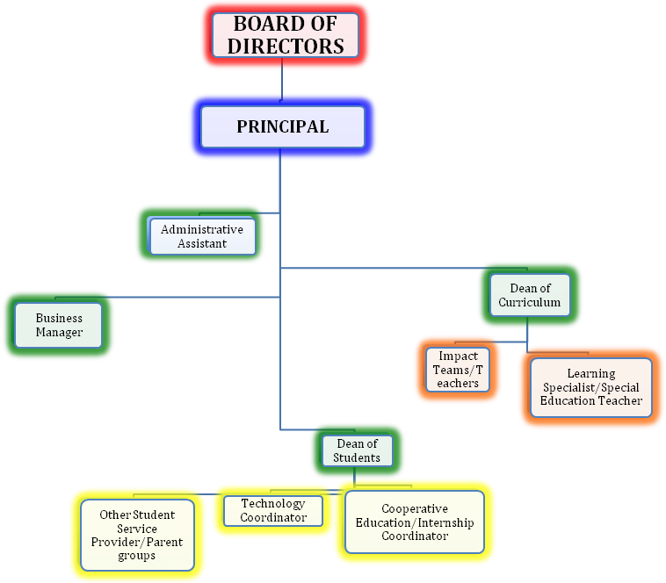
The SEMA Board of Directors is responsible for the supervision and control of SEMA in accordance with the terms of its charter. The primary function of the Board of Directors is to provide governance to the school and to ensure that the school stays true to its mission, is a viable organization, and serves the community of Albuquerque and Rio Rancho as well. The Board will work in partnership with the senior administrator of SEMA, the Principal. The Principal will be the sole school employee charged with reporting directly to the Board of Directors. The Principal will attend all Board meetings as an ex-officio, non-voting member, and in his or her capacity as board liaison, will keep the Board informed of the school’s educational, programmatic, and fiscal condition as well as any significant issues that arise.

The Principal will serve a dual function of educational leader and chief executive officer of the school. His or her primary responsibilities include mission and program development, school operations and personnel management. Three key administrators will assist with these responsibilities: Dean of Curriculum, Dean of Students and Business Manager. Working with the Business Manager and finance committee of the Board, the Principal will oversee the school’s daily finances as well as short and long-term fiscal strategies. The two Deans will report directly to the Principal and will be responsible for day-to-day operations, including curriculum, instruction, accountability, student and family services and community outreach.

The role distinction between the Board of Directors and the Principal will be as follows:
Board of Directors
- Curriculum
  - Establishes mission and overall program direction.
  - Reviews and approves strategic curriculum and programming plan.
  - Assesses compliance/progress of educational program outcomes as defined in charter
- Personnel Decisions
  - Sets and reviews personnel policies
  - Hires and evaluates the Principal
- Budget Allocation
  - Approves annual budget
  - Reviews periodic financial reports
  - Ensures proper internal controls are in place
- Vendor Selection
  - Reviews and approves selection of vendors

Principal
- Curriculum
  - Participates in establishing mission and program direction
  - Develops and oversees specific program goals and curriculum in conjunction with other administrators and faculty
  - Participates in the assessment of the educational program
- Personnel Decisions
  - Sets and reviews personnel policies
  - Hires and evaluates the Deans and Business Manager
  - Hires and evaluates the Faculty of SEMA
- Budget Allocation
  - Approves annual budget
  - Reviews periodic financial reports
  - Ensures proper internal controls are in place
- Vendor Selection
  - Reviews and approves selection of vendors

B. DESCRIPTION OF THE GOVERNING BODY

- Provide policies and procedures by which the governing body will operate in compliance with all applicable statutes and regulations, including the Open Meetings Act. Policies and procedures must address:
  - board powers and duties as a whole, individual members, and officers of the governing body;
  - governing body member recruitment and selection, including the orientation process for new members and ongoing professional development;
  - the criteria and the process that will be used to select the school’s head administrator;
  - budgeting and operation of the school; and
  - how decisions will be made.
- List each of the members of the school’s governing body.
- Provide a brief description of the qualifications of each governing body member.
- Explain the nature and extent of staff, families, and the community involvement in the governance of the school, and how they will be notified of the opportunity to participate in the school governance.

Using the model from US Charter Schools Organization, the governance of SEMA will be guided by the governance body referred to as the Board of Directors (BOD), which shall seek and, as appropriate, shall utilize the advice, counsel, collective expertise, and each individual’s resources from across the leadership array, starting with the members of the board, the Principal, the other Administrative team members, the Impact Teams/teachers, and the Students and their Families. The SEMA board of Directors will work with an experienced board consultant who will provide guidance on best practice board development, and board assessment and evaluation. The board will hold periodic retreats and workshops that focus on establishing a good culture and effective processes. Routine evaluations at the end of most board meetings will also be conducted to facilitate on-going board development.

The Board of Directors will hire the Principal and approve all policy. The Principal will hire all other employees and oversee the operation of the school, and all other leaders will be responsible for areas as described in their individual job descriptions. The Principal will make decisions of the day to day running of SEMA with input from his/her administrative team.

The authority of SEMA’s Board of Directors is derived from its own charter, the laws governing public schools, and the Public Education Department of New Mexico as found in article 5 sections 22-5-1 through 22-5-16 of state statutes. It is subject to all pertinent federal statutes as well as its rules and regulations, after appropriate approvals, both locally and on a statewide basis.

The primary purpose of the SEMA Board of Directors is to:
1. Maintain the mission of SEMA
2. Establish and oversee policies that support the mission of SEMA
3. Oversee the financial and academic progress of the school

No member of the Board of Directors of SEMA shall be personally liable for any action of failure to act on any subject that comes before him or her as a member of the Board.

The SEMA Governing Board of Directors will follow a code of ethics that may include, but may not be limited to the following:
• The Board supports the school’s mission, goals and objectives as established in the Charter and establishes policies and procedures consistent with this statement.
• The Board reviews and maintains appropriate Board policies that conform to all legal requirements.
• The Board assures that the school and school employees operate in compliance with applicable laws and regulations.
• The Board operates under a conflict of interest policy, a sworn oath, and a Code of Ethics. These documents are reviewed with and signed by all members.
• The Board conducts its business in compliance with the New Mexico Open Meetings Act.
• The Board accepts accountability for both the financial stability and the financial future of the institution, engaging in strategic financial planning, assuming primary responsibility for the preservation of capital assets and endowments, overseeing operating budgets, and participating actively in fund-raising.
• The Board selects, supports, nurtures, and evaluates the Principal. Evaluations must occur on an annual basis. The Board delineates clearly the roles, responsibilities and appropriate compensation for the Principal.
• The Board’s primary work and focus are long-range and strategic.
• The Board keeps full and accurate records of its meetings, committees and policies.
• Board members come to each meeting prepared, make every attempt to attend meetings and participate in committees of the Board.
• The Board engages proactively in partnership with the Principal in cultivating and maintaining good relations with school constituents as well as with the broader community.
• The Board supports a program of professional development that includes annual new member orientation, ongoing member education and evaluation, and Board leadership succession planning.

Board of Directors
Upon approval of the charter the applicants will become the Founding/Interim Board of Directors. The Founding/Interim Board of Directors (BOD) will appoint an additional three at-large community members representative of our proposed student body. The 5 member Council complies with Section 22- 8B-4 (B) NMSA.

Board of Directors members shall be entitled to receive $75.00 per day pursuant policy to the per diem and of $0.35 per mile or the going rate consistent with the mileage policy. The per diem and mileage paid for attendance at meetings or for other activities in which per diem and mileage are allowed shall be the maximum allowed set forth by applicable state regulations unless the Board of Directors shall by resolution provide for a lower amount. The Board of Directors may also by resolution specify the types of activities for which per diem may be received provided that such specification may include any activities in which per diem and mileage would not be permitted by the per diem and mileage act or applicable state regulations interpreting or implementing that act. Per diem may be paid for pre-approved training sessions other than regularly scheduled Board of Director meetings or standing committee or overnight travel regarding Board of Directors/Academy business as needed and provided such request if approved by the Board of Directors.

The Founding/Interim Board of Directors will recruit members for the first permanent Board of Directors. In subsequent years new or returning board members will be elected on a three-year cycle. The permanent Board of Directors will include at least 6 members that represent the following constituencies; The Principal of SEMA, the SEMA Business Manager, a Professional Educator with K-12 teaching experience, a Business Professional, a community member who represent our proposed student body and a parent.

Professional Educator
The professional educator that serves on the SEMA Governing Board of directors will be appointed by the Founding Administrator and the SEMA teachers to ensure that a true understanding and connection exists and supports the academic focus of SEMA.

Business Professional
The Founding/Interim Board of Directors will recruit a Business Professional. In subsequent years the Business or other Professional will be recruited and elected by the permanent governing board for a three-year term.

Principal
The current principal will sit as a non-voting member on the school’s Governing Board.

Business Manager
The current Business Manager will sit as a non-voting member on the school’s Governing
Board.

Community Member
A community member will be recruited by the Interim Board and later elected. All members of our community will be encouraged to attend. A process will be defined to allow community members to address the Board as indicated by the agenda and appropriate protocols.

Parent
One parent will be recruited by the Founding/Interim Board and later elected. All parents will be encouraged to attend. A process will be defined to allow community members to address the Board as indicated by the agenda and appropriate protocols.

From this group, the specific officer roles for the Board will be elected. The officers of the BOD shall be a president, a vice president, and a secretary. The BOD members may create additional officer positions, define the authority and duties of each such position, and elect or appoint persons to fill the positions. The same person, except the offices of president and secretary, may hold any two or more offices. The officers of the BOD and their roles and responsibilities of each of these positions are detailed below:

PRESIDENT: The president shall be the chief executive officer of the BOD and is to ensure that the mission of the school is being fulfilled at all times. The president shall supervise and control all of the business affairs of the school. The president shall preside at all meetings of the members and of the BOD. The president may execute any deeds, mortgages, bonds, contracts, or other instruments that the BOD members have been authorized to be executed. However, the president may not execute instruments on behalf of the school if this power is expressly delegated to another officer or agent of the school by the BOD members, the bylaws, or statute. The president shall perform other duties prescribed by the BOD members and all duties incident to the office of president.

VICE PRESIDENT: The role of vice president is to serve as chief executive officer if the president is absent or unable to act, or refuses to act, a vice president shall perform the duties of the president. When a vice president acts in place of the president, the vice president shall have all the powers of and be subject to all the restrictions upon the president. If there is more than one vice president, the vice presidents shall act in place of the president in the order of the votes received when elected. A vice president shall perform other duties as assigned by the president or Board of directors.

SECRETARY: The role of the Secretary is to administrate documentation and communication of BOD activities. The Secretary shall:
• Give all notices as provided in the bylaws or as required by law.
• Take minutes of the meetings of the members and the BOD and keep the minutes as part of the corporate records.
• Maintain custody of the corporate records and of the seal of the School.
• Prepare any correspondence the Board deems necessary.
• Maintain a calendar of all scheduled board meetings.
• Perform duties as assigned by the president or by the BOD.

BUSINESS MANAGER: The role of the Treasurer is to oversee the financial processes of the foundation and the proposed school to ensure that: 1) the corporation is fiscally stable; and 2) all transactions are documented in accordance with Generally Accepted Accounting principles. The treasurer shall:
• Have charge and custody of and be responsible for all funds and securities of the School.
• Oversee the implementation and management of school budget.
• Maintain the financial books and record of the School.
• Prepare financial reports.
• Perform other duties as assigned by the president or by the BOD members.
• Review the school’s annual budget periodically.
• Oversee the preparation of monthly accounting statements to the BOD.

Interim Board Members (Resumes in Appendix G)

WILLIAM SILVA
33 years of counseling experience and manager of the State DWI Educational Services Department. Community volunteer and Master Degree from the College of Santa Fe

TARRA HODEN
Lawyer and community activist. Defense attorney for personal injury lawsuits.

STEVE MARTINEZ
Professor Highlands University and leader of community outreach program.

PATRICK DEPALMA
13 year Counselor, local business owner and community activist. MA Webster University

SHERRY LOBER
20 Year APS teacher. DECA Advisor, Internship Coordinator, Academy Lead Teacher

ERIC STRAUSS
Licensed Administrator and 15 year APS educator. DECA Advisor and internship coordinator

C. PARTNERSHIPS (optional) - Not Applicable

D. SCHOOL ORGANIZATIONAL STRUCTURE

- Based on the organizational chart provided under subsection A. GOVERNANCE/MANAGEMENT STRUCTURE above, provide job descriptions that identify key roles, responsibilities and accountability for each staff position listed on the organizational chart.
- Provide a staffing plan for each year of the first charter term, including the proposed pupil-teacher ratio to support the educational plan.

PRINCIPAL
Key Roles: School leader and chief executive officer, bearing overall responsibility for the mission for the school, program development, student achievement, personnel and staff development, long-range planning, fund-raising and facilities development financial management and operations.
External Responsibilities: Manage budget, lead long-range planning; oversee fundraising in collaboration with the Board of Directors; serve on board committees as needed; represent the school to the larger community. Report directly to the Board of Directors, serving as an ex-officio, non-voting member.
Internal Responsibilities: Supervise all administrators; share supervision of teaching faculty; make final decision on faculty hiring; play major role in professional development and community building among faculty; work closely with administrative team and faculty on program and curriculum development, parent communication, and student discipline, including expulsion hearings.

BUSINESS MANAGER
Key Roles: Financial officer and operations manager.
Responsibilities: Oversee, manage and review all SEMA accounts; oversee cash management; maintain, back up, protect, and provide government access to all records; maintain accounting records and related financial reports for revenues and expenditures on the accrual basis of accounting adopting consistent, standard accounting policies and financial reporting practices; maintain a separate set of self-balancing accounts comprising assets, liabilities, net assets, revenues and expenditures, appropriately and efficiently submitting all grant and contract invoices, properly retaining of and disposing records, and setting the chart of accounts, with input from the Board; arrange and maintain school insurance accounts for general liability, business and personal property, computer and other technical equipment, workers’ compensation, personal injury liability, and fidelity bond.
Assist the Principal in preparing the annual, monthly, and periodic financial reports, financial statements for audit, a monthly trial balance and updated cash flow projection, and periodic tax returns. Assist the Principal and the Board of Directors in planning for fund-raising and development. Oversee facilities management. Serve on board committees as needed; represent the school to the larger community. Serving as an ex-officio, non-voting member on the Board of Directors. Perform other duties as assigned.

DEAN OF CURRICULUM
Key Roles: Coordinator of curriculum development, assessment, school accountability, and professional development.
Responsibilities: Work with faculty to build curriculum and assessment aligned with state frameworks and SEMA expected student outcomes; coordinate data collection and reporting for assessment/accountability; oversee student achievement and passage through Impact Teams; construct and coordinate master schedules and teacher and student schedules; coordinate professional development activities for faculty; organize panels and presentations of student work; supervise and evaluate teaching faculty in collaboration with the Principal; other duties as assigned by the Principal

DEAN OF STUDENTS
Key Roles: Coordinator of student services and activities, manager of day-to-day school culture and student discipline, coordinator of community outreach.
Responsibilities: Oversee community outreach, including the cooperative education/internship program, community service activities, service learning projects, School Based-Enterprise-Operations, and other field experience programs; work with faculty to develop student handbook; monitor attendance and student discipline with reference to the SEMA code of conduct, including suspension hearings; coordinate Impact Team meetings, student portfolio presentations, Student Next Step plans and Cooperative Education journals; oversee all student support activities including tutoring, student government and extracurricular activities; other duties as assigned by the Principal.

ADMINISTRATIVE ASSISTANT: (If Budget Allocations allow)
Key Roles: To organize and maintain the normal work activities of the office of administration. Provide clerical duties to the principal, assistant principals, and other charter staff.
Responsibilities: The Administrative Assistant must have exceptional keyboarding, word processing and file maintenance skills, strong communication and interpersonal skills, basic math skills, knowledge of personal computer and software in order to compile spreadsheets and databases and do word processing; complete records and correspondence to include draft correspondence, forms, reports, etc., for the principal and other department staff members using a personal computer; prepare data as needed when completing state and local reports; organize and manage hardcopy and computerized departmental files; manage student records as needed; perform basic accounting functions to include routine bookkeeping duties, including basic math operations, for the department; assist with the completion of purchase orders and payment authorizations; maintain personnel time records including leave requests and reports. Draft and submit information to the central office; answer incoming calls, take accurate messages and transfer to appropriate staff; oversee appointment schedule and make travel arrangements for department staff; receive, sort and deliver mail and other documents to department staff; ensure confidentiality of information; other duties as assigned by the Principal.

IMPACT TEAM TEACHERS:
Key Roles: The primary role and purpose of a teacher is to provide students with appropriate educational activities and experiences that will enable them to fulfill their potential for intellectual, emotional, physical and social growth. Teachers will help students develop the skills necessary to be a productive, educated member of society.
Responsibilities: Design, write and use lesson plans that conform to the charters curriculum; ensure written plans are available for review; ensure lesson plans show modifications for differences in student learning styles; teach instructional subjects according to guidelines established by New Mexico Department of Education, charter polices and administrative regulations; implement appropriate instructional and learning strategies, activities, materials and equipment to ensure comprehension of learning styles and student needs; design instructional activities by using data from student learning style assessments; collaborate with special education teachers on student Individual Education Plans to ensure all modifications are met; collaborate with staff to determine charter requirement for the instructional goals, objective and methods; produce and oversee teacher aide and volunteer assignments; employ technology practices to strengthen the instructional process.
Help students assess and enhance their study methods and habits encouraging growth and development; produce formal and informal testing to evaluate student success; coordinate and manage extracurricular duties as assigned; sponsor outside activities approved by the charter principal; serve as an example for students, support mission of charter; manage and organize classroom including: classroom preparation to enhance learning and to aid in physical, social and emotional development of students, controlling student behavior in agreement with the student handbook, ensuring necessary and reasonable measures are taken to protect students, equipment, materials and facilities; provide input on textbook, equipment and material selection; communicate with parents, students, principals and teachers through conferences; create and maintain a professional relationship with colleagues, students, parents and community members; present information accurately through clear communication skills; enrich job skills through professional development activities; keep up to date on and abide by state and charter regulations and policies for classroom teachers; gather, manage and file all reports, records and other documents required; be active in faculty meetings and assist in staff committees as necessary; other duties as assigned by the Principal.

LEARNING SPECIALIST/SPECIAL EDUCATION TEACHER
Key Role: In collaboration with the Principal, this person is responsible for/facilitates the structures, processes, and supports that ensure the needs of special education students are being met appropriately at SEMA and that SEMA is in compliance with state and federal special education regulations. In addition to a teacher and advisor’s duties, including one content prep period, and IEP Consultant duties,
Responsibilities: This person will do the following with one additional open class period in his/her schedule: attends a weekly student support meeting; meet with Principal and Impact Teams regularly (bi-monthly); facilitate special education team meeting (bi-monthly); facilitate communication between IEP consultants, parents, leadership, and regular education staff; facilitate special education sections of standardized tests; administers Alternative Assessment; collect data needed to evaluate structures and provides data to administration for required reports; keep data base current and complete with regards to special education student data; schedule IEPs with notification for both parents and students and obtains consent to test and reevaluate history; sends all documentation out to parents and students; schedule testing for reevaluations and ensure the evaluators have needed space and documentation and communicates testing schedule to SEMA staff; facilitate contracts for ancillary services including tracking of ancillary needs; work with Technology Coordinator to make available technology needed for students who require it; manage paperwork required to maintain compliant documentation for IDEA and state regulations; facilitate professional development activities related to special education; facilitate/participate in the FBA/BIP process for students with IEPs; attend all IEPs meetings as the special education representative unless another special education teacher is attending in this role; works with outside agencies and other schools regarding special education needs including APS, PED, and other charter schools; requests files for new students to ensure we have current documentation for student files and creates new student files while archiving students who have left or graduated from SEMA; schedule and facilitate school visits and open houses for potential parents and students; attend transition off campus IEPs for incoming 9th graders; other duties as assigned by the Principal.

TECHNOLOGY COORDINAOR
Key Role: to assist faculty members at SEMA in enhancing learning through technology. Emphasis of all technology instruction should be in enhancing content learning while strengthening technology skills of students, teachers and staff. Technology coordinator will be skilled in total group management, and have clear goals and strategies for integrating technology in instruction aligning to SEMA mission. The technology coordinator reports directly to the Dean of Students. Position has some administrative responsibilities in coordinating teams, overseeing budgets and supervising training activities.
Responsibilities: Collaborate with teachers in implementing technology into the curriculum; structure technology education of students, teachers and staff; coordinate budget for computer resources including hardware, software, learning resources and training needs; develop monetary resources for school/district, including collaborating with others in school/district to establish grant funding, corporate sponsorships, community partnerships to enhance computer resources; recommend and, in some cases, purchase hardware, software and related resources; provide troubleshooting on a limited basis; coordinator will be available for simple troubleshooting of software and hardware for teachers, and will serve as a liaison with systems analysts and network coordinators ensuring technical problems are resolved; provide software guidance as needed as well; identify trends in software, curriculum, teaching strategies and new resources; create, maintain and oversee integration of technology plan for school; create learning resources for teachers, staff and students; support the efforts of teachers by guiding and encouraging them in developing their own resources and the providing additional support as needed; experience with effective technology teaching strategies in teaching software and hardware skill; Understanding of key learning theories and methods of instruction and their relation to technology integration and SEMA’s mission. Other duties as assigned by the Principal.

COOPERATIVE EDUCATION/INTERNSHIP COORDINATOR
Key Role: Plans and coordinates the work-based learning cooperative education learning programs for SEMA’s curriculum programs and researches job opportunities for students working with the employment community. Actively contacts and courts businesses throughout the community, soliciting each organization's participation in the program and possible donations. Throughout the course of the internship program, the internship coordinator maintains constant contact with the employer and intern, monitoring the student's job performance and relaying that information to the Dean of Students and the Impact Team.
Responsibilities: Develops comprehensive, strategic marketing and recruitment plan for targeted industries and student population; integrates institutional strategic goals; collaborates with the administrative teams, Impact teams, external consultants, graphics design interns for production of innovative, multi-media resources for potential corporate partners; participates in job and career fairs, multi-campus resources days and other events for student recruitment; promotes the development of personal traits, social skills and work ethics necessary for optimal student success in the community workplace; counsels students in the development of job search skills and critical work preparedness attributes including resume writing, researching, interviewing, social skills and appropriate attire; collect student demographics for institutional reporting, organize employer/corporate partner profiles and update status; ensures required records and documentation from students, teachers and employer/corporate partner are included for high school credit validation; informs and advises students, faculty and employers of state and institutional policies, legal compliance with ADA and EEO regulations, and program guidelines and expectations; assists in the development of the Faculty and Student Handbook; develops relationship and a network of local, state, regional and national-level of corporate and community partnerships; effectively communicates the institution’s position as a national leader in workforce development, the cooperative education program’s values and principles, the customized option for the cooperative education model, and the expectations and responsibilities of employer/corporate partner; submits reports, develops professional correspondence and serves as members and/or officers of college-wide committees and student success initiatives, community boards, state and national professional organizations; designs and maintains assessment instruments for accreditation requirements as well as state requirements through written evaluations in student workbooks, evaluations and surveys to employers/corporate partners, faculty and students, and faculty focus groups; solicits feedback from learners on a regular basis; oversees and organizes on-going special projects to promote the cooperative education program; such as the annual APS Employer Appreciation Breakfast, as well as customized employer development efforts; other duties as assigned by the Principal.

SEMA staffing plan will follow the five-year budget with a 20 to 1 pupil teacher ratio inclusive of a full-time special education teacher. The small pupil teacher ratio will allow SEMA to effectively implement its mission and goal in creating dynamic project based learning and real world internships that allows for direct application of curricular concepts.

E. EMPLOYEE RELATIONS

- Provide a description of the school’s personnel policies and procedures that comply with all applicable federal statutes and regulations, including the School Personnel Act.
- Provide proposed salary schedules that comply with the minimum salary requirements as identified in the School Personnel Act for all employees.
- Describe the evaluation process for staff that will include evaluation of teachers by a licensed school administrator.
- Explain the school’s staff discipline process that provides for due process.

SEMA has researched numerous charter school policies in New Mexico and Albuquerque Public Schools and has adopted the following policies:

If the staff chooses (through the proper procedures) to establish a relationship with a labor representative, the Board of Directors and the administration of this school will willingly work with the labor representative. However, there is no relationship with labor representatives at this time.

• Description of personnel policies and procedures.

In accordance with Title 6, Chapter 61, NMAC, SEMA will retain or employ teachers, licensed administrators, and other instructional personnel who hold appropriate New Mexico licensure in elementary and secondary education, grades nine-twelve, or other documents issued by the New Mexico State PED Licensing Division. SEMA teachers and administration will be responsible for overseeing student’s academic progress, for grading, and for matriculation decisions as specified in the school’s operational policies. Qualifications for SEMA teachers and licensed administrators will include, but not be limited to, years of teacher and administrator experience, familiarity with State of New Mexico content and benchmark standards, demonstrated ability to differentiate instruction (additional specific training proved), and strength of their teaching credential (i.e. special education, ESL or bilingual, master’s degree).

SEMA shall reserve the right to employ non-licensed personnel to fulfill the remainder of its staffing as permitted by state and federal law regarding credentialing and licensing. Non-licensed personnel may include, but not be limited to, strategic planning and community support coordinator, clerical and office administrative services, special education support personnel and janitorial services.

All non-instructional staff and teachers will possess the experience and expertise required for their position within the school as outlined in the school staffing plan and the school’s adopted personnel policies, and in accordance with the School Personnel Act. All staff shall meet New Mexico PED and any other state of New Mexico safety requirements including background checks and fingerprinting in the methods mandated by the state.

SEMA will recruit individuals for open positions through a public process including advertising in newspapers and professional printed media, referral, and through appropriate electronic recruitment mechanisms. In accordance with the Charter Schools Act, SEMA employees are not employees of Albuquerque Public Schools but shall be hired directly by SEMA. Employees will be hired in accordance with all state and federal employment rules and regulations and in compliance with the School Personnel Act.

SEMA will abide by state and federal laws dealing with equal employment opportunity. Therefore, in order to provide equal employment opportunities to all individuals, employment decisions at SEMA will be based on qualifications and abilities. SEMA does not discriminate in employment opportunities or practices on the basis of race, color, religion, gender, national origin, age, disability, sexual orientation, or any other characteristic protected by law.

SEMA will make reasonable accommodations for qualified individuals with known disabilities unless doing so would result in an undue hardship that state and federal laws recognize as just. This policy governs all aspects of employment including selection, job assignment, compensation, discipline, termination, and access to benefits and training (pending the publication of the Employee Handbook).

SEMA participates in the State of New Mexico Educational Retirement Act (ERA) administered by the Educational Retirement Board (ERB). Eligible employees participate in the Retirement Plan subject to all terms and conditions of the plan.

Regular full-time and regular part-time employees will be eligible to receive benefits, including, but not limited to, paid time off (PTO), health insurance, and health benefits provided by enrollment in New Mexico Public Schools Insurance Authority (NMPSIA).

A complete SEMA Employee Handbook will be published prior to opening of the charter school. This handbook will be compliant with all federal and state regulatory requirements and with the School Personnel Act. Proposed Personnel Polices and Procedures are provided in the Appendix A and by reference are included herein.

• Proposed salary schedules for all employees.

SEMA reserves the right to set its own salary schedule. At this time the base pay of each licensed staff member will be determined by the state’s mandated three-tiered salary schedule – although it is the intention of SEMA to pay their employees above the mandated three-tiered salary schedule. Additional money may be available for positions such as: athletic coaches, testing coordinator, math/language arts literacy teachers, technology specialists, English as a Second Language (ESL) and Teachers of English to Speakers of Other Languages (TESOL) endorsed teachers, and job coaches.

SEMA shall be in compliance with all applicable state and federal employment taxes. Compensation of all employees will be based on experience, qualifications, skill and technical level, and performance of the individual. All compensation decisions shall be at the discretion of the Principal and within approved budget constraints.

Unless otherwise budgeted, SEMA will follow State of New Mexico mandated three tiered 30/40/50 teacher salaries plus 10%. The Principal is budgeted at $80,000 per year, the contract Business Manager - $45,000 per year and Deans at $50,000. Teachers are currently budgeted at an average of $50,000 (will vary based upon level of licensure and years of experience) and an Administrative Assistant at $30,000 (may vary based upon level of expertise and years of experience) and if money becomes available. One Technology coordinator is budgeted at $45,000. Raises are built in for administrative staff and an overall average of $50,000 per teacher based on a twenty to one pupil teacher ratio. Also, there was no special education population built in to the budget to insure budget stabilization.

• Description of staff evaluation process.

SEMA will evaluate its licensed teaching and licensed administrative staff in accordance with the School Personnel Act and as mandated by the Public Education Department. Professional
Development Plans will be completed by the 40th day for all teachers, and all required observations and evaluation forms will be completed before the school year ends. Additionally, instructional support and administrative staff will be formally evaluated each contract year, and all staff provided with informal, ongoing coaching and mentoring as needed.

SEMA wishes to create an environment that is supportive and fosters development and constructive change for its employees whom it believes will translate directly to the students under their care. Notwithstanding its commitment to this supportive environment, SEMA will provide its employees with traditional performance evaluations conducted by their supervisor (s).
Along with incorporating some of the PED teacher competencies to enhance its learning environment and the personal development of all employees, SEMA will implement a multi- source feedback system to appraise the performance of all staff, professional, licensed and non-licensed to nurture self-efficacy and goal-orientation. All employees will receive feedback from their supervisors, peers, team members, parents and students. The multi-source feedback system will be used to supplement the traditional evaluation system, enabling SEMA to engage its employees in development activities, thereby enlisting its entire staff in continuous learning based on quality feedback. This continuous cycle of improvement will allow SEMA to enhance teaching and learning throughout the school.

• Explanation of staff discipline process.

SEMA will have the following discipline process for staff that provides for due process as follows:

The purpose of this policy is to provide for the reporting and resolution of legitimate employment-related concerns of the employees of SEMA at the earliest possible time and with the least possible expense, disruption and friction. The Board of Directors will recognize that most personnel difficulties encountered by employees arise from a lack of communication. This procedure is designed to provide a formal mechanism for promoting or restoring such communication so that problems may be resolved before more serious difficulties result.

Definitions and Limitations

i. “Grievant” will mean an employee who is personally and directly affected by a condition for which he or she seeks a resolution.

ii. A “grievance” will be an allegation by an employee that the treatment he or she has received from a superior is unfair or improper, or that there has been a violation, a misinterpretation or an inequitable application of Board of Directors policy, administrative rules or procedures that directly and adversely affect the grievant. A single grievance may be submitted jointly by more than one grievant.

iii. A “Resolution(s)” will be the proposed written decision by the appropriate administrator(s), grievance review committee, or Board of Directors, in response to the grievance.

iv. ”Parties in interest” will be the grievant and the superior or other employee(s) of SEMA whose conduct or actions are the subject of the grievance.

v. The following situations are not covered by this grievance procedure and are therefore not a grievance under this policy:

- The discretionary act(s) of professional judgment relating to the evaluation of the work performance of any employee by his or her immediate supervisor.
- Any personnel decision made by the Board of Directors, including, but not limited to a refusal to re-employ, a discharge, a demotion, or any other action directly and adversely affecting the employment of an employee.
- Situations in which the Board of Directors and Principal are without authority to act.
- Situations in which the remedy for the alleged violation exclusively resides in some person, agency, or authority other than the Board of Directors.
- Situations as to which a different procedure with SEMA is prescribed by a state or federal authority.
- Situations as to which a different procedure or remedy has been provided by the Board of Directors
- Situations involving a grievance by a contractor with SEMA.
- A former employee cannot file a grievance after the effective date of termination or discharge of employment.

General Procedural Requirements

i. A grievance must be initiated at Level 1 within ten (10) workdays of the date upon which the grievant became aware of the circumstances, which gave rise to the grievance.
ii. No persons will suffer retaliation, recrimination, discrimination, harassment, or be otherwise adversely affected because of his or her use of this grievance procedure.
iii. Whenever possible, any grievance conference or hearing at any level will be scheduled during a mutually convenient time that does not conflict with the regularly scheduled school program.
iv. A grievant requiring the attendance and testimony of other employees will have the right to bring such witness as are willing to testify in his or her behalf, and any necessary substitutes or release time will be provided and the expense borne by SEMA when hearings must be scheduled during the school day.
v. A separate file will be maintained by the Principal for grievances. All documents produced during the processing of a grievance will be filed herein. All parties maintain confidentiality with regard to proceedings, and the resolution of the grievance will not be made public unless agreed to by the grievant and the Principal or Board of Directors or unless the grievant pursues the matter beyond this policy. The grievance file will be maintained for one (1) year after being cleared according to the New Mexico State Records Center and Archives, and access to the file will be limited to the grievant, the immediate supervisor, the Principal and the members of the Board of Directors.
vi. Nothing contained herein will be construed to limit in any way the ability of SEMA and the grievant to resolve any grievance by informal means, and nothing herein will be construed as requiring resort to the formal procedures when grievance problems arise.
vii. A grievant may terminate the process at any level if he or she indicates in writing a desire to do so, accepts the resolution at that level, or fails to pursue his or her grievance by filing at the next level within the specified time period.
viii. All grievances will be filed and processed on grievance forms prepared by SEMA and available in the office of the Principal.
ix. The time limits at any level may be extended by mutual agreement between the grievant and the Principal, review committee or Board of Directors.
x. Except as otherwise provided herein, unless a party can demonstrate prejudice arising from a departure from the proceedings established in this policy, such departure will be presumed to be harmless error.

Procedural Steps
Level 1 (Informal Conference)

Prior to the filing of a formal written grievance, the grievant will first discuss the grievance with his or her staff representative in a good faith attempt to resolve the grievance prior to the filing of a formal grievance. In the case of a claim of sexual harassment in which the grievant’s staff representative is the subject of the claim, the grievant may initiate the grievance at the next supervisory level above that of the staff representative.

Level 2 (Principal)

If the grievant is not satisfied with the discussion and disposition of the grievance at Level 1, he or she may file a written grievance with the supervisor (Principal) within ten (10) days of the disposition. The Principal will communicate his or her proposed resolution in writing to the grievant within five (5) workdays from the filing of the written grievance. If the proposed resolution is not acknowledged or approved by the grievant within five (5) workdays, the Principal has the discretion to require a hearing or conference and gather such evidence prior to the preparation of the decision as he or she feels would assist in any appropriate resolution of the grievance. The hearing or conference will occur within five (5) workdays of the grievant’s action/inaction regarding the Principal’s proposed resolution. The hearing or conference should be as informal as possible and will be conducted as the Principal feels is appropriate for a full understanding of the grievance, the position of the grievant and the evidence supporting the position. The Principal will have the right to ask any question of the interested parties, as he or she deems necessary. Within five (5) workdays following the hearing, the Principal will render his or her written proposed resolution to the grievant.

Level 3 (SEMA Board of Directors)

If the grievant is not satisfied with the resolution of the grievance at Level 3, or if the
Principal fails to issue a proposed resolution within the specified time limit, the grievant may make a written request to the Principal for a hearing with the Board of Directors within ten (10) work days after the Principal’s resolution was rendered or due, if none was received. At its sole option, the Board of Directors may appoint a Grievance Review Committee to hear the grievance. The Grievance Review Committee (GRC) will be comprised of three (3) persons, one from each of the following staff categories: Certified School Instructor, Administrator, other than the immediate supervisor or Dean involved, and one Board of Directors member. The Board of Directors will appoint the members of the GRC. The Committee will select its Chairperson prior to the processing of the grievance. The Chairperson of the Committee will schedule an informal hearing within ten (10) workdays of receipt of the grievance. If a Committee member is unable to participate in the informal hearing, the Chairperson will designate a substitute from within the employee category of the non-attending member.

Procedure for Hearing
i. The grievant will present his/her grievance first through testimony, witnesses, documents, etc. cross-examination will not be allowed by the other party in interest, if any.
ii. The other party or parties in interest, if any, will present their responses to the grievance.
Cross-examination will not be allowed.
iii. The Committee may ask any questions that it deems necessary.
iv. Arrangements to make a taped recording or to keep minutes of the proceeding will be made by the Chairperson. A verbatim transcript is not required, but any minutes or other written record will fairly reflect the substance of the hearing.
v. Within five (5) days following the date of the hearing, the Committee will transmit its findings and recommendations for proposed resolutions to the Board of Directors. Within ten (10) workdays, the Board of Directors will accept the recommendations of the Committee by a majority vote or agree to hear the grievance.

The holding of a hearing by the Board of Directors is discretionary with the Governing Council, and such decisions will be made by the Board of Directors at its next regularly scheduled meeting after receipt of the written request for a hearing. If the Board of Directors rules that it is appropriate to hear the grievance, it will set the date for such hearing and the parties in interest will be notified by the Board of Directors President.

The parties in interest will submit written statements of position, which will be delivered to the Board of Directors members at least five (5) days prior to the hearing. In addition, any other documentary evidence desired to be reviewed by the Board of Directors will be submitted at that time.

Conduction of Hearing

i. Each party in interest to the grievance will have the opportunity to present oral statements limited to thirty (30) minutes each. The presentation will be limited to a review of evidence previously presented, unless the Board of Directors, in its discretion, allows new evidence to be presented during the hearing. Evidence may not be cross-examined by the other party in interest.
ii. Since grievances are “personnel matters”, the hearing may be conducted in an executive session, if the grievant so requests and the Board of Directors votes to close the hearing. The grievant may demand that the hearing be held in open session, in which case the hearing must be open.
iii. The Board of Directors may make such inquiries of any party in interest as it deems necessary or appropriate.
iv. The Board of Directors will render a written decision within a reasonable time. In arriving at its decision, the Board of Directors has complete discretion in fashioning such relief, if any, as it believes is appropriate, regardless of the relief requested.
v. A certified school employee, aggrieved by a decision of the Board of Directors to discharge him/her after a discharge hearing, may appeal to an independent arbitrator by submitting a written notice of appeal to the Principal within five (5) working days from receipt of the Board of Director’s written decision. If a timely notice of appeal is submitted, a hearing will be held pursuant to 22.10.17.1 NMSA.

Provisions are evident that mediation, problem solving and facilitation services for students, staff and community are available. This requirement for staff is covered in the preceding information. Regarding the students and community, SEMA adds the following:
- Students should address issues first with teachers. If they are unable to resolve the issue with teachers, they should then address the Principal. The Principal provides the final decision with respect to student issues;
- Parents and community members should first address issues with respect to specific classes to the classroom teacher (or coach, in the case of athletics). Parents and community members who are dissatisfied with teacher responses may then choose to discuss the issue with the Principal. Parents who are dissatisfied with the Principal’s decision may appeal to the SEMA Board of Directors in writing. If the Board of Directors chooses to hear the appeal, the issue will be placed on the agenda of the next regularly scheduled Board of Directors meeting and the issue will be handled in Executive Session.
- A student or staff member aggrieved by a decision of the Board of Directors may appeal to an independent mediator and/or arbitrator by submitting a written notice of appeal to the Principal within five (5) working days from receipt of the Board of Directors written decision. If a timely notice of appeal is submitted, a hearing will be held pursuant to 22.10.17.1 NMSA.

F. STUDENT ENROLLMENT PROCEDURES AND DISCIPLINE POLICY

- Describe the school’s admissions policies and procedures, including an explanation of the timeline for admission.
- Describe the school’s lottery process that is in accordance with applicable law.
- Provide a brief description of the proposed student discipline policy that complies with the Student Rights and Responsibilities set forth in the Public Education Department rules and regulations [6.11.2 NMAC]. (Note: Include the proposed student discipline procedures in the Appendices.)

SEMA has researched numerous charter school policies in New Mexico and Albuquerque Public Schools and has adopted the following policies:

SEMA Charter School is open to any New Mexico resident, grades 9-12. SEMA accepts all students that come to the school in “good standing” with all proper records and shots if space is available. SEMA fills available spaces through a lottery process the first week of each month beginning in April. Spaces available are filled from applications randomly drawn through a lottery system according to Chapter 22-8B-4.1NMSA, 1978.

SEMA’s doors will be open to any 9th – 12th grade student regardless of race, gender, creed or religious affiliation.

SEMA has developed projected numbers progressing through the first 5 years; SY(1): 150, SY(2): 150, SY(3): 200, SY(4) 350 and subsequent years 350. In SY(1), if the number of applicants do exceed 150, then the members are selected by a lottery process. The interested members are assigned a number and a random number generator will determine the 150 that are selected to attend that school year. The remaining members will be placed on an ordered waiting list, generated by the random numbering generator. Members on the waiting list will be contacted to join the Academy when a seat is made available. SEMA can choose to exceed the 150-enrollment limit. These procedures will be followed each year.

SEMA’s proposed student discipline policy complies with the Student Rights and Responsibilities set forth in the Public Education Department rules and regulations [6.11.2 NMAC]

(See Appendix B for the proposed student discipline matrix.)

The philosophy of the discipline policy is to encourage positive relationships. Attitudes and soft skills are a cornerstone of SEMA’s mission. Using techniques from Jim Fay and David Funk’s book, Teaching with Love & Logic, students will be taught self-efficacy and problem solving. Every attempt is made to handle discipline issues in a student centered solution oriented context. Fay states, “When we offer kids a choice instead of making a demand, no power struggle ever begins.” (p 8) Every Discipline situation will try to be handled at the lowest level possible. The 1st step column indicates this process. When that is not appropriate, the discipline matrix will be used to standardized consequences across the campus at the 2nd step. The student discipline policy shall provide clear rules, regulations, responsibilities, rewards and consequences to the members and their families. Contracts shall be signed by members, families and school officials upon enrollment verifying the reading and understanding of said rules, regulations, responsibilities, rewards and consequences.

SEMA will build a team concept, building relationships on TRUST, RESPECT AND RESPONSIBILITY. Each member will be held accountable, not just by the Academy’s administration, but also by his or her Impact team members and peers. Members will be expected to demonstrate characteristics that are necessary for a strong and productive team: punctuality to daily work hours, meeting team project timelines, delivery of minimum required project specifications, meeting individual timelines and expectations, performing individual duties assigned to them in the team projects, demonstrating trust, respect and responsibility to all.
Rewards will be things like team and/or individual recognitions, celebrations and rewards occurring in a regularly scheduled timeline; Celebrations of Success events. Consequences will be actions ranging from team probations to Academy expulsion or disenrollment. All of these discipline procedures align with the Student Rights and Responsibilities set forth in the Public Education Department rules and regulations [6.11.2 NMAC] as sited on the following website:
http://www.nmcpr.state.nm.us/nmac/parts/title06/06.011.0002.htm

G. FACILITIES

The facilities plan should demonstrate that the applicant group has carefully considered the school’s facilities needs and understands its options for meeting those needs.

If the school site has not been selected/secured:

- Explain the needs of a facility that will support the implementation of the school’s educational plan, including desired location, size, and layout of space.
- Describe a reasonable plan to identify and secure an adequate facility.
- Provide the proposed capital outlay needs for the facility, including projected requests for capital outlay assistance for the school.

SEMA plans to lease a commercial space of 15,000 to 20,000 square feet to accommodate the school’s anticipated 150-student enrollment for the two years (best practice estimate is approximately 100 square feet per student based on 6.27.30 New Mexico Public School Adequacy Standards). The Board of Directors will research suitable sites for the school in the Albuquerque area. The area is favorable to short term leases for commercial properties and there are many suitable vacant properties. Upon approval of the charter, the Board of Directors intends to review potential sites. The Board will work with a professional leasing agent and a professional architect to develop a list of criteria for the site, including a layout of the school and a plan for renovations that will accommodate the need for the increase of size of the facility over the years to accommodate the additional number of students coming in. The Public School Facility Authority will be consulted in this process as needed.

The School’s educational program requires 8 classrooms, 2 science labs (chemistry/physics, biology), two computer labs, meeting/planning room (board room), administrative offices, clerical offices, School-Based-Enterprise facilities and a multipurpose commons space used for activities such as lunch and class registration.

The School Board members understand that the School is required to meet educational adequacy standards on or before the date of its next renewal pursuant to 22-8B-4.2 NMSA 1978. The founders are looking for a site that will meet the guidelines ahead of time. However if it is not financially feasible to meet all of these standards when initially securing the facility, the founders will work with the building owner and the architect to phase in these requirements. However the facility will meet educational occupancy requirements before it opens its doors to students.

The founders plan to identify a school site by the fall of 2011 after the charter is approved. When the space is leased, the building owner will be asked to work with the school’s architect to make sure that the renovation will meet the applicable code requirements for a public school.

No access to funding for a down payment towards a facility lease payment has been granted yet because the School’s charter has yet to be approved. Specific facility needs will be determined once the site has been secured. The school intends to apply for lease reimbursement payments in compliance with the Public School Facility Authorities procedures.

H. OTHER STUDENT SERVICES

- Describe the school’s plans for meeting the transportation needs of its students and plans for contracting services for transportation, if applicable.

- Describe the school’s plans for meeting the food services needs of its students and plans for contracting services for food services, if applicable.

- Describe the school’s plans for providing student access to other services, including but not limited to counseling and health services and plans for contracting services, if applicable.

Transportation
No transportation services to and from school will be provided. All field trip transportation will be provided by SEMA in accordance with applicable laws. SEMA expects to be located near public transportation; otherwise parents will be required to transport students to and from school.

Food Service
SEMA students will operate a School-Based-Enterprise (SBE) that will provide several food options in accordance with New Mexico Healthy Schools Law. Students may either purchase food from the SBE or bring their own food.

Counseling and Health Services
It is our intention to join a coalition of charter schools so that we can share the resource pool of licensed personnel for ancillary services. SEMA will provide counseling services on an as needed basis. Students will be directed to group and one-on-one counseling as determined by their Impact Team. We will contract these services with local providers. SEMA will also provide health services on an as needed basis. SEMA will hire a qualified contract health care provider who will be responsible for maintaining Cumulative Student Health Records for each student and will provide health services for students. SEMA will comply with all immunization and blood-born pathogen laws. We will contract these services with local providers on an as needed basis. We plan to work with the other charter schools in the area to form a consortium of charter schools to share the costs of these services. We have budgeted monies for a part-time health services specialist to be contracted throughout the charter.

- REQUIREMENTS

The Requirements section of the application addresses the necessary arrangements that school leaders must make to define the respective legal liability and responsibility of the governing body and the Public Education Department. These requirements include, but are not limited to, securing appropriate insurance coverage and identifying waivers that will be sought by the school from the Public Education Department.

A. LEGAL LIABILITY AND INSURANCE COVERAGE

- Provide a statement that the charter school will participate in coverage by the public school insurance authority and will comply with all applicable rules of that authority.

SEMA will participate in the Public School Insurance Authority and comply with all applicable rules of that authority.

B. WAIVERS

- List the specific waivers that will be requested from the department’s requirements, rules, and provisions of the Public School Code pertaining to individual class load, teaching load, length of the school day, staffing patterns, subject areas, purchase of instructional material, evaluation standards for school personnel, school principal duties, driver education, and graduation requirements.
- If any waivers will be requested that are not pertaining to those listed above, cite the applicable statute and/or state rule that the school will request to be waived.

Note: Identifying waivers as required in this section of the application does not guarantee future approval. Official waiver requests may only be submitted to the Secretary of Education AFTER APPROVAL OF THE CHARTER SCHOOL APPLICATION and must follow the Public Education Department Waiver Request process. Additional information may be found on the Public Education Department website: http://www.ped.state.nm.us/admin.personnel/waiver_requests.html

SEMA shall operate in compliance with all applicable federal, state and local laws, rules and regulations, unless specifically waived. The Charter School by submitting such a request, in writing, to PED, may request waivers from specific state law, now and at a later date. The request shall include the reasons SEMA is in need of/or desires the waiver such as to allow SEMA to purchase instructional materials that may not be found on the state approved instructional materials listings. Waivers of policies and regulations may be granted only to the extent permitted by state.

- APPENDICES

The contents of the appendices will be evaluated as they pertain to the appropriate sections IV through VIII of the application.

Please provide each of the following documents as an appendix:
- The School’s proposed personnel policies;
- The School’s proposed student discipline procedures;
- A completed Form 910B5;
- A completed 5-Year Budget Plan;
- If applicable, a bibliography of citations using the APA References Citation format;
- If applicable, an acronyms list (an alphabetical listing of all acronyms used in the application [Example: CSD – Charter Schools Division]).

Appendix A

Proposed Personnel Policies

SEMA’s personnel policies and procedures will comply with all applicable federal statutes and regulations and the School Personnel Act. SEMA is an equal opportunity employer. Upon approval of the charter, the SEMA Board of Directors will develop other policies as needed.

SEMA prohibits discrimination on the basis of disability, race, ethnicity, color, sex, sexual orientation, gender identity, national origin or ancestry, religion, age, veteran status and/or any other protected status as defined by law, in all facets of employment, compensation, promotion, transfer, demotion, layoff, termination or selection for District-sponsored training programs. Discriminatory behavior violates state and federal laws and regulations.

Upon review of other similar charter schools SEMA has adopted the following Personnel Policies:

Sexual Harassment Policy
This policy is intended for all employees, volunteers, administration, partner members, and others attached to the operation of SEMA.

The Board of Directors of SEMA under no circumstances will tolerate sexual harassment by or of anyone in/or at any meeting or in the school during or outside the regular operation hours of said institution. This includes all classrooms, functions activities (athletic or non-athletic), anything directly or indirectly related to the personnel or any organization as has been established by SEMA in or of the property of SEMA.

Sexual harassment is defined as any un-wanted physical, verbal, or visual sexual advances, requests for sexual favors, or any other sexually oriented conduct which may be deemed offensive or objectionable to the recipient including but not limited to epithets, derogatory or suggestive comments, slurs or gestures; offensive posters, cartoons, pictures, drawings or objectionable touching. A violation occurs as a matter of procedure when:
1. Submission to such contact is made implicitly a condition of an individual’s employment
2. Submission to or rejection of such contact by an individual is used as a basis for any employment decision effecting such individual, or
3. Such conduct has a purpose or effect of unreasonably interfering with the individual’s work performance, participation, or creating an intimidating, hostile or offensive environment to patrons, participants or other workers, voluntary or paid employees/individuals.

Any employee, volunteer, individual, spectator has the right at any time to raise their concern about sexual harassment without fear of reprisal. Allegations of sexual harassment will be promptly investigated, giving due regard to the need for confidentiality. Harassment should be brought to the attention of the immediate supervisor in such event and/or the Principal of SEMA.

Conflict of Interest:
All employees of SEMA owe their full attention and their undivided loyalty while on the job to the best interests of SEMA. Various situations can create the potential for interfering with the physical performance of employees’ duties, or for bringing employees’ personal interest or the interests of some other person, group or entity into conflict with the school’s best interests. All SEMA employees must use their good judgment and avoid situations or relationships which interfere with their physical ability to perform their duties or which tend to divide their on-the-job loyalties.

Non-School Employment:
The board of directors recognizes that many school employees find it necessary or desirable to supplement their income through outside employment. Nevertheless, the Board of Directors considers that it has given its full-time employees full-time jobs, and expects all SEMA employees to give their school responsibilities priority over outside work. The Board of Directors does not wish to infringe unduly on any employees’ ability to augment his or her income through legal outside activities, such as professional consulting, college teaching, or research and writing; such activities reflect credit upon SEMA and may contribute to an employee’s professional growth. However, outside work may legitimately concern the Board of Directors if it interferes with the effective performance of an employee’s SEMA responsibilities, if it tends to compromise or embarrass SEMA, or if it suggests a conflict of interest. Accordingly, the following rules shall govern employees’ non-SEMA employment:
• Employees of SEMA shall not perform any duties related to outside employment during regular working hours or during any additional time that is needed to fulfill the responsibilities of SEMA position.
• Employees shall not at any time use SEMA facilities, equipment or materials to assist them in performing non-SEMA work.
• No employee of SEMA may solicit or negotiate for, accept employment from, or render any services for, any outside person(s), firm, group, or entity or on the employee’s own account if such employment or service:
- Physically impairs the proper discharge of the employee’s official SEMA duties; or
- Creates or tends to create a conflict between the interests of SEMA and the employee’s personal interests or the interests of the outside person(s), firm, group, or entity.

Gifts and Gratuities
Employees are prohibited from accepting anything of material value from any other individual, organization, or company, which might compromise or reasonably appear to influence the exercise of independent judgment in the performance of official duties for SEMA.

Employee's Business Dealings with SEMA
SEMA exists to educate children in accordance with the highest human ideals. To foster public confidence in the system and to ensure fidelity to SEMA’s proper mission, it is essential that no employee of SEMA be permitted to exploit the employment relationship for personal financial gain beyond his or her authorized compensation. Even a suspicion of such exploitation is sufficient to erode public confidence in the school. The Board of Directors accordingly adopts the following policies to guard against such eventualities:
(a) Section 22-21-1, NMSA, broadly prohibits certified employees of a school from profiting, even indirectly, from additional business or contractual dealings with their employing schools beyond the employment relationship. The Board of Directors hereby adopts the statutory prohibitions for non-certified employees as well as certified personnel.
Except for authorized special services, as provided below, or for allowable overtime compensation for non-certified personnel, it is the policy of the Board of Directors that no employee of SEMA shall, directly or indirectly, receive or seek to receive any monetary gain from business dealings with, or work for, SEMA beyond his or her authorized official compensation.
(b) Section 22-21-1b, NMSA, exempts from the statute's general prohibitions those cases in which certified school instructors or certified school administrators contract to perform special services with the school with which they are employed during the time periods wherein service is not required under a contract for instruction or administration. The Board of Directors, upon a recommendation by the administrator, may occasionally authorize special services contracts when such action seems appropriate to meet a particular need. However, no special services contract shall be authorized in any situation:
i. where the additional responsibilities would interfere physically with the proper performance of the employee's primary duties, or
ii. where the additional responsibilities would create a conflict of interest with or tend to influence the employee's exercise of judgment in the performance of his or her primary duties, or where the potential for the appearance of such a conflict or influence reasonably exists.

Paid Tutoring of Teacher's Assigned Students
To assure all students reasonable assistance without charge from their own teachers and to avoid the potential for conflicts of interest, no teacher may receive any pay or anything of material value for tutoring any student who is assigned to one of the teacher's classes.

Staff-Community Relations
The Board of Directors will, upon the recommendation of the administrator, employ personnel who are specialists in the field of education to staff SEMA. The Board of Directors advises, however, that the task to be accomplished in the community by professional school staff is not limited to the classroom. The Board of Directors urges staff members to become active participants in community affairs and to set an example of good citizenship.

Participation in Community Activities
The Board of Directors will provide opportunities for staff members to be absent during duty hours for participation in community obligations, such absence to be governed by procedures specified by the administrator. For example, staff members may be required to provide a speech regarding their duties. A staff member may also attend a civic function during school hours as a representative of the school or serve as an expert on a particular program sponsored by the school. All such leaves to participate in community activities are subject to approval of the Principal.

Political Activities
Each Employee:
(a) May assume full political and citizenship responsibilities, but shall refrain from exploiting the instructional privileges of one's professional position.
(b) Shall make it clear while engaged in political activity that any statements and actions are his or hers as an individual and that they in no manner represent the views of SEMA or the Board of Directors.
(c) Shall not engage in partisan political activity on school premises during hours of professional assignment.
(d) Shall request a leave of absence from the Board of Directors if extended community or political activity interferes with his or her professional duties.
(e) Shall counsel with the administrator, The Board of Directors Chair, and the board members prior to announcing for a public office in order to determine if any conflicts are apparent between responsibility to SEMA and the position of the public office.

Public Appearances
Staff members appearing before the public or professional groups may not speak for the Board of Directors on matters that are solely within the purview of the Board. Specific examples include comments on sensitive political and financial issues, including commentary on school policies, bond issues, levies, facility financing and other matters. This prohibition extends to speaking with journalists and with elected officials. This prohibition may be waived on a case-by-case basis via a written letter of permission from the president of the Board of Directors.
The Board of Directors encourages staff to discuss and support the extracurricular, curricular, and fundraising activities of the school when speaking before groups, in interviews with the press, and in discussions with elected officials.

Personnel Records
Employee Files
The administrator shall maintain a file on each employee. This file will be retained in the school's office. The personnel records of SEMA will comply with all State and Federal regulatory agencies. The records may include, but not be limited to, the following documents where applicable:
(a) Verification of previous service
(b) A complete transcript of college credits
(c) A current health certificate
(d) A current NM teaching certificate/license
(e) Retirement record
(f) Current contract or employment agreement
(g) Appropriate supervision reports
(h) A copy of birth certificate

Protection of Privacy
It shall be the policy of the Board of Directors to protect the privacy of current, former and prospective employees to the extent permitted by law. Accordingly, all personnel information retained by SEMA shall be considered confidential unless the Inspection of Public Records Act, NMSA 14-2-1, et. sec., requires otherwise. Confidential personnel information will not be released without the affected person's written consent unless an administrator who is responsible for maintaining the relevant records determines that exceptional circumstances justify such action. Other personnel information will be made available pursuant to the Inspection of Public Records Act, as interpreted by the New Mexico courts.

The Act and decisions interpreting it provide that the following types of personnel information may be treated as confidential:
(a) Letters of reference concerning employment, licensing or permits
(b) Letters of memoranda which are matters of opinion in personnel files, including documents concerning infractions and disciplinary actions, performance evaluations, and related materials, opinions as to whether a person should be rehired or reasons why an applicant was not hired, and any other material expressing an opinion as to a current or former employee or an applicant for employment
(c) Medical and related information pertaining to illness, injury, disability to perform a job task, or sick leave
(d) Names or other identifying information on applicants with SEMA, until and unless one or more persons outside SEMA are contacted for further information regarding a particular applicant
(e) Other types of personal information, such as military discharge or arrest records which is solicited by SEMA which is considered vital to the employment procedure; which was furnished after a promise to keep the information confidential, and for which disclosure would not appear to serve any identifiable interest

SEMA will treat these types of information as confidential to protect the privacy of current, former, and prospective employees and to encourage qualified persons to apply for positions with assuring that the mere fact of their application for another job need not become public information.

SEMA shall be entitled to ask persons seeking disclosure of personnel records to provide reasonable justification for such disclosure. (14-2-1 NMSA, 1978 Comp.)

Appendix B

Proposed Student Discipline Procedures

SEMA expects that all students, faculty, and staff, demonstrate, without exception, respect for one another for teaching and learning, and for school space and property. All students, faculty, and staff will continuously work together to ensure that such respect is evident in the classroom, the extra/co-curricular activities, and community including the students’ cooperative/internship programs.

To reinforce the respect that all of us are due and to nurture a school environment where learning and teaching can flourish, SEMA will develop a Code of Conduct in collaboration with students, Impact Team members, the Principal, Deans, Coordinators, parents, school safety personnel and other Board-approved school personnel, which will include but not be limited to the following parameters, rules, and consequences:

School Attendance – Students are expected to be on time to school every day and to be on time to each class or activity. Students who are tardy to school will see the Dean of Students. Three tardies will require a phone call home to parents/guardians and a written warning. The fourth tardy and any thereafter will require a parent conference where a corrective action plan will be developed by parent/guardian, Dean, Impact team representative and student.
- Students are expected to be in school every day and to attend every scheduled class every day. Parents/guardians must call the school daily to inform the school if a student will be absent due to illness, death in the family, religious holidays, school-sponsored/approved activities, medical appointments or other family emergencies. Absence form school that results in a student missing more than 15% of the days (for reasons other than a lengthy illness) in a given school term will require a parent/student conference.
- Students who skip school or cut a class will meet with the Dean of Students. Work missed during either set of circumstances may be made up or turned in at the discretion of the teacher(s) involved and the Dean of Students.

School Behavior – All students are expected to be respectful of each other and of faculty and staff. In any case where a student is verbally or physically abusive including but not limited to, cursing, bullying, harassment, hitting, pushing, making fun of, insulting or otherwise belittling, refusing to allow teaching and learning to proceed in the classroom through continuous interruption, distraction, and/or other disruptive behavior, towards another student, a SEMA faculty or staff member, or a community member working with SEMA students, an incident report will be filed with copies sent to the student’s parent/guardian and the Dean of Students. A conference will be scheduled with student, Dean, Impact Team Representative, and Parent/guardian to develop a corrective action plan, which could include counseling to review behavior strategies to improve that behavior, and/or community service.
- All students are expected to respect school property and to assist in keeping the school clean and orderly. Any vandalism to any school property will immediately result in a conference with the student, his/her parents or guardians and the Dean of Students. Student will be expected to pay for all damages incurred and, in addition, may be assigned “clean-up” responsibilities.

Search and Seizure - When there are reasonable grounds to suspect that a search of a student’s belongings or person will result in evidence that the student has violated or is violating either the law or the rules of the school, students should be aware that the law allows school officials to search a student’s back-pack or other personal belongings.

SEMA has adopted the following matrix for discipline outlining further discipline procedures:

Teacher intervention includes: Behavior correction, classroom consequences, parent contact, and Dean Referral (if appropriate). Violations that require teacher intervention should be referred to the Principal only after all interventions have proven ineffective.

Violation | 1st Step | 2nd Step
Dress Code Violation | Teacher Intervention | Refer to Administration
Classroom Disruption | Teacher Intervention | Refer to Administration
Cheating or Plagiarism | Teacher Intervention | Refer to Administration
Excessive Tardies | Teacher Intervention | Refer to Administration
Harassment & Bullying | Teacher Intervention | Refer to Administration
Inappropriate Use of Technology | Teacher Intervention | Refer to Administration
Defiance of Authority | Teacher Intervention | Refer to Administration
Ditching |  | Refer to Administration
Alcohol/Drugs |  | Refer to Administration
Fighting |  | Refer to Administration
Weapons |  | Refer to Administration
Leaving Class without Permission |  | Refer to Administration
Tobacco Use/Possession |  | Refer to Administration
Theft |  | Refer to Administration

Disciplinary terms can be described as follows:

Cheating or plagiarism – Copying or presenting someone else’s work as your own. Minimum consequence will be the loss of credit on the assignment.

Excessive Tardies – Tardies one through three will incur classroom consequences. Tardies after the fourth will result in administration and/or counselor referral.

Profanity – Using language, which is crude, offensive, insulting, or irreverent; use of words to show contempt or disrespect; swearing.

Harassment and Bullying – Threatening, intimidating, or inducing fear in another by an individual or in concert with others.

Inappropriate Use of Technology – SEMA Rules of Appropriate Use will be developed by Technology Coordinator after employment and will be approved by the Board of Directors.

Defiance of Authority – Refusing to comply with any reasonable demand or request by any school official or sponsor at places and times where school personnel have jurisdiction.

Ditching – Not in class or assigned area at the school designated time.

Alcohol/Drugs – Students are prohibited from use, possession, sale, or transportation of alcohol and/or illegal drugs (including drug paraphernalia) on school property, at school or at school- sponsored activities. Illegal drugs include: controlled substances, prescription drugs used or possessed without a prescription, or solvents used for intoxication.

Fighting – Employing hostile contact in which at least one party has contributed to a situation by verbal action and/or bodily harm.

Weapons – Possessing a weapon such as, but not limited to: a firearm, knife, club, rock, explosive, chain, or other item that may cause or is intended to cause injury or death.

Tobacco Use/Possession – Using or possessing any form of tobacco.

Theft – Unauthorized possession and/or sale of property of another without consent of owner.

Vandalism – Deliberately or maliciously destroying, damaging and/or defacing school property or the property of another individual.

Chronic Offenders – Students who are repeatedly warned and disciplined for violating school regulations. The Administration will determine when a student is considered a chronic offender. Chronic offenders may warrant more severe discipline or expulsion as determined by the Administration.

In-School Suspension
The purpose of In-School Suspension is to provide for the students, parents/guardians, and school administrators an alternative to out-of-school suspension. This alternative involves a suspension in which the students are allowed to remain in the school setting and receive credit for academic work and attendance. The duration of the suspension will be determined by the administration.

Procedures:
1. Only the Principal or Deans may assign In-School Suspension (ISS).

2. The student will contact each of their teachers in order to obtain the student’s assignments for the suspension time. Teachers should provide enough work to occupy the student's time during that duration.

3. The student will report to the detention center and will follow his/her class schedule in completing the assignments. Students will be allowed five-minute restroom breaks only and lunch.
4. ISS students will not be allowed to visit with other students nor will they be allowed free time.

5. Violation of any of the above procedures, unsatisfactory conduct, or unsatisfactory progress on assignments may result in additional In-School Suspension days or Out-of-School suspension.

School Suspension and Expulsion

- Any and all physical fighting will result in a one to five-day suspension determined by the Dean of Students.

- More than three incidents of verbal or physically abusive behavior will result in a one to three-day suspension determined by the Dean of Students

- In accordance with State Law, any student in possession of a dangerous weapon, including but not limited to a gun or knife; a controlled substance including but not limited to marijuana, cocaine and heroine may be subject to expulsion from school. Any student who assaults a school administrator, teacher, or any educational staff under any circumstance or location, may be subject to expulsion from the school.

At SEMA any student in possession of a dangerous weapon, alcohol, or a controlled substance and any student involved in an assault on a SEMA staff member will be automatically suspended for a minimum of ten school days. Students and their parent/guardians will be informed of a hearing to be held by the Principal at the end of the suspension to determine whether the student will be excluded from SEMA. Students may appeal the hearing decision to the SEMA Board of Directors and must do so within ten days of the hearing.

The Dean of Students, in consultation with the Principal, may suspend students from school for 1-15 school days without appeal in the following cases:
- Sexual Harassment
- Possession of drug paraphernalia
- Possession or use of cigarettes
- Calling in a false alarm or bomb scare
- Use or possession of a pocketknife, matches or lighter without explicit permission from a teacher for an educational purpose
- Possession or distribution of pornographic items or materials including via the Internet or a computer or any other technological device such as a cell phone or video camera.
- Repeated class cutting or skipping school
- Repeated violations of the expectations of SEMA, including the SEMA Technology Use Policy.

As part of the eligibility requirements to attend SEMA, all students must agree to comply with the school’s code of conduct. This Code of Conduct outlines the basic rules and regulations at SEMA that are designed to create a safe, positive, and appropriate culture and environment for all students and adults. In addition, all parents/guardians of the student must sign a statement indicating that they understand their family’s obligations to SEMA, including a commitment to SEMA’s Code of Conduct and attendance at specified Impact Team meetings, public demonstrations of their student’s work such as the student’s portfolio presentations, and any necessary meetings with the Dean of students or Principal.

SEMA is a charter school that strives for the very highest in academic achievement.
To meet this goal our students must be free from distractions and know that they are in a safe environment. Students that do not share this goal and habitually break the rules of the school will not be allowed to continue their studies at SEMA.
Appendix C – Completed Form 910B5

Year 1
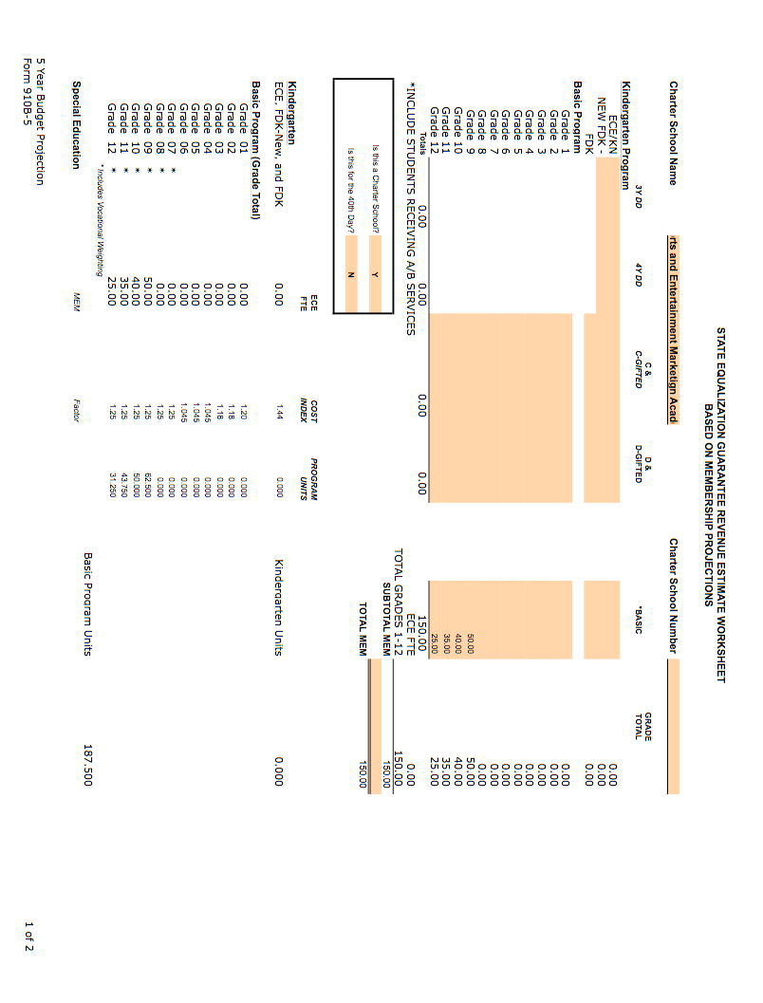

Year 1 continued
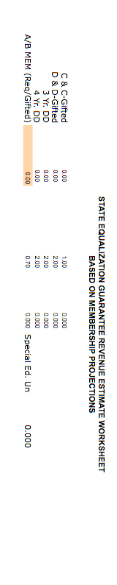

Year 2
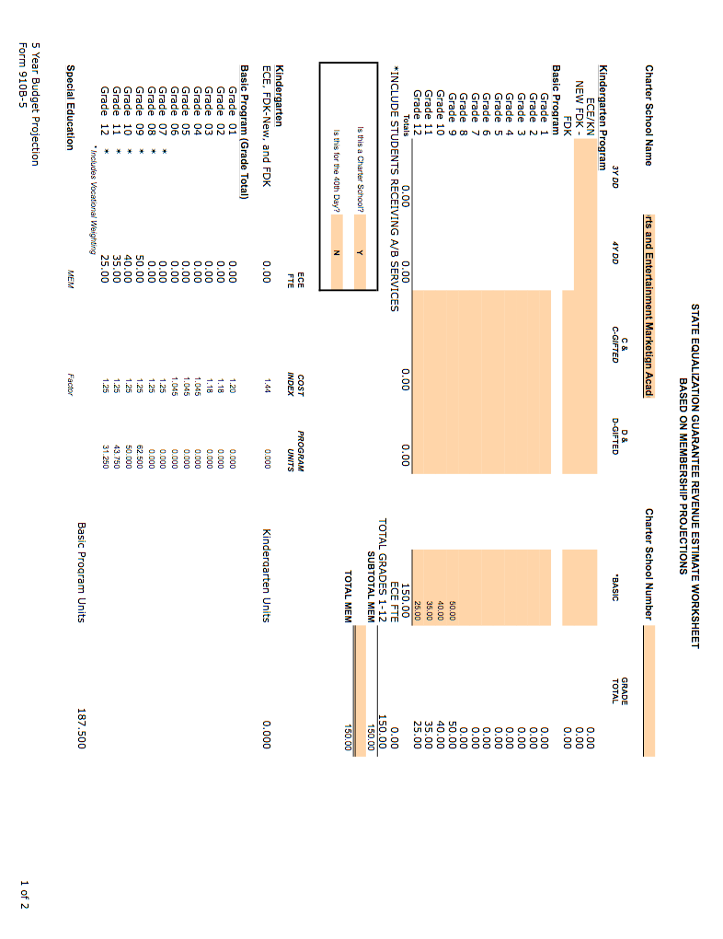

Year 2 continued
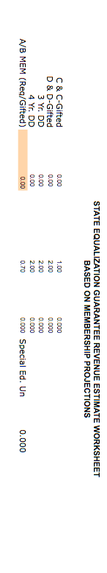

Year 3
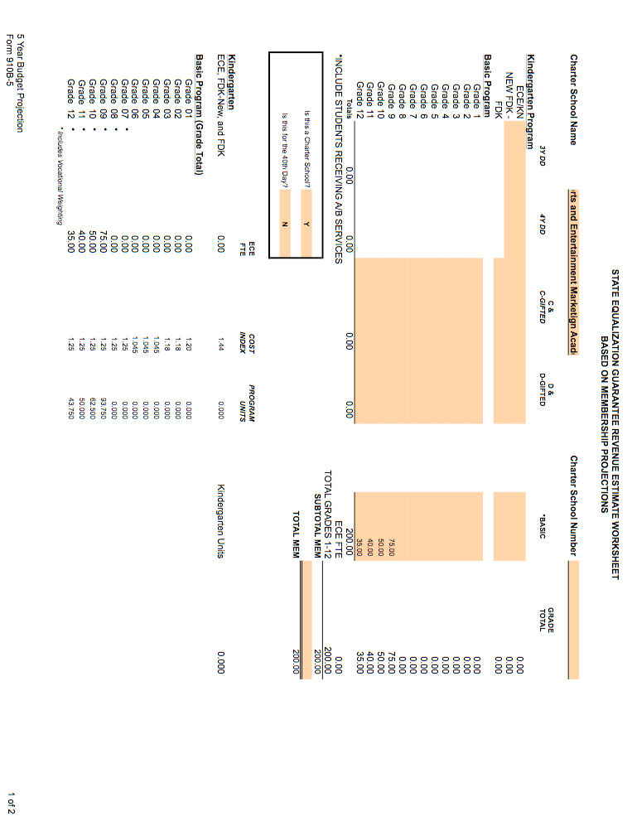

Year 3 continued
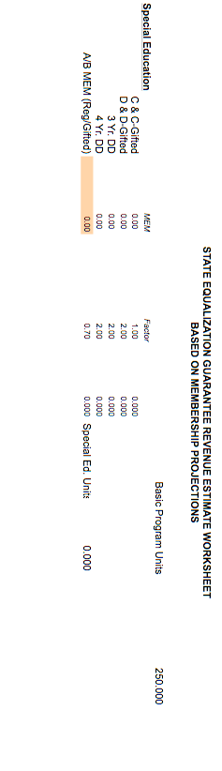

Year 4
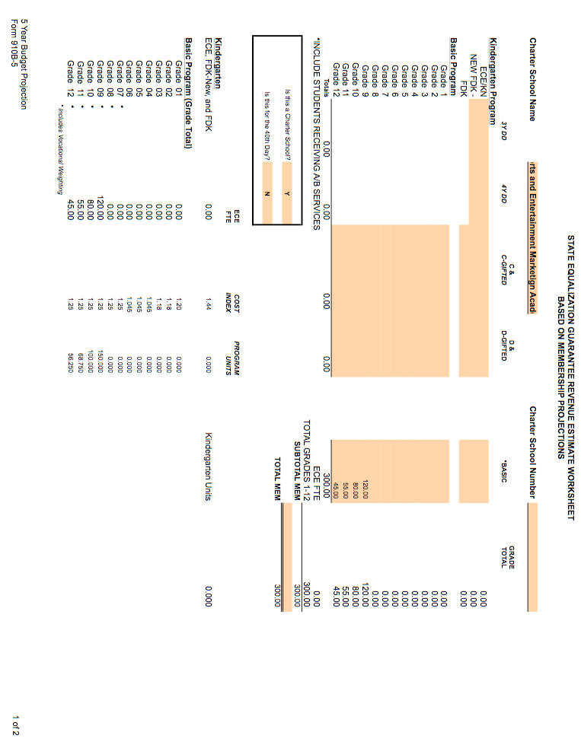

Year 4 continued

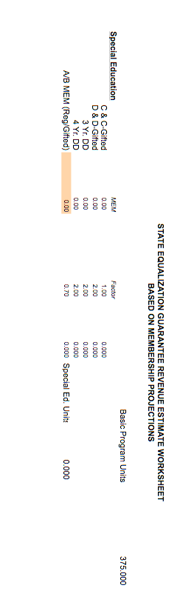

Year 5
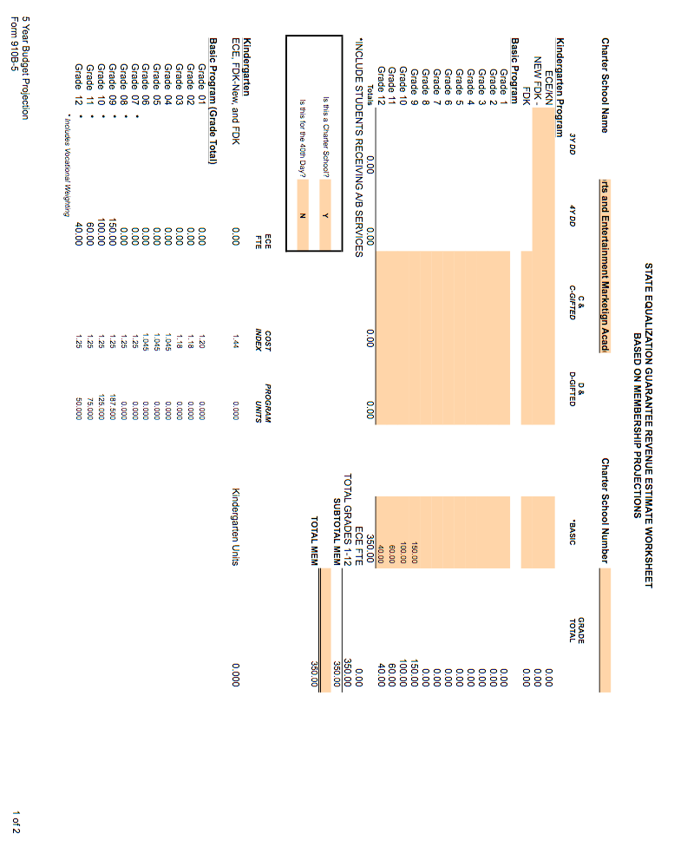

Year 5 continued
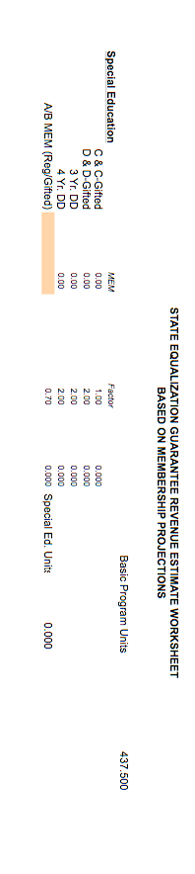

APPENDIX D - Completed 5-Year Budget Plan
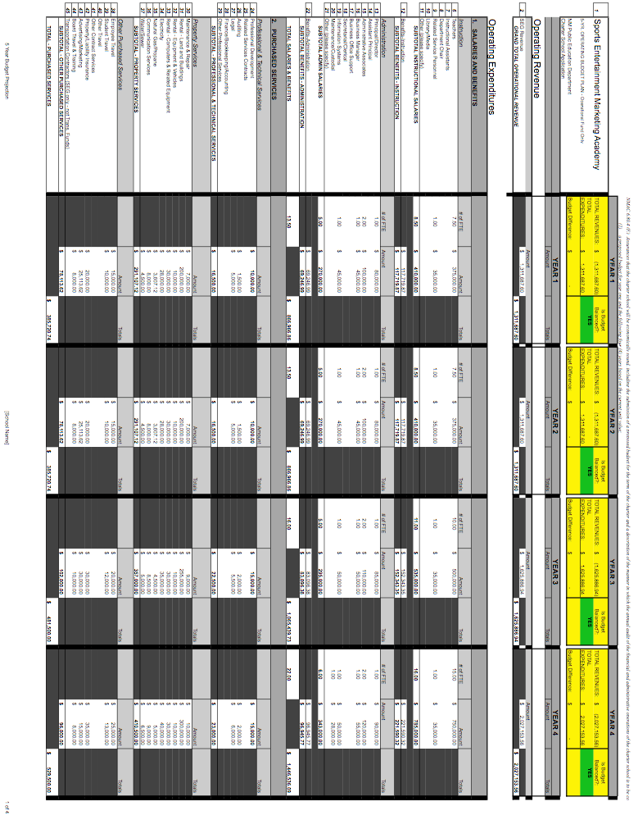

Completed 5-Year Budget Plan continued

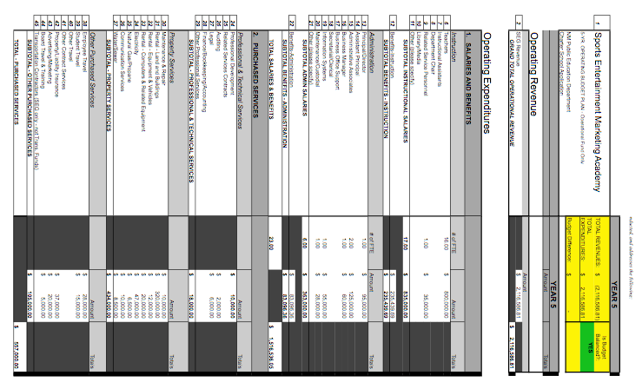

Completed 5-Year Budget Plan continued

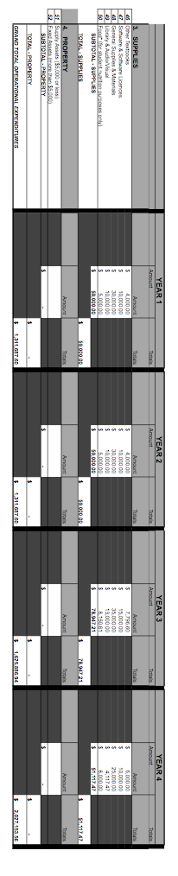

Completed 5-Year Budget Plan continued

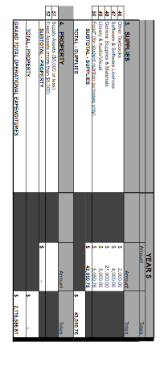

APPENDIX E

Bibliography

Arter, J. et. al. (199510. “Portfolios for Assessment and Instruction.” ERIC Digest.
http://www.ericfacility.net/databases/ERIC_Digests/ed388890.html

The Buck Institute for Education, Project-Based Learning: a Handbook for Middle and High School Teachers, 1999.

Bruner, J., The Process of Education. Cambridge, MA: Harvard University Press, 1960.

Caine, R. and G. Caine. Making Connections: Teaching and the Human Brain. Association for Supervision and Curriculum Development, 1991.

Cohen, E. Designing Groupwork. New York: Teachers College Press, 1994.

Costa, A. and B. Kallick, eds. Assessment in the Learning Organization: Shifting the Paradigm. Association for Supervision and Curriculum Development, 1995.

Cromwell, S. “A New Way of Thinking: The Challenge of the Future. “Educational Leadership 49/1 (1989): 60-64.

Darling-Hammond, L. and J. Ancess, Graduating by portfolio at Central Park East Secondary School. New York: National Center from Restructuring Education, Schools, & Teaching, Teachers College, Columbia University, 1994

Darling-Hammond, L. The Right to Learn: A Blueprint for Creating Schools That Work, San Francisco: Jossey-Bass, 2001

Delpit, L. Other People’s Children: Cultural Conflict I the Classroom. New York: The New Press, 1996

Fowler, W.J.Jr. “School Size and Student Outcomes.” Advances in Educational Productivity. 5:3, 1995.

Gonzalez, V. et. al. Assessment and Instruction of Culturally and Linguistically Diverse Students with or At-Risk of Learning Problems: From Research to Practice . New York: Allyn & Bacon, 1997.

Heck, T. and R. Mayer. “School Characteristics, School Academic Indicators and Student Outcomes: Implications for Policies to Improve Schools. Journal of Rural and Small Schools, 4:2, 1993.

Jobs for the Future. “School-to-Career Initiative Demonstrates Significant Impact on Young People.” Boston: Jobs for the Future, May 1998

Johnson, D. W., R. T. Johnson, and E. J. Holubec. Circles of Learning: Cooperation in the Classroom, 4th Edition. Edina, MN: Interaction Book, 1993.

Lee, V. and J. Smith. Effects of High School Restructuring and Size on Gains in Achievement and Engagement for Early Secondary School Students. Madison, WI: National Center on the Organization and Restructuring of Schools, 1994.

McLaughlin, M. and A. Talbert. Professional Communities and the Work of High School Teaching. University of Chicago Press, 2001

Newmann, F. Authentic Achievement: Restructuring Schools for Intellectual Quality. (San Francisco: Jossey-Bass, 1996).

Making Schools Work (2008). Strategic Plan for Public Education. New Mexico Public Education Department, Santa Fe, New Mexico.

Osofsky, D. et. al. Changing Systems to Personalize Learning: The Power of Advisories. The Education Alliance at Brown University, forthcoming.

Raywid, M., “Small School: A Reform That Works,” Educational Leadership, December 1997 – January 1998.

School District Report Card for 2007-2008 School Year (2009). New Mexico Public
Education Department, Santa Fe, New Mexico.

Slavin, Robert E. “Synthesis of Research on Cooperative Learning. “Educational Leadership, 48 (February 1991): 71-82.

Stahl, R.J. “Essential Elements of Cooperative Learning in the Classroom.” ERIC Digest, 1994, http://www.ericfacility.net/ericdigest/ed370881.html

Stahl, R.J., and R.L. VanSickle, eds. Cooperative Learning In The Social Studies Classroom: An Invitation To Social Study. Washington, DC: National Council for the Social Studies, 1992

Tomlinson, C. The Differentiated Classroom: Responding to the Needs of All Learners. Association for Supervision and Curriculum Development, 1999.

Tucker, M. and J. Codding. Standards for Our Schools. San Francisco: Jossey-Bass, 1998

APPENDIX F = Acronyms List
American With Disabilities Act (ADA)
Behavioral Intervention Plan (BIP)
Central New Mexico Community College (CNM)
Educational Plan for Student Success (EPSS)
Educational Retirement Act (ERA)
Educational Retirement Board (ERB)
Educational Retirement Board (ERB)
English as a Second Language (ESL)
English as a Second Language (ESL)
Free appropriate public education (FAPE)
Full-time equivalent (FTE)
Functional Behavioral Assessment (FBA)
Grievance Review Committee (GRC)
Impact Team Advisory program (ITAP)
Individualized Education Plan (IEP)
Individuals with Disabilities Education Improvement Act of 2004 (IDEA)
Limited English Proficient (LEP)
Local Education Authority (LEA)
Multidisciplinary Team Meeting (MDT)
National Association of Colleges and Employers (NACE)
National Collegiate Athletic Association (NCAA)
New Mexico Administrative Code (NMAC)
New Mexico Public Schools Insurance Authority (NMPSIA)
New Mexico Statutes Annotated (NMSA)
Office of Civil Rights (OCR)
Paid time off (PTO)
Personal learning plans (PLP’s)
Public Education Department (PED)
School-Based-Enterprise (SBE)
Sports and Entertainment Marketing Academy (SEMA)
Student Assistance Team (SAT)
Sustainability Tracking, Assessment & Rating System (STARS)
Teachers of English to Speakers of Other Languages (TESOL)

APPENDIX G
Resumes

VITA
Steve Martinez
7405 Via Cometa SW. Albuquerque, New Mexico, 87121
505-321-1212, scmartinez@nmhu.edu

Education:
1993, Bachelor of University Studies, University of New Mexico,
1997, Master of Arts, Southwest Studies, New Mexico Highlands University,
2006, Doctorate of Philosophy, American Studies, University of New Mexico.

University/College Teaching Experience:

History of New Mexico, New Mexico Highlands University, Spring 2008

Western Civilization, New Mexico Highlands University, Spring 2007

Seminar: Hispanic Leadership, New Mexico Highlands University, Fall 2006

Seminar: New Mexico History, New Mexico Highlands University, Fall 2005

The Modern Period of New Mexico History: 1880-1950, University of New Mexico, Summer 2004

History of New Mexico, Technical Vocational Institute College, Albuquerque, Summer 2004
Hispano Community Biographies, University of New Mexico, Spring 2004

Western Civilization, Technical Vocation Institute College, Albuquerque, Spring 2004

Chicano Student Activism, University of New Mexico, Fall 2003

Introduction to Chicano Studies, University of New Mexico, Spring 2003

Western Civilization, Spring 2003, Valley High School, Albuquerque New Mexico

United States History, Spring 2002, Fall 2002, fall 2004, SIPI Southwest Indian Polly- Technical Institute, Albuquerque New Mexico

Treaty of Guadalupe Hidalgo, Spring 2002, Chicano Studies Program, University of New Mexico

Student Activism, Fall 2001, Fall 2002, Chicano Studies Program, University of New Mexico

Social and Political Conflict in New Mexico, Spring 2000, Chicano Studies Program, University of New Mexico

Border Matters, Spring 2000, Department of American Studies, Chicano Studies, University of New Mexico

Latino/as in the 21st Century, Spring 2000, Department of American Studies, Chicano Studies, University of New Mexico

Social History of New Mexico, American Studies, Santa Fe Branch, Spring 2000

Community Biographies of the SW, American Studies Department, Santa Fe Branch, Fall 1999

Introduction to Chicano Studies, Fall 1999, Fall 2000, Spring 2001, Spring 2003

Introduction to Southwest Studies, Spring 1998, Summer 1998, Fall 1998, Department of American Studies, University of New Mexico

Professional and Academic Experience:

Director, New Mexico Highlands University, Santa Fe/Espanola Centers, Fall 2004 to present
Duties: Staff Supervision, Curriculum Development, Budget Reports, Education Outreach, Student Advisement, Consultation with Deans, Vice Presidents, and other Administrators.

Consultant (Research/Administration) Center for Regional Studies, University of New Mexico, Fall 1998-Spring 2004
Duties: Historical Research, Curriculum Development, Staff and Administrative Coordination, lobbyist

University of New Mexico, Chicano Studies Program, Directorship Search Committee Member, Spring 2004
Duties: Committee Member for selecting Director for Chicano Studies Program

University of New Mexico, Chicano Studies Program, Steering Committee (curriculum committee), Fall 2003, & Spring 2004
Duties: Curriculum Development, Course Sequencing, and Scheduling for Chicano Studies Program

Lobbyist, Chicano Studies Program, University of New Mexico, Spring 2003

Education Trust Board (College Savings Program), Graduate Student Member, State of New Mexico, 1999-2004
Duties: Budget Development, Grant Writing, Advertisement, University Relations, and Lobbyist

Senior Page, President Pro-Tem. State of New Mexico, Spring 2000

Title Two, Grant Reader, United States Department of Education, Washington D.C. Spring 1999
Duties: Evaluating/Rating/Selecting Title Two Grants for the U.S. Department of Education

Chief Lobbyist, University of New Mexico Graduate Student Association, 1999

Adjunct Instructor, University of Utah Salt Lake City, School of Education, Fall 1998

Graduate Assistant University of New Mexico, Department of American Studies, 1997-1998

Research Consultant, Rio de Las Gallinas Acequia Association, Las Vegas New Mexico, 1995-1996
Duties: Grant Writing, Priority Dating (research)

Program Director, Project I Teach, University of New Mexico, College of Education, 1992-1997
Duties: Scheduling Classes, Curriculum Development, Coordinating with the Dean of the College of Education, and Student outreach for High Schools in northern New Mexico

New Mexico Highlands University Student Senate, Senate Finance Committee Chairman, 1995
Lobbyist, New Mexico Highlands University Student Senate Finance Committee, 1995

Graduate Assistant New Mexico Highlands University, Department of History, Las Vegas New Mexico, 1994-1996

Publications:

Civic Ideals in New Mexico: The Sacred Quest for Citizenship, Dissertation, Department of American Studies, University of New Mexico, 2006

Organizations/Activities:

President, MECHA (Chicano Student Organization, UNM), 1992
Student Senator, New Mexico Highlands University 1996-1997
LULAC, SOS (save our students), Albuquerque, New Mexico, student volunteer tutor and mentor, Albuquerque Public Schools, 1991-1993
University of New Mexico, Volunteer Freshman Mentor Program, 1992-1993
New Mexico Highlands University, Student Mentor and Tutor, Student Services Program, 1995-1996
Graduate Student Advisor, Republica del Norte, organization, University of New Mexico, 2000-2001
SOLAS, Students Organization of Latin American Students, member 2002-2003
RAZA Graduate Student Association, member, 1997-1998

Reference:

Dr. Francisco Hidalgo, Dean School of Education, New Mexico Highlands University, Las Vegas New Mexico, 1-877-850-9064

Dr. William Taylor, Dean School of Business, New Mexico Highlands University, Las Vegas New Mexico, 1-877-850-9064

Dr. Alfredo Garcia, Dean School of Social Work, New Mexico Highlands University, Las Vegas New Mexico, 1-877-850-9064

1211 El Portal NW  Albuquerque, New Mexico  87107 | Hm: (505) 332-7875  Cell: (505) 459-7412
Eric Strauss
Objective | To open a dynamic Sports and Entertainment Marketing Academy Charter School that improves the lives of students
Educational Work Experience | 2001-Present Albuquerque High School Albuquerque, NM  Marketing and Journalism Teacher, DECA Supervisor  - Served as department chair for Career and Technical Skills department.  - Effectively directed the implementation of State Standards.  - Coordinated student internships with local businesses.  - Designed and implemented curriculum for marketing and business.  - Managed student-based enterprise including personnel supervision.  - Managed extensive records for tracking student performance.  - Served on the Instructional Council and Advanced Technology Academy curriculum design team.
Industry Experience | 2000-Present(Summer) Custom Grading Inc. Albuquerque, NM  Marketing and Public Relations  - Effectively involved in the management of resources including: Promotional Literature Design and Company Mission and Vision  - Utilized Market Analysis to improve company performance  - Conducted Marketing Research for promotional materials  2008 - Present Ryan's Sew and Vac Albuquerque, NM  Marketing and Public Relations  - Effectively involved in the management of resources including: Promotional Literature Design and Company Mission and Vision  - Utilized Market Analysis to improve company performance  - Conducted Marketing Research for promotional materials
Educational Work Experience | 1998-1999 West Mesa High School Albuquerque, NM  Administrative Intern  - Assisted with Dean of Students activities.  - Created School Safety Response Plan.  - Instituted a Mentorship program to train peer tutors.  - Assisted with teacher and staff evaluations.  - Facilitated disciplinary referrals.  - Administered organization of State Report and North-Central accreditation process.  - Participated in EPSS meetings.
Summer 1997 Sandia High School Albuquerque, NM
Assistant Principal Intern
- Administered discipline for all grade levels.
- Directed buildings and grounds including allocation of resources.
- Coordinated and conducted interviews for new staff hiring.
- Conducted formal and informal staff evaluations.
1998-2000 West Mesa High School Albuquerque, NM
Marketing Teacher and DECA Supervisor
- Coordinated student internships with local businesses.
- Designed and implemented curriculum for marketing and business.
- Managed student-based enterprise including personnel supervision.
- Managed extensive records for tracking student performance using Baldridge strategies.
1998-1999 Highland High School Albuquerque, NM
Marketing Teacher and DECA Supervisor
- Coordinated Special Education student internships with local businesses.
- Participated in design and evaluation of Individual Education Plans.
- Designed and implemented curriculum for full-inclusion special education marketing class.
- Managed extensive records for tracking student performance.
1995-1997 McKinley Middle School Albuquerque, NM
English Teacher
- Participated in the School Restructuring Committee.
- Directed a mentorship program with La Cueva Seniors and McKinley students.
- Implemented a community book drive to supplement school materials.
- Active member of the technology committee helping to implement school technology plan.
1994-1995 Albuquerque High School Albuquerque, NM
Marketing Teacher and DECA Supervisor
- Coordinated student internships with local businesses.
- Designed and implemented curriculum for marketing and business.
- Managed student-based enterprise including personnel supervision.
Education | 1990-1997 University of New Mexico Albuquerque, NM  - B.A., Double Major English and History  - Post Bachelor Certification in Secondary Education  - M.A., Educational Administration
Awards | - Excellence in Education Albuquerque Public Schools 2003  - Crystal Apple Award finalist
Professional Certifications | - New Mexico Administrator License, K-12  - New Mexico Secondary Education License, 6-12

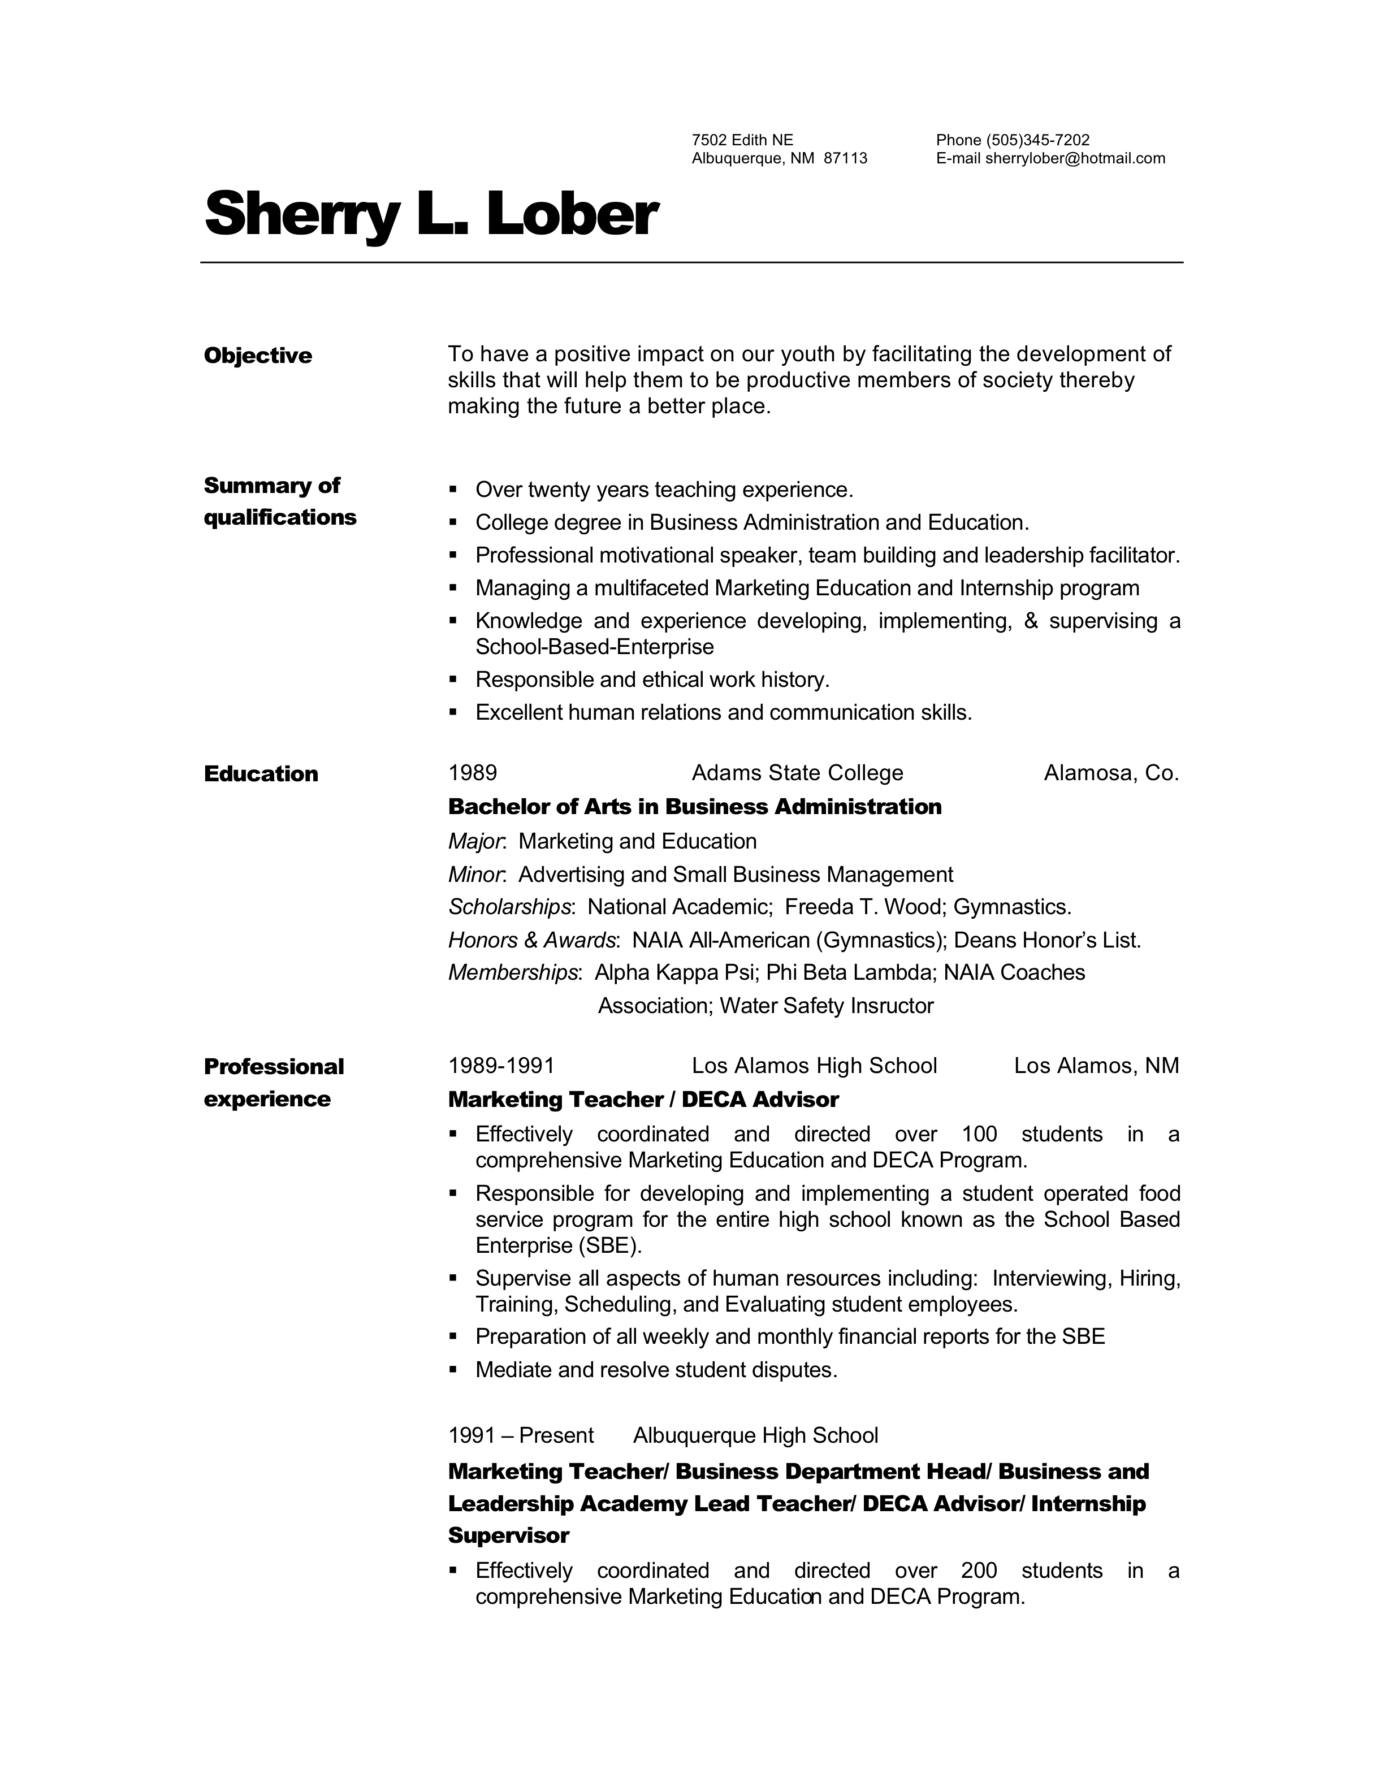

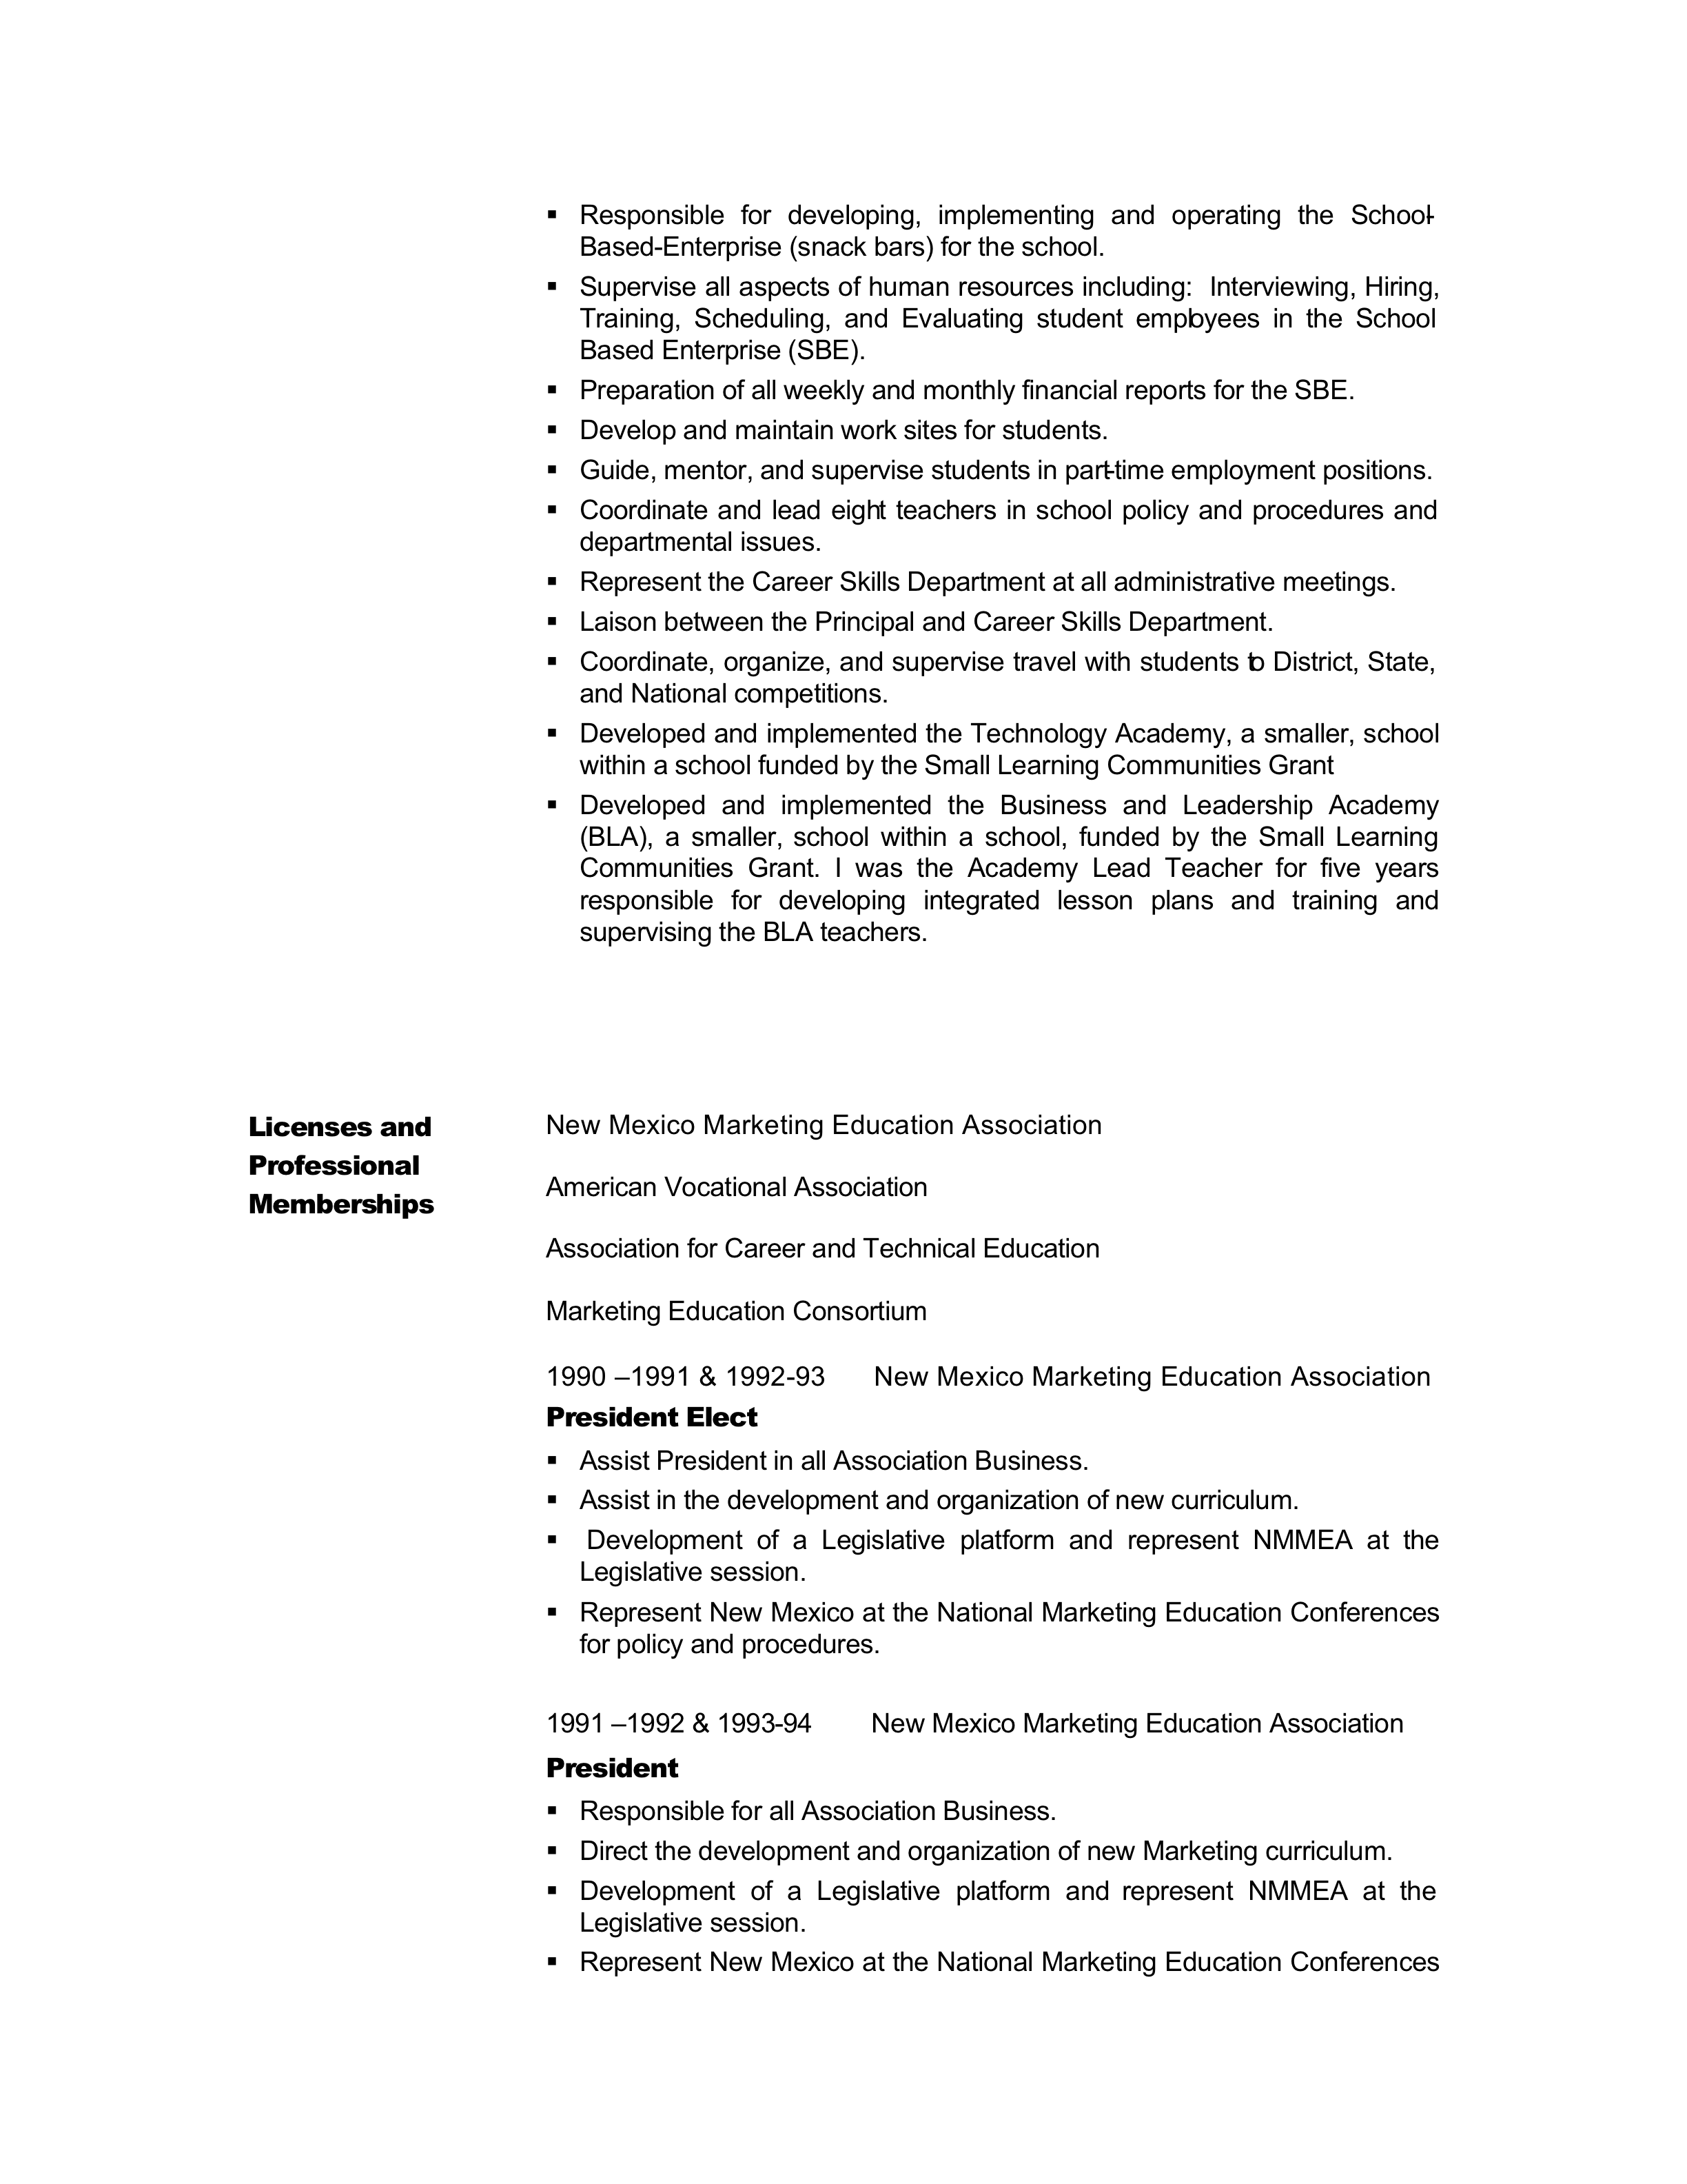

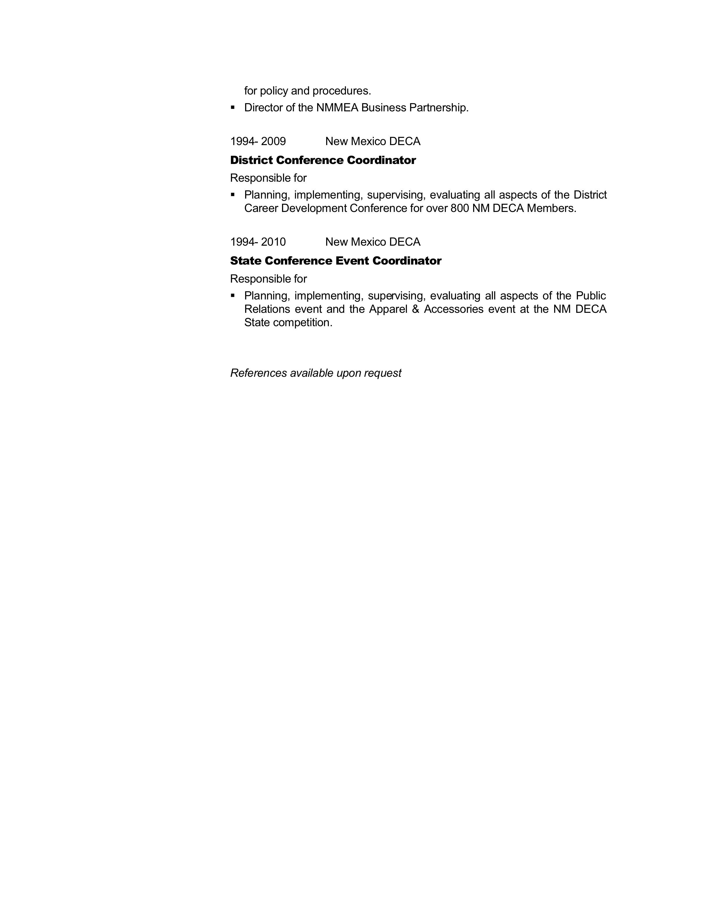

TARRA L. HODEN
1020 Stuart Rd., NW, Albuquerque, N.M. 87114
Cell (619) 709-0387; tarrahoden@juno.com

STATE BAR LICENSING
Licensed/admitted: (1) Colorado Bar October 1999; (2) California Bar July 2002; and (3) New Mexico Bar April 2007

EXPERIENCE
RUGGE, ROSALES & ASSOCIATES, Albuquerque, New Mexico
Associate Attorney, January 2009 -- present. Case evaluations, prepare pleadings, discovery, client evaluation letters, and various motions; conduct depositions, legal research; retain experts; and conduct all hearings, arbitrations, mediations and trials. Areas of Practice: Insurance defense (third party) and general civil litigation.

KELEHER & MCLEOD, Albuquerque, New Mexico
Associate Attorney, August 2008 -- December 2008. Prepare pleadings, discovery, client evaluation letters, initial disclosures, and various motions; legal research; assist in retaining experts; and attend scheduling conferences. Areas of Practice: medical malpractice.

FOSTER, RIEDER & JACKSON, Albuquerque, New Mexico
Associate Attorney, March 2007 -- August 2008. Prepare pleadings, discovery, briefs, memorandum; legal research; and attend workers’ compensation hearing and mediation conference. Areas of practice: general civil litigation (employment law), commercial litigation (real estate, business and contract disputes, and ERISA law), and workers’ compensation.

FULLER, GLASER & JENKINS, La Jolla, California
Associate Attorney, November 2003 -- November 2006. Handle high volume case load from initiation until conclusion; represent insurance companies/employers at hearings, settlement conferences and administrative trials; legal research; conduct depositions of plaintiffs and some treating physicians; conducted administrative trials; prepare pleadings, motions, briefs, client letters with legal analysis and recommendations. Areas of practice: workers’ compensation (majority of practice) and general civil litigation (employment and personal injury).

NEIL, DYMOTT, PERKINS, BROWN & FRANK, San Diego, California
Associate Attorney, July 2002 -- October 2003. Attend discovery dispute hearings and calendar conferences; conduct depositions of plaintiffs and treating physicians; assist in obtaining and maintaining relationships with expert witnesses; client contact and interviews; legal research; prepare discovery requests, pleadings, various motions, trial briefs, motions in limine, and motions for summary judgment; assist in trial preparation. Areas of practice: medical malpractice (defense) and personal injury (plaintiff).

SHEEHAN, SHEEHAN & STELZNER, P.A., Albuquerque, New Mexico
Law Clerk, September 2000 – September 2001
Research case law; and prepare legal memorandum, motions, motions for summary judgment, discovery requests and responses, and general pleadings. Areas of practice: legal malpractice and attorney disciplinary proceedings, construction, products liability, insurance defense, water law, foreclosure and mortgage issues, and redistricting and zoning.

WHITE AND STEELE, P.C., Denver, Colorado
Associate Attorney, November 1999 – June 2000
Legal research; client interviews; defended expert deposition; and prepare legal memorandum, motions for summary judgment, trial briefs, arbitration briefs, disclosures, motions, discovery requests, and general pleadings. Areas of practice: insurance defense (bad faith, coverage, personal injury protection, homeowner’s), employment law, legal malpractice, products liability, ski law and workers’ compensation.

EDUCATION
CALIFORNIA WESTERN SCHOOL OF LAW, ABA/AALS San Diego, California
Juris Doctor received May 1999 (G.P.A. 81.04 out of 95.0)

UNIVERSITY OF NEW MEXICO, Albuquerque, New Mexico
B.A. received December 1994. Bachelor of Arts: Political Science. Distributed Minor: English, Philosophy, Economics, and Communication Dean’s List, Honor Roll, Golden Key National Honor Society, Phi Kappa Phi Honor Society

PUBLICATIONS AND CHAIR MEMBERSHIP
Assistant Colorado editor for the Product Liability Desk Reference manual (2000) and Tort Law Desk Reference manual (2000). Chair of the Student Committee (2002 – 2005) for the Lawyers Club (San Diego).

OTHER INTERNSHIPS/EMPLOYMENT
N.M. State Senator Pro Tem, Secretary on the Committees’ Committee, Santa Fe (1995). Handle affairs for the Committees’ Committee, track bills, sponsors, and committee locations, wrote summaries of all bills concerning capital outlays.

United States Senator, Pete V. Domenici (N.M.), Internship, Washington, D.C. (Summer 1994). Attend press conferences and brief budget committee staffers respecting salient content; draft comments in Congressional Record; research and inform staffers on entitlement programs/social security issues for the Bipartisan Entitlement and Tax Reform Commission.

William Silva
5700 Cactus Flower NW
Albuquerque, New Mexico 87120
(505) 899-8561
Language spoken – English & Spanish

Work Experience

2009 to Present- Albuquerque Public Schools Counselor – Sandia High School
Duties and responsibilities:
- Counselor/Administration

2002 to 2008- Albuquerque Public Schools Counselor – Taylor Middle School
Duties and responsibilities:
- Most urgent – Mediations and parent conferences.
- SchoolMAX – Master Schedule build, student scheduling.
- Next Step Plan, SAT, 504’s, Mental Health Team, Student Safety Plan Team, NMELPA Testing Coordinator.
- Assist when administration is off campus to include discipline.

1980 to Present- Albuquerque Metropolitan Court School Coordinator
Coordinator for DWI, Driver Improvement, and Petty Larceny School
Duties and Responsibilities:
- Prepare and maintain budget and instructor schedules
- Recruitment, hiring, training, and supervising of sixteen instructors
- Development and implementation of the DWI, Driver Improvement, and Petty Larceny curriculum
- Teach DWI classes in English and Spanish
- Train DWI Instructors for NM Traffic Safety Bureau statewide

1976 – 2001 Albuquerque Public Schools Counselor – Valley High School
Department Head duties and responsibilities:
- Coordinating a staff of five counselors
- Developing and implementing a school level guidance program focused on the physical, social, intellectual, emotional, and vocational growth of each student
- Serve as a consultant to the school and community
- Provide individual and group counseling

1975 – 1976 Albuquerque Public Schools Counselor
Old Town Elementary & Dolores Gonzales Elementary School

1973 – 1972 Albuquerque Technical-Vocational Institute/Skill Center Counselor

1971 – 1972 University of New Mexico – ISRAD/New Careers Associate of Arts Program Educator

1969 – 1971 United States Armed Forces – Vietnam Medical Corpsman
Honorable Discharge

1965 – 1969 Santa Fe Boys’ Club - Assistant Director

Education & Training
1980 DWI Certified Instructor (New Mexico Traffic Safety Bureau)
1973 Mater of Arts Degree – Vocational Rehabilitation & Guidance Counselor K-12
(University of New Mexico)
1969 Bachelor of Arts Degree – Education (College of Santa Fe)

References

Margaret D. Dieppa, PHD Roberta Murata
Educational & Community Services Director Principal – Taylor MS
Bernalillo County Metropolitan Court 8200 Guadalupe Trail NW
401 Roma NW Albuquerque, NM 87114
Albuquerque, NM 87102 (505) 898-3666
(505) 841-8139

Jennifer Montano Pam Meyer
Counselor – Evening High School Assist. Principal – Taylor MS
5904 Avenida Arturo NW 8200 Guadalupe Trail NW
Albuquerque, NM 87120 Albuquerque, NM 87114
(505) 898-0870 (505) 898-3666

Patrick Matthew De Palma
517 Pennsylvania Street NE
Albuquerque, NM 87108
Tel: 505-319-6969

Working with and in the Albuquerque Public School system has helped me to develop the ability to create, implement and monitor policies that promote a safe and effective learning environment.

Experience

2008 Del Norte High School, Albuquerque, NM
Counselor
- Support students dealing with personal stress and problems of adjustment.
- Guide students to make wise decisions regarding educational and career opportunities.
- Network with universities and local businesses to promote students and the school.

2006 - 2008 Jimmy Carter Middle School, Albuquerque, NM
Dean of Students
- Created and implemented the Cavalier Code of Conduct (Discipline Matrix).
- Assisted in designing and implementing security measures, crisis plans, and emergency procedures.
- Work daily with behavior and attendance issues.
- Created, distributed and tracked 504’s.
- Coordinated registration and orientation for incoming 6th graders.
- Developed and designed the Jimmy Carter Parent/Student Handbook and Student Agenda.
- Instructional Council, Student Assistant Team (SAT), and Threat Management Team member.
- Member of the Middle School Curriculum Board.
- Sexual harassment trainer for students and staff.
- Building and athletic field usage controller.

2001-2006 Highland High School, Albuquerque, NM
Smaller Learning Community Coordinator, Magnet Grant Coordinator, Crisis Counselor, Head Baseball Coach
- Administrator level position supervising and supporting the implementation of smaller learning communities.
- Developed and established Highland’s 9th Grade Academy.
- Created and implemented advisory periods and career academies.
- Created Highland’s Academic Portfolio & Career Planners.
- Assisted with day-to-day disciplinary issues for all grade levels.
- Created and implemented programs that address academic, career and personal/social development.
- Lead Chair for Highland’s Scientific Research & Technology Magnet Program.
- Designed and implemented comprehensive school counseling programs to include divorce groups, anger management groups and self-esteem groups.
- Continuously supported various mental health needs for students and families in all grade levels.
- Presided over Highland’s Mental Health team and Student Assistance Team (SAT).
- Standardized testing coordinator.
- Created and organized Highland’s Yearly Career Fair.
- Join-A-School liaison building professional relationships with the business community.
- Coordinator for city block grant, drop-out and at-risk student prevention programs.

1999 Metro Court, Albuquerque, NM
DWI Instructor
- Implementing program goals to raise awareness, encourage self-assessment, and build personal commitment to reduce the tragic impact of alcohol and drugs.

1999-2001 Andrew Jackson Middle School, Albuquerque, NM
Counselor
- Provided counseling services for academics, career awareness, basic work skills, self-awareness, relationships, communication skills, and life success skills.
- Standardized testing coordinator.

1998-2000 National American University, Albuquerque, NM
Instructor
- Psychology, Sociology, and Humanities instructor for undergraduate programs.

1998-1999 St. Pius X High School, Albuquerque, NM
Guidance Counselor
- Supported students dealing with personal stress and problems of adjustment.
- Guided students to make wise decisions regarding educational and career opportunities.
- Junior varsity and freshmen baseball coach.

1998-2000 APN & Associates Family Support Center, Albuquerque, NM
Counselor
- Provided supervised visits and exchanges.
- Individual and group counseling.
- Parent Education Programs.

1988-1998 Joint Theater Missile Defense, Kirtland AFB, NM
Intelligence Officer
- Hand picked to take part in an Office of the Secretary of Defense joint test study.
- Responsible for the planning, developing and establishing methods and procedures for information management and control.
- Desert Storm Veteran.

Education

1998 Webster University, Albuquerque, NM
Master of Arts degree: Counseling
Graduated with honors.

1994 College of Santa Fe, Santa Fe, NM
Bachelor of Arts degree: Psychology
President’s list: four consecutive semesters. GPA: 3.88

