New Mexico Striving Readers Comprehensive Literacy (SRCL) Grant
Frequently Asked Questions (FAQs)

- Is there a cap on the amount of dollars that an applicant may ask for? What guidance is provided for the amount of dollars that can be requested?
- There is no specific guidance on the dollar amount applicants can ask for. All applicants are required to submit a budget that adheres to the following budget breakdown:
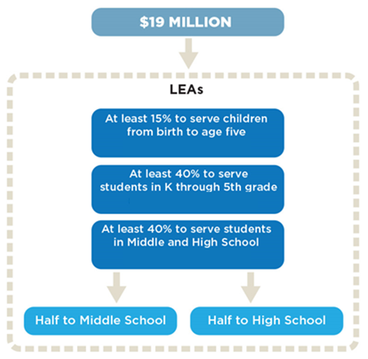

Q) Is there any way that charter schools will be able to participate in this grant?

A) Charters are eligible to apply for the SRCL grant. If your charter does not serve a birth to Grade 12 continuum, then you will need to partner with other schools and Early Childhood Education partners to establish a birth-Grade 12 continuum.

Q) Can the grant support salaries for Reading Coaches or Interventionists?
A) Salaries for Reading Coaches or Interventionists may be an acceptable expense under SRCL Grant. Please note SRCL funding must supplement and not supplant current funding for literacy initiatives.
Additionally, note the table in Tab 6.B Budget Calculator:
"Unallowable​ ​Expenses​ ​(Not​ ​an​ ​exhaustive​ ​list):
-Furniture​ ​for​ ​office​ ​use
-Salaries​ ​and​ ​benefits​ ​of​ ​current classroom​ ​teachers​ ​and​ ​clerical/secretarial​ ​staff (new staff may be hired on a contractual basis)
-Pre-award​ ​costs
-Entertainment,​ ​refreshments,​ ​snacks,​ ​alcohol
-Field​ ​trips​ ​or​ ​​​retreats
-Promotional​ ​or​ ​marketing​ ​items
-Decorative​ ​items
-Land​ ​or​ ​building​ ​acquisition
-Construction​ ​costs​ ​or​ ​renovations/remodeling​ ​costs
-Gifts​ ​or​ ​incentives
-Fundraising​ ​costs
-Dues​ ​to​ ​organizations,​ ​federations,​ ​or​ ​societies​ ​for​ personal​ ​benefit
-Computers, printers or other technology​
-Student​ ​services​ ​such​ ​as​ ​AP​ ​testing​ ​fees,​ ​concurrent​ ​enrollment​ ​fees​ ​and​ ​books,​ ​or​ ​other​ ​direct​ ​student​ ​services
-Convocation/graduation​ ​costs"

Q) In terms of priority funding, how does an applicant calculate “economically disadvantaged”?
A) The percentages included in the RFA were pulled from the SY17-18 STARS 80-day Count. For Economically Disadvantaged, the PED used the data element: ​PctFRL (% Free and Reduced Lunch). Applicants should use the PctFRL (% Free and Reduced Lunch) for reporting "Economically Disadvantaged."

Q) Must the grant include the entire birth to high school continuum?
A) Birth–Grade 12 (B–12) Continuum of Partners and Supports
Applicants are required to identify a birth through Grade 12 progression that serves underserved populations of children (defined below). All programs or schools for the following age spans must be included in the application:
- Certified early care and education (ECE) providers and programs serving children birth to kindergarten;
  - Note: all ECE providers must be certified by a federal or New Mexico state agency (e.g., Head Start, Early Head Start, New Mexico Children Youth and Families Department, New Mexico Department of Health) and adhere to all federal and state program requirements.
- Elementary schools (grades K–5);
- Middle school (grades 6–8); and
- High school (grades 9–12).

