Introduction to Asbestos Learning Package
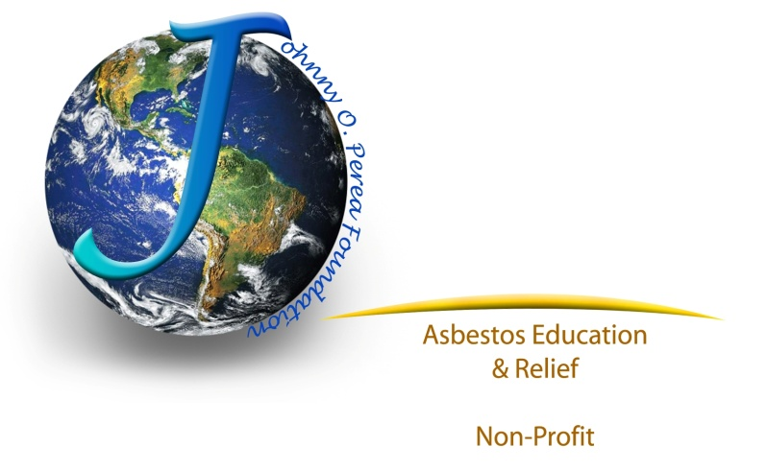
A 45-minute lesson to educate students about asbestos and its dangers.
Introduction for lecturers
Asbestos-related diseases account for around 107,000 deaths worldwide according to 2011 data from World Health Organization (WHO). In America we lose 10s of thousands every year. Tradespeople in particular; joiners, carpenters, auto mechanics, electricians and plumbers, are at risk in the workplace. Residents’ are also at high risk because asbestos is in homes as well. Homes are not regulated by the Environmental Protection Agency (EPA) or the Occupational Safety and Health Administration (OSHA). This is how we can ensure future generations get the information on how to live with asbestos.
The number of deaths attributable to asbestos continues to rise and is not likely to peak until around 2015. Although the use of asbestos has decreased, it is still present in buildings and homes. Therefore, your students will come in contact with asbestos if they are in or around renovations, remodels, repairs, or demolition work.
Every day 294 people die from asbestos-related diseases worldwide. 28 Americans die every single day according to numbers from the World Health Organization.

This lesson
This lesson will introduce asbestos and its dangers to your students – America’s tradespeople & mechanics of tomorrow. It will educate them about what asbestos is, where it can be found, how it can harm people and animals.
This pack has been designed to allow you to deliver the key messages about asbestos in a single lesson of around 45 minutes.
The lesson uses a PowerPoint presentation to explain the dangers of asbestos, where it might be found, what action to take and other vital information. At key points throughout the presentation teachers are encouraged to open up the lesson for discussion and to encourage students’ input.
Once the lesson has been completed, students should complete the task sheet (also included) by locating on the image where asbestos could be found. There are two task sheets included of varying difficulty that will test how much students have learned.

Prior to the lesson
Before starting the lesson, please ensure that you download the relevant materials, also available from the JOPF website. You will need:
■ PowerPoint Presentation: Asbestos – The Hidden Killer. This will need to run on Microsoft PowerPoint along with Don’t mess with asbestos 3 part video. You will need a live feed to the internet.
■ The task sheet: The hunt for asbestos (two versions and lecturer’s answer sheet)

Please check that the PowerPoint presentation runs on your IT system. It is strongly recommended that you print out a copy of the presentation, which includes notes – the notes provide a ‘script’ for the presentation, and you should follow this as a guide.
Learning objectives
■ Understand what asbestos is
■ List the uses of asbestos in the building trade as well as mechanics
■ Identify where students may come across asbestos in their homes or work
■ Explain procedures for dealing with asbestos

References
U.S. Environmental Protection Agency (EPA)

World Health Organization (WHO)

U.K. Health & Safety & Executive (HSE)

Agency for Toxic Substance & Disease Registry (ATSDR)
Johnny O. Perea Foundation for Asbestos Education & Relief
Lesson plan
Asbestos – A Hidden Killer to the unaware!
Starter
Short introduction from the speaker followed by asking the question; what is asbestos? Ask if someone might know where it can be found? Don’t take more than a few minutes because this lesson will cover this in detail.

Explain to the class that you will be discussing asbestos and its dangers. Open the PowerPoint presentation and start the slideshow.
After watching the part 1 of the 3 part “Don’t Mess With Asbestos” YouTube video on slide two, ask the class the following questions. Do this for all three parts.
1) What do you think about this short video? 2) What does the class already know about asbestos? 3) Does anybody in the class know someone who has been affected by asbestos?
Main body
Work through the rest of the PowerPoint presentation, slide by slide, using the notes at the bottom of the PowerPoint to guide you through the lesson. During the lesson, encourage your students to engage in short discussions about the topics raised. The presentation notes suggest appropriate points at which you can pause and ask the students questions or seek their opinions.

Summarize
Use the final slide to affirm the lesson’s learning objectives. Ensure, above all else, students can remember these key messages:
■ Asbestos is dangerous, especially to young people.
■ Asbestos can be found in any building in America, it is still used.
■ If in doubt, stop working and check.
■ Don’t put yourself at risk – asbestos is a hidden killer.

Ask your students to note down three key points they think a new tradesperson or mechanic should know about asbestos.
Homework Task sheet
Hand out the homework task sheet to the class. Using the knowledge they have gained from the lesson, complete the task sheet at home with family involvement to increase awareness at home as well. Using the diagram, students should try to find the possible locations of the listed asbestos materials in their own homes. These task sheets can also be reproduced form HSEs web site. They are from the UK but still apply. There is a short test that the whole family can take together “Do you know the facts“. It is important to understand that the U.K. has banned asbestos so the pre 1999 construction reference does not apply to the United States of America. Unfortunately, we still use asbestos.
An alternative task sheet has been provided for students you feel may need to be given more of a challenge (this task sheet does not give a list of asbestos-containing materials or hotspots).

For more information on asbestos and its dangers, visit Johnny O. Perea Foundation. You can also email me @ cperea8208@gmail.com

Respectfully,

Charles R. Perea, Founder
Johnny O. Perea Foundation for Asbestos Education & Relief
501(c)3 non-profit, NM SCC# 2662930
816 Chihuahua Rd. NE
Rio Rancho, NM 87144
505-331-8984

