MEMBERSHIP PROJECTIONS
Program Instructions

PUBLIC EDUCATION DEPARTMENT
School Budget & Finance Analysis Bureau
300 Don Gaspar Street
Santa Fe, NM 87501

In accordance with Section 22-8-12-1 NMSA 1978, the Membership Projection files and reports are due on or before October 15.

Technical Assistance
Please contact Richard Trujillo at 505-827-7937 or Lisa Hamilton at 505-827-7931 for IT technical questions. Please call your assigned Budget Analyst, if you have questions about the data collection.

Software
The Membership Projections data collection is compiled over the internet via SharePoint. Advantages to using the internet process include:
- System runs on any operating system (Apple, Windows).
- Automatic email notification upon approval.
- Easier processing steps.

Browsers
Internet Explorer (best option for support).
Safari (supported).
Firefox (may not work).
Chrome (may not work).

PK and KN Students
PK should only be reported with 3Y and 4Y DD students. No C, D, or Basic Membership should be included in PK.
KN should only be reported with students in approved Full-day Kindergarten programs. When entering data, every student shall be counted as “1”.

Charter Schools
Charter school membership projections should be reported by each approved charter school and NOT by the district.

Adding Schools and Grades
To add new schools or grades, please contact the Information technology Bureau. Ensure that the reorganization process is complete and that PED approval has been given to add new grade or new school before contacting IT.

In accordance with NMAC 6.29.1.9 F, “Organization of grade levels and establishing/closing schools. Any change in a school district of charter school’s organizational pattern, including the establishment or closing of a school, shall have the secretary’s approval prior to implementation. Requests for change shall be submitted using the department’s organization of grade levels and establishing/closing school waiver request form. This form shall include: name of superintendent; district/school; mailing address; phone; fax; email address; name of a secondary contact person including the same information; date of submission; local board policy requirement and approval, if required; date of board approval; statement of applicable district or charter school policy and rationale for request. The waiver request shall outline the expected educational benefits.”
Step 1 – Using a web browser, go to the Projected Membership website.
https://eui.ped.state.nm.us/sites/SchBudProjMem/SitePages/default.aspx
The Website address will also be on PED’s School Budget and Finance Analysis Bureau Web Page.

Step 2 – Sign in
The User Name is your email address. The Password will be emailed to you. (PED staff should use same password as STARS).

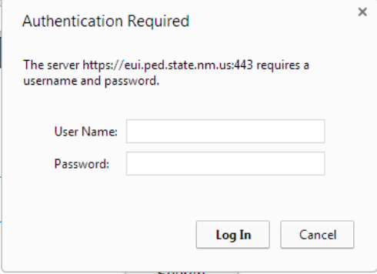

Entry Process

Select

Select

Select

Enter

Step 3 – Click on the Edit Icon.

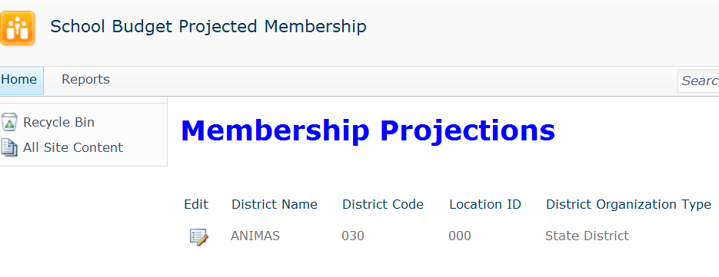

Step 4 – Enter your A/B MEM and Ancillary FTE.

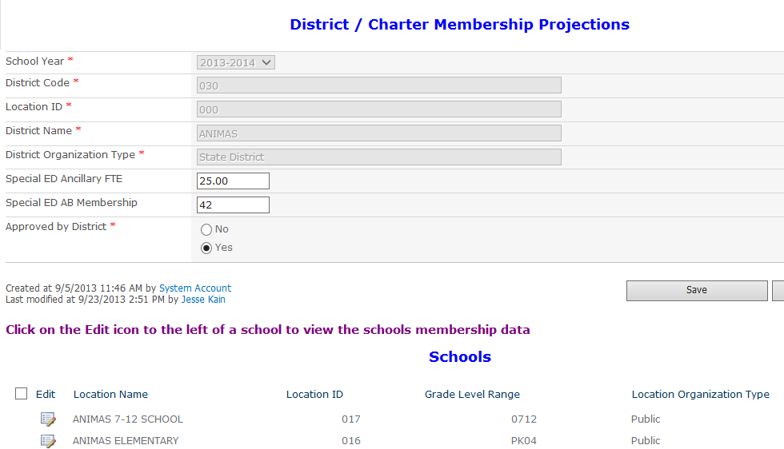

Step 5 – Click on the Edit Icon to select a school to enter Membership.

Step 6 – Select Grade.

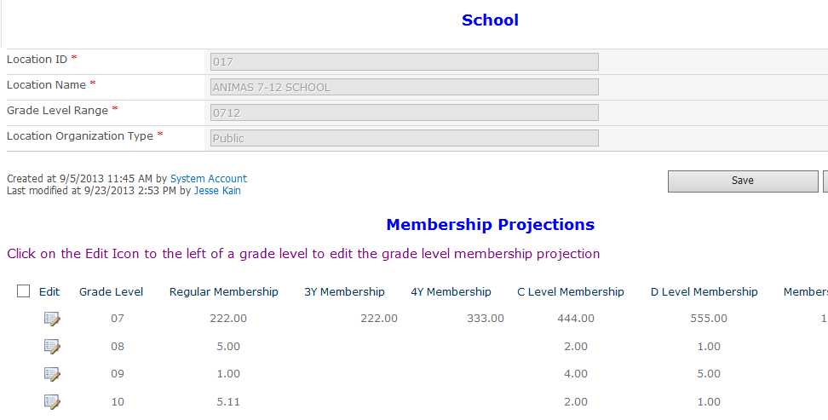

Step 7 – Enter Grade Membership.
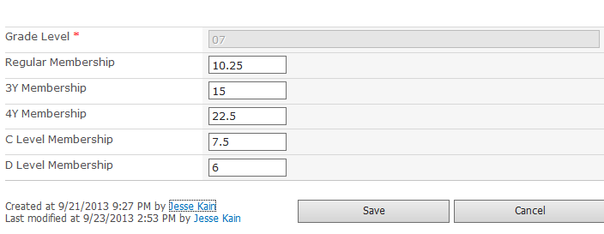

Click Save after entering the data.

Step 8 – Repeat steps 6 and 7 until all grades have been entered.

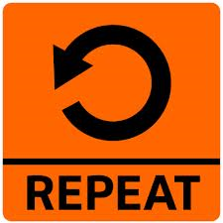

Step 9 - Click on Save to return to the list of schools.

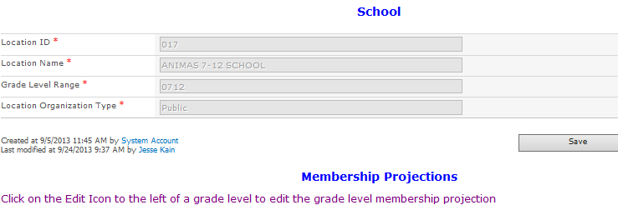

Step 10 – Repeat steps 5 thru 9 until all Schools have been entered.

Step 11 – Approve Projected Membership.

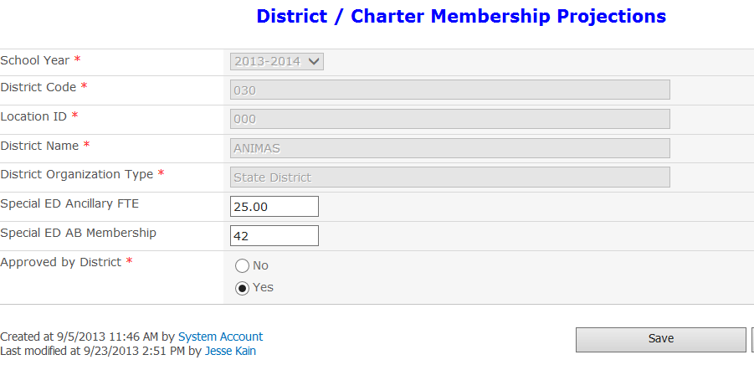
Approving the report will automatically send an email to PED (and copy you), which will initiate the review process.

Step 12 – Save the Membership.

Step 13 – Go to the report menu.

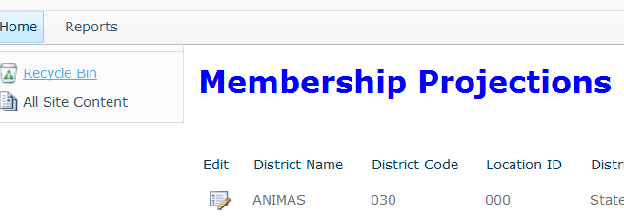

Step 14 – Run and print Certification Report.

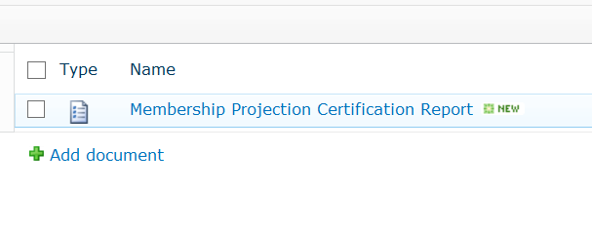
Click on the report name to run the report.

Step 15 – Select Year and District.

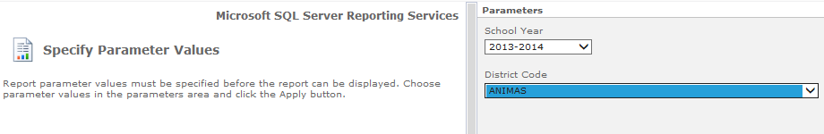

Step 16 – Run the report.

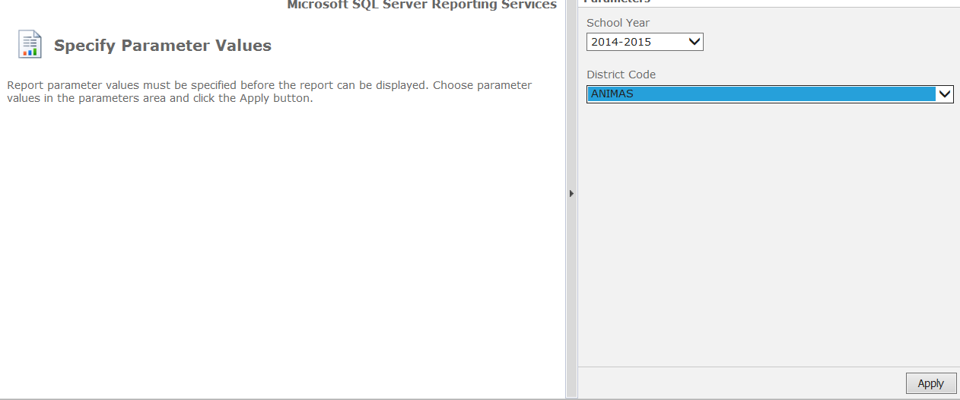

Step 17 – To print the report, first Click on Actions. Then select Print.

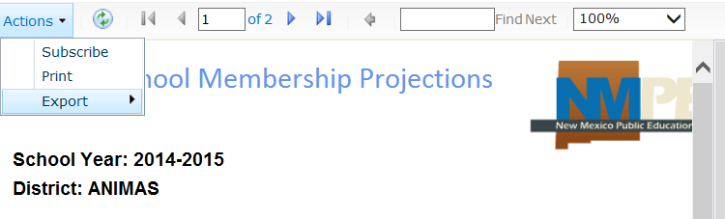

Step 18 – Click the back button on your browser to return to the site.

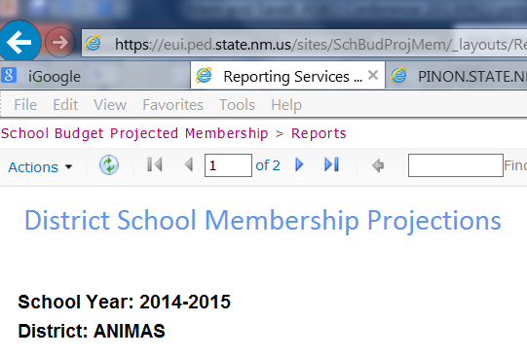

Step 19 – Sign (superintendent or designee) and scan and email the report.

