District Thought Partner Application

Application due March 15, 2019

District Thought Partner: Charged with collaborating with district superintendents and cabinet level leaders to align or create systems to better differentiate support for schools.
Continuation of the PPE Year 7 selections process in spring 2019 and the program in SY 2019-20 is pending continued legislative funding.

Application Process:

- By midnight on Friday, March 15, 2019: Scan and submit complete application by email to ppe.ped@state.nm.us. Only complete applications will be reviewed.

- Selected applicants will be invited to participate in a 75-minute competency-based interview.

- Applicants will be notified of selection decisions in late May.

- All new District Thought Partners must attend a regional PPE Cohort 7 Induction event, dates TBD in summer 2019.

Application Materials & Submission Guidelines:

To be considered for the District Thought Partner role in Principals Pursuing Excellence, submit a complete application that includes all of the items listed below. Only complete applications will be reviewed.

- Letter of Intent (500 words)
  - In a professionally formatted cover letter, please explain why you want to become a PPE district thought partner, how you hope to develop as a leader, and describe what experiences have specifically prepared you to take on this role.

- Application Form (Attachment A)

- Essay Question (500 words)
  - Turnaround principals must have an urgent desire to set challenging goals and reach a high standard of performance despite barriers. What characteristic(s) do you believe to be most important to the success of a school-level turnaround leader? Explain your reasoning and describe how you have demonstrated the characteristic(s) in your professional life.

- Current resume

- Scanned copy of New Mexico Level 3-B License
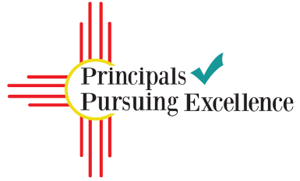

Principals Pursuing Excellence is a two-year program aimed at leveraging the expertise of New Mexico’s educational leaders to support and empower New Mexico’s school leaders as they work to dramatically improve student outcomes in their schools.

PPE is…
- Focused on building leadership capacity in New Mexico’s schools and districts
- Multilayered professional learning and coaching for school and district leaders

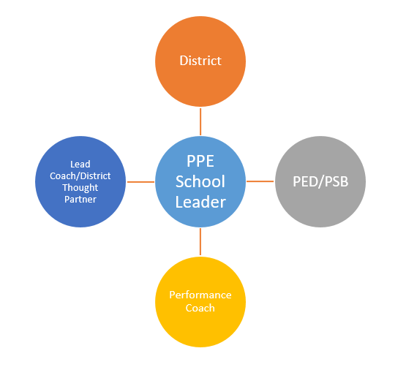
Project Structure:
With the support of the district, Performance Coach and Lead Coach/District Thought Partner, each School Leader works with their core team to assess school needs based on data and establish an Annual and 90-day Plan containing effective turnaround strategies (e.g. data-driven instruction, school culture of learning, observation and feedback).

To support successful implementation and monitoring of the school’s 90-day Plan, each School Leader principal receives ongoing coaching and mentoring during monthly onsite visits and frequent check-ins.

All roles, including superintendents and district leadership, participate in executive education convenings to further cultivate the competencies and skills of turnaround leaders.

The Theory of Action that underpins Principals Pursuing Excellence follows:

If we strengthen the competencies of leaders to transform districts and schools, then they will have the capacity to take bold and purposeful action.

If leaders take bold and purposeful action, then they will establish the conditions for effective teaching and learning.

If the conditions for effective teaching and learning are established, then teachers will have the opportunity to improve instructional practice.

If teachers improve instructional practice, then student learning will increase.

District Thought Partner Expectations:

EXTERNAL DTPs
- First semester only
  - 1 onsite visit and meeting with each assigned district by the end of October of each school year (1/2 day)

- Over course of year
  - Visit each participating school once, in collaboration with other PPE roles and PSB.

- Monthly/bimonthly minimums (new or transitioning/established)
  - Check-in with district PPE team (required) and Lead Coach (optional) (15-30 minutes)
  - Connect with assigned Lead Coach for each district (15-30 minutes)
  - Check-in conversation with PSB lead

- Ongoing practices
  - Track data on shifts in district-level thinking and practice
  - Reflect on impact of coaching actions and adjust/differentiate as needed to accelerate development

- Periodic expectations
  - Fully participate in PPE convenings and other required events
  - Engage in collaborative visits organized by Priority Schools Bureau (PSB)
  - Participate in regular program check-ins by phone, Zoom, or in-person (time dependent on meeting format, 30 min to half day)

INTERNAL DTPs
- Each semester
  - Visit each participating school once, in collaboration with other PPE roles and PSB.

- Monthly minimums
  - Schedule and facilitate monthly planning and updates meetings with superintendent and relevant cabinet level staff (30 – 60 minutes)
  - Check-in with district PPE team and Lead Coach (30 minutes)
  - Check-in conversation with PSB lead

- Ongoing practices
  - Track data on shifts in district-level thinking and practice
  - Reflect on impact of coaching actions and adjust/differentiate as needed to accelerate development

- Periodic expectations
  - Fully participate in PPE convenings and other required events
  - Engage in collaborative visits organized by Priority Schools Bureau (PSB)
  - Participate in regular program check-ins by phone, Zoom, or in-person (time dependent on meeting format, 30 min to half day)

Attachment A: District Thought Partner Application Form
Name:

Email address:

Cell phone:

Work phone:

Current position:

Organization:

Turnaround Leadership Competencies: A Presentation by the West Comprehensive Center. http://ped.state.nm.us/ped/PrioSchoolsDocs/Turnaround_Leadership_Competencies_PDF_of_power_point.pdf

