Lead Coach Application

Application due March 15, 2019

Lead Coach: Charged with providing support to and foster collaboration among for performance coaches in regional groups, as well as holding performance coaches accountable to high impact support to school leaders.
Continuation of the PPE Year 7 selections process in spring 2019 and the program in SY 2019-20 is pending continued legislative funding.

Application Process:

Note: Current PPE performance coaches are eligible to apply as Lead Coaches.

- By midnight on Friday, March 15, 2019: Scan and submit complete application by email to ppe.ped@state.nm.us. Only complete applications will be reviewed.

- Selected applicants will be invited to participate in a 75-minute competency-based interview.

- Applicants will be notified of selection decisions in late May.

- All new Lead Coaches must attend a regional PPE Cohort 7 Induction event, dates TBD in summer 2019.

Application Materials & Submission Guidelines:

To be considered for the Lead Coach role in Principals Pursuing Excellence, submit a complete application that includes all of the items listed below. Only complete applications will be reviewed.

- Letter of Intent (500 words)
  - In a professionally formatted cover letter, please explain why you want to become a PPE lead coach, how you hope to develop as a leader, and describe what experiences have specifically prepared you to take on this role.

- Application Form (Attachment A)

- Essay Question (500 words)
  - Turnaround principals must have an urgent desire to set challenging goals and reach a high standard of performance despite barriers. What characteristic(s) do you believe to be most important to the success of a school-level turnaround leader? Explain your reasoning and describe how you have demonstrated the characteristic(s) in your professional life.

- Current resume

- Scanned copy of New Mexico Level 3-B License

Principals Pursuing Excellence is a two-year program aimed at leveraging the expertise of New Mexico’s educational leaders to support and empower New Mexico’s school leaders as they work to dramatically improve student outcomes in their schools.

PPE is…
- Focused on building leadership capacity in New Mexico’s schools and districts
- Multilayered professional learning and coaching for school and district leaders

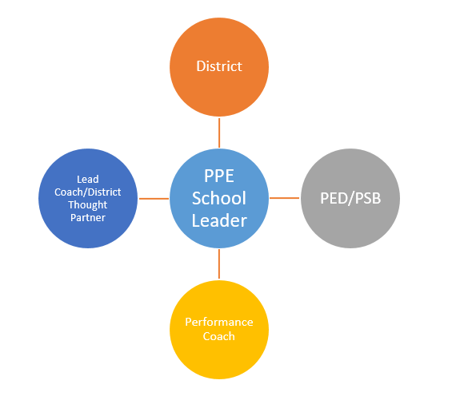
Project Structure:
With the support of the district, Performance Coach and Lead Coach/District Thought Partner, each School Leader works with their core team to assess school needs based on data and establish an Annual and 90-day Plan containing effective turnaround strategies (e.g. data-driven instruction, school culture of learning, observation and feedback).

To support successful implementation and monitoring of the school’s 90-day Plan, each School Leader principal receives ongoing coaching and mentoring during monthly onsite visits and frequent check-ins.

All roles, including superintendents and district leadership, participate in executive education convenings to further cultivate the competencies and skills of turnaround leaders.

The Theory of Action that underpins Principals Pursuing Excellence follows:

If we strengthen the competencies of leaders to transform districts and schools, then they will have the capacity to take bold and purposeful action.

If leaders take bold and purposeful action, then they will establish the conditions for effective teaching and learning.

If the conditions for effective teaching and learning are established, then teachers will have the opportunity to improve instructional practice.

If teachers improve instructional practice, then student learning will increase.

Lead Coach Expectations:

- First semester only
  - For new Performance Coaches, plan and execute 1-2 modeling, collaborative, and/or observational onsite coaching visits during the first semester (continue as needed)

- Monthly minimums
  - Plan and execute monthly check-in conversations with PCs (15-30 minutes each)
  - Engage in monthly check-in conversation with PSB lead (15-30 minutes)

- Semester minimums
  - Plan and facilitate learning team meetings 2 times each semester, once in person and once remotely (i.e. 1 30 min team phone call for PCs, collaboratively with their performance coaches bring school leaders together for a half day of discussion and lunch, etc.)

- Ongoing practices
  - Track data on school leader growth in leadership competencies and in implementation of instructional leadership levers
  - Track data on PC growth in coaching skills
  - Reflect on impact of coaching actions and adjust/differentiate as needed to accelerate development
  - Engage in cycles of feedback focused on increasing the efficacy of each PC, new or returning

- Periodic expectations
  - Fully participate in PPE convenings and other required events
  - Engage in collaborative visits organized by Priority Schools Bureau (PSB)
  - Participate in regular program check-ins by phone, Zoom, or in-person (time dependent on meeting format, 30 min to half day)

Attachment A: Lead Coach Application Form
Name:

Email address:

Cell phone:

Work phone:

Current position:

Organization:

Turnaround Leadership Competencies: A Presentation by the West Comprehensive Center. http://ped.state.nm.us/ped/PrioSchoolsDocs/Turnaround_Leadership_Competencies_PDF_of_power_point.pdf

