Performance Coach Application

Application due March 15, 2019

Performance Coach: Charged with prioritizing the instructional leadership development of a small portfolio of school leaders through performance-based coaching.
Continuation of the PPE Year 7 selections process in spring 2019 and the program in SY 2019-20 is pending continued legislative funding.

Application Process:

- By midnight on Friday, March 15, 2019: Scan and submit complete application by email to ppe.ped@state.nm.us. Only complete applications will be reviewed.

- Selected applicants will be invited to participate in a 75-minute competency-based interview.

- Applicants will be notified of selection decisions in late May.

- All new Performance Coaches must attend a regional PPE Cohort 7 Induction event, dates TBD in summer 2019.

Application Materials & Submission Guidelines:

To be considered for the Performance Coach role in Principals Pursuing Excellence, submit a complete application that includes all of the items listed below. Only complete applications will be reviewed.

- Letter of Intent (500 words)
  - In a professionally formatted cover letter, please explain why you want to become a PPE performance coach, how you hope to develop as a leader, and describe what experiences have specifically prepared you to coach school leaders attempting turnaround.

- Application Form (Attachment A)

- Essay Question (500 words)
  - Turnaround principals must have an urgent desire to set challenging goals and reach a high standard of performance despite barriers. What characteristic(s) do you believe to be most important to the success of a school-level turnaround leader? Explain your reasoning and describe how you have demonstrated the characteristic(s) in your professional life.

- Current resume

- Scanned copy of New Mexico Level 3-B License

Principals Pursuing Excellence is a two-year program aimed at leveraging the expertise of New Mexico’s educational leaders to support and empower New Mexico’s school leaders as they work to dramatically improve student outcomes in their schools.

PPE is…
- Focused on building leadership capacity in New Mexico’s schools and districts
- Multilayered professional learning and coaching for school and district leaders

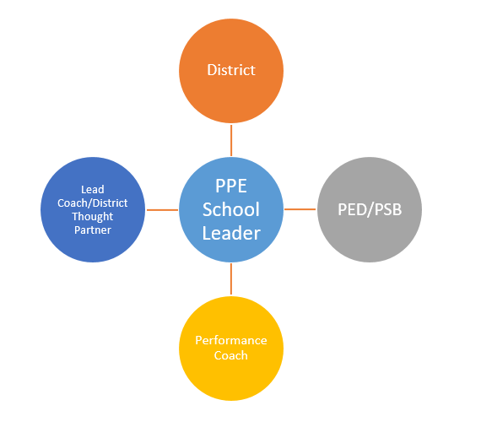
Project Structure:
With the support of the district, Performance Coach and Lead Coach/District Thought Partner, each School Leader works with their core team to assess school needs based on data and establish an Annual and 90-day Plan containing effective turnaround strategies (e.g. data-driven instruction, school culture of learning, observation and feedback).

To support successful implementation and monitoring of the school’s 90-day Plan, each School Leader principal receives ongoing coaching and mentoring during monthly onsite visits and frequent check-ins.

All roles, including superintendents and district leadership, participate in executive education convenings to further cultivate the competencies and skills of turnaround leaders.

The Theory of Action that underpins Principals Pursuing Excellence follows:

If we strengthen the competencies of leaders to transform districts and schools, then they will have the capacity to take bold and purposeful action.

If leaders take bold and purposeful action, then they will establish the conditions for effective teaching and learning.

If the conditions for effective teaching and learning are established, then teachers will have the opportunity to improve instructional practice.

If teachers improve instructional practice, then student learning will increase.

Performance Coach Expectations:

- Monthly
  - 1 onsite coaching visit (2-3 hours)
  - 1 monthly virtual coaching call, e.g. Zoom or phone (15-30 minutes)
  - Check-in conversation with lead coach (15-30 minutes)

- Ongoing practices
  - Track data on school leader growth in leadership competencies and in implementation of instructional leadership levers
  - Reflect on impact of coaching actions and adjust/differentiate as needed to accelerate development

- Periodic expectations
  - Fully participate in PPE convenings and other required events
  - Engage in collaborative visits organized by Priority Schools Bureau (PSB)
  - Participate in regular program check-ins by phone, Zoom, or in-person (time dependent on meeting format, 30 min to half day)

Attachment A: Performance Coach Application Form
Name:

Email address:

Cell phone:

Work phone:

Current position:

Organization:

Have you previously applied for PPE? Yes / No

How did you hear about PPE? If someone referred you, please indicate whom.

Turnaround Leadership Competencies: A Presentation by the West Comprehensive Center. http://ped.state.nm.us/ped/PrioSchoolsDocs/Turnaround_Leadership_Competencies_PDF_of_power_point.pdf

