Text: New Mexico Public Education DepartmentCommunity Schools Act

Community Schools Implementation Grant Application

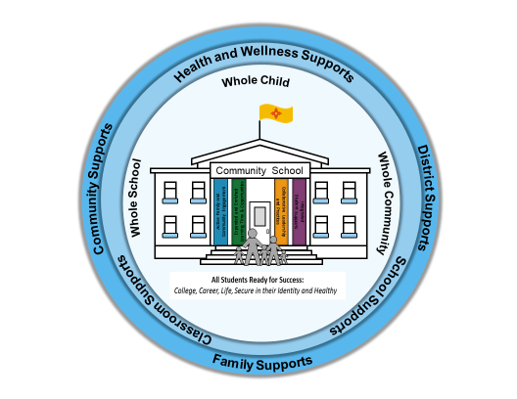

Released: July 22, 2019 Due: August 30, 2019

**Application Submission**

Applications along with any attachments must be submitted no later than 5:00 p.m. on August 30, 2019 to:

[NMcommunity.schools@state.nm.us](mailto:NMcommunity.schools@state.nm.us)

When attaching data with your application submission, please label the data according to the question(s) the data is responsive to. For example: Question Number One (1) under the Planning Grant Narrative should be labeled PGN_1.

Clearly label the needs assessment and asset map for each eligible public school. For example: needs_assessment_Mesa_ES.

If you have any questions regarding the application process, please contact:

Feliz Garcia, Deputy Director for Community Schools

[FelizE.Garcia@state.nm.us](mailto:FelizE.Garcia@state.nm.us) (505) 827-3572

The Public Education Department’s Community School’s Website includes information and resources [click here](https://webnew.ped.state.nm.us/bureaus/community-schools/).

***Background*:**

Governor Michelle Lujan Grisham put together a plan for education in New Mexico. *“A New Direction for New Mexico Schools”* includes eleven (11) focus areas needed in order for New Mexico’s students to achieve their very best.

1. Funding the education system we need and our children deserve.
2. Make universal access to quality Pre-K a reality for every New Mexico family.
3. Give our students 21st Century Skills and enhance career technical education programs.
4. Improve graduation rates.
5. Pay our principals, teachers, and educational personnel more.
6. Limit school testing and use qualitative data to track student and school achievement.
7. Create a fair and balanced system of accountability.
8. *Engage families, communities, and students as substantive partners.*
9. Make sure every student in public school has an equal opportunity to learn and get ahead.
10. Make certain New Mexico’s American Indian populations are well served by the state’s education system.
11. Prepare every student for success in college or a career.

One way in which to engage families, communities and students as essential partners in our public schools is through the expansion of the community schools model. A community school is an integration of services focused on academic, health and social services, youth and community development, and community engagement which leads to improved student learning, stronger families and healthier communities. On April 3, 2019, Governor Michelle Lujan Grisham signed House Bill 589, the amended Community Schools Act, into law.

New Mexico’s Community Schools Act

The Community Schools Act provides a strategy to organize the resources of a community to ensure student success while addressing the needs, including cultural and linguistic needs, of the whole student from early childhood programs and voluntary public pre-kindergarten through high school graduation. The Community Schools Act encourages federal, state and local and tribal governments to work with community-based organizations to improve the coordination, delivery, effectiveness and efficiency of services provided to students and families and to coordinate resources, in order to align and leverage community resources and integrate funding streams.

***Funding*:**

The General Appropriation Act of 2019 provides the Public Education Department (PED) with $2 million in state funding for community school initiatives in New Mexico. Funds for community school initiatives shall be used to establish, expand or support community school initiatives pursuant to Section [22-32-4](https://codes.findlaw.com/nm/chapter-22-public-schools/nm-st-sect-22-32-4.html), NMSA 1978.

Annual implementation grants of $150,000 each year for a period of three years are available through an application process for each **eligible public school**. Implementation grants must address the **four pillars of the community schools**: 1) Integrated Student Supports, 2) Expanded and Enriched Learning Time and Opportunities, 3) Active Family and Community Engagement and 4) Collaborative Leadership and Practices. Implementation of the community school framework may include the broader use of public school facilities in which school buildings become hubs of student and family supports.

Established community schools that have been implementing an **evidence-based** community school framework may apply for an annual implementation grant without having to first apply for a planning grant. However, established community schools will still be required to complete the application, provide documentation of a completed **needs assessment** and **asset map** and provide documentation of an established **community-wide leadership team** and **site-based leadership team**.

Each eligible and funded community school site will need to update the “Breakdown of Requested Funding Worksheet” and other applicable sections of the application on an annual basis.

At the conclusion of the initial three-year grant period, applicants may apply for a renewal grant for one year in an amount determined by the PED, subject to availability of funding.

***Eligibility:***

Subject to the availability of funding, grants for community schools initiatives are available for a school district, a group of public schools (**consortium of schools**), or a single public school that has a demonstrated partnership with the local community to establish, operate, and sustain the **community school framework**. A school district that wishes to apply does not have to include all schools within the district in its application in order to be eligible for funding. It is possible that not all schools included in the school district’s or consortium of school’s application will be funded.

An **eligible public school** means any of the following:

* A public elementary or secondary school that: has a student body where at least forty percent of students are eligible for free or reduced-price lunch pursuant to the Richard B. Russell National School Lunch Act; or
* A public elementary or secondary school that has been identified as a school for comprehensive or targeted support and improvement under the Elementary and Secondary Education Act of 1965; or
* A public elementary or secondary that has otherwise been identified by the state as in need of additional support. Schools in need of additional support are struggling in the areas of academic proficiency in English Language Arts, math and/or science, attendance, graduation rates, drop-out rates and/or parent/family engagement.

Depending upon the demand for funding, priority for awards is for schools identified as needing **comprehensive support and improvement (CSI)** and **targeted support and improvement (TSI)** under the Every Student Succeeds Act (ESSA). If schools identified as CSI or TSI are part of the school district’s or consortium of school’s application and funding is limited, the CSI and TSI schools may be the only eligible applicants that receive funding.

In the event that a school applies for funding, but is not identified as CSI or TSI, yet it does have at least forty percent of students eligible for free or reduced-price lunch, it may still qualify for funding. The school must demonstrate through the application process that it is in need of additional support, which may be in any of the following areas: academic proficiency in English Language Arts, math and/or science, attendance, graduation rates, drop-out rates, and/or parent/family engagement.

***Evidence-based Community School Framework:***

The community school framework shall ensure the use of evidence-based interventions, programs or strategies and best practices that support students, families and communities in ensuring student success.

**Evidence-based interventions included in the ESSA** are practices or programs that have been proven effective in producing results and improving outcomes. The kind of evidence described in ESSA has generally been produced through formal studies and research. Under ESSA, there are four tiers, or levels, of evidence:

|  |  |  |  |
| --- | --- | --- | --- |
| **CATEGORY ONE:**  *Demonstrates a statistically significant  effect on improving student  outcomes or other relevant outcomes.*  **Tier 2**  **Tier 1**  **Tier 3**  **Tier 4** | | | **CATEGORY TWO:**  *Demonstrates a rationale based on high-quality research findings or positive evaluation that such activity, strategy, or intervention is likely to improve student outcomes or other relevant outcomes.* |
| **STRONG  EVIDENCE** | **MODERATE EVIDENCE** | **PROMISING EVIDENCE** | **“STRONG THEORY”** |
| *Based on at least 1 well-designed and well-implemented experimental study.* | *Based on at least 1 well-designed and well-implemented quasi-experimental study.* | *Based on at least 1 well-designed and well-implemented correlational study with statistical controls for selection bias.* | *Includes ongoing efforts to examine the effects of such activity, strategy, or intervention.* |

*Policy Brief ESSA and Evidence: Why it Matters*

In December 2017, The Learning Policy Institute published *“Community Schools as an Effective School Improvement Strategy: A Review of the Evidence,* [click here](https://learningpolicyinstitute.org/product/community-schools-playbook). The report reviewed 143 studies representing a broad range of research methods. The studies included in this publication are classified according to the ESSA tiers and include studies pertaining to the four pillars of community schools. This information will support you when developing your community school plan. The publication also includes many evidence-based interventions which you will need to include when completing the application for funding. The breakdown is listed in the table below.

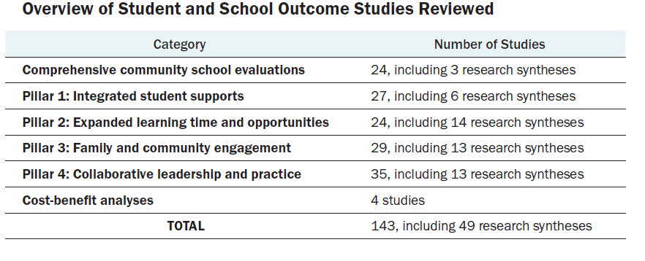

Applicants are encouraged to review the studies before selecting an intervention and completing the application.

The Learning Policy Institute and the National Education Policy Center put together a policy brief “*Community Schools: An Evidence-Based Strategy For Equitable School Improvement”* [click here](https://learningpolicyinstitute.org/sites/default/files/product-files/Community_Schools_Evidence_Based_Strategy_BRIEF.pdf)*.* The brief summarizes the review of the evidence conducted above and concluded that based upon the research, well-implemented community schools and the four pillars provide a strong justification as to how community schools can support school improvement.

State law requires that the implementation of the community school framework ensure the use of research- and evidenced-based strategies. State funding received through the Community Schools Act is to be used to transform a public school into an evidence-based community school. Although the evidence-based strategies do not have to meet the ESSA Tiers of Evidence, it is recommended that the evidence-based interventions, programs and practices selected meet the ESSA criteria. The Learning Policy Institute in collaboration with National Education Policy Center published an online research compendium *“Community Schools: An Evidence-Based Strategy for Equitable School Improvement”* [click here](https://learningpolicyinstitute.org/product/online-research-compendium)which can assist youin selecting the evidence-based intervention, programs and practices that work best for your school and community.

***Community School Staffing:***

At each eligible public school applying for an implementation grant, the **lead partner agency** shall employ a **community school coordinator** to:

* Implement the community school framework.
* Lead the needs and assets assessment.
* Facilitate communication between partners as a stakeholder- and community-driven approach to problem solving.
* Guide data-informed continuous improvement.
* Manage data collection.
* Align, leverage and coordinate resources for student and family success.

State law requires that grantees receiving funds to implement the **community schools initiative,** as a consortium in three or more public school sites, work with the school district in order to employ a **community schools director or manager.** The community schools director or manager shall oversee and coordinate implementation across all of the eligible school sites and ensure the employment of a community school coordinator by the lead partner agency at each school site.

***Fiscal Considerations:***

A school district shall bear any indirect costs associated with the establishment and implementation of a **community school** within the school district.

State law requires that a community school shall be given sufficient operational flexibility by its district in programming (school-wide Title I programs), curriculum (community based learning), staffing (use of Title I teachers and reading or math specialists), budgeting (site-based budgeting) and scheduling (begin school day later or end school day later). This flexibility is necessary so that the community school can fully implement a comprehensive community school framework designed to focus on improving school climate, student academic achievement, attendance, behavior, family engagement and for high schools graduation rates and readiness for college or a career.

***Application Review and Approval:***

Applications will be reviewed by the PED and the **Coalition for Community Schools** (CCS) in order to ensure equitable distribution of resources to all school districts in New Mexico. The CCS will provide PED with recommendations for awards.

*terms **bolded** are defined in the glossary of terms

**Glossary of Terms**

**“Asset mapping”** means an assessment of the community including organizations, people, partnerships, facilities, funding, and policies. An asset assessment provides information about the strengths and resources of a community.

**“Coalition for community schools”** means a statewide coalition of community schools, members of their site-based leadership teams, foundations, businesses and other organizations including unions, cultural and linguistic experts and tribal leaders, who have joined together to advocate for and support the development of community schools across New Mexico in alignment with an evidence-based community school framework.

**“Community-based learning”** or CBL means a model that grounds student learning in civic engagement and addresses real world community issues. CBL is interdisciplinary in nature and deepens the purposeful connection between neighborhoods and schools. The goal of a community-based curriculum is to strengthen and galvanize the assets of families, school educators, and local community members to work collaboratively to enrich and expand student learning. The curriculum centers on local institutions, history, knowledge, language, literature, culture, and environments and aligns with scientific discoveries about how sociocultural factors and the structure of learning environments influence learning.

**“Community-based organization”** means a public or private nonprofit organization of demonstrated effectiveness that is representative of a community or significant segments of a community and provides educational or related services to individuals in the community.

**“Community school”** means a public school that partners with families and the community, including tribal partners, nonprofit community-based organizations and local businesses, to provide well-rounded educational opportunities and supports for student success through the implementation of a community school framework.

**“Community school coordinator”** means a full-time person employed by the lead partner agency who works within a community school as part of the site-based leadership team.

**“Community school director or manager”** means a person who oversees three or more community schools and coordinates implementation of the community schools framework across all community school sites.

**“Community school framework”** means a set of strategies implemented in a community school that include culturally and linguistically responsive instruction, programs and services and restorative practices that focus on building and maintaining relationships. The community school framework is the method by which to meet the implementation of the community school initiative.

**“Community school initiative”** means the implementation of the community school framework to provide comprehensive or targeted and improvement activities pursuant to the federal Every Student Succeeds Act (ESSA).

**“Community school plan”** means a team that includes the site-based leadership team, families, community partners, tribal partners, nonprofit organizations, and unions that guides collaborative planning, site-based budgeting, and implementation of the community school framework.

**“Community-wide leadership team”** means a team at the local education agency level that is responsible for guiding the visions, policy, resources alignment, oversight of implementation and goal-setting for community school programs with a local education agency. This team shall include representatives from the local education agency, educators, teacher unions, school administrators, students and family members from eligible schools, system-level partners including community members, philanthropic organizations and local and tribal governments.

**“Comprehensive support and improvement or CSI”** means a school identified as needing intervention under the every student succeeds act, including the lowest-performing five percent of Title I schools, schools with a high school graduation rate of less than 67 percent for two out of the last three years, and schools with chronically low-performing ESSA subgroups of students.

**“Consortium of schools”** means a group of public schools or Bureau of Indian Education (BIE) schools across school districts or within a regional education cooperative.

**“Culturally and linguistically responsive”** means validating and affirming an individual’s home culture and language to create connections with other cultures and languages in various social contexts.

**“Eligible applicant”** means a single public school, school district or consortium of schools that has demonstrated partnerships with at least one non-profit organization with approval from the governing entity responsible for the local education agency.

**“Eligible public school”** means a public elementary or secondary school that has a student body where at least forty percent of students are eligible for free or reduced-price lunch pursuant to the Richard B. Russell National School Lunch Act or has been identified as a school for comprehensive or targeted support and improvement under the Elementary and Secondary Education Act of 1965 or otherwise identified by the state as in need of additional support.

**“Evidence-based interventions under ESSA”** means practices or programs that have been proven effective in producing results and improving outcomes.

**“Four pillars of community schools**” means the four pillars under 22-32-2 NMSA, 1978 necessary in order to implement a comprehensive community schools framework that includes active family and community engagement, collaborative leadership and practices, expanded and enriched learning time and opportunities and integrated student supports.

**“Lead partner agency”** means the agency that employs the community school coordinator and works collaboratively the community school coordinator, the school principal and the site-based leadership team to assess, plan and carry out the community school framework

**“Needs assessment”** means a systematic process for determining and addressing needs or gaps between current conditions and desired conditions or wants.

**“Nonprofit organization”** means an organization that is granted a tax-exempt status and is dedicated to furthering a particular social cause or advocating for a shared point of view.

“**Site-based leadership team**” means an interdisciplinary, school-based team that includes the school principal, teachers, the community school coordinator, and other school employees.

**“Targeted support and improvement or TSI”** means a school identified as needing an intervention under the Every Student Succeeds Act due to a consistently underperforming subgroup of students for a period of time.

**Community School**

**Implementation Grant Application**

New Community School(s)  Established Community School(s)

Contact Information:

|  |  |
| --- | --- |
| Name of Person Completing Application: |  |

|  |  |
| --- | --- |
| Title: |  |

|  |  |
| --- | --- |
| School District or Organization: |  |

|  |  |
| --- | --- |
| Email: |  |

|  |  |
| --- | --- |
| Phone Number: |  |

Type of Application:

A single public school, consortium of schools or a school district that has demonstrated partnership with at least one community-based organization can apply for an implementation grant. Bureau of Indian Education (BIE) schools can apply for funding as part of a consortium of schools. Fill out only the applicable section; for example, if you are applying as a consortium of schools, complete that section only.

Check CSI if the school has been identified as comprehensive support and improvement and TSI if the school has been identified as targeted support and improvement. N/A means that the school has not been identified as CSI or TSI.

A. Single School Application

|  |  |
| --- | --- |
|  | Single Public School |

|  |  |  |  |  |
| --- | --- | --- | --- | --- |
| CSI | TSI | NA | School Name: |  |

|  |  |
| --- | --- |
| District Name: |  |

B. Consortium of Schools Application

A consortium of schools means a group of public schools across school districts or within a regional education cooperative (REC).

|  |  |
| --- | --- |
| School district or REC serving as fiscal agent: |  |

Bureau of Indian Education (BIE) schools can apply for funding through the consortium of schools but cannot serve as the fiscal agent.

List of eligible schools in the consortium--within the district, REC or across districts—for which you are applying:

|  |  |  |  |  |  |
| --- | --- | --- | --- | --- | --- |
|  |  |  | Name of School: |  | District Name (Indicate BIE if applicable): |
| CSI | TSI | NA |  |  |  |
| CSI | TSI | NA |  |  |  |
| CSI | TSI | NA |  |  |  |
| CSI | TSI | NA |  |  |  |
| CSI | TSI | NA |  |  |  |
| CSI | TSI | NA |  |  |  |
| CSI | TSI | NA |  |  |  |
| CSI | TSI | NA |  |  |  |
| CSI | TSI | NA |  |  |  |
| CSI | TSI | NA |  |  |  |
| CSI | TSI | NA |  |  |  |
| CSI | TSI | NA |  |  |  |
| CSI | TSI | NA |  |  |  |
| CSI | TSI | NA |  |  |  |
| CSI | TSI | NA |  |  |  |
| CSI | TSI | NA |  |  |  |
| CSI | TSI | NA |  |  |  |
| CSI | TSI | NA |  |  |  |
| CSI | TSI | NA |  |  |  |
| CSI | TSI | NA |  |  |  |
| CSI | TSI | NA |  |  |  |

C. School District Application

|  |  |
| --- | --- |
|  | School District |

|  |  |
| --- | --- |
| School District Name: |  |

List of eligible schools within the School District for which you are applying:

|  |  |  |  |
| --- | --- | --- | --- |
|  |  |  | Name of School: |
| CSI | TSI | NA |  |
| CSI | TSI | NA |  |
| CSI | TSI | NA |  |
| CSI | TSI | NA |  |
| CSI | TSI | NA |  |
| CSI | TSI | NA |  |
| CSI | TSI | NA |  |
| CSI | TSI | NA |  |
| CSI | TSI | NA |  |
| CSI | TSI | NA |  |
| CSI | TSI | NA |  |
| CSI | TSI | NA |  |
| CSI | TSI | NA |  |
| CSI | TSI | NA |  |
| CSI | TSI | NA |  |
| CSI | TSI | NA |  |
| CSI | TSI | NA |  |
| CSI | TSI | NA |  |
| CSI | TSI | NA |  |
| CSI | TSI | NA |  |
| CSI | TSI | NA |  |
| CSI | TSI | NA |  |
| CSI | TSI | NA |  |
| CSI | TSI | NA |  |
| CSI | TSI | NA |  |
| CSI | TSI | NA |  |

**Community School Plan Narrative**

**State of the Community School(s) (STORY)**

1. Tell the story about your community school(s). Talk about how you will use the $150,000. in state funding to expand and sustain the community school(s).

|  |
| --- |
|  |

**Required Activities for the Community Schools Plan**

In accordance with 22-32-2 NMSA, 1978, implementation of the community school framework shall include the four pillars of community schools (Integrated Student Supports, Expanded Learning Time and Opportunities, Active Family and Community Engagement and Collaborative Leadership and Practice). Selection of interventions must support the 5 or 6 indicators (school culture and climate, student academic achievement, student attendance, student behavior, quality family engagement and for high schools graduation rates and readiness for college and career). When responding to each pillar, be sure to document how the selection of an intervention connects and relates to the school’s needs assessment, asset map, site-based leadership team recommendations, community-wide leadership team recommendations, visioning process and listening session(s).

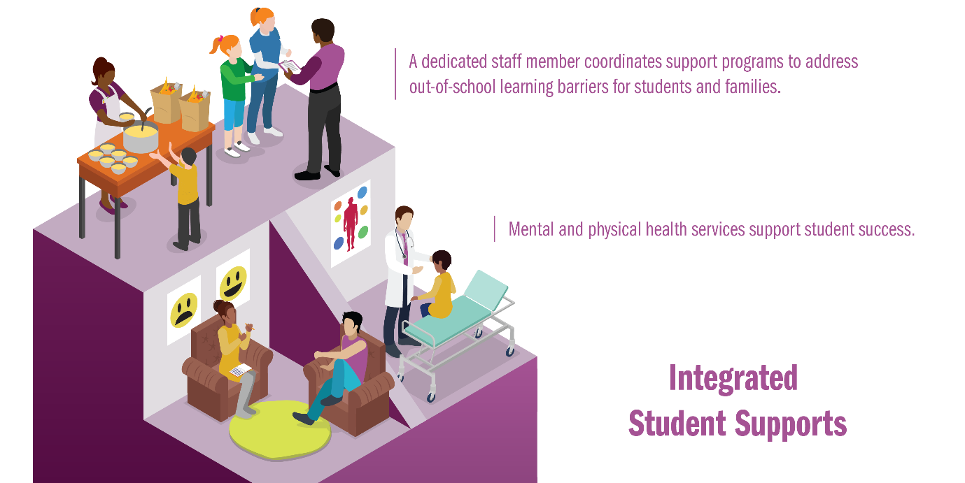

*Integrated Student Supports* (ISS)address non-academic and out-of-school barriers to learning through partnerships with social and health services agencies and providers that may include school-based or school-linked health care, case management services and family stability supports coordinated by a community school coordinator that are **culturally and linguistically responsive.**

Selection of the intervention(s) must relate back to the school(s) needs assessment, asset map, vision and input from the community through listening sessions and data collection.

Describe how each eligible public school will address Integrated Student Supports.

* What interventions, programs, or practices will you employ?
* What are the expected outcomes?
* Why do you believe the interventions, programs, or practices will achieve these expected outcomes?

Note: In answering the last question, please discuss any evidence drawn from existing research, as described on pages 3 and 4, or from local data or research associated with your prior community school work. Examples of evidence-based integrated student supports can be found [here](https://learningpolicyinstitute.org/sites/default/files/product-files/Community_Schools_Effective_REPORT.pdf).

1. (ISS 1) What interventions, programs, or practices will you employ?

|  |
| --- |
|  |

1. (ISS 2) What are the expected outcomes?

|  |
| --- |
|  |

1. (ISS 3) Why do you believe the interventions, programs, or practices will achieve these expected outcomes? Please discuss any evidence drawn from existing research, as described on pages 3 and 4, or from local data or research associated with your prior community school work.

|  |
| --- |
|  |

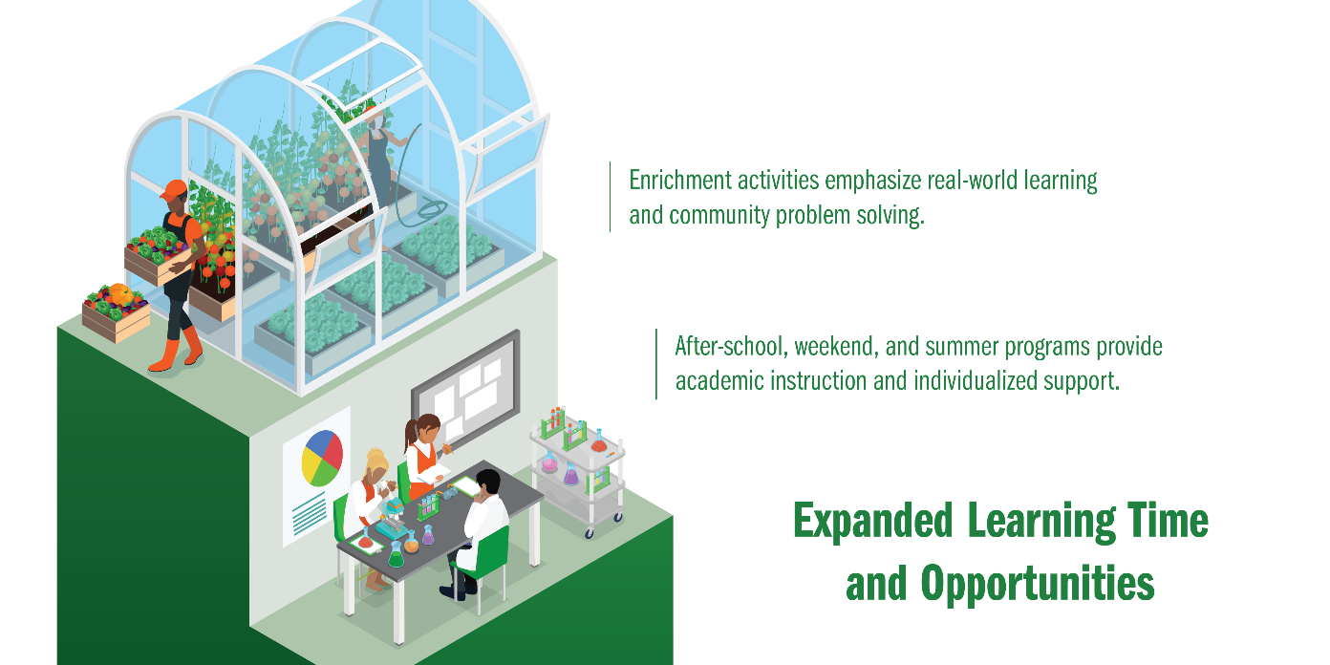

*Expanded and Enriched Learning Time and Opportunities* (EELTO) include before-school, after-school, weekend, summer and year-round programs that provide additional academic support, enrichment activities and other programs that may be offered in partnership with **community-based organizations** to enhance academic learning, social skills, emotional skills and life skills aligned with the school’s curriculum. Partnerships can also include institutions of higher education, health-care providers, businesses and other community -based organizations.

Selection of the intervention(s) must relate back to the school(s) needs assessment, asset map, vision and input from the community through listening sessions and data collection.

Describe how each eligible public school will address Expanded Learning time and Opportunities.

* What interventions, programs, or practices will you employ?
* What are the expected outcomes?
* Why do you believe the interventions, programs, or practices will achieve these expected outcomes?

Note: In answering the last question, please discuss any evidence drawn from existing research, as described on pages 3 and 4, or from local data or research associated with your prior community school work. Examples of evidence-based expanded and enriched learning time and opportunities can be found [here](https://learningpolicyinstitute.org/sites/default/files/product-files/Community_Schools_Effective_REPORT.pdf).

1. (EELTO 1) What interventions, programs, or practices will you employ?

|  |
| --- |
|  |

1. (EELTO 2) What are the expected outcomes?

|  |
| --- |
|  |

1. (EELTO 3) Why do you believe the interventions, programs, or practices will achieve these expected outcomes? Please discuss any evidence drawn from existing research, as described on pages 3 and 4, or from local data or research associated with your prior community school work.

|  |
| --- |
|  |

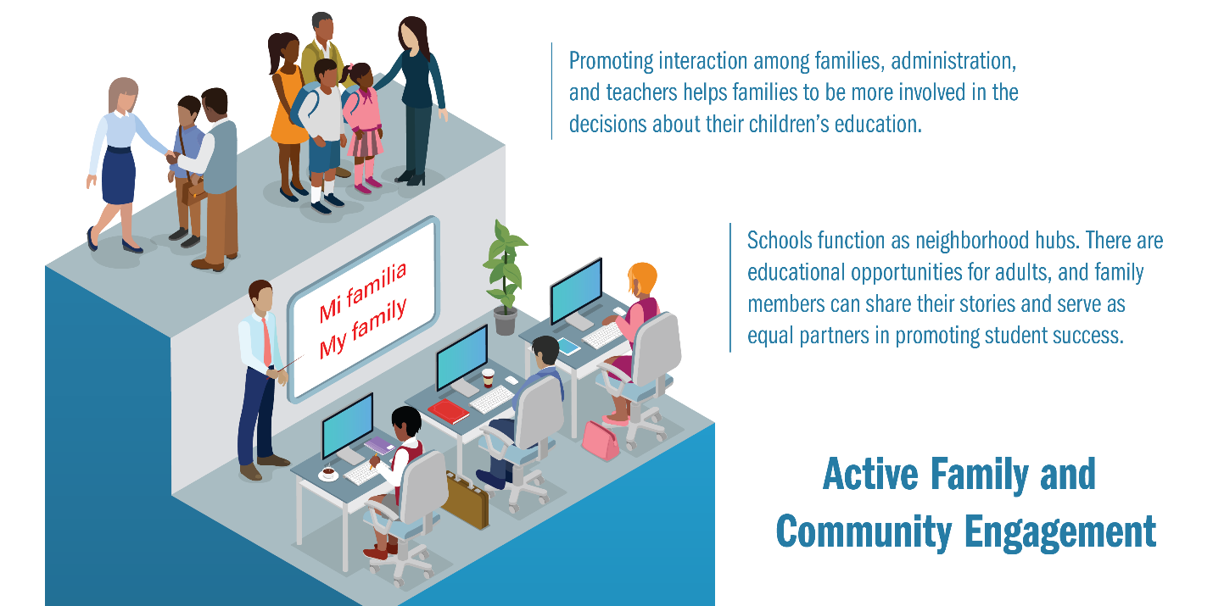

*Active Family and Community Engagement* (AFCE) values the experiences of people from diverse backgrounds as empowered partners in decision-making and encourages partnerships with parents or caregivers to develop and promote a vision for student success. Courses, activities and services are offered for parents, caregivers and community members.

Selection of the intervention(s) must relate back to the school(s) needs assessment, asset map, vision and input from the community through listening sessions and data collection.

Describe how each eligible public school will address Active Family and Community Engagement.

* What interventions, programs, or practices will you employ?
* What are the expected outcomes?
* Why do you believe the interventions, programs, or practices will achieve these expected outcomes?

Note: In answering the last question, please discuss any evidence drawn from existing research, as described on pages 3 and 4, or from local data or research associated with your prior community school work. Examples of evidence-based active and family community engagement can be found [here](https://learningpolicyinstitute.org/sites/default/files/product-files/Community_Schools_Effective_REPORT.pdf).

1. (AFCE 1) What interventions, programs, or practices will you employ?

|  |
| --- |
|  |

1. (AFCE 2) What are the expected outcomes?

|  |
| --- |
|  |

1. (AFCE 3) Why do you believe the interventions, programs, or practices will achieve these expected outcomes? Please discuss any evidence drawn from existing research, as described on pages 3 and 4, or from local data or research associated with your prior community school work.

|  |
| --- |
|  |



*Collaborative Leadership and Practice* (CLP) builds a culture of professional learning, collective trust and responsibility using strategies that, at a minimum, include a site-based leadership and a community school coordinator.

Selection of the intervention(s) must relate back to the school(s) needs assessment, asset map, vision and input from the community through listening sessions and data collection.

Describe how each eligible public school will address Collaborative Leadership and Practice.

* What interventions, programs, or practices will you employ?
* What are the expected outcomes?
* Why do you believe the interventions, programs, or practices will achieve these expected outcomes?

Note: Be sure to include how the school’s community school plan will support the school’s 90 day plan focus areas through NM DASH, if applicable.

Note: In answering the last question, please discuss any evidence drawn from existing research, as described on pages 3 and 4, or from local data or research associated with your prior community school work. Examples of evidence-based collaborative leadership and practice can be found [here](https://learningpolicyinstitute.org/sites/default/files/product-files/Community_Schools_Effective_REPORT.pdf).

1. (CLP 1) What interventions, programs, or practices will you employ?

|  |
| --- |
|  |

1. (CLP 2) What are the expected outcomes?

|  |
| --- |
|  |

1. (CLP 3) Why do you believe the interventions, programs, or practices will achieve these expected outcomes? What role did the community-wide and site-based leadership teams play in making this determination? Please discuss any evidence drawn from existing research, as described on pages 3 and 4, or from local data or research associated with your prior community school work.

|  |
| --- |
|  |

**Additional Requirements (AR) for the Community Schools Plan**

United States Department of Agriculture (USDA) school meal and snack programs

Reimbursements will be provided for schools and school districts through the PED or CYFD for school meal and snack programs.

If the eligible community school provides an after-school program, at a minimum a USDA [afterschool snack program](https://www.fns.usda.gov/school-meals/afterschool-snacks) must be provided. After school meal programs are preferred and are available through the Children Youth and Families Department (CYFD) Child and Adult Care Food Program (CACFP), see [At-Risk Afterschool Meal Program](https://www.fns.usda.gov/cacfp/afterschool-programs).

If the eligible community school provides a summer program, the school must provide summer meals through the [Seamless Summer Option](https://www.fns.usda.gov/school-meals/opportunity-schools), operated by the school district or the [Summer Food Service Program](https://www.fns.usda.gov/sfsp/summer-food-service-program) operated by the Children Youth and Families Department CACFP.

1. For each eligible community school, provide the type of meal or snack program provided after school and during the summer.

|  |
| --- |
|  |

High Quality Professional Development

An evidence-based community schools initiative shall provide ongoing, high quality professional development that aligns with the community school’s instructional program, facilitates effective teaching and learning and supports the implementation of school reform strategies. The professional development plan must be developed in conjunction with the site-based leadership team.

1. For each eligible public school, describe the professional development program that meets the criteria above.

|  |
| --- |
|  |

Evidence-based Evaluation System

An **annual assessment** must be completed. An evidence-based community school initiative shall use a rigorous, transparent, equitable and evidence-based evaluation system to assess the effectiveness of the implementation of the community school initiative. The annual assessment shall be conducted in the format required by the department and at a minimum shall include:

* Submission of community school data through the Student Teacher Accountability Reporting System (STARS) each reporting period.
* Completion of the Research for Action: *COMMUNITY SCHOOLS PROGRESS REPORT TOOLKIT: Indicators of Engagement, Planning and Early Success.* [*Click Here for Toolkit*](https://8rri53pm0cs22jk3vvqna1ub-wpengine.netdna-ssl.com/wp-content/uploads/2018/01/Community-Schools-Progress-Report-Template-1.8.18-FINAL-with-cover-1.pdf)*.*
  + The progress report toolkit shall be submitted on an annual basis to the PED and Coalition for Community Schools by the last day of July for their review and analysis.
* Progress on the NM DASH focus areas that include the community school framework.
* Eligible public schools that receive an implementation grant for the 2019-2020 school year and for the next two consecutive years will be required to collect data and information. This data and information must be collected, reviewed and analyzed by the site-based leadership team and submitted in accordance with the PED’s guidelines and in a format required by the PED for the following indicators:
  1. Community school culture and climate;
  2. Student academic achievement;
  3. Student attendance;
  4. Student behavior;
  5. Quality family engagement; and
  6. For high schools graduation rates and readiness for college or a career.
* Progress on the NM DASH focus areas that include the community school framework.

1. Describe the process each eligible public school will use to evaluate and assess the effectiveness of the community school’s progress on meeting the 5 or 6 indicators using data from STARS, data and information from the toolkit and any other measures utilized by the community school.

|  |
| --- |
|  |

**Optional Activities (OA) for the Community Schools Plan**

The activities listed below are optional; however, they support the community school framework. Possible additional points may be assigned to schools that support these activities.

The community school framework may include:

*Broader use of school facilities* in which school buildings become hubs for neighborhood events, activities, advocacy and civic life.

1. Describe how each applicable eligible public school will broaden the use of the school facilities.

|  |
| --- |
|  |

***Community-Based Learning (CBL)*** *through a community-based curriculum* in which the content of instruction is centered on local knowledge, service learning and problem-solving around community issues.

1. Describe how each applicable eligible public school will implement a community-based curriculum.

|  |
| --- |
|  |

*Public pre-kindergarten and other federally funded early childhood services* that: support working families and help ensure that children come to kindergarten ready to learn; provide students and working parents or caregivers with full-day and after-school child care; provide high-quality pre-kindergarten programs that are aligned to early childhood professional and early learning standards; provide health, vision, dental and other supports and services to children before school age; and include strong partnerships and alignment with early learning centers and child care providers that may include transportation or coordination to meet the broader early childhood community needs.

*Note: the addition of pre-kindergarten and early childhood services should be a need identified through the eligible public schools needs assessment. Partnerships with early learning centers should be noted in the eligible public schools asset assessment or mapping.

1. Describe how each applicable eligible public school will provide a pre-kindergarten program or other early childhood services.

|  |
| --- |
|  |

**Breakdown of Requested Funding (BRF)**

1. Below, list the amount of funding for eligible community school. Each awarded school will be entitled to receive $150,000/year.

|  |  |  |  |  |  |  |  |
| --- | --- | --- | --- | --- | --- | --- | --- |
| Name of Eligible Public School | Community School Coordinator Salary | Community School Coordinator Benefits | Community School Director or Manager Salary | Community School Director or Manager Benefits | High Quality Professional Development | Site-Based Leadership Team | Other: Describe |
|  | $ | $ | $ | $ | $ | $ | $ |
|  | $ | $ | $ | $ | $ | $ | $ |
|  | $ | $ | $ | $ | $ | $ | $ |
|  | $ | $ | $ | $ | $ | $ | $ |
|  | $ | $ | $ | $ | $ | $ | $ |
|  | $ | $ | $ | $ | $ | $ | $ |
|  | $ | $ | $ | $ | $ | $ | $ |
|  | $ | $ | $ | $ | $ | $ | $ |
|  | $ | $ | $ | $ | $ | $ | $ |

**Leveraging of Funds (LEV)**

Leveraging of local, state and federal funds

The leveraging of local, state and federal funds allows eligible community schools to expand and enhance services for students as well as be sustainable over time. This includes federal funds such as Title I, Part A, Rural and Low-Income School Program (RLIS), Title I, Part C Migrant Education Program, Title IV, Part A Student Support and Academic Enrichment (SSAE), Title IV, Part B, 21st Century Community Learning Centers, McKinney-Vento and the Individuals with Disabilities Education Act, Part B. State funds could include extended learning time programs, K-5 plus, pre-kindergarten and Science, and Technology, Engineering and Math (STEM).

1. Describe the types of funds that will be leveraged for each eligible community school and the evidence-based intervention, program or practice that will be implemented to support the students. For example, a school may use part of its Title I Part A funds to pay for a parent engagement coordinator.

|  |
| --- |
|  |

1. List the amount of local, state and federal funds that are being leveraged to expand and sustain the community school and the activities the funding supports. Add rows as needed.

|  |  |  |  |  |  |  |  |
| --- | --- | --- | --- | --- | --- | --- | --- |
| Name of Eligible Public School | List Type of Funding Being Leveraged | Activity | Activity | Activity | Activity | Activity | Activity |
|  |  |  |  |  |  |  |  |
|  |  |  |  |  |  |  |  |
|  |  |  |  |  |  |  |  |
|  |  |  |  |  |  |  |  |
|  |  |  |  |  |  |  |  |
|  |  |  |  |  |  |  |  |
|  |  |  |  |  |  |  |  |
|  |  |  |  |  |  |  |  |
|  |  |  |  |  |  |  |  |
|  |  |  |  |  |  |  |  |
|  |  |  |  |  |  |  |  |
|  |  |  |  |  |  |  |  |
|  |  |  |  |  |  |  |  |

**Assurances**

Each eligible applicant must meet all of the assurances below. Check all of the applicable assurances.

|  |  |  |
| --- | --- | --- |
|  |  | The lead partner agency shall employ a community school coordinator. |

|  |  |  |
| --- | --- | --- |
|  |  | The community school coordinator will work with the STARS coordinator and shall enter the required data into the Student Teacher Accountability Reporting System (STARS) each reporting period in accordance with 22-8-13, NMSA 1978. |

|  |  |  |
| --- | --- | --- |
|  |  | Each eligible public community school shall complete the Community Schools Progress Report Toolkit on an annual basis and submit the results from the toolkit to the PED and Coalition for Community Schools by the last day in July for review and analysis. |

|  |  |  |
| --- | --- | --- |
|  |  | The school district shall establish and maintain a community-wide leadership team. |

|  |  |  |
| --- | --- | --- |
|  |  | Each eligible public school shall establish and maintain a site-based leadership team. |

|  |  |  |
| --- | --- | --- |
|  |  | The school district shall bear any indirect costs associated with the establishment and implementation of a community school within the school district. |

|  |  |  |
| --- | --- | --- |
|  |  | The school district or governing body shall give the community school sufficient operational flexibility in programming, curriculum, staffing, budgeting and scheduling so that the community school can fully implement a comprehensive community school framework. |

|  |  |  |
| --- | --- | --- |
|  |  | If a grantee receives funding to implement the community schools initiative at three or more public school sites, the school district(s) of the funded community schools shall employ a community schools director or manager to oversee and coordinate implementation of the community school framework and ensure a community school coordinator is employed at each community school site. |

|  |  |  |
| --- | --- | --- |
|  |  | Eligible public schools will actively recruit students who qualify for the migrant education program (Title I, Part C) and their families as well as students experiencing homelessness and their families for community school programs. This includes community schools that operate pre-kindergarten and early childhood education programs. |

|  |  |  |
| --- | --- | --- |
|  |  | As a condition of receiving Community Schools Act funds, the school certifies to the PED that it has a policy in effect that prohibits any individual who is a school employee, contractor, or agent from assisting a school employee, contractor, or agent in obtaining a new job, apart from the routine transmission of administrative and personnel files, if the individual or agency know, or has probable cause to believe, that such a school employee, contractor, or agent engaged in sexual misconduct regarding a minor or student in violation of the law. |

Additional Assurances: Needs Assessment and Asset Mapping

A needs assessment has been conducted for each eligible public school and is included with the application. The needs assessment analyzed student demographic data including the ESSA subgroups of students in the areas of academic proficiency and attendance.

An asset map has been conducted for each eligible public school and is included with the application.

**Eligible Applicant Information and Signatures**

In the section below, for each eligible public school, list the name(s) of the principal or charter school administrator, the name of the superintendent(s) or governing body leader(s), the name of the school or district business official(s), and the name of the chair or leader of the school’s leadership team.

The signatures below indicate that we will support the implementation of the community school framework including the necessary ongoing professional development for the school principal and staff members in order for the community school to be successful. The signatures also indicate agreement to support the needs assessment and asset mapping process for the eligible school’s implementation of the community school framework.

**Single School**

Name and signature of eligible school’s principal or charter school administrator:

|  |  |  |  |
| --- | --- | --- | --- |
| Signature | |  | |
| Printed or Typed Name: | | |  |
| Title: |  | | |
| Date: |  | | |

Name and signature of eligible school’s superintendent or governing body chair:

|  |  |  |  |
| --- | --- | --- | --- |
| Signature | |  | |
| Printed or Typed Name: | | |  |
| Title: |  | | |
| Date: |  | | |

Name and signature of eligible school’s business manager or district business official:

|  |  |  |  |
| --- | --- | --- | --- |
| Signature | |  | |
| Printed or Typed Name: | | |  |
| Title: |  | | |
| Date: |  | | |

Name and signature of eligible school’s school site leadership team chair:

|  |  |  |  |
| --- | --- | --- | --- |
| Signature | |  | |
| Printed or Typed Name: | | |  |
| Title: |  | | |
| Date: |  | | |

**Consortium of Schools** *add lines if necessary



|  |  |
| --- | --- |
| School District or REC for consortium |  |

Name of eligible schools’ superintendent or governing body leader or Regional Education Cooperative Coordinating Council Chairperson in accordance with 22-2B-4, NMSA 1978:

|  |  |  |  |
| --- | --- | --- | --- |
| Signature | |  | |
| Printed or Typed Name: | | |  |
| Title: |  | | |
| Date: |  | | |

Names of eligible school principal or charter school administrator (School Name      ):

|  |  |  |  |
| --- | --- | --- | --- |
| Signature | |  | |
| Printed or Typed Name: | | |  |
| Title: |  | | |
| Date: |  | | |

Names of eligible school principal or charter school administrator (School Name      ):

|  |  |  |  |
| --- | --- | --- | --- |
| Signature | |  | |
| Printed or Typed Name: | | |  |
| Title: |  | | |
| Date: |  | | |

Name of each eligible school’s school or district business official (School Name      ):

|  |  |  |  |
| --- | --- | --- | --- |
| Signature | |  | |
| Printed or Typed Name: | | |  |
| Title: |  | | |
| Date: |  | | |

Name of each eligible school’s Leadership Team Chair or Leader (School Name      ):

|  |  |  |  |
| --- | --- | --- | --- |
| Signature | |  | |
| Printed or Typed Name: | | |  |
| Title: |  | | |
| Date: |  | | |

**School District** *add lines if necessary

Names of eligible school principal or charter school administrator (School Name      ):

|  |  |  |  |
| --- | --- | --- | --- |
| Signature | |  | |
| Printed or Typed Name: | | |  |
| Title: |  | | |
| Date: |  | | |

Names of eligible school principal or charter school administrator (School Name      ):

|  |  |  |  |
| --- | --- | --- | --- |
| Signature | |  | |
| Printed or Typed Name: | | |  |
| Title: |  | | |
| Date: |  | | |

Name of eligible school’s superintendent or governing body leader (School Name      ):

|  |  |  |  |
| --- | --- | --- | --- |
| Signature | |  | |
| Printed or Typed Name: | | |  |
| Title: |  | | |
| Date: |  | | |

Name of each eligible school’s school or district business official (School Name      ):

|  |  |  |  |
| --- | --- | --- | --- |
| Signature | |  | |
| Printed or Typed Name: | | |  |
| Title: |  | | |
| Date: |  | | |

Name of each eligible school’s Leadership Team Chair or Leader (School Name      ):

|  |  |  |  |
| --- | --- | --- | --- |
| Signature | |  | |
| Printed or Typed Name: | | |  |
| Title: |  | | |
| Date: |  | | |