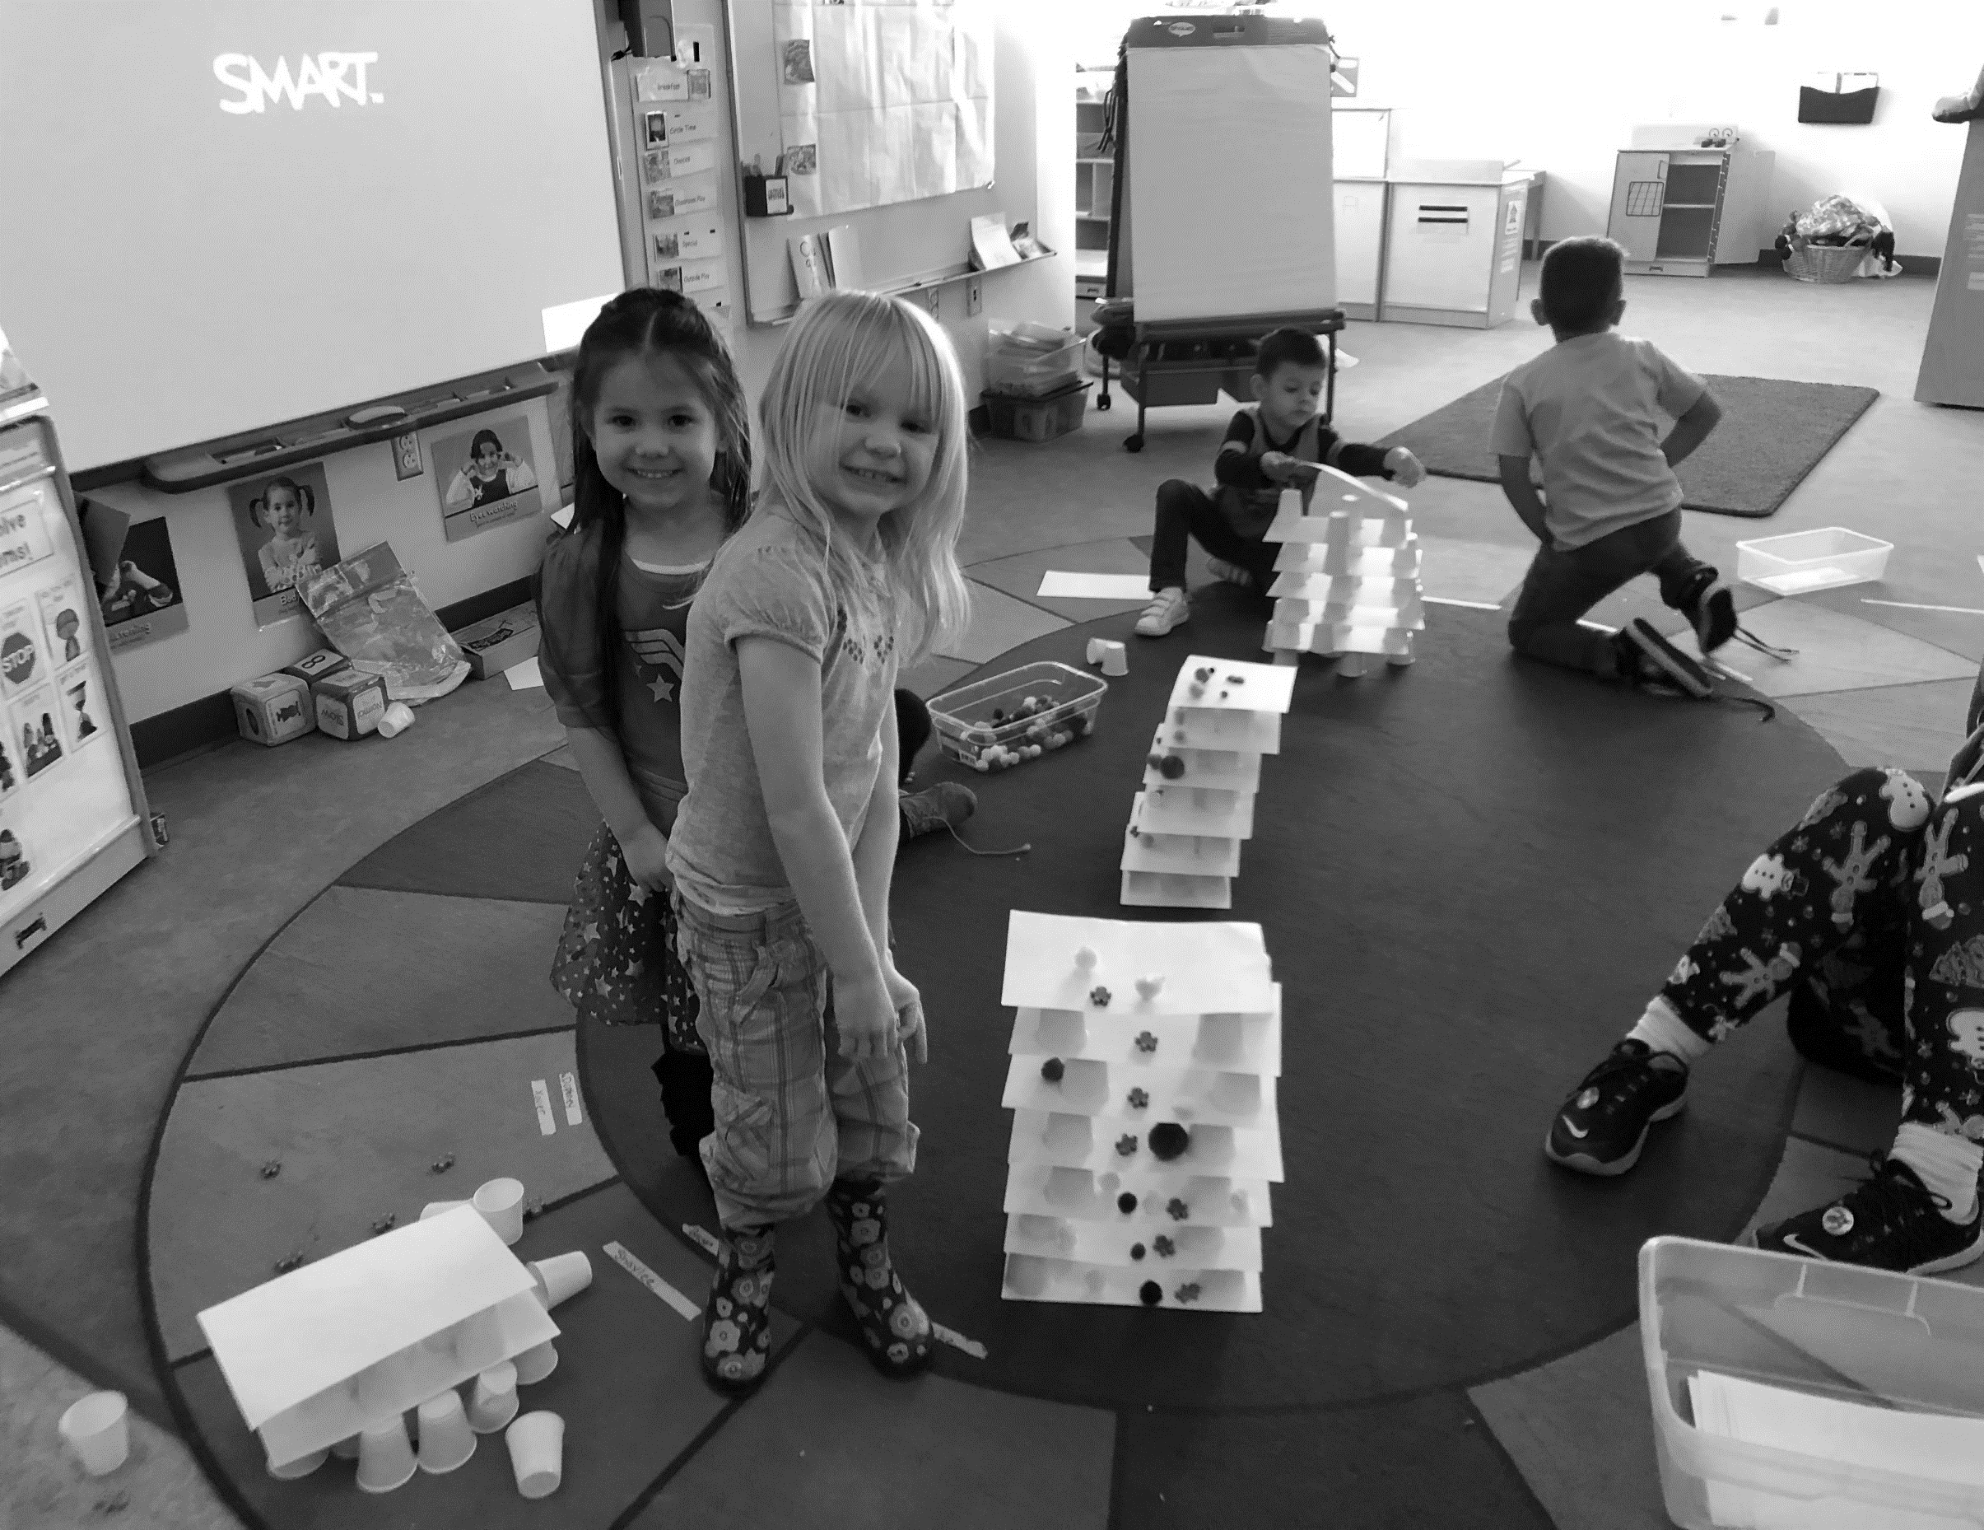
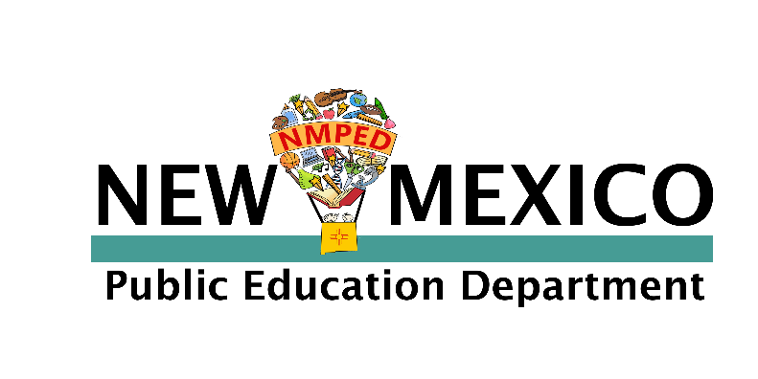
Teacher Checklist for New Mexico PreK Teachers

Brenda Kofahl
Director
Early Childhood Bureau
Before School Starts
☐ Track Mileage. Get a mileage form, so you can enter the mileage you drive for home visits.
☐ Calendaring. Review your school's Family Handbook with your administrators. Make sure that you have planned three parent conferences and, at least, four family engagement activities, and these events are listed in the handbook's school calendar.

☐ Essential Forms. Make sure you have the Home Visit form, school Pre-K handbook, school calendar, breakfast/lunch calendar, photo release form, classroom letter to families, community resources, and the developmental screener that includes a social-emotional component for each family, printed in their home language.

☐ PD Online. Sign Up for ECOT training and take it online. It is part of Pepper Professional Learning. You must complete the ECOT refresher annually and the new teacher training in your first year.

☐ Meet your coach (they should email you) and sign your coaching agreement. Discuss everyone’s
celebrations/concerns and commitment to work together. Set up a coaching schedule for the year.

☐ Menu of Practices. Check out the online version of the Practice Based Coaching Menu of Practices and the resources that go with it. Print a copy of the Menu to have when you work with your coach.

☐ Lesson Plans. Read the Lesson Plan Procedures, find your online lesson plan (bookmark it). Create a folder on your computer for your completed lesson plans. Create a spot in/outside your classroom to hang a copy of the public part of your plans for families to see.
☐ PD In-person. Sign up for any in-person trainings you will need to complete for the year. We are working to provide many trainings online, but please check to make sure you register for all Full Participation that must be completed within 6 months of hire/FOCUS implementation.
REQUIRED TRAININGS
-ECOT/ECOT refresher online must be completed within 30 days of a teacher’s start date for the school year.
-ECERS must be completed within 3 months of hire/FOCUS implementation
-Intentional Teaching must be completed within two months of hire/FOCUS implementation.
-NM Pyramid must be completed within 1 year of hire/FOCUS implementation.
-LETRS must be completed within 2 years of hire/FOCUS implementation.
-WIDA Early Years Modules

First Month of School
☐ Family Focus. Schedule home visits with families and assemble RESOURCES* for each of your families.

☐ PD. Take the TORCSH training and go over any questions with your coach.

☐ Data Collection. Think of, or collaborate with, other teachers to find a data collection strategy that is effective in completing
your ECOT. Make sure that your Essential Indicator labels are displayed in each center in your classroom and match the
objectives in your lesson plan. These labels will help to remind you what indicators you still need to assess.

☐ Roster to the STARS. Make sure that your district STARS coordinator has your roster to enter into ECOT.
RESOURCES*
Home Visit form, school's PreK handbook, school calendar, breakfast/lunch calendar, photo release, classroom letter to families, community resources, and developmental screener in the family’s home language.

☐ Observe and Record. Start observing and recording data immediately, since rubric ratings must be finalized in ECOT by the 30th instructional day, as counted from first day of child attendance (including portfolio forms and creativity sample). This is baseline data for your students. BOY data collection closes October 15. Start early, in order to ensure you have true beginning-of-the-year data for each student.

☐ Special Education Knowledge. Do you have students with IEPs? Who is their case manager? Is it you? If you are a child’s case manager, please seek out the special education teacher in your school. They need to help you. You may need training regarding IEP and IDEA law. (These links take you to a PED manual that will answer questions about IEPs and ways to support students with special needs.)
ECOT DATES
- Beginning of Year (BOY) Finalized in ECOT by the 30th instructional day from the first day of the child's attendance
- Middle of Year (MOY) Finalized in ECOT by 2/7/20
- End of Year (EOY) Finalized in ECOT within the last 2 weeks of the child’s program

☐ ECO. Read the information about Early Childhood Outcomes Summaries (ECO) for students with IEPs. Check in with your students’ special education case manager to figure out the ECO process. ECO are due to your STARS coordinator 30 calendar days from the day that student starts school. The ECO form is in the appendix or by clicking here. Again, please determine who will case manage your students with IEPs so there are no surprises.
Second month of school
☐ PED Resources. Follow this link for NM PED RESOURCES to help with implementation of a quality program. Support is also available from PED and your coach. Please reach out.

☐ Developmental Screening. Complete the developmental screening for each child (your district will provide these). Complete the screener as an interview with parents. Use all results to discuss next steps with your parents; especially if there are concerns about their child’s development, these will be very helpful.

☐ Screening Results. Have the developmental screening results and information about Child Find ready for your family conferences. This discussion must take place at or before the first conference.

☐ ECO Guidance. ECO summaries are due for preschool students with IEPs 30 calendar days from the child’s first day of attendance. Please read the ECO guidance and call each child’s team together to complete the ECO.

☐ ECOT and ECO. Both are due at the same time. Look at the crosswalk at the end of the ELG to make completing the ECO easier. You can cut and paste the indicator into the ECO form and then personalize and add the information for your students WITH AN IEP. ECO is a collaboration, everyone who works with this student contributes.

☐ Family Teacher Summary Report. Find each child's Teacher/Family Summary Report in ECOT on-line to get ready for your first set of conferences. Remember to record the family's input at the conference before printing the report. For children with an IEP, one IEP meeting may suffice for one family-teacher conference. The Family/Teacher Summary Report must be completed for each child at each of the three conferences.
☐ PD. Take the online training for Pyramid. Get a login from your coach. This will help you with classroom management and
supporting children with challenging behaviors.

☐ Data. The Beginning of Year (BOY) ECOT data must be finalized this month– pace yourself so it does not get crazy. Your Early Childhood Outcome summaries (ECO) are due for Preschool students with IEPs 30 calendar days from the child’s Please read the ECO guidance and get each child’s team together to complete the ECO.

Third month of school
☐ Early Childhood Environmental Ratings Scale-3 (ECERS-3). If you are new to PreK, complete the ECERS 3 training and complete the self-assessment. If you are a returning teacher, review the tool. The self-assessment is due October 15. This training will help you make decisions and make any adjustments to help children use classroom space and work with classroom routines.

☐ Family conferences. Make sure that ECOT reports are printed and Family/Teacher Summary reports are completed and ready for parent input at the conference. Families may choose to have these documents emailed. Make emailing documents an option on your conference sign in sheet. For children with an IEP, the IEP meeting may count for one family-teacher conference. You may want this meeting to be the progression IEP before kindergarten to support families with that transition. The teacher writing IEP goals should link them to the Essential Indicators.

☐ Family Conferences. Please share the results of developmental screenings at the first conference. Set up any further screenings. Give parents information about the Child Find procedures in your district.

☐ Your Professional Development Plan (PDP). Your PDP (which is a district requirement) is probably due to your principal. Find the NM Teach New Mexico PreK Training Workbook. It has resources to help you complete your PDP.

☐ Inclusive Practices. Read the New Mexico Early Childhood Guide for Inclusion and complete the Inclusive Practices Checklist.

☐ World-Class Instructional Design and Assessment (WIDA) PD. Begin the online WIDA module training. There are five modules to support working with multilingual children. The practices will also help you to build oral language with English-speaking children.

To infinity and beyond
☐ Special Education Knowledge. If you have students with IEPs and you are not the case manager, you must still be aware of IDEA law and quality IEPs. Please read Developing Quality IEPs. This is a Public Education Department manual that will answer many of your questions about IEPs and ways to support students with special needs.

☐ PD. One more important training. Please take Intentional Teaching online (or if you signed up for an in-person training, go to that training as soon as you can). It is important to take these trainings. They work together to give you the whole picture for FOCUS and PreK.

☐ LETRS Professional Development. Make sure you are signed up for LETRS-EC training. An online version is now available. It is important to take all trainings to support your practice.

☐ The Verification Process. How close is the administration to documenting their part? What do you need to get ready for the classroom verification self-study?
☐ Rubric Ratings. ECOT rubric ratings for the middle of year must be finalized in ECOT by the first Friday in February (February 7, 2020). MOY data collection window opens October 16.

NMPED PREK IS HERE TO SUPPORT YOU –
Brenda Kofahl - Brenda.kofahl@state.nm.us
Mary Ellen Dannenberg- Marye.dannenberg@state.nm.us
Catherine Quick - Catherine.quick@state.nm.us

☐ EOY Rubric Ratings. Rubric ratings for the end of the year must be finalized in ECOT within the last two weeks of the child’s program (including portfolio forms and creativity sample). EOY data collection window opens February 8th 2020.

