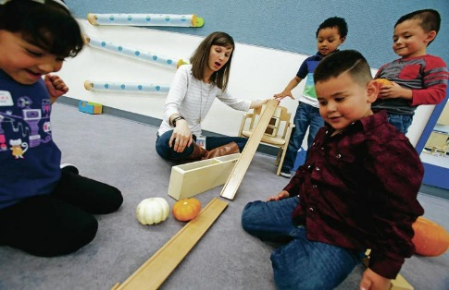
Parent Engagement
Parent engagement is an essential component of the PreK program. Each program must provide 90 hours of parent engagement activities throughout the school year. Parent engagement activities must include home visits and three parent/teacher conferences per school year. These activities might include literacy or math nights, parent meetings, etc.

Student Meals
All half-day PreK programs provide children with a nutritious meal—either breakfast or lunch. Extended-day PreK programs provide both breakfast and lunch. All children participating in a state–funded Pre-kindergarten program may apply for free or reduced-price meals provided by the School Lunch Program. Meal time is a perfect learning opportunity, and teachers use meal and snack times to teach all sorts of skills—and reinforce healthy habits, like washing hands and brushing teeth. Most programs provide meals family style, in which the learning community is seated and eat together. This setting ensures language-rich teacher/child interactions and promotes positive social skills.

Developmental Screenings
All PreK teachers conduct developmental screenings of all PreK children prior to the third month of attendance. Program staff are alert for early detection of children at–risk for developmental delays. During screenings, the dominant language of the child is used where possible. Parents are included in the screening process and informed of the results. Appropriate referrals and services are made available to address all identified concerns. PreK programs provide inclusive settings to accommodate children’s needs.

Health Screenings
Prior to the beginning of the program or within the first month of attendance, each child in the PreK program must receive the following five health screenings by a school health care professional: 1) physical examination, 2) current immunizations, 3) vision screenings, 4) hearing screenings, and 5) dental screenings. Parents are notified and appropriate referrals are made to address all identified concerns.

Guiding Principle
Every child in New Mexico has diverse strengths rooted in his or her family’s unique culture, heritage, language, beliefs, and circumstances. Early learning programs that support the full participation of every child build on these strengths. They do so by promoting a sense of belonging, by supporting positive social relationships, and by enabling families and professionals to gain advocacy skills that positively impact the life of every child.

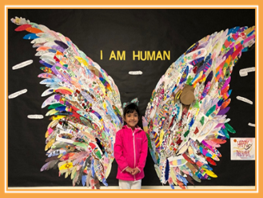

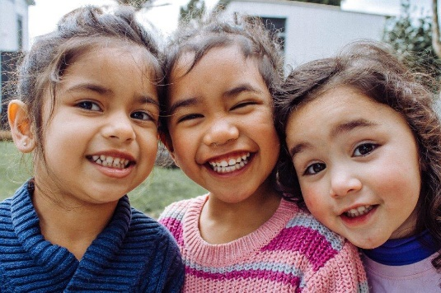
A state-funded, voluntary prekindergarten program for four-year- olds

For more information about PreK programs in the public schools, call 505-827-6516.

For more information about CYFD PreK programs,
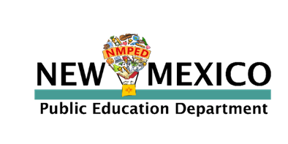
call 505-827-7946.

Welcome to NM PreK
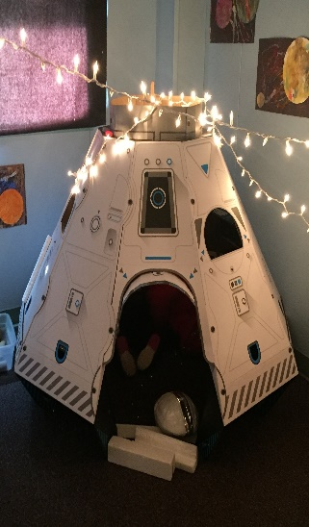
New Mexico PreK is a voluntary program created by the Pre- Kindergarten Act of 2005 and jointly administered by the Public Education and the Children, Youth, and Families Departments.

The purpose of PreK is to ensure every child in New Mexico has the opportunity to attend a high-quality, early childhood education program before entering kindergarten.
The purpose of New Mexico PreK is to:
- Increase access to voluntary, high–quality, pre–kindergarten programs
- Provide developmentally appropriate activities for New Mexico children
- Expand early childhood community capacity
- Support linguistically and culturally appropriate curriculum
- Focus on school readiness
“Children who attend high–quality, PreK programs do better in school from the first day of kindergarten through their postsecondary years. Compared with peers who have not completed PreK, they have higher achievement test scores, they repeat grades far less often, they need less special education, they graduate at higher rates, and they are more likely to attend college.” 1
1 Transforming Public Education: Pathway to a PreK-12 Future, page 8, The PEW Center
We are committed to…
- Valuing and embracing all children and their families.
- Involving families and communities as partners.
- Providing choice, flexibility, and continuity of services and supports for families within communities.
- Making a variety of services and supports available, so all children have access to—and can participate in—opportunities that are both respectful of, and responsive to, their family experiences, culture, beliefs, abilities, and circumstances.
- Advancing advocacy efforts for inclusive practices that build upon unique child, family, and community strengths and are accountable to every child and their family.

Planning & Curriculum
PreK teachers carefully plan indoor and out- door activities based on what children need to learn in the following areas:
- Mathematics, including counting, shapes, measurement, and sorting
- Literacy, including oral language, phonological awareness, writing, and reading comprehension
- Scientific understanding, including investigations, predictions, and earth science concepts
- Approaches to learning, including independence and focus
- Self, family, and community, including self-control, cooperative play, and interpersonal problem solving
- Physical development, including fine motor skills, spatial awareness, coordination, and strength
- Creativity, including music, art, movement, and engineering
We believe that…
- Every child has unique gifts and abilities that are to be celebrated and nurtured.
- The early years hold enormous promise and opportunity for every child to develop and reach their full potential.
- Every child learns within the context of relationships and through playful interactions within their environment.
- All children and their families deserve equitable access to appropriate services and to supports that acknowledge their uniqueness and enable them to reach their full potential.
Support &Training
Coaching and training are provided to teachers, educational assistants, and administrators who work in funded PreK pro- grams statewide. Support is provided to PreK staff for the implementation of an authentic assessment and curriculum process. The process includes the following:
- NM Early Learning Guidelines (ELG)
ELG are used to structure the authentic assessment and curriculum cycle using 25 of the indicators to assess PreK children.
- Practice-Based Coaching Cycles
Each PreK teacher uses NM PreK Child Observational Assessment as part of the assessment and curriculum cycle— which involves planning, observation, reflection, assessment, and individualization.
- PreK Teacher/Administrator Training
All PreK teachers and administrators are required to participate in PreK trainings.
- Coaching Support
All PreK programs receive regular visits from PreK coaches, who assist teachers and administrators to strengthen classroom skills.

