Thursday, September 26, 9 a.m. to 3 p.m. at the Roswell International Air Center, Roswell, NM. This year’s theme is Women in Aviation and Science. Attendees will directly interact with hands-on displays while engaging in activities that feature displays in aviation aerospace, over 50 general aviation aircraft, numerous military aircraft, higher education institutions, science demonstrations, flight training schools, military recruiting and aviation maintenance education. [Click here](http://www.nmaaa.net/events) to register.

### **NM Aviation Aerospace Expo**

The New Mexico Aviation Aerospace STEM Expo is an educational/diversity outreach event targeting young adults ages 13-21. This event focuses on science, technology, engineering and mathematics (STEM) while promoting general aviation and the aviation aerospace industry within the state of New Mexico. The seventh annual event is

### **September Listening**

[The ECHS Podcast](http://www.echs-nm.com/podcast/) – with guest Dr. Joel Vargas, Vice President of Jobs for the Future

[Work+Ed Podcast](http://www.careerpathways-nm.com/welcome/) – interview with Tina Turner, HR Expert for a local retail company

### **Merrion Mentorship Program**

Each fall Merrion Oil & Gas offers a petroleum engineering mentorship program open to local high school juniors, seniors and San Juan College students. Students meet once a week and learn to predict the performance of an oil well, create prediction spreadsheets, evaluate properties that are for sale and recommend a bid price to Merrion management. Starting with one student in 1994, a total of 375 students from 11 local schools have completed the program. For more information or for insight on how to create a similar program with businesses in your local area, contact George Sharpe at [gsharpe@merrion.bz](mailto:gsharpe@merrion.bz) or 505-402-5798.



### **Cybersecurity Entrepreneurship Workshop**

New Mexico Tech’s [Cybersecurity Center of Excellence](https://www.nmt.edu/academicaffairs/cybersecurity_centers/CyberEntrepreneurship.php) and the [Office of Innovation Commercialization](https://nmt.edu/academics/management/oic.php) are hosting a workshop around cybersecurity and privacy opportunities for entrepreneurs. The workshop will be September 27 (11 a.m. – 5 p.m.) and will be geared towards entrepreneurs, students, faculty, and researchers, but is open everyone interested in cybersecurity or building a technology business in New Mexico. Registration cost will be $20 per person; scholarships may be available for low income students. For more information [click here](https://www.nmt.edu/academicaffairs/cybersecurity_centers/CyberEntrepreneurship.php) or contact [Lorie.Liebrock@nmt.edu](mailto:Lorie.Liebrock@nmt.edu).



Las Cruces – October 19–20, 2019 (Administrators Course)

Santa Fe – November 2–3, 2019 (Administrators Course)

Roswell – January 25–26, 2020 (Administrators Course)

Farmington – February 29–March 1, 2020 (Administrators Course)

Silver City – April 25–26, 2020 (Teachers & Administrators Courses)

### **Are You NM STEM Ready?**

Experience adult-level science learning that incorporates multiple dimensions of the **NM STEM Ready! Science Standards**. The following courses and locations still have availability. [Click here](https://webnew.ped.state.nm.us/bureaus/math-science/professional-learning/) for more information.

### **Free Computer Science Workshops**

Code.org will be offering free Computer Science Fundamentals Workshops on Saturday September 28 at the New Mexico Natural History Museum. The courses offered are **Computer Science Fundamentals** (CSF) (free K-6 curriculum for teachers, librarians, technology instructors, administrators) and **Deep Dive into CS Fundamentals** (for teachers that have already done a CSF workshop but want to gain strategies to go deeper into the curriculum). [Register here](https://studio.code.org/pd/workshops/7546/enroll).



SEPTEMBER NEWS

College & Career Readiness Bureau

**Important Dates**

* September 19 – Ordering deadline for PSAT/NMSQT
* October 4 – Priority ordering deadline for AP exams
* October 10 – 17-18 Perkins Redistribution Final RfR Deadline
* November 1 – [BPA](http://nmctso.com/bpa/), [DECA](http://nmctso.com/deca/) , [FCCLA](http://nmctso.com/fccla/), [HOSA](http://nmctso.com/hosa/), [TSA](http://www.registermychapter.com/tsa/nat/StateDues.aspx), [EdRising](https://educatorsrisingnm.nmsu.edu/) Membership Registration Deadlines
* February 1 – [Skills USA](https://www.skillsusa.org/membership-resources/advisors/dues-and-deadlines/) Membership Registration Deadline

*If you would like to opt-out of this monthly newsletter please email [Andrea.Sisneros@state.nm.us](mailto:Andrea.Sisneros@state.nm.us).

[**College & Career Readiness Bureau**](https://webnew.ped.state.nm.us/bureaus/college-career-readiness/) **– 505.827.6475 – 300 Don Gaspar, Santa Fe, NM**

87501

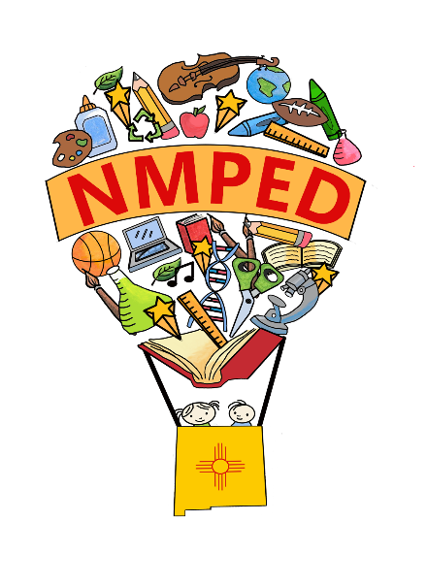

### **Scholarship of the Month**

[NM Alliance for Hispanic Education Scholarship](http://nmalliance.org/home/scholarships/)

* Applicants must be of Hispanic Heritage and a resident of New Mexico
* Must be a full-time student in an accredited U.S. institution and have a 3.0 cumulative GPA
* Must complete the Free Application for Federal Student Aid (FAFSA)