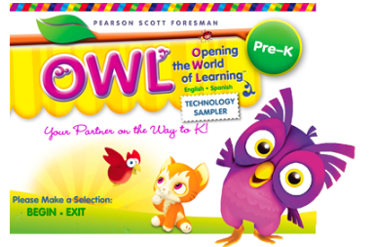
https://www.pearsonschool.com/index.cfm?locator=PSZpNy

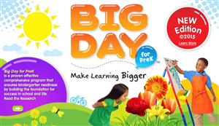
www.hmhco.com/Big-Day-PreK

.

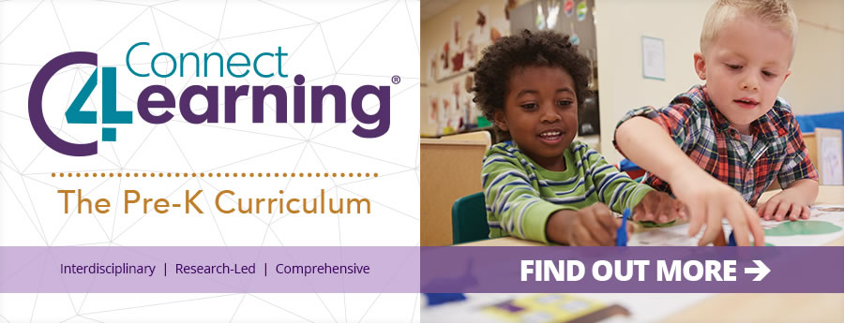
http://www.connect4learning.com/

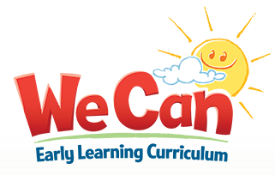
http://www.voyagersopris.com/literacy/we-can/overview

