Guide to log onto PEPPER to be become a User/Member
https://webnew.ped.state.nm.us/bureaus/literacy-humanities/
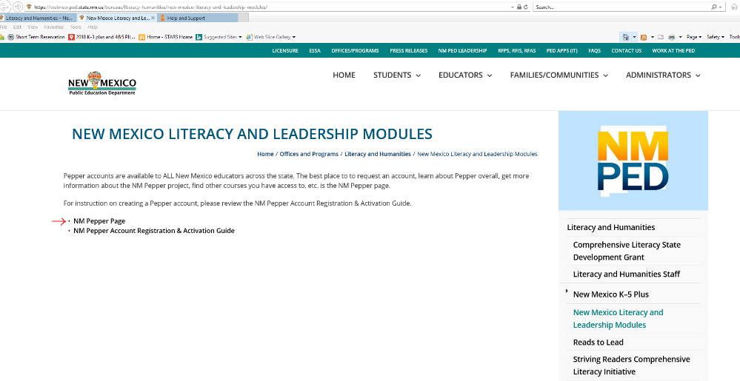

CLICK
CLICK

CLICK

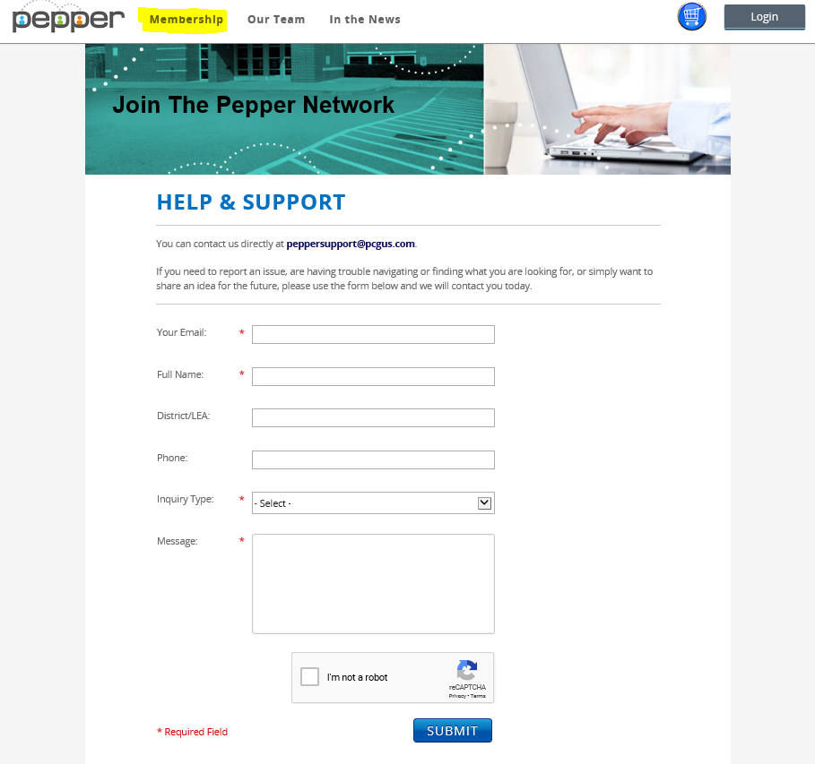

Link to become a new user/member:
https://www.pepperpd.com/contact

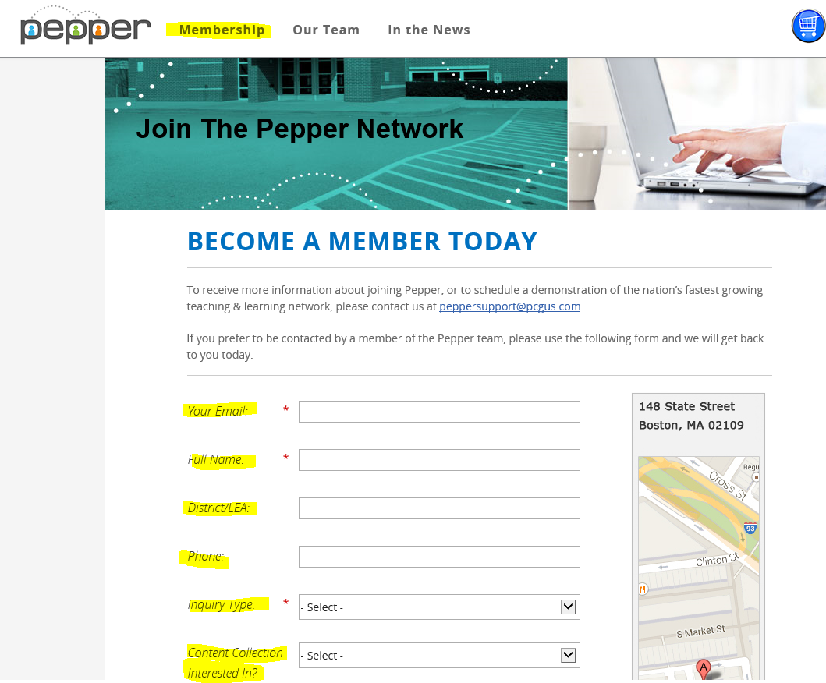

You will receive a confirmation email with login credentials and information within 24 hours.

Once you are logged in:
To Find Courses, click on down arrow (highlighted below).

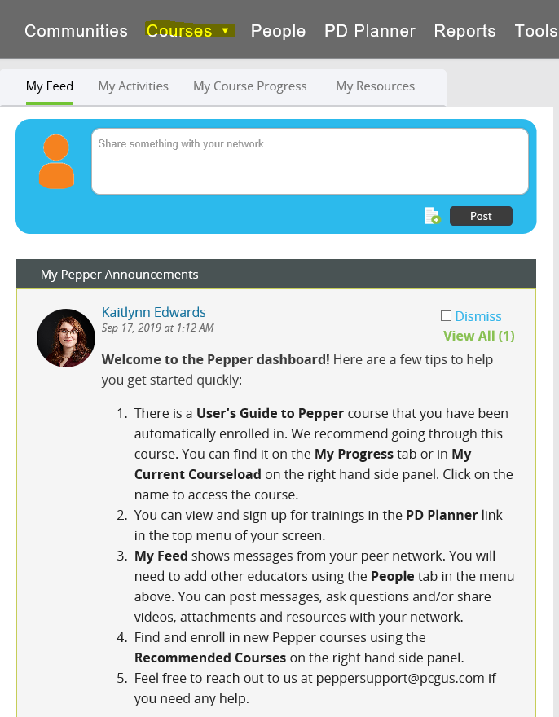
Click Courses available for New Mexico (highlighted below):
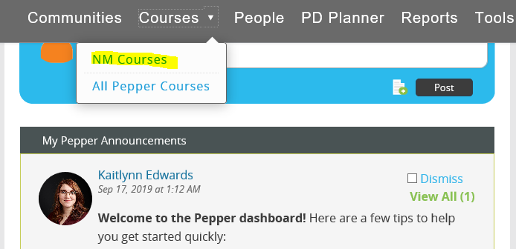

Users will see the following screen with all the Courses:
*List of courses on next page*
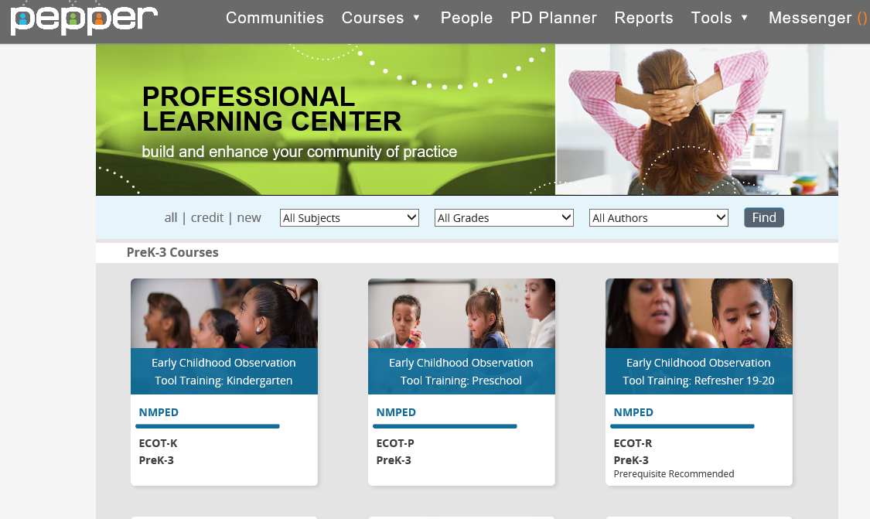

Available Courses:
3 sections of NM Courses
  - Prek-3 Courses
  - K5Plus Courses
  - K-12 Courses
- All Pepper Courses
NM Courses Available:
PreK-3 Courses
- ECOT-K - Kindergarten
- ECOT-P – Preschool
- ECOT-R – Refresher 19 - 20
- NMM0 – NM Building a Strong Foundation
- NMM1 – Focus on Foundational Reading Skills
- NMM2 – Advanced Word Recognition and Fluency
- NMM3 – Developing Academic Language
- NMM4 – Increasing Reading Comprehension
- NMR2L1 – Setting the Context for PreK-3 Literacy
- NMR2L2 – Understanding Early Language and Literacy for ELLs
- NMR2L3 – PreK-3 Instruction in Literacy Foundational Skills
- NMR2L4 – PreK-3 Instruction in Reading Comprehension and Language
- NMR2L5 – PreK-3 Instruction in Writing, Speaking, and Listening
- NMR2L6 – Prek-3 Instruction for ELLs in Reading and Writing
- NMR2L7 – Administrator’s Role-Classroom “Look-For’s”
- NMR2L8 – Administrator’s Role-Using Assessment Data
- NMR2L9 – Administrator’s Role-Supporting Family Engagement
- FOCUS – A1 – Administrator Overview – Intentional Teaching
- FOCUS - A2 – Administrator Overview – New Mexico Pyramid Framework
- FOCUS – A3 – Administrator Overview – Full Participation of Each Child
- FOCUS – T1 – Intentional Teaching – Powerful Interactions
- FOCUS – T2 – Intentional Teaching – Observational Assessment
K-5 Courses
- NMELA1 – Understanding Text Complexity
- NMELA2 – Literacy Supports for English Language Learners
- NMELA3 – Close Reading and Text – Dependent Questions
- NMELA4 – Building Fluency and Comprehension
- NMELA5 – Unlocking the Writing Standards
- NMELA6 – Best Practices for Writing Instruction
- NML1 – Effectively Discussing Student Data
K-12 Courses
- User’s Guide to Pepper
When Course is chosen users will see the following and will click Sign Up & Start Course (highlighted below):
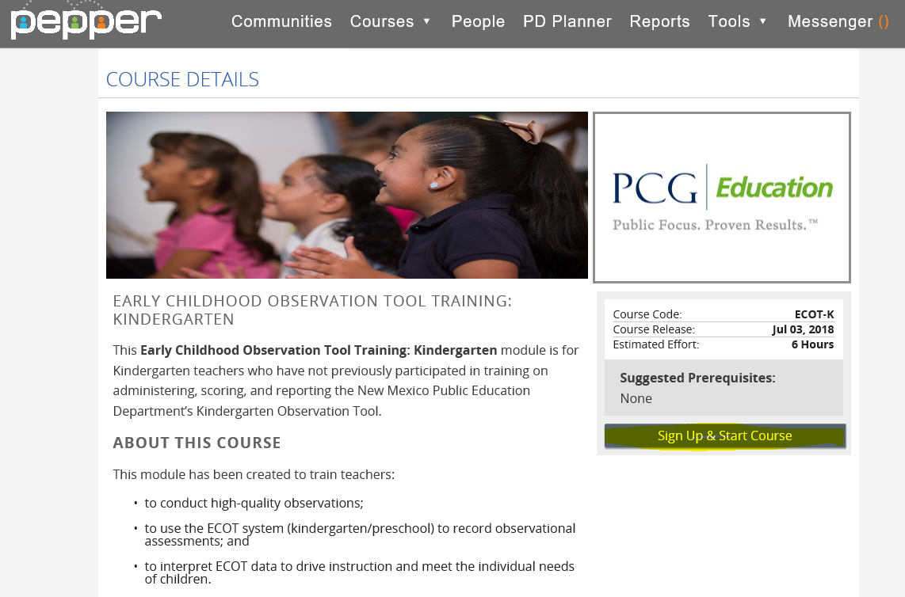
Users may also View a Detailed Course Outline by clicking + Expand or can also Download Detailed Course Outline (this is below the page above):
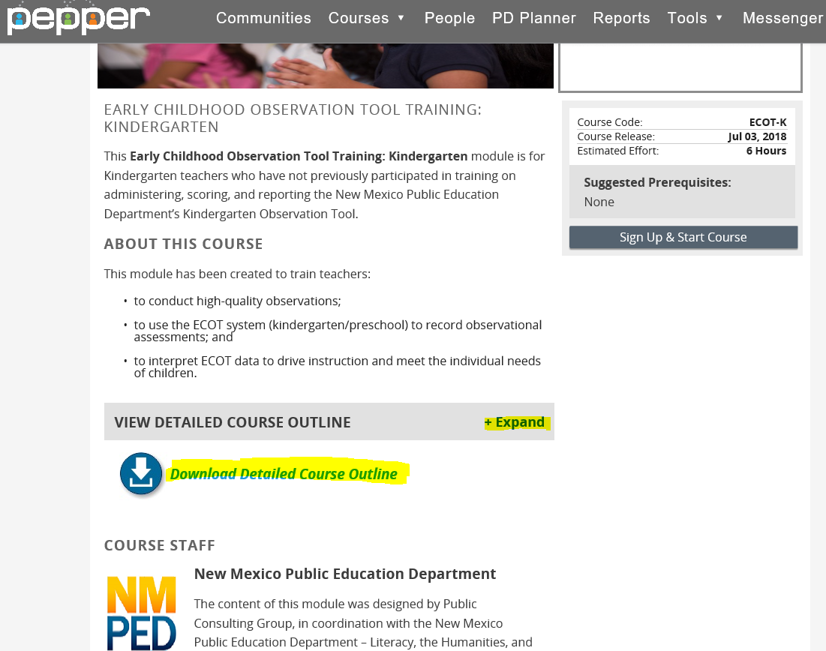

To print your “CERTIFICATE of COMPLETION” after the course.
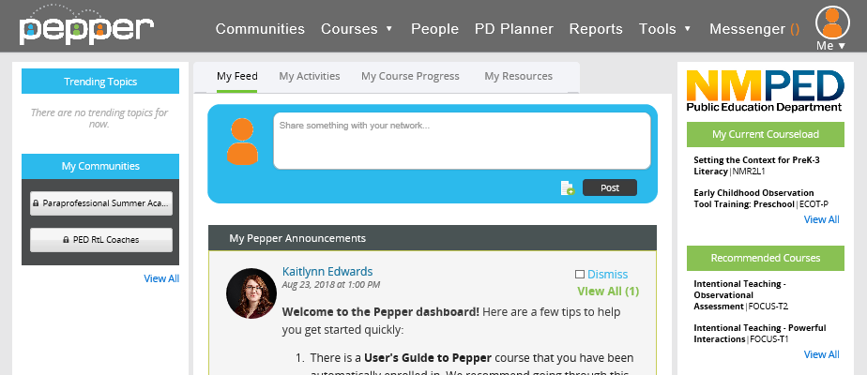
CLICK

Find “COMPLETED COURSES”
