Partial List of Research based Curricula
Click on the icons for links to research studies for these programs

Connect4Learning (C4L) is an interdisciplinary early childhood curriculum, the development of which was funded by the National Science Foundation. C4L aims to synthesize research-based approaches in four domains of learning: mathematics, science, literacy, and social-emotional development. The curriculum uses an interdisciplinary approach to address growing concerns that the majority of preschool instructional time is devoted to literacy at the expense of other content areas, particularly mathematics and science.
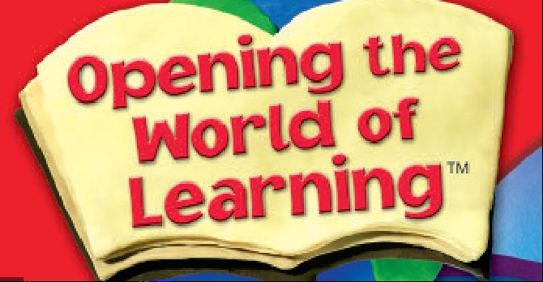
No longer available for purchase
Three Cheers for PreK will be available in the Fall of 2021
Research-based and field-tested, Opening the World of Learning is a comprehensive integrated, Pre-K curriculum designed to develop language and early literacy skills in the context of rich content - primarily in the areas of mathematics, science, and social studies. Unit topics include Family, Friends, Wind and Water, World of Color, Shadows and Reflections, and Things That Grow.
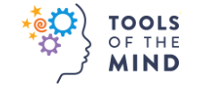
Tools of the Mind is a research-based early childhood model combining teacher professional development with a comprehensive innovative curriculum that helps young children to develop the cognitive, social-emotional, self-regulatory, and foundational academic skills they need to succeed in school and beyond.
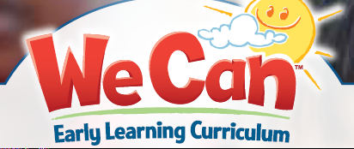
We Can is a dynamic, evidence-based PreK and early learning curriculum that provides age-appropriate, engaging, cross-curricular content designed to increase kindergarten readiness. We Can Early Learning Curriculum provides explicit instruction and guided practice that develops phonological sensitivity for hearing and using sounds in language and literacy. LETRS EC training supports the instructional strategies used in this curriculum.

Selecting a Curriculum for Your District

It is important when selecting a curriculum model not only to refer to the program’s student population and philosophy, but to ensure alignment with the New Mexico Early Learning Guidelines. The following questions can serve as a tool for guiding curriculum selection:
• Is the curriculum “research-based and research-validated”? Are elements of the curriculum clearly based on research about the development of young children?
•Has independent research demonstrated the effectiveness of the curriculum model in improving outcomes or results for children, particularly in oral language, early literacy, and social-emotional development?
• Are both scope and sequence included in the design? Are the relevant domains of development included? Is there evidence that the curriculum is tied to children’s developmental progress and the Early Learning Guidelines?
•Is the early literacy scope in this curriculum based on the principles of structured literacy? Does it include developmentally-appropriate, sequential development in the areas of phonological awareness, oral language including oral comprehension, alphabet knowledge, early writing, and vocabulary?
• What domains are included? Are there learning experiences and activities in all areas of development outlined in the Early Learning Guidelines? Does the methodology promote important development in “approaches to learning” such as initiative, persistence, and imagination?
• Are the materials appropriate? Are the materials appropriate for the age and level of development of four-year-old children, including children with special needs and those who may be more advanced in certain areas? Are supports provided to assist teacher in differentiating instruction? Are the materials free of cultural bias? Do the materials reflect the interests and home culture of the local community?
• Is there a balance of teacher-planned and child-initiated activities? Does the daily routine support a balance between adult-initiated and child-initiated activities?
• Are materials available throughout the learning environment to support systematic child observation in order to assess children’s abilities? Is there evidence that assessment for instructional purposes is integral to implementation of the curriculum?
• Are the teacher materials appropriate? Is there adequate explanatory material for the teachers on how to implement the curriculum?
• Is there a training component to support full implementation of the curriculum?
• Horizontal Alignment: Does the content of the curriculum align with the New Mexico Early Learning Guidelines, curriculum, and the Early Childhood Observational Assessment Tool?
• Vertical Alignment: Does the content of the curriculum align with New Mexico Early Learning Guidelines and kindergarten grade level Common Core State Standards and the New Mexico Standards for Excellence?

