NM CTE
Needs Assessment Guidebook

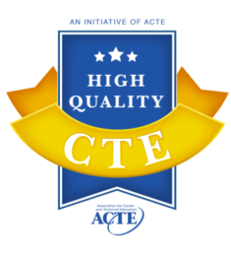 | - Access & Equity  - Business & Community Partnerships  - Career and Technical Student Organizations  - Data & Program Improvement  - Engaging Instruction  - Facilities, Equipment, Technology, Materials | - Prepared & Effective Program Staff  - Sequencing & Articulation  - Standards-Aligned & Integrated Curriculum  - Student Assessment  - Student Career Development  - Work-Based Learning
EQUITY RELEVANCE EXCELLENCE
NM champions High Quality CTE supported by three tenets: Equity, Relevance, and Excellence.

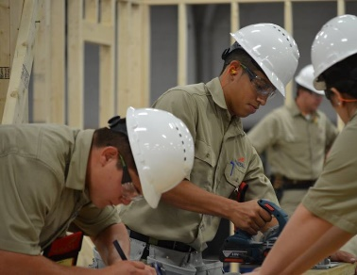
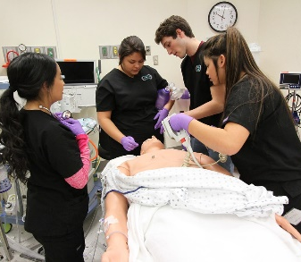
Introduction
One of the most significant changes in Perkins V (the Strengthening Career and Technical Education for the 21st Century Act) is the new requirement to conduct a comprehensive local needs assessment that is updated at least every two years for schools receiving federal funds for CTE. New Mexico will leverage this continuous improvement opportunity to build educational and workforce integrated systems, and reinforce High Quality Career & Technical Education (CTE) so that students are prepared by a cohesive network for lifelong career success. The collaborative needs assessment is the foundation for the development, improvement, approval, and funding of NM CTE programs.
The state’s educational, workforce, and economic development strategic vision and goals will be supported through a consortia-based organizational structure for CTE funding. Integrating a regional (rather than school site-based) needs assessment process has the potential to be a major driver of quality and equity in our state. It provides a coordinated, in-depth look at the entire CTE system to identify areas where targeted improvements can lead to increased alignment and opportunities for student success. It also provides an occasion to engage diverse stakeholders who are committed to the growth and improvement of NM CTE.
This guide will walk you through the steps necessary to complete a comprehensive local needs assessment according to the following workflow.
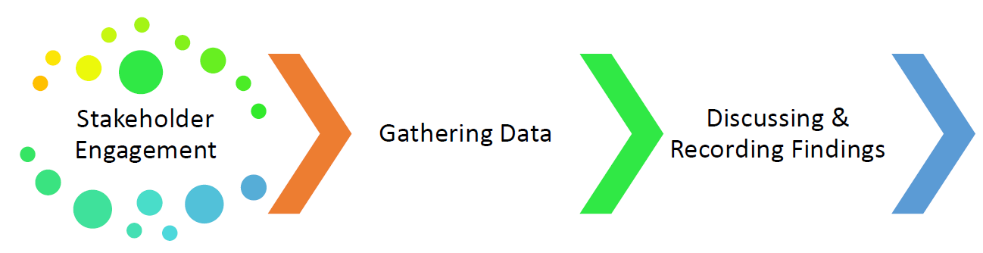
Local CTE Application & Regional Implementation
Regional
Local
Regional
Local
Needs Assessment Process Overview:
- The Bridge of Southern NM (contracted facilitator) will solidify CTE regions, organize regional employment data, coordinate with business/industry for regional meetings, identify/support CTE Consortia Leads, host webinars, and facilitate meetings.
Site-based CTE leaders (district/college)
- Review the Needs Assessment Guidebook and Needs Assessment Templates to create your plan for identifying CTE potential partners, resources, and information.
- Use the Labor Market Information available through www.nmcteclna.com to identify further resources and to answer needs assessment questions about your school site.
- Collaborate and communicate with your partners to review the current status of CTE related to the Potential Partners and the Local Needs Assessment templates.
- Record local information in the Needs Assessment Templates prior the regional meeting.
Regional level
- Diverse CTE partners will work together to set priorities and vision for the region and collaborate with the Consortia Lead on a regional strategic plan.
- The partners will plan for ongoing accountability and share needs assessment results documents prior to completing the NM CTE application for funding.
The needs assessment, if implemented thoughtfully, can be a powerful tool to engage stakeholders in a collective vision and partnership for implementing strong CTE programs in your community, specifically:
- Make certain that programs are aligned to and validated by local workforce needs and economic priorities;
- Ensure that local Perkins eligible recipients are serving each learner equitably;
- Enable eligible recipients to better direct resources towards programs that lead to high-skill, living-wage, and/or in-demand occupations and activities that close equity and opportunity gaps;
- Create a platform for coordinating and streamlining existing program review and school improvement processes to bring focus to strategic decisions; provide a structured way to engage key stakeholders regularly around the quality and impact of local CTE programs and systems.
Purpose
This guidebook and the related templates are intended to give NM CTE funding applicants a framework from which to structure your approach to the regional and local needs assessment efforts by translating the legal language into actionable steps that not only complete the requirements but also engage stakeholders in thoughtful program improvements.
The purpose of the needs assessment is to identify priorities, support data-driven decision making, and more closely align planning, spending and accountability activities to ensure a more strategic use of federal dollars and an overall increase in CTE program quality and equity. The results of the needs assessment must form the foundation of the local application and drive local spending decisions.
Regional Approach
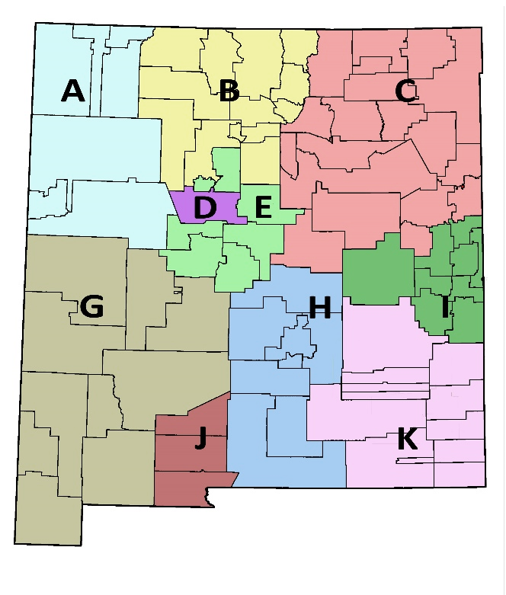
New Mexico will conduct needs assessments regionally, based on school district boundaries within modified economic and workforce regions.

NM CTE Regions
Each CTE region in the above map will bring community stakeholders and partners together to develop and inform the needs assessment. With the input of workforce partners, CTE programs developed and supported by all consortium partners will be highly effective at meeting the needs of employers, the community, and special populations. The Perkins V law provides flexibility in conducting the needs assessment, creating opportunities for enhanced collaboration across intra-state regions for both the needs assessment and the local application for funding.
A regional approach to the needs assessment can increase systems alignment and build stronger career pathways and programs for students and remove duplication of effort for stakeholders. If all CTE stakeholders in a region are reviewing the same programs and related data – and making plans together to address identified needs – there can be synergy around future plans that seamlessly connect secondary education, postsecondary education and the workforce. Benefits of a regional approach include:
- Aligned systems and career pathways
- Enhanced coordination and collaboration
- Streamlined stakeholder engagement
- Reduced duplication of effort
- Targeted state capacity
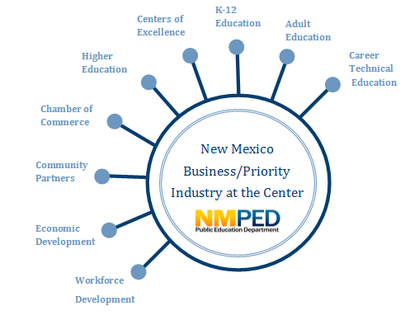
Consortia Leads will take an active partnership role with educators for the region and together you will compile information from consortia participants. The final product of New Mexico’s regional approach will be the completion of all parts of the Needs Assessment Results Document. This document will identify priorities to improve the quality of NM CTE and the use of Perkins funds in the local application.

Collaboration Model

Each district and/or two-year college in New Mexico desiring to operate an approved and funded CTE program is required to actively participate in the needs assessment process. At
the local level, the school districts, colleges, and industry partners will gather data and information that contribute to the larger regional needs assessment collaborative process.
Needs Assessment Templates
The NM CTE Needs Assessment Templates includes the following resources for use at the local and regional levels:
Part I Site-based templates completed by CTE leaders (district/college) before regional meeting
- Potential Partners - Site-based CTE leaders (district/college) use this template to identify individuals who may represent the required stakeholders to engage in the comprehensive needs assessment process. These potential partners are either currently engaged in, or they may be interested in engaging in the success of CTE programs. For secondary LEAs, this may include members of the Equity Council. Think of this resource as your local directory.

- Local Needs Assessment - Site-based CTE leaders use this template to coordinate a review and to document the current status for each of the essential elements required in the needs assessment. This summary is a cornerstone of the needs assessment process and supports conversations at the regional level. These templates should be completed by the site-based CTE leaders and provided to the regional meeting facilitator in advance of the regional CTE meetings. The template includes an overall rating section for each element and an area for potential strategies to improve the current state.
Part II Regional templates completed by CTE leaders during and after the regional CTE meeting
- Regional Needs Assessment - This section has both a Potential Stakeholders section and the Regional Needs Assessment. A template is provided for each of the required elements to summarize the findings of the assessment process on a regional level and next steps will be determined at the meeting. The first element of the Regional Needs Assessment, Priority Alignment, will be completed at the regional CTE meeting. The Regional Needs Assessment must be submitted to NMPED as documentation of the comprehensive needs assessment process.

- Needs Assessment Results Documents (Part 1 and 2) - Site-based CTE leaders use these documents to summarize the priorities established as a result of the comprehensive needs assessment process. This should be completed in consultation with partners at the regional level. This must be submitted as documentation of the comprehensive needs assessment process.

- Needs Assessment Results Signature Page - Each local education partner and the Consortia Lead will sign this page indicating commitment to the priority strategies for the region.

- Needs Assessment Stakeholder Verification - Regional site-based CTE partners collaboratively use this form to verify that all of the required stakeholders were engaged in the regional needs assessment process.
The Needs Assessment Elements
The CTE needs assessment has six required elements for evaluation. Many of these elements are interwoven and insights gained in evaluating one may be helpful in tackling another.
Priority
Alignment
Size
Scope
Quality
Student
Performance

Access
& Equity

Educator
Training,
Recruitment,
& Retention

Implementation
& Completion

Each element is described in the following pages as it should be evaluated with the Local Needs Assessment templates at the local level. In addition, the following resources are provided for each elements:
- A brief description
- Suggested areas to review and materials needed
- Suggested stakeholders to engage
- Suggested strategies for consultation
- Template questions to answer for this element

As you design your approach to reviewing each element in the context of Labor Market Information, one additional resource that you may have within your school, district, college, or community would be those individuals involved with the implementation of the Every Student Succeeds Act (ESSA) and the Workforce Innovation and Opportunity Act (WIOA). They may have some ideas, lessons learned, and best practices for your team to adopt.

Needs Assessment TIP: Share the load! To do this, assign two people, if possible, to be responsible for each part of the needs assessment. While it will take everyone working together, it will be the pair’s role to make sure the information is gathered and organized to share with the entire group. Their role is not to make judgments about the information gathered, but to present and help make sense of what has been collected so effective discussion can take place.

Identify your local needs assessment team for the following areas (it is OK to divide these up):
- CTE Program & Priority Alignment
- Each CTE program:
  - Size (capacity focus)
  - Scope (curricular focus)
  - Quality (outcome focus)
- CTE Student Performance
- CTE Student Access and Equity
- CTE Educator Training, Recruitment, Retention
- CTE Program Implementation and Student Program Completion
As you move forward in the important work, here are a few more items to consider:
  - Not all stakeholders mentioned must answer all the questions provided.
  - Choosing the appropriate questions that apply to each stakeholder group will result in the best feedback and engagement.
  - Site-based leaders can design their own customized questions.
  - Do not artificially inflate the local score on the rubric provided in the needs assessment templates. Most programs will not rate at the highest level in all categories or there would not be room for improvement.
  - There may be work already underway in your region that you can align with when working with stakeholders.
Element 1. Priority Alignment
Quality CTE programs are aligned to the needs of the future workforce. This element of the needs assessment examines CTE program alignment with state, regional, Tribal, or local in-demand industry sectors or occupations identified by the state workforce development board or local workforce and economic needs. This evaluation considers how well current CTE programs are aligned with NM priorities.
Current labor market information (LMI) about occupations, education and training requirements, and wages is crucial in order to make important life decisions about career goals and in order to guide leaders to drive CTE programs that best support students. LMI can help provide reasonable expectations of job openings and wages for individuals entering work.
The Economic Research and Analysis Bureau of the NM Department of Workforce Solutions is the principal source of LMI for the state.
What does the law say?  The comprehensive local needs assessment will include a description of how CTE programs offered by the eligible recipient are aligned to State, regional, Tribal, or local in‐demand industry sectors or occupations identified by the state workforce development board or local workforce development board, including career pathways, where appropriate. The comprehensive local needs assessment may also identify programs designed to meet local education or economic needs not identified by State boards or local workforce development boards. | What does the law mean?  The law requires an analysis of how CTE programs are meeting workforce needs and provides eligible recipients with multiple ways to demonstrate labor market demand, from a combination of state and local sources.
It is important to examine multiple sources of data. Great sources of information are:
• LMI websites
- LMI data sheets provided for the CTE regional meetings
• Discussion with local business and industry on workforce needs
• Economic development plans for businesses the region is trying to attract or expand
• Local workforce boards
• Information from local Chambers of Commerce

1. Priority Alignment
Suggested Areas to Review and Materials Needed
- State and local labor market information (LMI) including current and projected employment
- Follow-up data on program completers to determine entry and success in their career areas
Suggested Stakeholders to Consult | Suggested Strategies for Consultation
- Administrators, teachers & faculty  - School counselors and advisement professionals  - Former students  - Representatives of special populations  - Local data staff | - Workgroup to examine data including educators, school counselors/advisement personnel, and workforce development staff  - Engagement of advisory committee for input into workforce alignment  - Focus groups, interviews, or surveys with:  - Students and former students  - Local agencies involved in workforce initiatives
Template Questions to Answer for this Element
- To what extent are we offering programs of study that are preparing learners for current and future workforce and economic needs?
- What are the processes in place for reviewing workforce and economic data to determine effectiveness and impact of program offerings on a regular basis?

Element 2. Program Size, Scope, and Quality
Providing a quality CTE experience should be the goal of every New Mexico CTE program. This element of the needs assessment examines the extent to which local CTE programs are of sufficient size, scope, and quality to meet the needs of all students.
What does the law say?  The comprehensive local needs assessment will include a description of how CTE programs offered by the local eligible recipient are sufficient in size, scope, and quality to meet the needs of all students served by the eligible recipient. | What does the law mean?  The provision maintains the size, scope and quality requirements that were in Perkins IV, but instead requires that this description be addressed through the needs assessment (which is part of the local application in Perkins V) instead of in the local plan in Perkins IV. The state has the responsibility to establish the definition of these three requirements. (See the NM Perkins V Transition Plan).

Evaluation Indicators for Size, Scope, and Quality
New Mexico intends to evaluate the consortia within which the program applies in order to allow for a broad view of each program’s size, scope, and quality. NM has elected to report postsecondary credit attainment as its formal indicator of quality for secondary programs. In addition, secondary programs will also be evaluated on the other two indicators of quality (certificates and work-based learning). To evaluate size and scope, consortia applications will report the percentage of secondary and postsecondary students who are CTE participants, and the percentage who are CTE concentrators. CTE concentrator counts will be evaluated in terms of expected number of job openings, and the state will prioritize funding into those programs that offer the best prospects for future employment.
Size
Evaluate each program of study from a regional labor market perspective. A key consideration is an analysis of the number of recent high school and postsecondary program of study concentrators, to determine if the regional program is too large for the expected job opportunities in the state.
To determine if a secondary program is of sufficient size, it must include at least two aligned courses within an approved program of study sequence. Evaluation of adequate size also depends on the amount of physical equipment available, the amount of monetary award, the number of staff involved, and the average number of students served each year.
To determine if a postsecondary program is of sufficient size, consider the number of statewide program completers in relation to the number of projected job openings, as published by the Department of Workforce Solutions. Consider the possibility that a program could be too large, as well as too small.
Scope
Programs of study are articulated beginning in grade nine continuing through postsecondary credential attainment. Secondary and postsecondary institutions should develop working agreements with one another prior to funding approval. Working agreements shall include fiduciary agent agreements, consortia policies and procedures, and dual credit agreements. While a small subgrantee (school) might be unable to generate all elements of a program of study that is of sufficient scope, the consortia as a whole must meet evaluations of scope.
Quality
Quality programs of study all lead to living wage, high-skill and/or in-demand occupational outcomes.
New Mexico Definitions
Living Wage  New Mexico defines living wage careers for CTE programs of study as careers leading to a wage that can sustain a family. The federal guideline for reduced price lunch is 185% of the federal poverty guideline, and New Mexico defines a family as a household of three or more. Therefore, for a career to qualify as living wage, the median salary for that career, in New Mexico, must meet or exceed 185% of the federal poverty guideline for a family of three. For 2019-20, wages as defined by this standard are $38,443 annually. For reference, the 2016-17 mean salary in NM was $44,840.00. | High Skill  High-skill careers are found in occupations requiring completion of an apprenticeship, an industry-recognized certificate or credential, or a postsecondary certificate or degree. | In-Demand  Careers are considered in-demand when demand for particular careers exceeds supply. State, regional or local labor market data must document the demand. When demand exceeds projected employment supply, approved programs of study must lead to a living-wage or high-skill career. Such a program might also adequately prepare learners for the in-demand career, but the living-wage or high-skill career, not the in-demand career, must be the target career for the program.

 | 2. Program Size, Scope, Quality
 | Suggested Areas to Review and Materials Needed
Size (capacity focus)  - Total number of programs/ programs of study and number of courses within each  - CTE participant and concentrator enrollment for the past three years, aggregate and disaggregated  - Capacity of each program for the past three years  - Number of students applying for the program in the last three years, if applicable  - Number of students on waiting lists, if applicable |  | Scope (curricular focus)  - Documentation of CTE Programs of Study course  sequences from secondary to postsecondary including aligned curriculum  - Credit transfer agreements for CTE programs.  - Data on student retention and transition from secondary to postsecondary within the CTE program of study  - Description of dual credit courses and data on student participation and success  - Data on student credential attainment in each program disaggregated by student demographic and value of credential  - Curriculum standards showing depth and breadth of program and alignment to workforce and economic needs  - Opportunities for expanded learning within and across CTE programs of study |  | Quality (outcome focus)  - Curriculum standards and frameworks showing alignment to industry needs.  - Assessments leading to credentials of value  - Safety requirements  - Work-based learning procedures  - Career and Technical Student Organizations (CTSO) activities and alignment to curriculum  - Data collection mechanisms  - Program improvement/ assessment processes  - Placement in employment, education, or military following program participation (if applicable)
Suggested Stakeholders to Consult |  |  | Suggested Strategies for Consultation
- Administrators, teachers, and faculty  - Representatives of special populations  - Parents and students  - School counselors and advisory professionals  - Local data staff |  |  | - Workgroup to examine data including representatives of educators, school counselors/career advisory professionals, special populations, and employers  - Focus groups, interview, or survey of:  - Parents and students  - Employers  - School counseling staff and career advisory professionals
Template Questions to Answer for this Element
- How do programs maintain conversations with secondary, postsecondary, and business/industry representatives so that a robust and up-to-date skill set is developed in each program?
- Which programs have current industry standard equipment, appropriate classroom and laboratory space, and quality instructional materials?
- Which programs of study incorporate relevant academic, technical, and workforce readiness skills at every learner level? (Including dual credit opportunities)

Element 3. Student Performance
Quality CTE contributes to both the technical and academic preparation of all learners. Perkins V requires the needs assessment to evaluate student performance, including special populations and each subgroup identified in the law. The needs assessment must contain an evaluation of CTE concentrators’ performance on the core performance indicators.
This element will be addressed by reviewing the data from each education partner at the local level using the local needs assessment templates. The following information will help the education partner complete the templates.
What does the law say?  The comprehensive local needs assessment will include an evaluation of the performance of the students served by the local eligible recipient with respect to State determined and local performance levels, including an evaluation of performance for special populations and each subgroup. | What does the law mean?  The comprehensive local needs assessment must contain an evaluation of CTE concentrators’ performance on the core performance indicators. This includes an evaluation of performance for each subgroup and special population in funded programs.

3. Student Performance
Suggested Areas to Review and Materials Needed
- Review Perkins performance data for the past three years disaggregated by CTE program area and subgroups including:
  - Gender
  - Race and ethnicity
  - Migrant status
  - Individuals with disabilities
  - Individuals from economically disadvantaged families including low-income youth and adults
  - Individuals preparing for nontraditional fields
  - Single parents including single pregnant women
  - Out of work individuals
  - English learners
  - Homeless individuals
  - Youth who are in or who have aged out of the foster care system
  - Youth with a parent who is on active duty military
- Strategies utilized to address performance gaps for specific subgroups along with outcomes for the strategies attempted.

3. Student Performance (continued)
Suggested Stakeholders to Consult | Available Resources
- Administrators  - Secondary teachers  - Postsecondary faculty  - Academic and career advising professionals  - Tribal organizations and representatives  - Corrections education staff  - Representatives of special populations  - Local data staff | General K-12 data  - Accountability https://webnew.ped.state.nm.us/bureaus/accountability/  - STARS (CCR Reports) https://eui.ped.state.nm.us/sites/stars/default.aspx  General postsecondary data  - https://hed.state.nm.us/data-reports
Suggested Strategies for Consultation
- Establish a work group that includes educators, counseling professionals, data stewards, and representatives of special populations to examine data and identify gaps or areas of concern.
- Assemble educator groups by CTE career field or cluster to examine data in their specific area, review board policies, processes for developing student schedules, and graduation guidelines for systemic barriers to CTE enrollment by special populations.
Template Questions to Answer for this Element
- Where do the biggest gaps in Perkins performance indicators exist between subgroups of students and program areas?

Element 4. Access & Equity
Equity, access, and inclusivity are foundational to meeting the needs of all students in quality CTE. This element requires education partners to assess progress toward providing equitable access to all CTE programs. There should also be an examination of any barriers (real or perceived) that may prevent members of any special populations from entering and thriving in CTE programs.
The outcomes of this section include identified strategies to help ensure equitable access to high-quality CTE courses for all learners. This includes:
- Strategies to overcome barriers that result in lower rates of access to, or performance gaps in, the courses and programs for special populations;
- Providing programs that are designed to enable special populations to meet the local levels of performance; and
- Providing activities to prepare special populations for high-skill, living-wage, or in-demand industry sectors or occupations in competitive, integrated settings that will lead to self-sufficiency.

It is important to remind ourselves of who is included under the definition of special populations to ensure each is addressed in the needs assessment, the application, and your instructional services. The definition has broadened so it is important to check your data systems for access to information. (As a reminder, all definitions are included in Section 3 of the new Perkins V Act).
“Special Populations” include:
- Individuals with disabilities;
- Individuals from economically disadvantaged families, including low income youth and adults;
- Individuals preparing for non-traditional fields;
- Single parents, including single pregnant women;
- Out-of-work individuals;
- English learners;
- Homeless individuals described in section 725 of the McKinney-Vento Act;
- Youth who are in, or have aged out of, the foster care system;
- Youth with a parent who is:
- A member of the armed services
- Active duty status

What does the law say?  The comprehensive local needs assessment shall include a description of:  - Progress toward implementation of equal access to high‐quality CTE courses and programs of study, for all students including strategies to overcome barriers that result in lower rates of access to, or performance gaps in, the courses and programs for special populations;  - How they are providing programs that are designed to enable special populations to meet the local levels of performance; and  - How they are providing activities to prepare special populations for high‐skill, living‐wage, or in‐demand industry sectors or occupations in competitive, integrated settings that will lead to self‐sufficiency. | What does the law mean?  This requirement is focused on supports for special populations. The law challenges states to assist locals in directing resources or supports to close performance gaps and remove barriers. There may be different supports necessary to address different barriers and different populations.

4. Access & Equity
Suggested Areas to Review and Materials Needed
- School counseling and recruitment activities
- Program promotional materials
- Processes for communicating and providing accommodations, modifications, and supportive services for all students, including special populations
- Procedures for workplace experiences for special population students
- Information on accelerated credit and credentials available for special populations
- Data on CTE & CTSO participation & performance by each career area & each special population
- Findings from surveys/focus groups (students, parents, or community representatives)
Stakeholders to Consult | Suggested Strategies for Consultation
- Secondary and postsecondary teachers/faculty and administrators  - School counselors and advisement professionals  - Representatives of special populations  - Local data staff | - Workgroup to examine data including educators, school counselors/advisement professionals, and representatives of special populations  - Focus groups, interviews, or surveys with:  - Students and former students  - Parents  - CTSO advisors  - Representatives of special populations  - Business, industry, and community partners
Template Questions to Answer for this Element
- Which students identified as special population groups are under-represented or over-represented in CTE programs overall? In which program area?
- What barriers currently exist that prevent each special population group from participating in your programs?
- How can cultural elements such as racial, ethnic, socio-economic, or geographic elements be considered and addressed when seeking out and working with learners and their families?
- Are there new programs that need to be developed to ensure access in our region?
Element 5. Educator Training, Recruitment, Retention
This needs assessment element evaluates the educator workforce in your programs. This is not just about teachers, instructors, and faculty, but also includes specialized instructional support personnel, paraprofessionals, school counselors, and advisement professionals.
What does the law say?  A description of how the recipient will improve recruitment, retention, and training of CTE teachers, faculty, specialized instructional support personnel, paraprofessionals, career guidance and academic counselors. This includes individuals in groups underrepresented in such professions. | What does the law mean?  Eligible recipients must evaluate their current and future recruitment, retention and professional development needs. This may require root cause analyses of teacher or other staff shortages.

- CTE-Related Professional Development, Recruitment, Retention
Suggested Areas to Review and Materials Needed
- Data on faculty, staff, administrator, & school counselor preparation credentials, salaries, benefits, and demographics
- Student and faculty demographic data
- Description of recruitment process and retention efforts
- Description of professional development, mentoring and externship opportunities
- Data on educator participation in professional development, mentoring, and externships
- Survey or focus group results conducted with educators regarding needs and preferences
- Trend data: CTE educator hiring & retention in CTE areas w/demographics (> 5-10 years)
Suggested Stakeholders to Consult | Suggested Strategies for Consultation
All stakeholders required by law, particularly:  - Secondary and postsecondary teachers/faculty  - Human Resource department members  - Administrators, teachers, and faculty  - School counselors and advisement professionals  - Representatives of special populations  - Local data staff | - Workgroup to examine data including educators, school counselors/advisement professionals, and human resources staff  - Focus group, interview, or survey with:  - Veteran teachers and Human Resources staff  - Individuals charged with selecting, designing, and implementing professional development
Template Questions to Answer for this Element
- Describe the professional development plan for CTE program-related teachers, faculty, specialized instructional support personnel, paraprofessionals, career guidance and academic counselors.
- What processes are in place to recruit new CTE educators? For example, what is the process to develop or recruit CTE instructors from existing staff/students?
- What strategies are you using to retain CTE educators?

Element 6. Program Implementation and Student Completion
This needs assessment element evaluates both the progress toward fully implementing quality programs that have been funded as well as the number of students in those programs who complete the program with an aligned capstone course such as advanced placement, dual credit, or a work-based learning experience.
What does the law say?  The comprehensive local needs assessment will include an evaluation of progress toward the implementation of CTE programs and programs of study. | What does the law mean?  This evaluation should be both a backward and forward‐looking review of the programs and programs of study offered. In addition to meeting the size, scope and quality (Element 2), this requirement addresses current and future plans to support the full implementation of programs and programs of study. Student completion rates are an indicator of quality program implementation.

- Program Implementation and Student Completion
Suggested Areas to Review and Materials Needed
- Programs of study, as proposed to NMPED in the Perkins applications over the past five years with enrollment numbers.
- Total number of programs/programs of study and number of course within each
- Capacity of each program for the past three years
- Number of students on waiting lists, if applicable
- Review of secondary courses that support transition aligned with the CTE program (advanced placement, work-based learning, dual credit)
- Current Dual Credit agreement
Suggested Stakeholders to Consult | Suggested Strategies for Consultation
All stakeholders required by law, particularly:  - Secondary and postsecondary teachers/faculty  - Employers  - Advisory committee members  - Administrators, teachers, and faculty  - School counselors and advisement professionals  - Representatives of special populations  - Local data staff | - Workgroup to examine data including educators, school counselors/advisement professionals, and human resources staff  - Focus groups, interviews, or surveys with:  - Veteran teachers  - Current and former students  - Employers  - Counselors
Template Questions to Answer for this Element
- To what degree were all proposed CTE programs of study fully implemented over the last five grant years?
- Describe student completion rates of implemented CTE programs (through the capstone level at the secondary level).
Summarize Findings at Regional Level
Each site-based CTE leader will complete the Local Needs Assessment prior to the regional CTE meeting through the portal: www.nmcteclna.com.
During the regional meeting, local education leaders and business partners will work together to summarize the strategies for each element. The CTE consortia will work collaboratively to establish the priority industries and strategies for the region.
Develop the Needs Assessment Results Document
The final product of this needs assessment process will be the Needs Assessment Results Document. This will be completed in collaboration with the Consortia Lead after the regional meeting and will summarize the prioritized strategies and the discussions. All three parts of the Needs Assessment Results Document must be completed.
The Needs Assessment Results will provide meaningful input and direction for the improvement of New Mexico’s CTE system. It also provides the priorities to be addressed in the local application for CTE funds.
The worksheets from the education partners must be submitted to the Consortia Lead to assist with the development of the results documents. The regional worksheets and the Needs Assessment Results Document along with the Needs Assessment Stakeholder Verification and Education Partner Signature Page must be submitted to NMPED. The Consortia Lead will ensure all education partners have signed off on the final document prior to submission.
Local Education Partners use Regional Needs Assessment Results Document to Improve the Quality of CTE and to Prepare Perkins Application
The Needs Assessment Results Document must be signed by all local education partners. Specifically, this signature should be from each entity’s educational leadership (superintendent, president). This document should be used to establish an action plan by each local education partner to work toward the improvement of CTE. It will be the guiding document for the preparation of the local application for Perkins funds.
Required Stakeholders (Sec 134(d) of Perkins V)
- Representatives of CTE programs in a local or educational service agency, including:
  - teachers
  - career guidance and academic counselors
  - principals and other school leaders
  - administrators
  - specialized instructional support personnel and paraprofessionals
- Representatives of CTE programs at the postsecondary educational institutions, including faculty and administrators
- Representatives of state board or local workforce development boards, regional economic development organizations, and local or regional business and industry
- Parents and students
- Representatives of special populations
  - Individuals with disabilities;
  - Individuals from economically disadvantaged families, including low income youth and adults;
  - Individuals preparing for non-traditional fields;
  - Single parents, including single pregnant women;
  - Out-of-work individuals;
  - English learners;
  - Homeless individuals described in section 725 of the McKinney-Vento Act;
  - Youth who are in, or have aged out of, the foster care system;
  - Youth with a parent who is:
  - A member of the armed services
  - Active duty status
- Representatives of regional or local agencies serving out-of-school youth, homeless children and youth, and at-risk youth
- Representatives of Indian Tribes and Tribal Organizations in the State, where applicable
- Any other stakeholder required by the state, region, or local agencies

High Quality CTE Framework (ACTE) https://www.acteonline.org/professional-development/high-quality-cte-tools/
Maximizing Perkins V’s Comprehensive Local Needs Assessment & Local Application to Drive CTE Program Quality and Equity (Advance CTE)
Promoting a Regional Approach to the Perkins V Comprehensive Local Needs Assessment (Advance CTE)
https://www.bls.gov/oes/2017/may/oes_nm.htm

