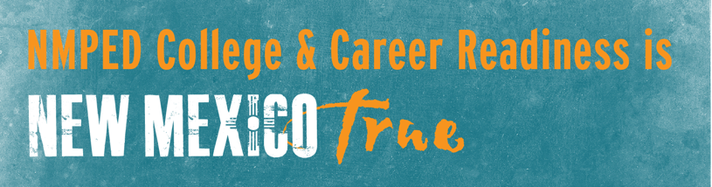

Building the Next Generation
of Career and Technical Education
Outcomes – March 27 Region B Consortia Meeting
Vision Statement: DRAFT STATEMENT FOR YOUR REVIEW/SUGGESTIONS/EDITS
Career and Technical Education in Region B provides relevant career exposure, preparation, and pathways for students aligned to meaningful careers in key industry sectors. CTE programs are agile and responsive to employers’ needs, equipping students with foundational skills for cross-industry application. It is flexible in design and delivery to provide the broadest possible access to high-quality programs throughout the region.

Target Industries for Investment:
- Healthcare
- STEM/IT-Computer Science
- Skilled Trades including application to:
  - Green Technology
  - Broadband Infrastructure

Entrepreneurship skills are vital to all pathways in order to support graduates’ readiness for solo-work and business ownership in a host of industries, as well as maximum ability to participate in the gig economy.

Opportunities to Pursue Moving Forward:
- There is great value in delivering hands-on work-based learning opportunities for students throughout the region to support the creative way they think. Strong partnerships with employers like LANL and FLUTe can expand access to new avenues for work-based learning.
- How can we leverage other funding sources to increase resources for STEM teachers, using efforts like the new STEM challenge?
- There is a real need to elevate awareness with students and parents of the value of career certifications and two-year degrees to secure high-paying jobs in the region.
- How can we create flexibility in requirements for teacher credentials/endorsements to support smaller schools in the delivery of aligned programs throughout the region?

NOTES FROM THE DISCUSSION:

Characteristics of the Workforce Talent of Region B:
- Adaptable (4)
- Interactively-relevant
- Responsible
- Motivated (2)
- Self-directed
- Professional
- Environmentally conscious
- Engaged
- Skilled
- Capable
- Advanced

Characteristics of our CTE Program to Build the Talent We Need:
- Available/Accessible
- Agile (2)
- Aligned
- Exposure
- Employability
- Responsive
- Equitable (2)
- Culturally-responsive
- Relevant (2)
- Supported
- Meaningful
- Partnership
- Seamless
- Ethics

