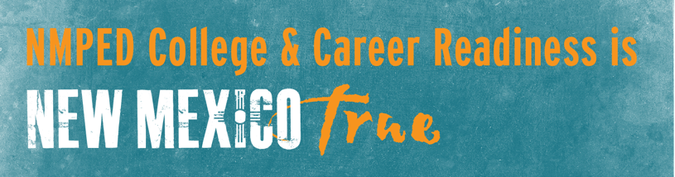

Building the Next Generation
of Career and Technical Education
Outcomes – April 9 Region D Consortia Meeting
Vision Statement: DRAFT STATEMENT FOR YOUR REVIEW/SUGGESTIONS/EDITS
Career and Technical Education in Region D is seamlessly aligned and integrated in supporting career readiness for students as they navigate accessible pathways between K-12, college, and careers in relevant industry sectors. CTE is flexible and responsive to the evolving needs of both students and employers, generating talent with the right skills, attitudes, and credentials for long-term success.

Target Industries for Investment:
- STEM/IT-Computer Science (7 votes), including application to:
  - Engineering
- Skilled Trades (5 votes), including application to:
  - Architecture
  - Manufacturing
- Healthcare (4 votes)
- Hospitality/Tourism (3 votes)

Within each program of study aligned to the target industries, there will be an intentional effort to support:
- Management skills
- CTE educator preparation

Opportunities to Pursue Moving Forward:
- Skills are a big focus for Region D. In thinking about equipping talent for careers they need to be equipped with:
  - Foundational skills
  - Employability skills
  - Technical skills
  - Cross-disciplinary skills
- There is also a focus on working to help instructors be ready to deliver instruction that instills these kinds of skills.
- Work-based learning opportunities like internships and apprenticeships need to be intentionally woven into CTE pathways.
- There is an important role for intermediaries to play in the integration and alignment of the workforce system.
- There is a recognition of the need to generate teachers more broadly, and the need to identify other resources for building the teacher workforce will benefit the region.

NOTES FROM THE DISCUSSION:

Characteristics of the Workforce Talent of Region D:
- Adaptable (3)
- Highly skilled (3)
- Technically skilled
- Professional skills
- Dedicated
- Evolving
- Ready
- Diverse
- Flexible (2)
- Resilient/Grit (3)
- Aligned
- Agile
- Prepared
- Stable
- Competent
- Motivated
- Innovative (2)
- Reliable
- Takes Initiative (2)
- Cross-disciplinary
- Relevant
- Collaborative

Characteristics of our CTE Program to Build the Talent We Need:
- Evolving
- Dedicated
- Aligned (2) – comprehensive programs of study aligned to post-secondary outcomes
- Adaptable (2)
- Integrated
- Accessible
- Disjointed (use a common language, shared expectation)
- Psychological – instills both attitudes and employability skills to prepare students for career success
- Defined
- Connected
- Innovative
- Flexible (2) – ready to adapt in a changing economy
- Responsive
- Relevant
- Collaborative
- Readiness

