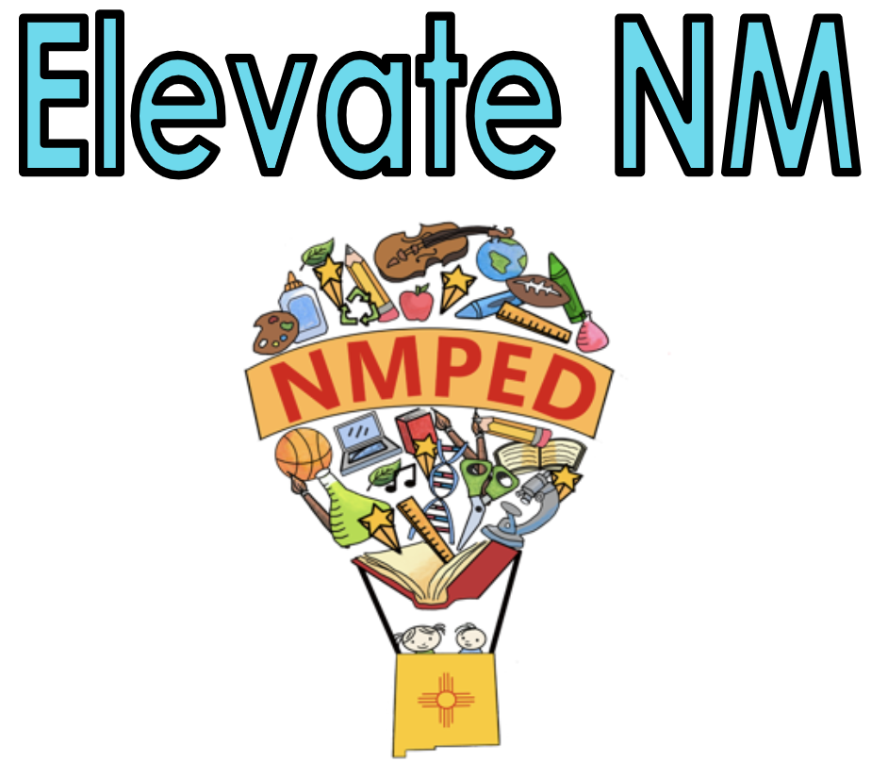
Element 1-A. Demonstrating Knowledge of Content

The teacher knows the subject matter well, has a good grasp of child development and how students learn. The teacher designs effective and rigorous standards-based units of instruction consisting of well-structured lessons with measurable outcomes for “all students.”

Note: Any reference to “all students” includes culturally and linguistically diverse students, English Learners (ELs), and Students with Disabilities (SWD).
Note: Any reference to New Mexico adopted standards includes the 2012 Amplification of WIDA English Language Development (ELD) Standards when serving English Learners (ELs) and Individualized Education Program (IEP) goals when serving SWD.
Not Demonstrating | Developing | Applying | Innovating
- Demonstrates little knowledge of the subject matter and /or its pedagogy.  - Rarely engages students in learning experiences focused on complex knowledge or subject-specific skills and vocabulary.  - Minimal or no alignment to NM adopted standards.  - IEP goals for present levels of performance are not addressed in the unit and lesson development.  - Demonstrates little or no knowledge of developmental levels of students in the grade, subject, or differences in how students learn. (Develops one learning experience for all students and does not enable most students to meet the intended outcomes.) | - Demonstrates factual knowledge of subject matter and the pedagogy it requires by sometimes engaging students in learning experiences that enable them to acquire complex knowledge and subject-specific skills and vocabulary.  - Develops lessons/units that are partially aligned to NM adopted standards and/or minimal focus on IEP goals for present levels of performance.  - Implements lessons/units of instruction with some elements of appropriate student engagement strategies.  - Students’ outcomes are poorly defined and tasks are not challenging;  - Minimal evidence of differentiated instruction or scaffolding of instruction. | - Demonstrates sound knowledge and understanding of the content area and academic language demands at a grade-appropriate level, and consistently engages students in the learning experiences that enable them to acquire complex knowledge, skills, and vocabulary.  - Demonstrates knowledge of the developmental levels of students in this grade or subject by providing differentiated learning experiences that enable all students to exercise self-management, make responsible decisions, and make significant progress toward intended learning outcomes.  - Lessons/units are directly aligned to all NM adopted standards and/or IEP goals for present levels of performance.  - Lesson/units developed contain evidence of collaboration between general and special education teachers to ensure understanding and inclusion of IEP goals, modifications, and accommodations related to self-advocacy skills. | - Demonstrates extensive knowledge of the content area(s) to be taught, including academic language demands, and correlates the IEP objectives with lesson plans/unit, when applicable.  - Adapts as needed and implements standard-based units comprising well-structured lessons with challenging tasks and measurable outcomes with appropriate student engagement strategies, pacing, resources, grouping, and purposeful questions and strategic use of technology and digital media.  - Students are able to learn and apply authentic context to the knowledge and skills defined in the state standards. It contains evidence-based specialized instruction according to the IEP, when applicable.  - Creates opportunities for students to contribute to the lesson design and content; includes opportunities for modifications in the IEP or language proficiency levels to be implemented across content areas, when applicable.
Evidence:

Indicators include:
- Lesson and unit plans that reflect important concepts and academic language in the discipline and progress in a logical manner
- Lesson and unit plans that integrate a variety of strategies to help learners access information
- Lesson and unit plans that contain differentiation

Element 1-B. Demonstrating Knowledge of Students

The teacher has a good grasp of child development and how students learn and designs effective and rigorous standards-based units of instruction consisting of well-structured lessons with measurable outcomes for “all students.”

Note: Any reference to “all students” includes culturally and linguistically diverse students, English Learners (ELs), and Students with Disabilities (SWD).
Note: Any reference to New Mexico adopted standards includes the 2012 Amplification of WIDA English Language Development (ELD) Standards when serving English Learners (ELs) and Individualized Education Program (IEP) goals when serving SWD.
Not Demonstrating | Developing | Applying | Innovating
- Demonstrates little or no knowledge of students’ backgrounds, cultures, skills, academic language development, interests, and/or special needs, including present levels of performance for applicable content areas and behavioral issues.  - Lacks evidence of using student achievement data to design activities for differentiated instruction.  - Limited knowledge of students’ learning styles and does not integrate varied approaches to learning.  - Very limited knowledge of how to design activities that support student understanding, performance and growth. | - Demonstrates limited knowledge of students’ backgrounds, cultures, skills, academic language development, interests, and special needs, including present levels of performance for applicable content areas and behavioral issues.  - Inconsistently uses evidence of student achievement data to the design activities.  - Does not consistently differentiate instruction;  limited in their knowledge of student learning styles varying approaches to student learning.  - Some knowledge of how to design activities that support student understanding, performance and growth. | - Demonstrates knowledge of students’ backgrounds, cultures, skills, academic language development, interests, and special needs, including present levels of performance for applicable content areas and behavioral issues as well as accommodations and modification for individual students, as applicable.  - Incorporates culturally responsive strategies into instructional planning and practice.  - Integrates high-quality instructional materials to enhance student learning.  - Provides moderate evidence of using student achievement data to differentiate instruction including—when supporting ELs—the use of ACCESS scores for EL students to differentiate instruction according to English language proficiency levels.  - Develops lessons using a variety of strategies to incorporate student background knowledge and culture as well as learning styles. | - Demonstrates extensive knowledge and responsiveness to students’ backgrounds, cultures, skills, academic language development, interests, special needs—including present levels of performance for applicable content areas and behavioral issues as well as accommodations and modification for individual students.  - Includes students in the planning of culturally sustaining strategies and incorporates those into instructional practice.  - Provides strong evidence of using student achievement data to differentiate instruction, including the use of ACCESS scores to support and monitor the progress of ELs and to differentiate their instruction according to English language proficiency levels.  - Uses a wide repertoire of strategies to integrate a variety of learning styles and lessons and activities.
Evidence:

Indicators Include:
- Formal and informal information about students gathered by the teacher for use in planning and instruction
- Student interests, cultural and linguistic background, as well as needs, are learned by the teacher for use in planning
- Teacher-designed opportunities for families to share their heritage
- The teacher has listed the modifications or accommodations that a student needs to be successful in obtaining the learning goals of the lesson

Element 1-C. Setting Instructional Outcomes and Designing Student Assessment

The teacher analyzes data from assessments, draws conclusions, and shares them appropriately.

Note: Any reference to “all students” includes culturally and linguistically diverse students, English Learners (ELs), and Students with Disabilities (SWD).
Note: Any reference to New Mexico adopted standards includes the 2012 Amplification of WIDA English Language Development (ELD) Standards when serving English Learners (ELs) and Individualized Education Program (IEP) goals when serving SWD.
Not Demonstrating | Developing | Applying | Innovating
- Learning outcomes are not communicated to students or communicated with low expectations, not grade-level appropriate, and/or not clearly written.  - Administers only the assessments required by the school and does not utilize a variety of assessment methods.  - Does not communicate with students as to how they will be assessed.  - Makes few adjustments to practice based on formal and informal assessments. | - May administer some informal and /or formal assessments to measure student learning but rarely measures student progress toward achieving NM state standards.  - Learning outcomes are statted but not measurable.  - Provides some direction to students as to how they will be assessed but does not check for understanding throughout the lesson.  - Assessments may not be suitable for all students, somewhat grade-level appropriate, and/or do not reflect more than one type of learning but lack coordination and integration. | - Uses formative assessments that explicitly support instructional outcomes in both content and language.  - Learning outcomes are explicitly stated as measurable and observable and reflect high expectations.  - Checks for understanding throughout the lesson.  - Establishes instructional processes and assessments that address the varying abilities of all learners.  - Assessments address the language demands of the content by including differentiated language demands based on individuals students’ academic language proficiency levels.  - Assessments contain modifications and are aligned to IEP goals, as required to ensure all students can complete the instructional outcomes.  - Consistently and explicitly informs students of the content and language objectives for the lesson.  - Includes a variety of assessments, both formative and summative, in the four language domains (Reading, Writing, Speaking, Listening).  - Include differentiated language demands based on individual student’s academic language proficiency levels. | - Reflects high expectations that are clearly stated.  - Designs and administers a comprehensive system of informal and formal assessments, including common interim assessments and ongoing progress monitoring methods, to measure each student’s learning, growth,critical thinking, and progress toward achieving state standards.  - Assessments contain modifications, as required to ensure students can complete the instructional outcomes and address IEP goals.  - Involves students in the process of developing learning goals, based on NM adopted standards.  - Provides opportunities for students to demonstrate and/or record where they are in their own learning. Shares clearly aligned rubrics with students and supports students to monitor their academic and linguistic growth.
Evidence:

Indicators include:
- Outcomes of a challenging cognitive level
- Statements/Evidence of student learning, not student activity
- Outcomes permitting assessment of student attainment
- Outcomes differentiated for students of varied ability

Element 1-D. Demonstrating Knowledge of Resources

Teacher utilizes skills and content learned from professional development opportunities
and ensures “all students” have access to resources to support their learning.

Note: Any reference to “all students” includes culturally and linguistically diverse students, English Learners (ELs), and Students with Disabilities (SWD).
Note: Any reference to New Mexico adopted standards includes the 2012 Amplification of WIDA English Language Development (ELD) Standards when serving English Learners (ELs) and Individualized Education Program (IEP) goals when serving SWD.
Not Demonstrating | Developing | Applying | Innovating
Little to no evidence of resources being utilized to enhance the teacher’s own content knowledge, to use in teaching, or to use with students who demonstrate need. | - Minimal use of existing resources—including support materials, textbooks, and supplementary materials—to enhance content knowledge for teaching and to differentiate instruction for all students.  - Minimal use of resources and supplementary materials—which may include those available through the school, district, community, and/or on the internet—in the language(s) of the students, when appropriate.  - Minimal use of information and strategies obtained through professional development to address students’ individual learning needs, styles, rates, and level of learning—including academic English language proficiency. | - Uses existing resources—including support materials, textbooks, and supplementary materials—to enhance content knowledge for teaching and to differentiate instruction for all students.  - Uses resources and supplementary materials—which may include those available through the school, district, community, and/or on the internet—in the language(s) of the students, when appropriate.  - Uses information and strategies obtained through professional development to address students’ individual learning needs, styles, rates, and level of learning—including academic English language proficiency. | - Seeks out and uses resources available beyond the school and district—including those from professional organizations, the internet, and/or within the community—to enhance content knowledge and to use in teaching all students and especially those who demonstrate need.  - Strategically implements information and strategies obtained through professional development to address individual learning styles, rates, and levels of learning including students with disabilities, students’ cultural backgrounds, and/or English language proficiency.  - Creates lessons that reduce barriers, optimize levels of challenge and support, meet the needs of all learners, and increase access to the grade-level curriculum.
Evidence:

Indicators include:
- Materials provided by the district
- Materials provided by professional organizations
- A range of texts
- Internet resources, community resources, and/or guest speakers (experts in the field)
- Ongoing participation by the teacher in professional education courses or professional groups

Element 1-E. Designing Coherent Instruction

The teacher develops meaningful sequenced lessons and activities that are also differentiated to support the learning of “all students.”

Note: Any reference to “all students” includes culturally and linguistically diverse students, English Learners (ELs), and Students with Disabilities (SWD).
Note: Any reference to New Mexico adopted standards includes the 2012 Amplification of WIDA English Language Development (ELD) Standards when serving English Learners (ELs) and Individualized Education Program (IEP) goals when serving SWD.
Not Demonstrating | Developing | Applying | Innovating
- Learning activities are not suitable and/or are not research-based.  - Lessons lack a variety of learning strategies and do not provide individual student supports.  - Time allocations for learning activities are unrealistic and/or not grade-level appropriate. | - Learning activities are minimally suitable and/or are minimally research-based.  - Some variety of learning strategies and minimal individual student support.  - Time allocations for learning activities that are relatively reasonable and/or somewhat grade-level appropriate. | - Learning activities are suitable and/or are research-based.  - A variety of learning strategies and individual student supports.  - Time allocations for learning activities that are reasonable and/or grade-level appropriate.  - Learning activities are differentiated by scaffolding content and academic language for all learners.  - Learning activities create explicit connections between previous learning and new concepts and develop skills for all learners.  - Opportunities for all students to participate in flexible grouping.  - Challenging research-based learning tasks that are structured to progressively develop students’ cognitive abilities and academic language.  - Explicit use of students’ backgrounds to teach relationships among topics, concepts, and language. | - Pedagogical practices include flexible grouping and differentiated instruction, based on student level and IEP goals, as applicable.  - Questions to reinforce and extend student learning and engagement to include real-world and application-based experiences, while including purposeful scaffolding of questions based on students’ level of academic language.  - Learning activities that, when possible, incorporate students’ use of their first and second languages to make connections to real-world applications and include learning activities that progress coherently, are research-based, and are relevant to students and the instructional/IEP goals, as applicable.  - Opportunities to incorporate student-centered learning as an instructional tool.  - Research-based practices, including sheltered and differentiated instructional strategies, with a variety of specially designed instructional materials.
Evidence:

Indicators include:
- Lessons that support instructional outcomes and reflect important concepts
- Instructional maps that indicate relationships to prior learning
- Activities that represent high-level thinking
- Opportunities for student choice
- Use of varied resources
- Thoughtfully planned learning groups
- Structured lesson plan/unit

