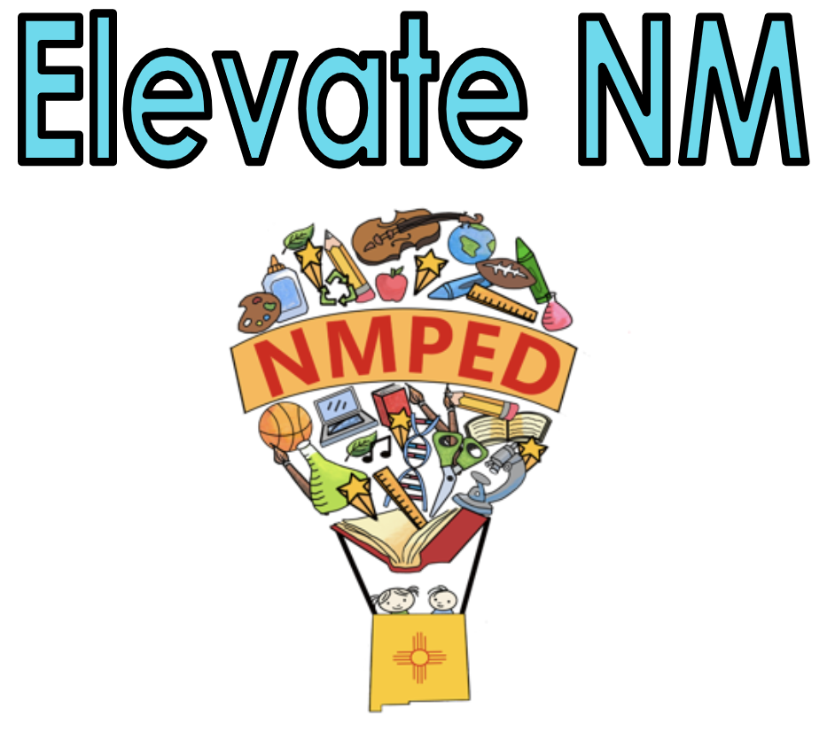
Element 4-A. Communicating with Families

Teachers establish relationships with families by communicating with them about the instructional program, conferring with them about their individual student(s), and inviting them to be part of the educational process itself on a regular basis throughout the academic school year.

Note: Any reference to “all students” includes culturally and linguistically diverse students, English Learners (ELs), and Students with Disabilities (SWD).
Note: Any reference to New Mexico adopted standards includes the 2012 Amplification of WIDA English Language Development (ELD) Standards when serving English Learners (ELs) and Individualized Education Program (IEP) goals when serving SWD.
Not Demonstrating | Developing | Applying | Innovating
- Rarely adheres, or does not adhere, to the district’s/school’s requirements for communicating with families.  - Provides little or no information to families about the instructional program, the IEP goals (academic and/or behavioral) as applicable, and/or progress toward goals for all students.  - Communicates with or responds to families only through report cards or at conference time.  - Communicates with families inappropriately or disrespectfully; makes no effort to understand different home languages, cultures, and values. | - Minimally adheres to the district’s/school’s requirements for communicating with families.  - Does not clearly communicate to families the instructional program, the IEP goals (academic and/or behavioral) as applicable.  - Relies primarily on newsletters and other one-way media to communicate with families.  - Usually responds promptly and respectfully to communications from families, but demonstrates inconsistent or little understanding of different home languages, cultures, and values. | - Fully adheres to the district’s/school’s requirements for communicating with families.  - Conducts effective communications from school-to-home about appropriate school programs and student progress, including the ACCESS for ELs Parent Report and IEP goals, as applicable, and effectively responds to home-to-school communications.  - Consistently provides families with clear, user-friendly expectations for student learning and behavior.  - Regularly communicates with families in an affirming manner about student learning and performance, invites and responds promptly to communications from families while demonstrating an understanding of and respect for different home languages, cultures, and values. | - Goes beyond the district’s/school’s requirements for communicating with families, and provides frequent information to families about ways to support children as learners, student progress, instruction, and assessment— including the ACCESS for ELs Parent Report, as applicable.  - Communicates with families on student progress, learning goals and/or IEP goals (academic and/or behavioral) and progress towards goals when supporting SWD as well as EL students, using specific examples of student progress based on data in parent-friendly language, as applicable.  - Regularly uses a reciprocal system that supports frequent, proactive, and personalized communication with families about student learning and performance, while demonstrating an understanding of and appreciation for different families’ home language, culture, and values.
Evidence:

Indicators include:
- Frequent and culturally appropriate information sent home regarding the instructional program and student progress
- Two-way communication between the teacher and families
- Frequent opportunities for families to engage in the learning process

Element 4-B: Participating in a Professional Learning Community

Teachers collaborate with their colleagues in order to share strategies, plan joint efforts, and plan for the success of individual students.

Note: Any reference to “all students” includes culturally and linguistically diverse students, English Learners (ELs), and Students with Disabilities (SWD).
Note: Any reference to New Mexico adopted standards includes the 2012 Amplification of WIDA English Language Development (ELD) Standards when serving English Learners (ELs) and Individualized Education Program (IEP) goals when serving SWD.
Not Demonstrating | Developing | Applying | Innovating
- Does not participate in a professional learning community.  - Does not participate in required school/district activities.  - Demonstrates relationships with colleagues which are negative and/or unprofessional. | - Participates minimally in a professional learning community.  - Inconsistently attends required school/district activities.  - Maintains relationships with colleagues that are cordial, but these relationships do not lead to productive work that benefits students.  - Interacts minimally with appropriate personnel about instructional, environmental, and behavioral modifications for SWD and/or about instructional strategies for culturally and linguistically diverse students. | - Participates actively in a professional learning community.  - Participates in school and district required activities.  - Maintains positive and productive relationships with colleagues that benefits students.  - Provides appropriate information on SWD and ELs to appropriate personnel as applicable (e.g., strengths, weaknesses, preferred modalities, environmental modifications, IEP goals, etc.).  - Consults with appropriate personnel about instructional, environmental, and behavioral modifications for SWD and about instructional strategies for culturally and linguistically diverse students, as applicable.  - Participates in interactions with colleagues that are characterized by a willingness to listen and consider multiple points of view. | - Makes a substantial contribution to the professional learning community.  - Actively and consistently participates in school/district activities.  - Shares knowledge of, and proactively seeks, opportunities to learn more about techniques and strategies to work with all students, which may include cultural perspectives.  - Proactively seeks opportunities to learn about researched-based techniques and strategies for sheltering academic language and that address student learning.  - Collaborates with other teachers to monitor IEP objectives addressed in the regular classroom.
Evidence:

Indicators include:
- Regular teacher participation with colleagues to share and plan for student success
- Regular teacher participation in professional courses or communities that emphasize improving practice
- Regular teacher participation in school and/or district initiatives

Element 4-C. Reflecting on Teaching

Demonstrates the capacity to reflect on and improve the educator’s own practice, using informal means as well as meetings with teams and workgroups to gather information, analyze data, examine issues, set meaningful goals and develop new approaches in order to improve teaching and learning.

Note: Any reference to “all students” includes culturally and linguistically diverse students, English Learners (ELs), and Students with Disabilities (SWD).
Note: Any reference to New Mexico adopted standards includes the 2012 Amplification of WIDA English Language Development (ELD) Standards when serving English Learners (ELs) and Individualized Education Program (IEP) goals when serving SWD.
Not Demonstrating | Developing | Applying | Innovating
- Rarely or never accurately assesses the effectiveness of their instructional practices.  - Lacks awareness of how instructional practices can be improved.  - Rarely or never uses data to reflect on their instructional practices. | - Provides a partially accurate and objective description of instructional practices with some evidence.  - Makes general, non-specific suggestions as to how instructional practices might be improved.  - Occasionally uses data to inform and modify instructional practices. | - Provides an accurate and objective description of instructional practices with specific evidence.  - Uses progress monitoring to reflect on the effectiveness of instructional practices.  - Provides specific suggestions as to how instructional practices might be improved, based on students’ progress and use of assessment data. | - Consistently reflects on instructional practices thoughtfully and accurately with specific evidence.  - Consistently uses progress monitoring to reflect on the effectiveness of instructional practices.  - Exhibits skills and knowledge that reflect current research and best practices in the field.  - Suggests alternative instructional practices and predicts the likely success of each.  - Uses assessment data as a primary driver to inform the quality and effectiveness of instructional practices.
Evidence:

Indicators include:
- Accurate reflections on a lesson
- Citation of adjustments to practice that draw on a repertoire of strategies
- Reflects on student data on an ongoing basis looking for trends and areas for improvement

Element 4D – Demonstrating Professionalism
The teacher demonstrates professionalism by acting with integrity and honesty. The teacher is ethical and reliable and meets routine responsibilities consistently while putting student needs at the forefront of their decision-making.
Note: Any reference to “all students” includes culturally and linguistically diverse students, English Learners (ELs), and Students with Disabilities (SWD).
Note: Any reference to New Mexico adopted standards includes the 2012 Amplification of WIDA English Language Development (ELD) Standards when serving English Learners (ELs) and Individualized Education Program (IEP) goals when serving SWD.
Not Demonstrating | Developing | Applying | Innovating
- Contributes to practices that are negative and/or harmful to students, colleagues or school climate.  - Rarely complies, or fails to comply, with district/school regulations and timelines.  - Does not comply with school regulations, timelines, assigned duties, or attend regularly scheduled meetings. | - Displays minimal professionalism by making decisions and recommendations based on the needs of some students.  - On occasion condones or supports practices that are negative and/or harmful to students, colleagues or school climate.  - Minimally complies with district/school regulations and timelines.  - Inconsistently follows district/school regulations, timelines, and fails to maintain accurate documentation. | - Displays a high level of professionalism by making decisions and recommendations based on the needs of all students.  - Promotes a positive working/learning environment for students, colleagues, and community members.  - Demonstrates knowledge of applicable laws, policies, regulations, and procedures related to all students.  - Consistently follows district/school regulations and timelines and maintains accurate documentation.  - Promotes a safe environment when monitoring students and activities.  - Works to achieve equitable learning and achievement outcomes for all students. | - Seeks leadership opportunities to ensure the highest level of professional practice by all members of the learning community.  - Works with colleagues to create activities promoting a positive school environment.  - Assists in designing school practices that honor all students and the goals and mission of the learning community.  - Models advocacy for, and instructs, all students in self-advocacy skills, making particular effort to challenge negative attitudes and to ensure that all students are honored and valued.
Evidence:

Indicators include:
- The teacher has a reputation as being trustworthy and often sought as a sounding board
- The teacher frequently reminds participants during committee or planning work that students are the highest priority
- The teacher supports and advocates for students, even in the face of difficult situations or conflicting policies
- The teacher consistently fulfills district mandates regarding policies and procedures

Element 4E – Growing and Developing Professionally
Actively pursues professional development and learning opportunities to improve the quality of practice and build the expertise and experience to assume different instructional and leadership roles.
Note: Any reference to “all students” includes culturally and linguistically diverse students, English Learners (ELs), and Students with Disabilities (SWD).
Note: Any reference to New Mexico adopted standards includes the 2012 Amplification of WIDA English Language Development (ELD) Standards when serving English Learners (ELs) and Individualized Education Program (IEP) goals when serving SWD.
Not Demonstrating | Developing | Applying | Innovating
- Rarely participates, or does not participate, in professional development activities.  - Makes no effort to share knowledge with colleagues.  - Demonstrates resistance to feedback from supervisors and/or colleagues. | - Participates minimally in professional development activities that are convenient and/or required.  - Makes limited attempts to share knowledge with colleagues.  - Attempts to integrate feedback from supervisors and colleagues. | - Accepts opportunities for professional growth, based on identified areas in need of improvement.  - Implements evidence-based strategies learned in professional development sessions.  - Actively reads and applies current research in areas of greatest impact for all students.  - Implements feedback from supervisors and colleagues regarding evidence-based instruction. | - Actively pursues professional development opportunities.  - Initiates activities to share expertise with others, including evidence-based instruction.  - Seeks out feedback and best practices from supervisors and colleagues/specialists in areas such as Indian Education, ELs, special education, and bilingual education, in order to make instruction accessible and understandable for all students.  - Expands on feedback from supervisors/colleagues and uses it to directly improve instruction.
Evidence:

Indicators include:
- Frequent teacher attendance in courses and workshops; regular academic reading
- Participation in learning networks with colleagues; freely shared insights
- Participation in professional organizations supporting academic inquiry

