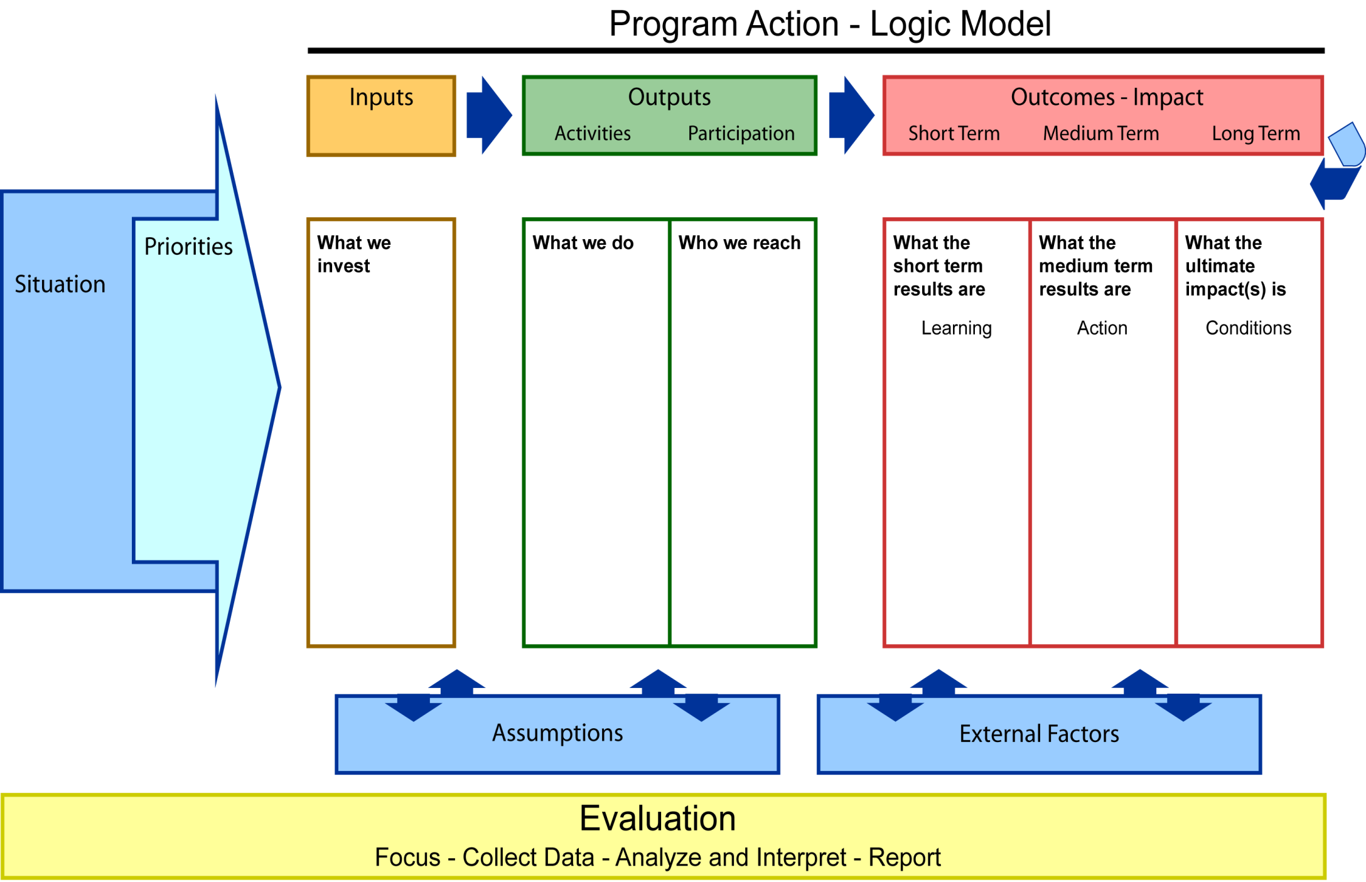

Community

{Populate with details}

Elders

Community members

Parents/Guardians

Administrators

Teachers

Students

{Populate with details}

|  |
| --- |
| Culturally Responsive programs |
| Native Language Programs |
| Culturally Responsive Teaching and curriculum |

{Populate with details}

Language proficiency increases

Improvement in student attitudes

{Populate with details}

Indigenous Language Loss

Cultural Identity loss

{Populate with details}

Fund culturally responsive programs

Fund programs to revitalize Indigenous languages

Fun professional development for culturally responsive teaching

Fund efforts to articulate culturally responsive curriculum

{Populate with details}

Students become proficient in Indigenous languages

Students are positively impacted indirectly through learning about their culture and languages

Budget Available

{Populate with details}

Students start to learn the Indigenous languages

{Populate with details}

Students speak Indigenous languages outside of school settings

Community members become more supportive of the schools

Parents

Family

{Populate with details}

Language and culture revitalization

{Populate with details}

Revitalize the Indigenous Languages

Revitalize the Culture