Distance Learning Tips

As we shift into hybrid, remote and distance learning models teachers and students are approached with a new way of learning and teaching. Below are ideas to accommodate the teacher in the classroom as they go forward and to assist as they begin the process of collecting data and artifacts to complete the PDD(dossier) process.

What Does Evidence, Artifacts and Data Look Like?
- Observing (screen shots- while on zoom/meets)
- Share Screen- student leaders
- Discussion post participation
- Completion reports from online practice tools
- Student video responses explaining a concept
- Daily exit slips
- If utilizing GSuites- the communication/collaboration in a doc/slide/sheet
- Building, inventing, postcard writing
- Interview questions
- Storytelling (record)
- Map-making, drawing
- Note taking
- Program driven quizzes
- Class newsletter/Emoji Classroom
- Breakout room assignments ( for Differentiated Instruction)
- Create an engagement plan to blend online learning program
- Digital work samples/pictures

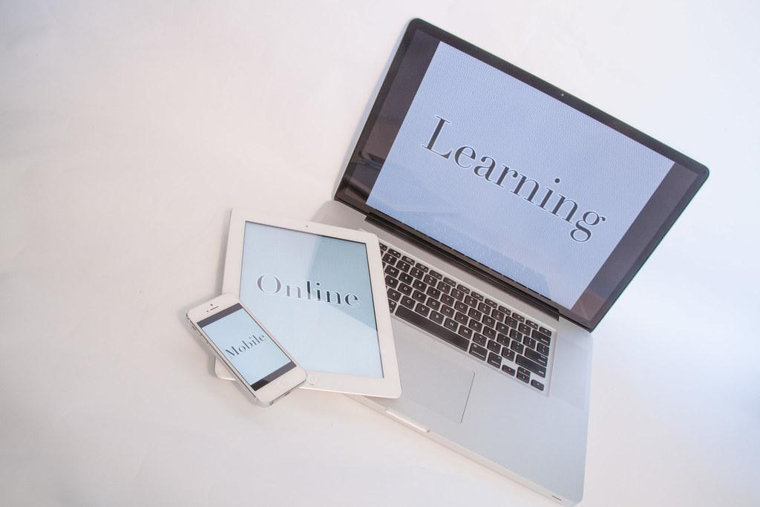
What Does Parent Communication Look Like?
- Targeted emails reaching out to parents
- Accommodating parents by creating a Form questionnaire
- Texts (screenshots), phone calls, phone logs
- Newsletters

Your willingness to advance online education for students will be shown with increased technological literacy and the ability to adapt and handle challenges with pedagogy, communication, and discipline while online. Continue to be creative and collaborate with colleagues to develop the different ways of asynchronous methods when teaching online.

More resources available at https://www.rec9nm.org/Professional-Development-Dossier
