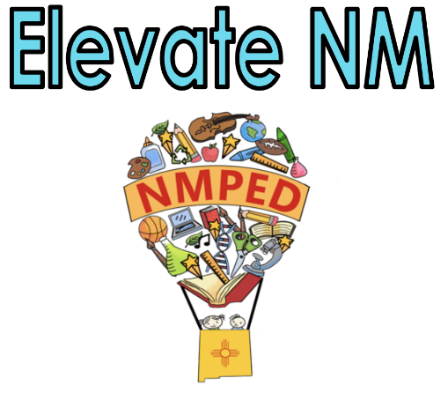

2A: Creating an Environment of Respect and Rapport

An essential skill of teaching is that of managing relationships with students and ensuring that relationships among students are positive and supportive. Teachers create an environment of respect and rapport in their classrooms by the ways they interact with students and by the interactions they encourage and cultivate among students. An important aspect of respect and rapport relates to how the teacher responds to students and how students are permitted to treat one another.

Note: Any reference to “all students” includes culturally and linguistically diverse students, English Learners (ELs), and Students with Disabilities (SWD).
Note: Any reference to New Mexico adopted standards includes the WIDA English Language Development Standards (ELD) Framework, 2020 Edition Standards when serving English Learners (ELs) and Individualized Education Program (IEP) goals when serving SWD.

Innovating | Applying | Developing | Not Demonstrating
- Exhibits a high degree of respect.  - Reflects warmth and caring.  - Reflects a high degree of sensitivity to students’ cultures that may include purposeful teacher-student or student-student dialogue in multiple languages.  - Reflects a high degree of sensitivity to students’ levels of development. | - Applying  - Exhibits politeness and respect.  - Supports students in managing disagreements.  - Creates and maintains an environment in which students’ diverse backgrounds, languages, identities, strengths, and challenges are respected.  - Displays respect and value for the languages and cultures of the school’s diverse community through classroom artifacts and interactions. | - Minimal display of politeness and respect.  - Minimal support of students in managing disagreements.  - Minimal maintenance of an environment in which students’ diverse backgrounds, languages, identities, strengths, and challenges are respected.  - Minimal display of respect and value for the languages and cultures of the school’s diverse community through classroom artifacts and interactions. | - Classroom interactions between the teacher and students, and among students are inappropriate and/or insensitive to students’ diverse backgrounds, languages, identities, and culture.
Evidence:

Indicators may include:
- Respectful talk, active listening, and turn-taking
- Acknowledgment of students’ backgrounds and lives outside the classroom
- Body language indicative of warmth and caring shown by the teacher and students
- Appropriate physical proximity
- Politeness and encouragement
- Fairness and inclusivity

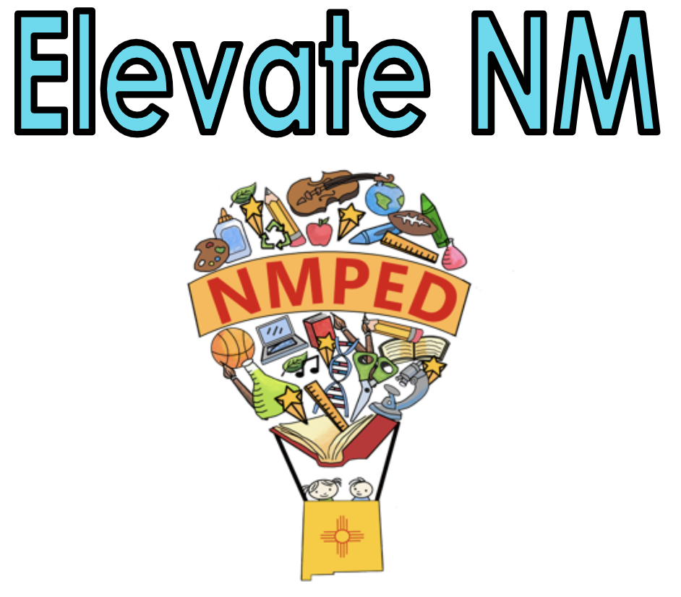
2B: Creating a Safe Learning Environment with Routines and Procedures

Creates and maintains a safe and collaborative learning environment that motivates all students to take academic risks, challenge themselves, and claim ownership of their learning. Access is provided to learning materials and resources.
Note: Any reference to “all students” includes culturally and linguistically diverse students, English Learners (ELs), and Students with Disabilities (SWD).
Note: Any reference to New Mexico adopted standards includes the WIDA English Language Development Standards (ELD) Framework, 2020 Edition Standards when serving English Learners (ELs) and Individualized Education Program (IEP) goals when serving SWD.

Innovating | Applying | Developing | Not Demonstrating
- Uses routines, and proactive responses that create and maintain a safe physical and intellectual environment where students take academic risks and play an active role—individually and collectively—in preventing behaviors that interfere with learning. Models this practice and shares thinking with students.  - Learning resources are accessible to use and adapt to advance learning and engage students at varying levels of academic content including English language proficiency and supports for students with disabilities.  - Students internalize daily routines.  - Students taking the initiative and contributing to the seamless operation of the classroom, well-organized transitions, and classroom procedures, including those that pertain to developmentally appropriate cooperative learning activities. | - Uses routines, and appropriate responses that create and maintain a safe physical and intellectual environment where students take academic risks and most behaviors that interfere with learning are prevented.  - Ensures learning resources are accessible to all students.  - The physical arrangement encourages teacher-student and student-student interaction in a variety of settings and student groupings.  - Learning goals, such as content and language objectives, are posted and easily accessible during the lesson for the teacher and all students to reference.  - Visuals, graphics, anchor charts, and technology are readily accessible to enhance learning opportunities.  - Provides techniques to enhance learning opportunities, such as preferential seating, study carrels, quiet areas, etc. | - Learning environment is safe.  - Routines and responses needed to prevent and/or stop behaviors that interfere with all students’ learning are used inconsistently and may not be developmentally appropriate.  - Partially effective routines for the transitions are utilized.  - Learning resources are accessible to most students. | - Learning environment is unsafe or does not support student learning.  - Uses inappropriate or ineffective routines and inefficient transitions.  - Uses inappropriate or ineffective responses to reinforce positive behavior or respond to behaviors that interfere with students’ learning.  - Students do not have access to learning resources and/or inefficient use of supplies and materials.
Evidence:

Indicators may include:
- Pleasant, inviting atmosphere
- Safe environment
- Accessibility for all students including the posting of learning and language goals
- Furniture arrangement suitable for the learning activities and supports the student to student collaboration
- Effective use of physical resources, including computer technology, by both teacher and students
- The smooth functioning of all routines
- Little or no loss of instructional time (smooth and efficient transitions)
- Students playing an important role in carrying out the routines
- Students knowing what to do, where to move

2C: Establishing a Culture for Learning

Uses instructional practices that reflect high expectations regarding content and quality of effort and work; engage all students; and are personalized to accommodate diverse learning styles, needs, interests, and levels of readiness.

Note: Any reference to “all students” includes culturally and linguistically diverse students, English Learners (ELs), and Students with Disabilities (SWD).
Note: Any reference to New Mexico adopted standards includes the WIDA English Language Development Standards (ELD) Framework, 2020 Edition Standards when serving English Learners (ELs) and Individualized Education Program (IEP) goals when serving SWD.

Innovating | Applying | Developing | Not Demonstrating
- High levels of enthusiasm for the subject by teacher and students is evidenced by student engagement.  - Students seek out support and initiate improvements to their efforts (may vary depending on the student group population, e.g., ID, ED).  - Students being encouraged to reflect on their personal learning and growth.  - Students regularly seek out their peers as resources.  - Routinely supports all students to identify strengths, interests, and needs; set and pursue learning and language goals; ask for support when appropriate; take academic risks; problem-solve; challenge themselves, and monitor their own progress.  - The tone is set by the students and is inclusive of cultural and linguistic differences. | - High expectations for all students.  - Norms and participant structures that are established with significant interaction by, and among, all peers, such as flexible student groups, student presentations, and structured student dialogue.  - Supports all students to hold themselves to high standards of performance through instruction, including addressing foundational skills, as per the IEP goals.  - Authentic and relevant use of research-based strategies to enhance the understanding of content and increase student engagement with the related academic vocabulary.  - Student commitment to the subject and demonstration of pride in their efforts.  - Provides opportunities for students to learn in groups with diverse peers and facilitates meaningful academic discourse by developing individual student’s relationship and communication skills.  - Often creates learning experiences that guide students to identify their strengths, interests, and needs; problem-solve; ask for support when appropriate; take academic risks, and challenge themselves to learn.  - The tone is inclusive of cultural and linguistic differences. | - Modest expectations for student achievement.  - Students and teacher only “going through the motions.”  - Teaches some relationship and communication skills by providing some opportunities for students to work in groups.  - Creates some learning experiences that guide students to identify needs, ask for support, problem-solve, and challenge themselves to take academic risks.  - Some student commitment to the subject and demonstration of pride in their efforts. | - Low expectations for student achievement and engagement.  - Uses limited and/or inappropriate practices to accommodate differences.  - Makes little effort to teach relationship and communication skills or facilitate student work in groups, or such attempts are ineffective.  - Directs all learning experiences, providing few, if any, opportunities for students to engage with the content.
Evidence:

Indicators may include:
- Belief in the value of what is being learned
- High expectations, supported through both verbal and nonverbal behaviors, for both learning and participation
- The expectation of high-quality work by the teacher and internalized by the student
- Expectation and recognition of effort and persistence on the part of the students
- High expectations for expression and work products

2D: Managing Student Behavior

The teacher utilizes a skill-building approach that strengthens the foundation of social skills for all students. Teaches behavioral expectations and acknowledges students for following them.

Note: Any reference to “all students” includes culturally and linguistically diverse students, English Learners (ELs), and Students with Disabilities (SWD).
Note: Any reference to New Mexico adopted standards includes the WIDA English Language Development Standards (ELD) Framework, 2020 Edition Standards when serving English Learners (ELs) and Individualized Education Program (IEP) goals when serving SWD.

Innovating | Applying | Developing | Not Demonstrating
- Allowing student ownership and creating opportunities for students to lead the implementation of the student behavior management plan.  - Evidence of students’ participation in setting conduct standards and monitoring their own behavior.  - Responds with sensitivity to the individual needs of all students including those with diverse linguistic and cultural backgrounds and identities while ensuring the FBA/BIP are being followed, when applicable. | - Evidence of a student behavior management plan with students’ knowledge of their roles.  - An atmosphere conducive to learning with a focus on student self-discipline, respect for the rights of others, and cooperation.  - Communication and modeling of said expectations for all students.  - Responses to student behavior are consistent, respect student’s dignity, sensitive to cultural and linguistic differences, and are in accordance with the student’s FBA/BIP strategies, when applicable. | - Some evidence of a student behavior management plan but not consistently implemented.  - Inconsistent response to student behavior (positive or negative).  - Unsuccessful implementation of the student’s FBA/BIP strategies, when applicable. | - Lack of a plan for student behavior or classroom management.  - Little or no teacher monitoring of student behavior.  - Responses to student misbehavior lack respect for student cultural and/or language differences.  - Lack of awareness, or no implementation of the student functional behavioral assessment (FBA) or behavior intervention plan (BIP) when applicable.

Evidence:

Indicators may include:
- Behavior Management plan or social contract posted
- Teacher acknowledging expected behavior and misbehaviors
- Teacher modeling student expectations for the classroom and/or activity
- Teacher prompting students of the expectations for each activity (proactive)

