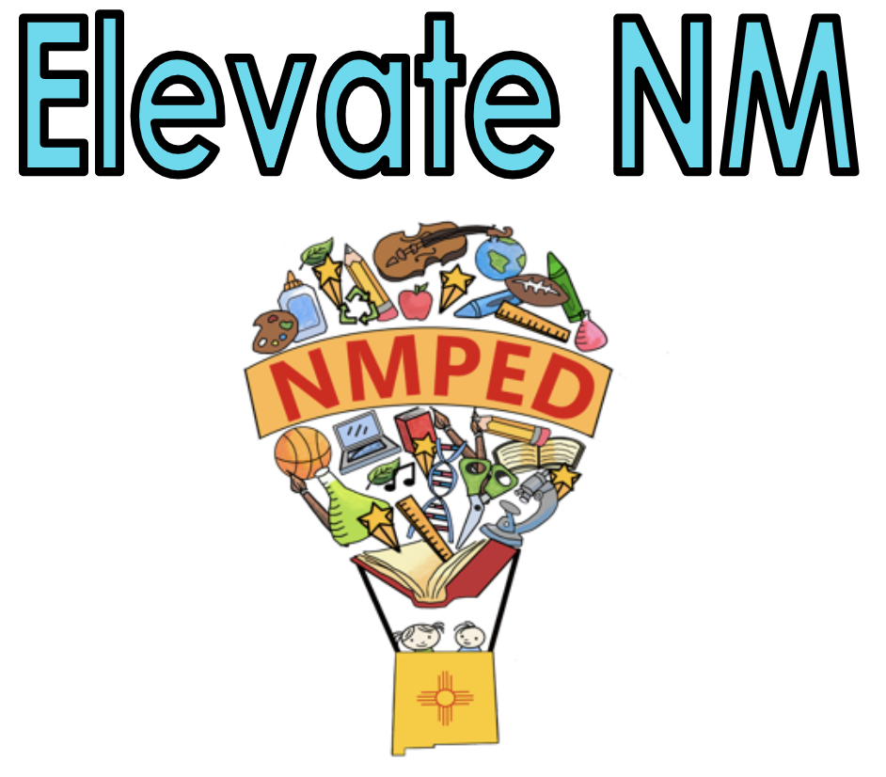
3A: Communicating with Students in a Manner that is Appropriate to their Culture, Language, and Level of Development

The teacher uses systems that evoke responses from all students and are appropriate to students’ developmental, cognitive, and academic language proficiency. The teacher consistently engages students in high levels of thinking within instruction and content.

Note: Any reference to “all students” includes culturally and linguistically diverse students, English Learners (ELs), and Students with Disabilities (SWD).
Note: Any reference to New Mexico adopted standards includes the WIDA English Language Development Standards (ELD) Framework, 2020 Edition Standards when serving English Learners (ELs) and Individualized Education Program (IEP) goals when serving SWD.

Innovating | Applying | Developing | Not Demonstrating
- Strategies for students to interact with each other and offer feedback to peers.  - Grade-level appropriate scaffolds that support students’ language and academic proficiency levels and IEP goals for content and explanation of academic tasks.  - Ensuring understanding of idioms and figurative language by clarifying and rephrasing when necessary.  - Opportunities for students to lead and direct lesson components.  - Intentionally creating connections to students’ cultural and linguistic background knowledge. | - Desired learning goals, such as content and language objectives, are posted, stated, and referred to during the lesson cycle.  - Use of clear communication and a range of vocabulary with scaffolds to ensure learning goals are understandable, including the solicitation of feedback and allowing for clarification from all students by using multiple strategies such as wait time, visuals, methodical systems, and physical cues.  - Instructions and procedures are consistent.  - Teacher begins lessons by accessing students’ prior knowledge.  - Student misconceptions are anticipated, planned for and addressed.  - Content is delivered and differentiated by language proficiency levels and/or IEP goals, as applicable.  - Use of opportunities to connect to students’ cultural and linguistic background knowledge. | - Occasionally communicates expectations for student work, effort, and behavior in the classroom, but inconsistently enforces the expectations or does little to counteract student misconceptions about innate ability.  - Teacher provides little elaboration or explanation about what the students will be learning.  - Teacher’s explanation of content consists of a monologue, with little student engagement.  - The teacher sometimes accesses the student's prior knowledge.  - Teacher’s explanations for content are purely procedural, with no indication of how students can think strategically.  - Teacher’s attempts to explain academic vocabulary but is only partially successful. | - The teacher does not communicate in a manner that allows all students to access specific academic and behavior expectations.  - The teacher does not model or illustrate a growth mindset for students.  - Lessons do not access students’ prior knowledge or build off of their backgrounds.  - At no time during the lesson does the teacher convey to the student what they will be learning.  - The teacher’s vocabulary is inappropriate to the age and/or culture of the students.  - Students indicate through their questions that they are confused about the learning tasks.
Evidence:

Indicators may include:
- Clarity of lesson purpose
- Clear directions and procedures specific to the lesson activities
- Absence of content errors and clear explanations of concepts and strategies, awareness of potential student misconceptions
- Utilizing opportunities to connect to students’ cultural and linguistic background knowledge

3B: Using Questioning and Discussion Techniques to Support Classroom Discourse

Teacher models and utilizes questioning techniques that allow all students to engage and participate in classroom discussions.

Note: Any reference to “all students” includes culturally and linguistically diverse students, English Learners (ELs), and Students with Disabilities (SWD).
Note: Any reference to New Mexico adopted standards includes the WIDA English Language Development Standards (ELD) Framework, 2020 Edition Standards when serving English Learners (ELs) and Individualized Education Program (IEP) goals when serving SWD.

Innovating | Applying | Developing | Not Demonstrating

- Models questioning and discussion approaches that lead students to access knowledge on their own.  - Allows consistent, analytical, and collaborative approaches to understanding.  - Scaffolds for a deep understanding of concepts using academic language.  - Create opportunities for student-led discussion and debate on key concepts.  - Encourages students to take ownership or to lead, ensuring that all voices are heard in classroom and group discussions.  - Incorporates student-generated, high-level questions that are within the instruction and are content-specific.  - Integrates the use of discourse prompts to support students’ when engaging in the classroom and/or small group discussions and/or debate. | - Provides frequent opportunities for interaction between teacher and student and student-to-student  - Uses scaffolds as appropriate for the developmental, cognitive and linguistic needs of the students.  - Uses pre-planned questions or tasks throughout the lesson.  - Employs systems that evoke responses from all students and are appropriate to students’ developmental, cognitive and academic language proficiency, including the use of wait-time.  - Consistently engages students in high levels of thinking within the instruction and content.  - Allows students to respond in a variety of ways, including kinesthetic or visual representation, depending on their developmental, cognitive, and academic language proficiency. | - Provides minimal opportunities for interaction between teacher and student and student-to-student.  - Limited use of scaffolds for the developmental, cognitive, and linguistic needs of the students.  - Uses low-level questions that evoke minimal student responses and engagement.  - Utilizes some questions that elicit a thoughtful response, but are posed in rapid succession with no wait-time, and may be answered by the teacher.  - Does not include an approach that allows all students to respond. | - Do not allow for interaction between teacher and student or student-to-student.  - Do not use scaffolds as appropriate for the developmental, cognitive, and/or linguistic needs of the students.  - Lacks alignment with the content and provides no opportunity for student engagement.  - Uses low-level or inappropriate questions.  - Elicits limited student participation and recitation rather than discussion.
Evidence:

Indicators may include:
- Questions of high cognitive challenge, formulated by both students and teacher
- Questions with multiple correct answers or multiple approaches, even when there is a single correct response
- Effective use of student responses and ideas
- Discussion, with the teacher stepping out of the central, mediating role
- Focus on the reasoning exhibited by students in discussion, both in a give-and-take with the teacher and with their classmates
- High levels of student participation in discussion

3C: Engaging Students in Learning

Effective teachers understand engaging students in learning is vital in order for students to acquire knowledge. Student engagement does not happen by accident, it is the result of careful planning and implementation.
Note: Any reference to “all students” includes culturally and linguistically diverse students, English Learners (ELs), and Students with Disabilities (SWD).
Note: Any reference to New Mexico adopted standards includes the WIDA English Language Development Standards (ELD) Framework, 2020 Edition Standards when serving English Learners (ELs) and Individualized Education Program (IEP) goals when serving SWD.
Innovating | Applying | Developing | Not Demonstrating

- The teacher provides opportunities for students to lead reading, writing, speaking, and listening activities throughout the lesson.  - Consistently uses instructional practices that motivate and engage all students in the content for the lesson and independent work.  - Students incorporate cognitive, developmental, linguistic, and cultural experiences to support learning.  - The lesson incorporates multiple means of representation, expression, and engagement.  - The teacher encourages students to negotiate meaning and clarify understanding with their peers, which may be supported using a language other than English, as appropriate.  - The teacher consistently assesses student engagement and understanding while adapting instruction for improved learning when needed. | - The teacher explicitly connects the lesson to prior understanding by integrating students’ cultural and linguistic background experience.  - Consistently uses instructional practices that are likely to motivate and engage most students in the content of the lesson.  - The lesson supports the active engagement of all students and maintains an awareness of the effective amount of student talk vs. teacher talk.  - The teacher delivers lessons coherently with attention to scaffolding, pacing, sequencing, flexible grouping, student reflection, and closure.  - The teacher incorporates cognitive, developmental, linguistic, and cultural experiences to support learning.  - The teacher assesses student engagement and understanding and adapts methods for improved learning when needed.  - Students are strategically grouped to provide opportunities to practice speaking, reading, writing, and listening. | - The teacher attempts to connect the lesson to prior understanding.  - Uses instructional practices that motivate and engage some students in the content of the lesson, but leave others uninvolved and/or passive participants.  - The lesson activities are inconsistently aligned with the desired learning outcomes.  - Pacing is somewhat appropriate for some learners.  - The lesson structure is not fully maintained. | - The teacher does not connect the lesson to prior understanding.  - Uses instructional practices that leave most students uninvolved and/or passive participants in the content of the lesson.  - The lesson activities do not align with the learning outcome.  - The pacing and grouping are not appropriate for all learners to be able to access the content.  - No lesson structure.
Evidence:

Indicators may include:
- Student enthusiasm, interest, thinking, problem solving, etc.
- Learning tasks that require high-level student thinking and invite students to explain their thinking
- Students highly motivated to work on all tasks and persistent even when the tasks are challenging
- Students actively “working”, rather than watching while their teacher “works”
- Suitable pacing of the lesson; neither dragged out nor rushed, with time for closure and student reflection

3D: Assessment in Instruction (Refers to both Formative and
Summative Assessment)

The teacher monitors student learning and provides feedback to support student growth.

Note: Any reference to “all students” includes culturally and linguistically diverse students, English Learners (ELs), and Students with Disabilities (SWD).
Note: Any reference to New Mexico adopted standards includes the WIDA English Language Development Standards (ELD) Framework, 2020 Edition Standards when serving English Learners (ELs) and Individualized Education Program (IEP) goals when serving SWD.
Innovating | Applying | Developing | Not Demonstrating

- Students approach assessment as an integral part of learning and comprehend how assessment is aligned to their development and growth by helping to establish assessment criteria.  - Students engage in setting and monitoring goals for learning and academic language development related to the content.  - Students can articulate their level of performance using the criteria and scoring guidelines provided.  - The teacher provides feedback that can be used by students in their learning.  - Supports students in monitoring their progress towards mastery of content standards and/or specialized instruction, using informal and formal classroom assessments including strategies that include a combination of self and peer assessment. | - Students understand the performance criteria.  - The teacher systematically gathers and uses assessment data to inform and guide instruction.  - Aligns assessment with the learning goals.  - Contains differentiated assessment strategies/instructions.  - Teacher checks for understanding throughout the lesson and uses techniques that are based on students’ academic language needs and developmental level of readiness.  - The teacher provides descriptive and actionable feedback in a timely manner. | - Students appear to be only partially aware of the assessment criteria, and the teacher monitors student learning for the class as a whole.  - Questions and assessments are rarely used to diagnose evidence of learning.  - Feedback to students is general and not actionable, a few students assess their own work. | - Students do not appear to be aware of the assessment criteria.  - Little or no monitoring of student learning.  - Feedback is absent or of poor quality.  - Students do not engage in self or peer assessment.
Evidence:

Indicators may include:
- The teacher paying close attention to evidence of student understanding
- The teacher posing specifically created questions to elicit evidence of student understanding
- The teacher circulating to monitor student learning and to offer feedback
- Students assessing their own work against established criteria

3E: Demonstrating Flexibility and Responsiveness

The teacher demonstrates the ability to make both minor and major adjustments to the lesson in order to maintain maximum student engagement and/or help students when they encounter difficulty in their learning.

Note: Any reference to “all students” includes culturally and linguistically diverse students, English Learners (ELs), and Students with Disabilities (SWD).
Note: Any reference to New Mexico adopted standards includes the WIDA English Language Development Standards (ELD) Framework, 2020 Edition Standards when serving English Learners (ELs) and Individualized Education Program (IEP) goals when serving SWD.
Innovating | Applying | Developing | Not Demonstrating

- Seizes opportunities to enhance learning by building on a spontaneous event or student interests.  - Creates opportunities for student-led instruction, discussion, and/or questioning.  - Appeals to student interests and makes cultural and linguistic connections to learning goals.  - Ensures the success of all students by using an extensive repertoire of instructional strategies in order to anchor instruction and help students make sense of content. | - Modifies instruction according to applicable IEPs.  - Adjusts instructional plans and makes accommodations for student questions, needs, and interests, while taking into account the language demands and grade-level appropriateness of the content and instruction.  - Adapts instructional plans by employing a variety of strategies and techniques that are responsive to students’ needs, proficiency, culture, and linguistic background.  - Revises the lesson based on periodic checks for understanding and/or formative assessments of all students. | - Attempts to modify the lesson, responds to student questions with moderate success, but has a limited repertoire of strategies to draw upon.  - Accepts minimal responsibility for student success.  - Occasionally uses strategies to support diverse learners. | - Makes no attempt to adjust the lesson in response to student confusion.  - Does not accept responsibility for the lack of student success.  - Does not attempt to clarify information for students and does not successfully answer student questions.  - Does not use strategies to support diverse learners.

Evidence:

Indicators may include:

Incorporation of student relevant events into a lesson
- The teacher adjusts instruction in response to evidence of student understanding (or lack of it)
- The teacher seizes teachable moments

