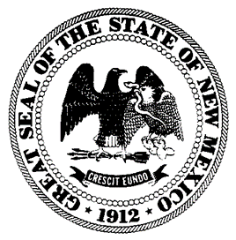

New Mexico Public Education Commission

2022 New Charter School Application Kit
Part D. Capacity Interview Rubric

Scoring
All responses will be scored using the following rubric:

Meets the Criteria | - The applicant’s response completely addresses the question posed  - The applicant’s response aligns with and enhances the related information presented in the written application  - The applicant understands the information in the written application and the work that will be necessary to successfully implement the proposal  - The applicant demonstrates the ability to appropriately respond to contingencies and challenges that will be faced when implementing the proposal  - The applicant demonstrates a strong capacity to successfully operate a high-quality, effective school by implementing the proposal in the written application
Approaches the Criteria | - The applicant’s response addresses the question posed, but may not do so fully  - The applicant’s response mostly aligns with the related information presented in the written application  - The applicant partially understands the work that will be necessary to successfully implement the proposal in the written application  - The applicant demonstrates limited capacity to appropriately respond to contingencies and challenges that will be faced when implementing the proposal  - The applicant demonstrates some capacity to operate a functional school by implementing the proposal in the written application
Does Not Meet the Criteria | - The applicant’s response does not address the question posed  - The applicant’s response does not align with the related information presented in the written application  - The applicant does not understand the work that will be necessary to successfully implement the proposal in the written application  - The applicant demonstrates no capacity to respond to contingencies and challenges that will be faced when implementing the proposal  - The applicant does not demonstrate the capacity to operate a functional school by implementing the proposal in the written application

The review team will ask applicant teams questions in areas that include but are not limited to:
- Educational Plan: Mission and Implementation
- Leadership and Governance
- Facility
- Finance
- Planning/Implementation Year
- Other topics specific to the proposed school

