# **Step for Submitting Endorsement Waivers and BMEP Waivers**

[NMPED Online Licensure Portal](https://licensureapp.ped.state.nm.us/)

**For the BMEP Waivers, LEAs must follow [Instructions for Submitting the Renewal BMEP Endorsement Waiver](https://webnew.ped.state.nm.us/wp-content/uploads/2021/07/Instructions-for-Submitting-the-Renewal-BMEP-Endorsement-Waiver-2021.pdf)

After the BMEP waiver is submitted, LEAs must also follow the below instructions

District Administrator will log into their account by entering their email (UserName) and password.

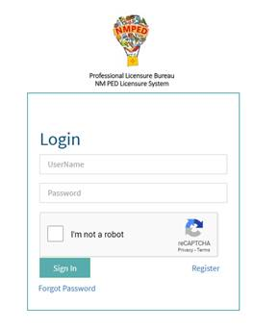

A Temporary Password will be sent to the District Admin’s registered email address and will be entered in the field seen below.       
        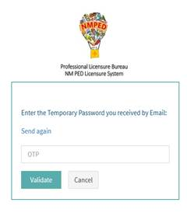

After Login, a dialog box will appear, you will click on the “OK” button and will then be re-directed to the Landing page as seen below. Select “License Application” from the PED Application dropdown and select “District Administration” as the user role from the Select Your Role dropdown.   
  
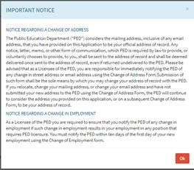 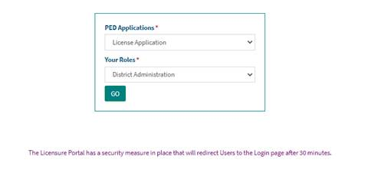

Selecting Existing Licensee from the navigation pane

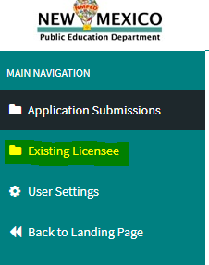

Enter the License Number you want to search and select search

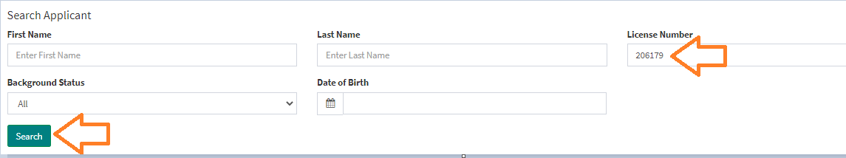

Click on the number the appears below the Column titled Applicant ID

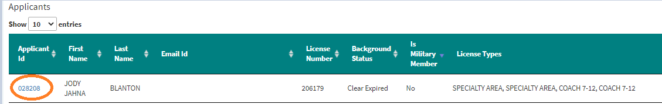

Scroll to the Application Documents section and click on the Miscellaneous Documents title as this will expand. You will upload your Endorsement Waiver/BMEP Wavier approval within the Endorsement Waiver Documents section by clicking on the paper clip icon

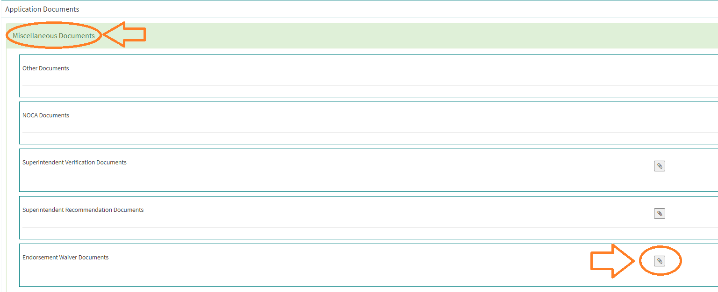

Scroll to the bottom of the page to the Endorsement Waiver section and select the endorsement you want to add to the license from the drop-down list, then click on “Add Endorsement Waiver” button.

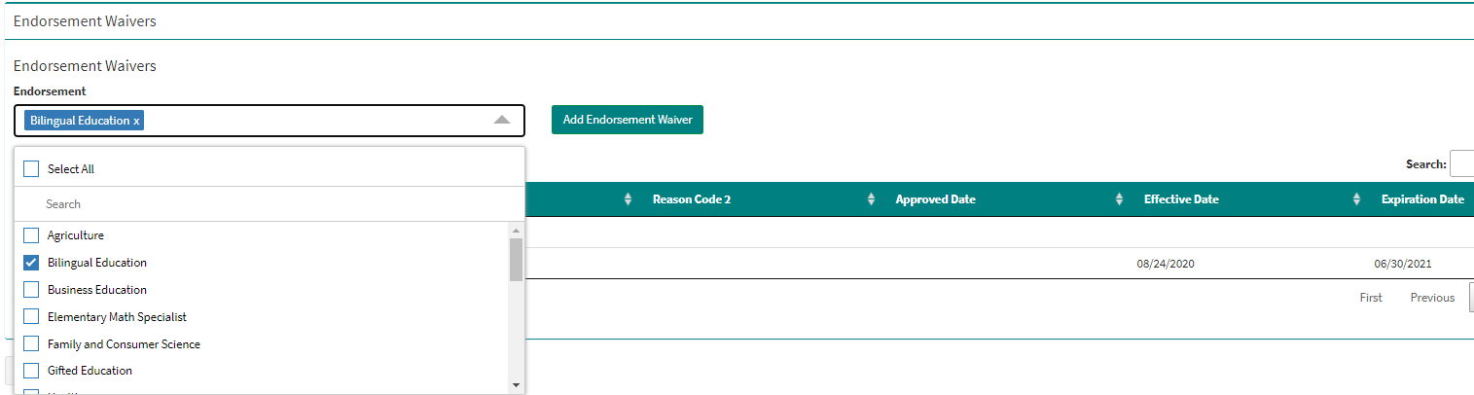

The system does not send out notifications when endorsement waivers have been uploaded/entered, so please send an email to [jenna.jaquez@state.nm.us](mailto:jenna.jaquez@state.nm.us) to alert her to review/confirm/approve. Thank you.