Title II, Part A
2022-2023
Application Instructions

Link to application

ESEA Consolidated Application

Step 1.
Access application by selecting the following link:
ESEA Consolidated Application
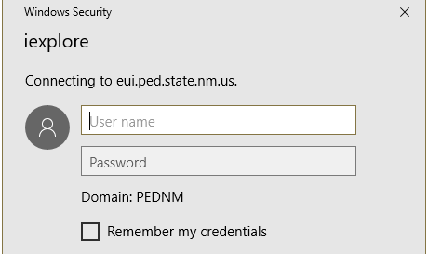
- Enter Username
- Enter Password
- Click “Ok”

Issues accessing site? Contact Mark Curran at
mark.curran@state.nm.us

Step 2.
Click “Home”

Next:
Hover over “Title I, II, III” and left click

Step 3. Access the TII Application
Select the “Edit” icon as shown below:
Note: The TII application consists of 14 sections with the following sections required for approval:
T II Section 1: ​Contact Information
T II Section 3_1: ​Outcomes for Students and High Quality Instruction
​​​T II Section 3_2: ​Educator Quality Measures by Subgroup
​​​​​T II Section 4 : Mentorship Support for Teachers
T II Section 9: Total Enrollment
T II Section 10: Locally-Authorized Charter Schools
- DISTRICTS with “locally-authorized” charter schools must complete
T II Section 11: Private Schools
- DISTRICTS containing “Private Schools” must complete
​​​T II Section 13: Upload Related Documents

!!Remember to SAVE after each section!!
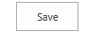

Note: As you allocate funds in the application, this table will keep a “running” balance.
Title II Part A
Preliminary Allocation | 286,697.25
Admin Indirect Funds | 18,052.90
Mentor Teacher Support Total Funds | 2,691.20
PD Budget Domain Funds | 94,232.02
Additional PD Funds Total | 4,153.00
Other Salary Funds Total | 157,990.39
Increase Equity Funds | 2,000.06

Charter School Amount Total
Private School Amount Total | 7,577.68
Transferred Funds | 0.00
Preliminary Allocation | 286,697.25
Debit | 286,697.25
Credit | 0.000.00
Balance | 0.00

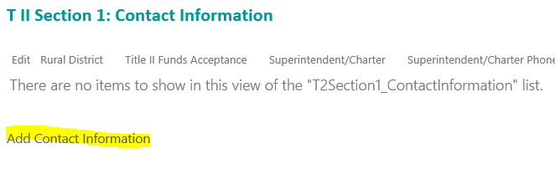
Click on “Add Contact Information”
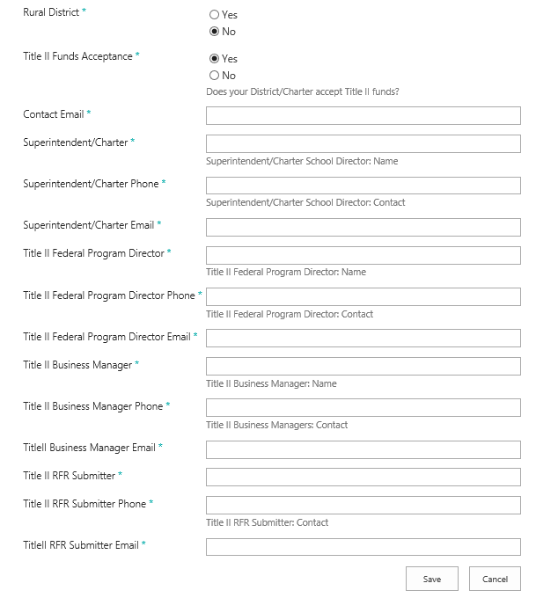

!!Remember to SAVE after each section!!

Click on the edit button and indicate if the LEA plans to use Title II, Part A funds for indirect administrative costs. The application automatically defaults to “NO”, selecting “YES” will automatically calculate what that amount is (see “Admin Indirect Funds” scenarios below), click on save and the amount will populate on the Budget/Allocation table at the beginning of the application.
Scenario 1
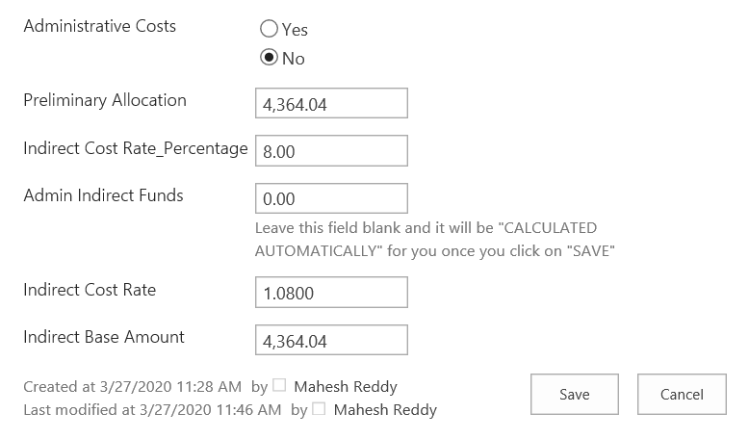
Scenario 2
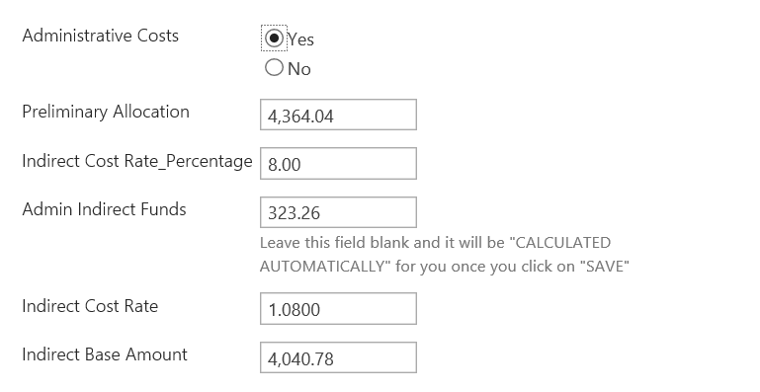

Click on:

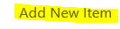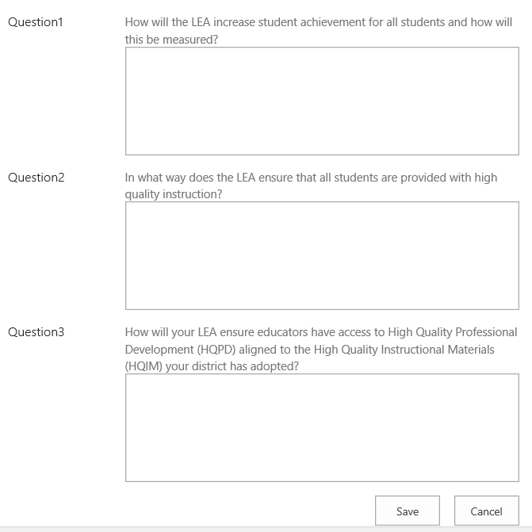
!!Remember to SAVE after each section!!

Click on:

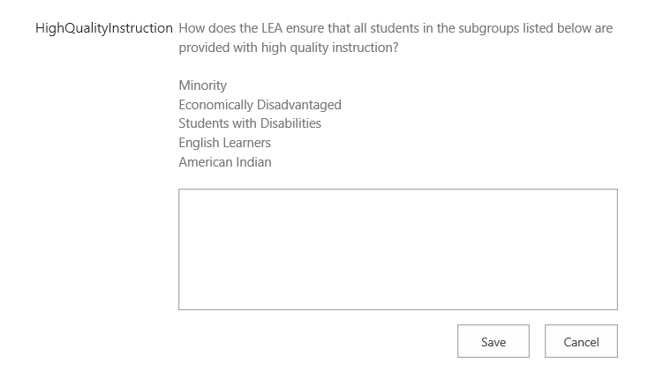

Please explain how the LEA plans to use Title II, Part A funds to establish and support high-quality evidence-based educator induction and mentorship programs. Programs should be designed to improve classroom instruction, student learning and achievement, and increase the retention of high quality teachers, principals, or other school leaders.
Click on:

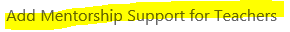
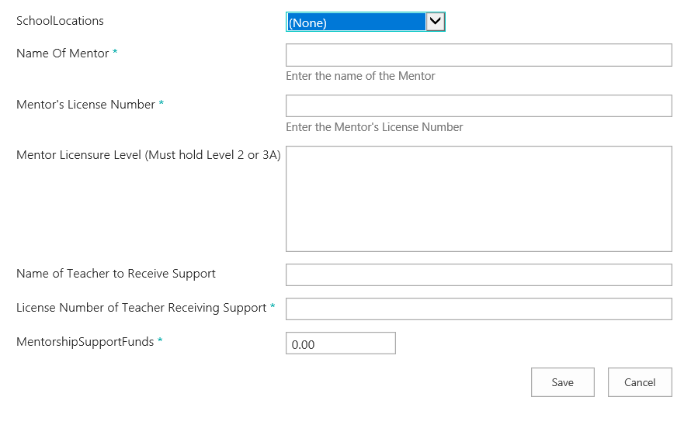

Click on:

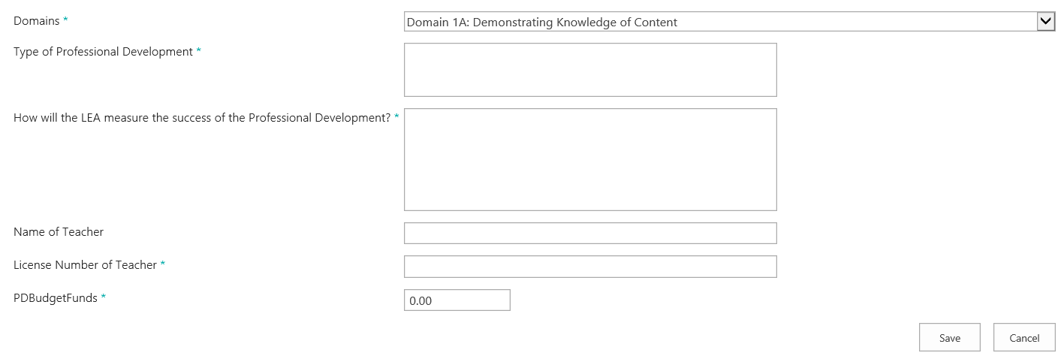

Include professional development that is consistent with local planning requirements and a needs assessment. Focus on evidence-based professional development that will help increase academic achievement by improving teacher and principal quality. NMPED recommends that you work with your Title II Liaison for prior approval of professional development activities to ensure that the activity aligns with Title II requirements.

Click on “Add Additional PD Activities” under section 6, populate the table and click save; repeat this action for each activity.
Click on:
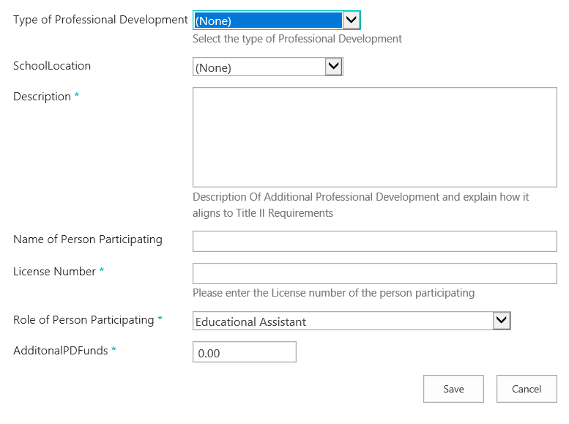

For allowable activities refer to:
Non-Regulatory Guidance for Title II, Part A: Building Systems of Support for Excellent Teaching and Leading
https://www2.ed.gov/policy/elsec/leg/essa/essatitleiipartaguidance.pdf
Non-Regulatory Guidance: Using Evidence to Strengthen Education Investments https://www2.ed.gov/policy/elsec/leg/essa/guidanceuseseinvestment.pdf

If these resources do not address your questions, please contact your Title II Liaison for assistance. To find the LEAs Title II Liaison visit the Title II webpage:
https://webnew.ped.state.nm.us/bureaus/educator-growth-development/title-ii/

Click on: “Add Other Salaries” in section 7, populate the table and click on save, repeat this action for each salary.
Click on:

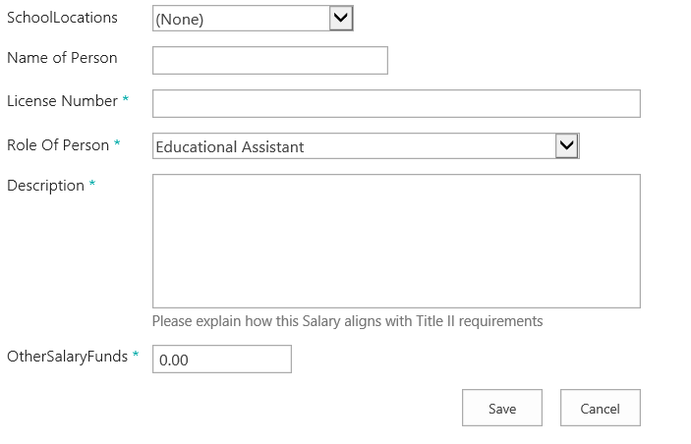

This section will allow LEAs to specify how potential carryover funds will be used in supporting TII, Part A program objectives.
Click on:

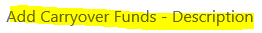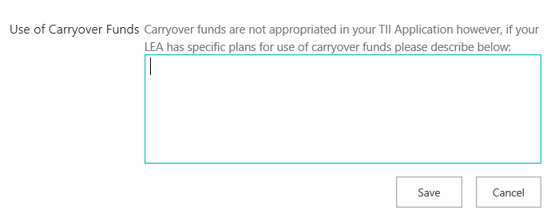

This section is for LEAs with local charter schools and private schools, state charters do not need to complete this section of the application. LEAs must obtain charter and private school enrollments from each school before completing this section. The data for local charters will be populated in section 10 and for private schools in section 11.To access this section, click on the edit button and populate the table with the data collected in sections 10 and 11. Once populated hit save and the per-pupil amount will be calculated.

Select the edit icon
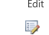
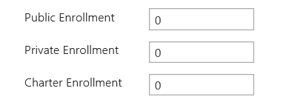

This section should be completed only by LEAs that have local charters, if you are a state charter or an LEA without local charters you may skip this section. To access this section, click on: “Add Consolidated Charter School Enrollment” and populate the table. If a charter school declined funds, please upload their official correspondence declining funds in section 13 of the application.
Click on:

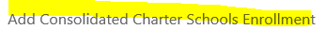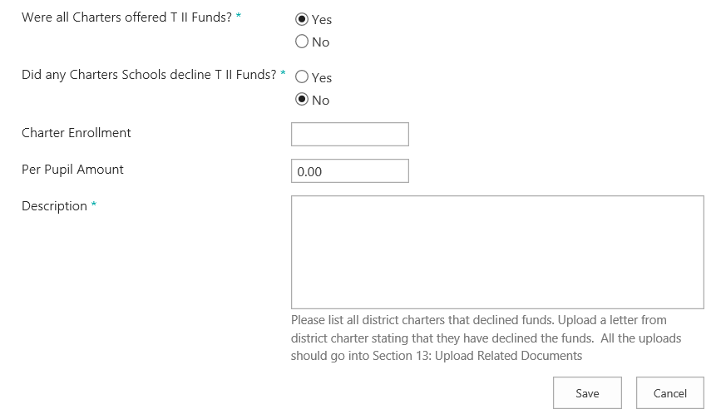

All district charter schools must complete their own application aligned with the ESSA guidelines and return the completed application worksheet to the district. A copy of this document can be found in the Title II Associated Documents section of this application and on the Title II website.
https://webnew.ped.state.nm.us/bureaus/educator-growth-development/title-ii/
Districts must review completed charter applications to ensure alignment with Title II objectives. Please upload all charter applications in section 13.
This section should be completed only by LEAs that have private schools, if you are a state charter or an LEA without private schools you may skip this section. To access this section, click on Add Private School Enrollment and populate the table; this process will be repeated for each individual private school. If a private school declined funds, please upload their official correspondence declining funds in section 14 of the application.
All private schools must complete their own application aligned with the ESSA guidelines and return the completed application worksheet to the district. A copy of this document can be found in the Title II Associated Documents section of this application and on the Title II website.
https://webnew.ped.state.nm.us/bureaus/educator-growth-development/title-ii/

Districts must review completed private school applications to ensure alignment with Title II objectives. Please upload all private school applications into section 14.
Click on:

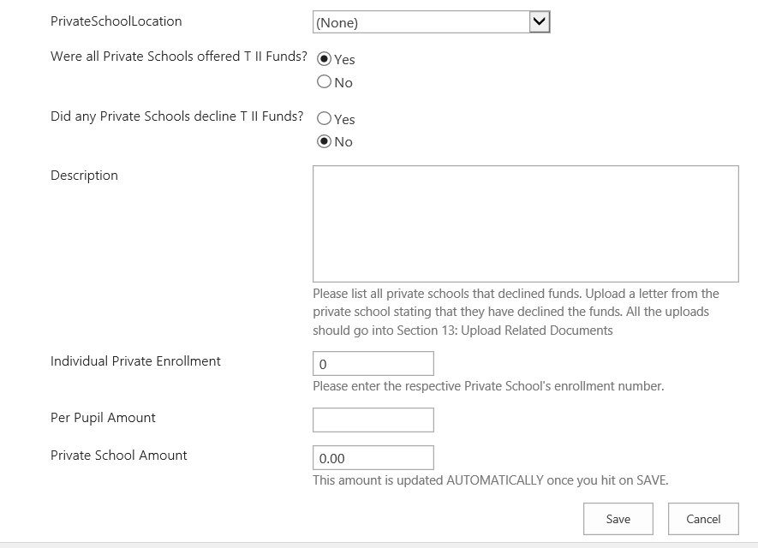

Note: This section will only be completed if the LEA is choosing to transfer funds to another Title program.
To access this section, click on: “Add to Transfer Funds”, populate the table and click “save”.
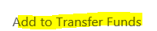
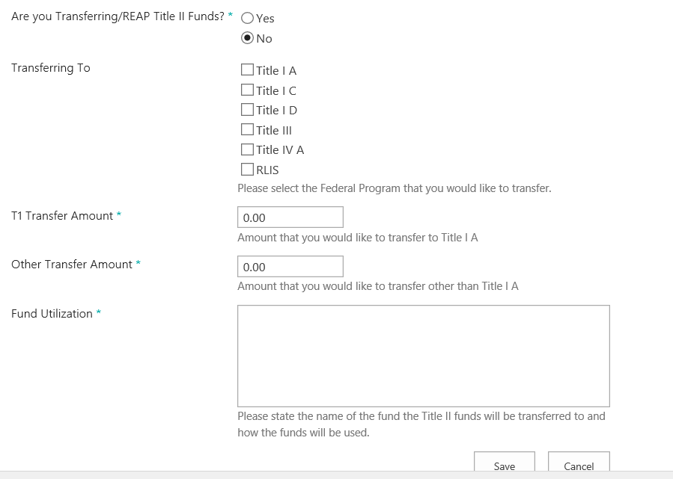

T II Section 13: Plan of Action to Increase Equity
Click on:

T II Section 14: Upload related Documents
LEAs will use this section to upload all supporting documentation including the signed Assurances Page. To add a document, click on “Upload Documents”
Click on:

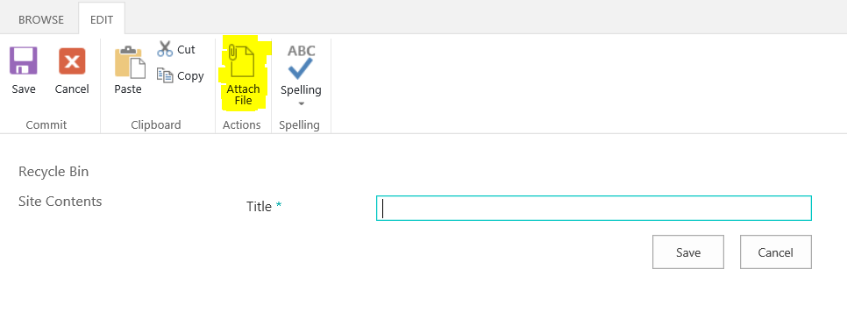

On this page you will click on Browse and select the file you saved on your computer.

Once you have selected the file click on OK:
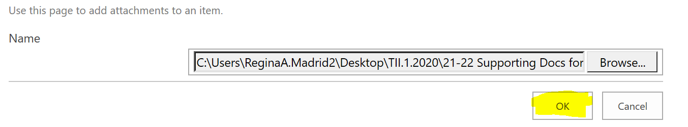
Name the file and click on Save. This will upload the file into the application.
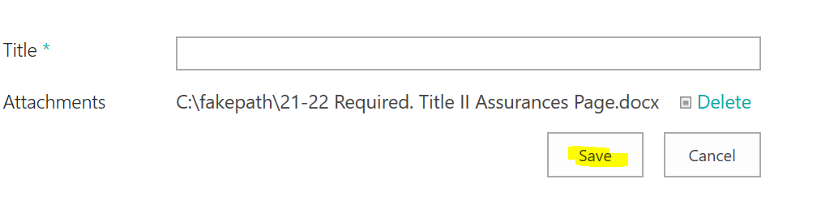

You will repeat the above steps for each file you need to upload into the application.

The 22-23 Assurance Page must be completed by each LEA and uploaded into section 14 of the application.
Private School Application Worksheet must be completed by all private schools in a LEA. Note: Not required if the private school is DECLINING funds. The Private School Worksheet must be returned to the LEA, and the LEA will upload into section 14 of the application. If you do not have any private schools in your district this document is not required.
District Charter Application must be completed by all local charters that are accepting funds. This application must be returned to the LEA, and the LEA will upload into section 14 of the application. If the LEA does not have any local charters this document is not required.
The remaining documents are resources developed by the Title II team that you may use during the application and RfR process.

Update after documents uploaded in TII Application
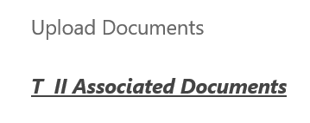
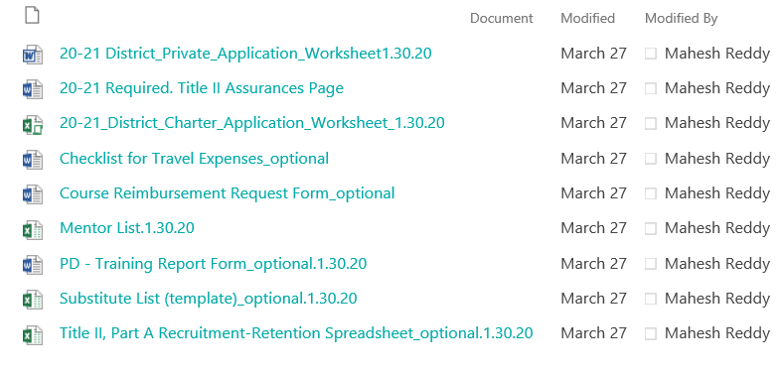

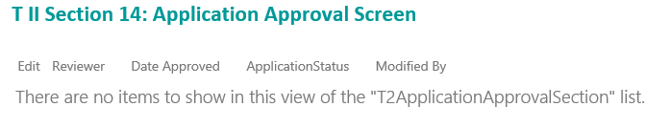
Hover over “Submit Your Application” and left click
Select “Submit to State” from the drop down
No entries required for “Reviewer” “Date Approved” or “Recommendations”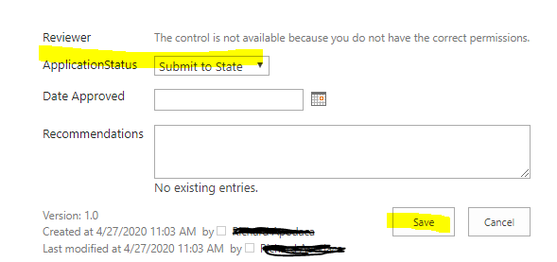
The Title II team member assigned to your district will review the application and either approve or return for additional information. To locate the Title II team member assigned to your LEA please refer to the Title II Liaison list located on the Title II website.
https://webnew.ped.state.nm.us/bureaus/educator-growth-development/title-ii/

