Text: New Mexico Public Education DepartmentCommunity Schools Act

**Community Schools Implementation Grant –**

**Renewal Supplemental Application**

**School Year 2022-23**

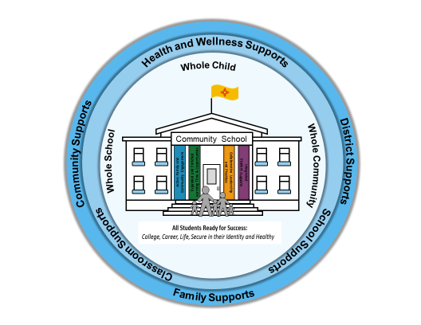

Released: April 21, 2022 Due: May 12, 2022

**Application Submission**

# The Particulars

**Deadline May 12, 2022, by 5 p.m.**

**Where to Submit** Upload application and attachments via the [Community Schools and Extended Learning SharePoint Site](https://eui.ped.state.nm.us/sites/Stars/DocumentRepository/SitePages/Home.aspx). Contact Sabrina Villalba ([Sabrina.Villalba@state.nm.us](mailto:Sabrina.Villalba@state.nm.us)) if you need credentials to access the portal.

**Application** Label and upload attachments according to the *Naming Documents Before*

**Naming** *Uploading to the SharePoint Site* section, which is located on the *2022–23* **Conventions** *Community Schools Grant Application Instructions*.

**Contact** Marangellie Trujillo

**Information** Community Schools and Extended Learning Time Coordinator

[Marangellie.Trujillo2@state.nm.us](mailto:Marangellie.Trujillo2@state.nm.us)

(505) 629-8120

**Resources** For additional guidance and resources, visit…

* The Resources section of the [Community Schools and Extended Learning SharePoint Site](https://eui.ped.state.nm.us/sites/Stars/DocumentRepository/SitePages/Home.aspx).
* The New Mexico Public Education Department’s (PED) [Community Schools](https://webnew.ped.state.nm.us/bureaus/community-schools/) webpage for additional information and resources.

Table of Contents

The Particulars 2

Background: 5

New Mexico’s Community Schools Act 5

Requirements 5

Funding Requirements 5

Eligibility 6

Evidence-based Community School Framework 7

Student and School Outcome Studies 8

Community School Staffing 8

Fiscal Considerations 9

Application Review and Approval 9

Glossary of Terms 10

Forms 12

Community School Implementation Grant - Renewal Supplemental Application 13

Contact Information 13

Grant History 14

Type of Application — Single, Consortium, District 15

Community School Implementation Renewal Plan Narrative 18

State of the Community School(s) (STORY) 18

Required Activities for the Community Schools Implementation Renewal Plan 19

Integrated Student Supports (ISS) 20

Expanded and Enriched Learning Time and Opportunities 21

Active Family and Community Engagement (AFCE) 22

Collaborative Leadership and Practice (CLP) 23

United States Department of Agriculture (USDA) school meal and snack programs 25

High-Quality Professional Development 25

Evidence-based Evaluation System—Annual Assessment 26

Optional Activities (OA) for the Community Schools Plan 27

Broader use of school facilities 27

Community-Based Learning (CBL) 27

Public pre-kindergarten and other federally funded early childhood services 27

Funding Request (FR) 28

Leveraging of Local, State, and Federal Funds (LEV) 29

SY2022–23 Community School Sustainability Plan Summary 33

Assurances 35

Needs Assessment and Asset Map 36

Partner Commitment Form 36

Eligible Applicant Information and Signatures 37

Single School 37

Consortium of Schools 38

School District 39

Attachments 40

Partner Commitment Form 41

# Background:

Governor Michelle Lujan Grisham developed a plan for education in New Mexico. *“A New Direction for New Mexico Schools”* includes 11 focus areas deemed necessary for New Mexico’s students to achieve optimally.

1. Funding for an education system that is high quality and that our children deserve.
2. Universal access to quality PreK is a reality for every New Mexico family.
3. 21st century skills and enhanced career technical education programs are provided to our students.
4. Improved graduation rates.
5. Increased pay for our principals, teachers, and educational personnel.
6. School testing is limited; qualitative data its used to track student and school achievement.
7. A fair and balanced system of accountability is created.
8. *Families, communities, and students are engaged as substantive partners.*
9. Every student in public school is ensured an equal opportunity to learn and advance.
10. NM’s American Indian populations are well served by the State’s education system.
11. Every student is prepared for success in college or a career.

One way in which to engage families, communities, and students as essential partners in our public schools is through the expansion of the community schools model. A community school is an integration of services that are focused on academic, health, and social services, youth and community development, and community engagement. Together, they lead to improved student learning, stronger families, and healthier communities. On April 3, 2019, Governor Michelle Lujan Grisham signed House Bill 589, the amended Community Schools Act, into law.

## New Mexico’s Community Schools Act

The Community Schools Act provides a strategy to organize the resources of a community to ensure student success while addressing the needs, including cultural and linguistic, of the whole student—from early childhood programs and voluntary public pre-kindergarten through high school graduation. The Community Schools Act encourages Federal, State, local, and Tribal governments to work with community-based organizations to improve the coordination, delivery, effectiveness, and efficiency of services provided to students and families. Coordinating resources, in order to align and leverage community resources and integrate funding streams, is also a goal of this Act.

# Requirements

## Funding Requirements

The General Appropriation Act of 2022 provides the Public Education Department (PED) with eight million dollars in State funding for community school initiatives in New Mexico. Funds for community school initiatives shall be used to establish, operate, and sustain the community school framework pursuant to Section [22-32-4](https://codes.findlaw.com/nm/chapter-22-public-schools/nm-st-sect-22-32-4.html), NMSA 1978.

At the conclusion of the initial three-year grant period, applicants may apply for a renewal grant for one year in an amount determined by the PED, subject to availability of funding. For FY2022-23, PED has determined that the amount of a renewal grant will be for up to $75,000 to help sustain the community school coordinator position only.

The implementation renewal grant is available through an application process for each **eligible public school[1]**. Implementation grants must address the **four pillars of community schools**:

1) Integrated student supports

2) Expanded and enriched learning time and opportunities

3) Active family and community engagement

4) Collaborative leadership and practices

Implementation of the community school framework shall include the broader use of public school facilities in which school buildings become hubs of student and family supports.

Only established community schools that have been receiving an NM PED implementation grant and have been implementing an **evidence-based** community school framework for three years may apply for a renewal grant. Established community schools will still be required to 1) complete the application, 2) provide documentation of a completed **needs assessment** and **asset map,** and 3) provide documentation of an established **community-wide leadership team** and **site-based leadership team**.

Each eligible and funded community school site will need to 4) complete a Funding Request and other applicable sections of the application.

## Eligibility

Subject to the availability of funding, grants for community schools initiatives are available for a school district, a group of public schools (**consortium of schools**), or a single public school that has an established partnership with the local community to operate, expand, and sustain the **community school framework**. A school district that wishes to apply does not have to include all schools within the district in its application in order to be eligible for funding. Similarly, it is possible that not all schools included in the school district or consortium of school’s application will be funded.

An **eligible public school** means any of the following. It is a public elementary or secondary school that has

* a student body in which at least 40 percent of students are eligible for free or reduced-price lunch, pursuant to the Richard B. Russell National School Lunch Act; or
* been identified as a school for comprehensive or targeted support and improvement under the Elementary and Secondary Education Act of 1965; or
* otherwise been identified by the State as in need of additional support. Schools in need of additional support are struggling in the areas of academic proficiency in English language arts, math and/or science, attendance, graduation rates, drop-out rates, and/or parent/family engagement.

Depending upon the demand for funding, priority for awards is for schools identified as needing **comprehensive support and improvement (CSI)** and **targeted support and improvement (TSI)** under the Every Student Succeeds Act (ESSA). If schools identified as CSI or TSI are part of the school district or consortium of school’s application and funding is limited, the CSI and TSI schools may be the only eligible applicants that receive funding.

In the event that a school applies for funding, but is not identified as CSI or TSI, yet it does have at least forty percent of students eligible for free or reduced-price lunch, it may still qualify for funding.

## Evidence-based Community School Framework

The community school framework shall ensure the use of evidence-based interventions, programs or strategies, and best practices that support students, families, and communities in ensuring student success.

**Evidence-based interventions included in the ESSA** are practices or programs that have been proven effective in producing results and improving outcomes. The kind of evidence described in ESSA has generally been produced through formal studies and research. Under ESSA, there are four tiers, or levels, of evidence:

|  |  |  |  |
| --- | --- | --- | --- |
| **CATEGORY ONE** *Demonstrates a statistically significant  effect on improving student  outcomes or other relevant outcomes.*  **Tier 2**  **Tier 1**  **Tier 3**  **Tier 4** | | | **CATEGORY TWO:** *Demonstrates a rationale based on high-quality research findings or positive evaluation that such activity, strategy, or intervention is likely to improve student outcomes or other relevant outcomes.* |
| **STRONG  EVIDENCE** | **MODERATE EVIDENCE** | **PROMISING EVIDENCE** | **“STRONG THEORY”** |
| Based on at least 1 well-designed and well-implemented experimental study. | Based on at least 1 well-designed and well-implemented quasi-experimental study. | Based on at least 1 well-designed and well-implemented correlational study with statistical controls for selection bias. | Includes ongoing efforts to examine the effects of such activity, strategy, or intervention. |

*Policy Brief ESSA and Evidence: Why it Matters*

In December 2017, The Learning Policy Institute published *“Community Schools as an Effective School Improvement Strategy: A Review of the Evidence,* [click here](https://learningpolicyinstitute.org/product/community-schools-playbook). The report reviewed 143 studies representing a broad range of research methods. The studies included in this publication are classified according to the ESSA tiers and include studies pertaining to the four pillars of community schools. This information will support you when developing your community school plan. The publication also includes many evidence-based interventions that you will need to include when completing the application for funding. The breakdown is listed in the table below.

### Student and School Outcome Studies

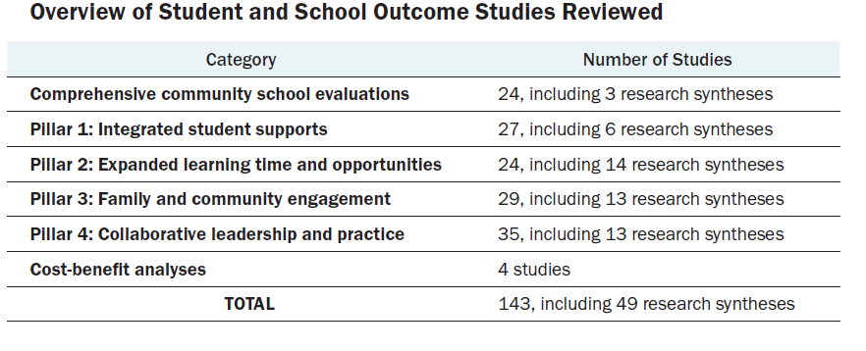

Applicants are encouraged to review the studies before selecting an intervention and completing the application.

The Learning Policy Institute and the National Education Policy Center developed a policy brief “*Community Schools: An Evidence-Based Strategy For Equitable School Improvement”* [click here](https://learningpolicyinstitute.org/sites/default/files/product-files/Community_Schools_Evidence_Based_Strategy_BRIEF.pdf)*.* The brief summarizes the review of the evidence listed above and concluded that, based upon the research, well-implemented community schools and the four pillars provide a strong justification as to how community schools can support school improvement.

State law requires that the implementation of the community school framework ensures the use of research- and evidenced-based strategies. State funding received through the Community Schools Act is to be used to transform a public school into a community school whose foundation is securely anchored in evidence-based practices. Although the strategies chosen to transform the public school into a community school are not required to meet any of the ESSA Tiers of Evidence, it is recommended that the evidence-based interventions, programs, and practices selected meet the ESSA criteria. The Learning Policy Institute in collaboration with National Education Policy Center published an online research compendium *“Community Schools: An Evidence-Based Strategy for Equitable School Improvement”*,

[click here](https://learningpolicyinstitute.org/product/online-research-compendium)which can assist youin selecting the evidence-based intervention, programs, and practices that best match the needs of your school and community.

## Community School Staffing

At each eligible public school applying for an implementation grant, the **lead partner agency** shall employ a **community school coordinator** to

* implement the community school framework;
* lead the needs and assets assessment;
* facilitate communication between community schools and partners as a stakeholder- and community-driven approach to problem solving;
* guide data-informed, continuous improvement;
* manage data collection; and
* align, leverage, and coordinate resources for student and family success.

State law requires that grantees receiving funds to implement the **community schools initiative,** as a consortium in three or more public school sites, work with the school district in order to employ a **community schools director or manager.** The community schools director or manager shall oversee and coordinate implementation across all of the eligible school sites and ensure the employment of a community school coordinator by the lead partner agency at each school site.

## Fiscal Considerations

A school district shall bear any indirect costs associated with the establishment and implementation of a **community school** within the school district unless is federally-funded.

State law requires that a community school shall be given sufficient operational flexibility by its district in programming (school-wide, Title I programs), curriculum (community-based learning), staffing (use of Title I teachers and reading or math specialists), budgeting (site-based budgeting), and scheduling (begin school day earlier or end school day later). This flexibility is necessary so that the community school can fully implement a comprehensive community school framework designed to focus on improving school climate, student academic achievement, attendance, behavior, family engagement, and—for high schools—graduation rates and readiness for college or a career.

## Application Review and Approval

Applications will be reviewed by the PED and the **Coalition for Community Schools** (CCS) in order to ensure equitable distribution of resources to all school districts in New Mexico. The CCS will provide the PED with recommendations for awards.

# Glossary of Terms

|  |  |
| --- | --- |
| **Term** | **Definition** |
| **Asset mapping** | An assessment of a school and the community, including organizations, people, partnerships, facilities, funding, and policies. An asset assessment provides information about the strengths and resources of a school and community. |
| **Coalition for community schools** | A statewide coalition of community schools, members of their site-based leadership teams, foundations, businesses, and other organizations. The latter might include unions, cultural and linguistic experts, and tribal leaders, who have joined together to advocate for and support the development of community schools, in alignment with an evidence-based community school framework. |
| **Community-based learning—** **CBL** | A model that grounds student learning in civic engagement and addresses real-world, community issues. Interdisciplinary in nature, CBL deepens the purposeful connection between neighborhoods and schools.  Goal of community-based curriculum: strengthen and galvanize assets of families, school educators, and local community members to work collaboratively to enrich and expand student learning. The curriculum centers on local institutions, history, knowledge, language, literature, culture, and environments. It aligns with scientific discoveries about how sociocultural factors and the structure of learning environments influence learning. |
| **Community-based organization** | A public or private nonprofit organization of demonstrated effectiveness that is representative of a community or significant segments of a community and provides educational or related services to individuals in the community. |
| **Community school** | A public school that partners with families and the community—including tribal partners, nonprofit community-based organizations, and local businesses—to provide well-rounded educational opportunities and supports for student success through the implementation of the community school framework. |
| **Community school coordinator** | A full-time person employed by the lead partner agency who works within a community school as part of the site-based leadership team. |
| **Community school director or manager** | A person employed by the district or lead partner agency who oversees three or more community schools and coordinates implementation of the community schools framework across all community school sites. |
| **Community school framework** | A set of strategies implemented in a community school that include culturally and linguistically responsive instruction and programs, services, and restorative practices that focus on building and maintaining relationships. The community school framework is the method by which the implementation of the community school initiative is met. |
| **Community school initiative** | The implementation of the community school framework to provide comprehensive or targeted and improvement activities pursuant to the federal Every Student Succeeds Act (ESSA). |
| **Community school plan** | A site-based leadership team or community school council—that includes families, community partners, tribal partners, nonprofit organizations, school staff, and unions—that guides collaborative planning, site-based budgeting, and implementation of the community school framework. |
| **Community-wide leadership team** | A team at the LEA level that is responsible for guiding the visions, policy, resources alignment, oversight of implementation, and goal-setting for community school initiatives with an LEA. This team shall include representatives from the LEA, educators, teacher unions, school administrators, students, and family members from eligible schools, system-level partners—including community members, philanthropic organizations, and local and Tribal governments. |
| **Comprehensive support and improvement —CSI** | A school identified as needing intervention under ESSA, including the lowest-performing five percent of Title I schools, schools with a high school graduation rate of less than 67 percent for two out of the last three years, and schools with chronically low-performing ESSA subgroups of students. |
| **Consortium of schools** | a group of public schools or Bureau of Indian Education (BIE) schools across school districts or within a regional education cooperative. |
| **Culturally and linguistically responsive** | Validating and affirming an individual’s home culture and language to create connections with other cultures and languages in various social contexts. |
| **Eligible applicant** | A single public school, school district, or consortium of schools that has demonstrated partnerships with at least one community organization with approval from the governing entity responsible for the LEA and with whom the school must apply as a co-applicant. |
| **Eligible public school** | A public elementary or secondary school that 1) has a student body in which at least 40 percent of students are eligible for free or reduced-price lunch, pursuant to the Richard B. Russell National School Lunch Act **or** 2) has been identified as a school for comprehensive or targeted support and improvement under the Elementary and Secondary Education Act of 1965 or otherwise identified by the state as in need of additional support. |
| **Evidence-based interventions under ESSA** | Practices or programs that have been proven effective in producing results and improving outcomes. |
| **ESSA** | Signed into law December 10, 2015, ESSA replaced No Child Left Behind and the waiver system. ESSA is the national education law that reinforces the longstanding commitment to ensuring equal opportunity for all students. It provides New Mexico with a long-term stability that holds states, local school systems, and schools accountable for results while encouraging them to be innovative in their work. |
| **Four pillars of community schools** | Under 22-32-2 NMSA, 1978, these are the four foundational concepts found necessary to successfully implement a comprehensive community schools framework: 1) active family & community engagement, 2) collaborative leadership & practices, 3) expanded and enriched learning time, and 4) opportunities & integrated student supports. |
| **LEA** | Local education agency. Just another way of saying district or State-chartered charter school |
| **Lead partner agency** | The agency that employs the community school coordinator and works collaboratively with the community school coordinator, the school principal, the site-based leadership team, and any established community partners, to assess, plan, and carry out the community school framework. |
| **Needs assessment** | A systematic process for determining and addressing needs/gaps between current conditions and those conditions that are desired. |
| **Nonprofit organization** | An organization that is granted a tax-exempt status and is dedicated to furthering a particular social cause or advocating for a shared point of view |
| **Site-based leadership team** | An interdisciplinary, school-based leadership team that includes the school principal, the community school coordinator, teachers, other school employees, families, community partners, tribal partners, nonprofit organizations, unions, and neighboring community residents that guides collaborative planning, implementation, and oversight. |
| **Targeted support and improvement— TSI** | A school identified as needing an intervention under the Every Student Succeeds Act due to a consistently underperforming subgroup of students for a period of time. |

# Forms

## Community School Implementation Grant - Renewal Supplemental Application

## Contact Information

**Note:** Add lines as necessary

|  |  |  |  |  |
| --- | --- | --- | --- | --- |
| **School Information** | | | | |
| **School Name\*** |  | | | |
| **School District Name** |  | | | |
| **Applicant Information** | | | | |
| **Primary Person Applying or Responsible for Grant** | | | | |
| **Name, Last Name** |  | | | |
| **Title** |  | | | |
| **Email** |  | | **Phone** |  |
| **School Principal** | | | | |
| **Name, Last Name** |  | | | |
| **Email** |  | | **Phone** |  |
| **Community School Coordinator** | | | | |
| **Name, Last Name** |  | | | |
| **Email** |  | | **Phone** |  |
| **School District Superintendent** | | | | |
| **Name, Last Name** |  | | | |
|  |  | | **Phone** |  |
| **Site-Based Leadership Team Members Completing Application** | | | | |
| **Name, Last Name** | **Role** | **Email** | | **Phone** |
|  |  |  | |  |
|  |  |  | |  |
|  |  |  | |  |
|  |  |  | |  |
|  |  |  | |  |
|  |  |  | |  |
|  |  |  | |  |
|  |  |  | |  |
|  |  |  | |  |
|  |  |  | |  |

## Grant History

|  |  |  |  |
| --- | --- | --- | --- |
| **Grant History** | | | |
| **Planning Grant** | **Yes** | **No** |
| Has the school you are applying for received a community school planning grant? |  |  |
| If so, what school year? *Example: 2021-2022* |  | |
| **Implementation Grant** | **Yes** | **No** |
| Has the school you are applying for received an implementation grant? |  |  |
| If so, what school year(s)? *Example: 2021-2022* |  | |

|  |
| --- |
| **Notes** *Use this space for notes you would like to add to this section.* |
|  |

# Type of Application — Single, Consortium, District

**Eligibility.** A single school, consortium of schools, or school district that has formed a partnership with at least one community-based organization, with approval from the local education agency’s governing body, may apply. Bureau of Indian Affairs (BIE) schools may apply as part of a consortium of schools but cannot serve as the fiscal agent.

**Order of operations.** The PED funds by school, not by district. Therefore, each individual school must write and submit a separate application. When a school is part of a consortium or a district, the individual school’s name must be bolded, and all the other school names must be listed.

**Type of Application.** Please check below if this application is being submitted for a single school, school district, or consortium of schools (only check one box).

|  |  |
| --- | --- |
| Single School | Check here if this application is for a single school (i.e. you seek funding for one school) |
| School District | Check here if this application is for a school district. |
| Consortium of Schools | Check here if this application is for a consortium of schools (i.e. you and other schools are seeking funding as part of a consortium) * |

**A. Single School Application**

|  |  |
| --- | --- |
|  | Single Public School |

|  |  |  |  |  |
| --- | --- | --- | --- | --- |
| CSI | TSI | NA | School Name: |  |

|  |  |
| --- | --- |
| District Name: |  |

Check the CSI box if the school has been identified as comprehensive support and improvement and the TSI box if the school has been identified as targeted support and improvement. Check the NA box if CSI or TSI do “not apply”, because the school has not been identified as CSI or TSI.

You may now skip to the **Community Schools** **Implementation Renewal Plan Narrative**.

**B. Consortium of Schools Application**

A consortium of schools means a group of public schools across school districts or within a regional education cooperative (REC).

|  |  |
| --- | --- |
| School district or REC serving as fiscal agent: |  |

Bureau of Indian Education (BIE) schools can apply for funding through the consortium of schools but cannot serve as the fiscal agent.

List the eligible schools in the consortium—schools within the district, within an REC, or across districts—for which you are applying:

|  |  |  |  |  |  |
| --- | --- | --- | --- | --- | --- |
|  |  |  | Name of School: |  | District Name (Indicate BIE if applicable): |
| CSI | TSI | NA |  |  |  |
| CSI | TSI | NA |  |  |  |
| CSI | TSI | NA |  |  |  |
| CSI | TSI | NA |  |  |  |
| CSI | TSI | NA |  |  |  |
| CSI | TSI | NA |  |  |  |
| CSI | TSI | NA |  |  |  |
| CSI | TSI | NA |  |  |  |
| CSI | TSI | NA |  |  |  |
| CSI | TSI | NA |  |  |  |
| CSI | TSI | NA |  |  |  |
| CSI | TSI | NA |  |  |  |
| CSI | TSI | NA |  |  |  |
| CSI | TSI | NA |  |  |  |
| CSI | TSI | NA |  |  |  |
| CSI | TSI | NA |  |  |  |
| CSI | TSI | NA |  |  |  |
| CSI | TSI | NA |  |  |  |
| CSI | TSI | NA |  |  |  |
| CSI | TSI | NA |  |  |  |
| CSI | TSI | NA |  |  |  |

You may now skip to the **Community Schools** **Implementation Renewal Plan Narrative**.

**C. School District Application**

|  |  |
| --- | --- |
|  | School District |

|  |  |
| --- | --- |
| School District Name: |  |

List the eligible schools within the school district for which you are applying:

|  |  |  |  |
| --- | --- | --- | --- |
|  |  |  | Name of School: |
| CSI | TSI | NA |  |
| CSI | TSI | NA |  |
| CSI | TSI | NA |  |
| CSI | TSI | NA |  |
| CSI | TSI | NA |  |
| CSI | TSI | NA |  |
| CSI | TSI | NA |  |
| CSI | TSI | NA |  |
| CSI | TSI | NA |  |
| CSI | TSI | NA |  |
| CSI | TSI | NA |  |
| CSI | TSI | NA |  |
| CSI | TSI | NA |  |
| CSI | TSI | NA |  |
| CSI | TSI | NA |  |
| CSI | TSI | NA |  |
| CSI | TSI | NA |  |
| CSI | TSI | NA |  |
| CSI | TSI | NA |  |
| CSI | TSI | NA |  |
| CSI | TSI | NA |  |
| CSI | TSI | NA |  |
| CSI | TSI | NA |  |
| CSI | TSI | NA |  |
| CSI | TSI | NA |  |
| CSI | TSI | NA |  |

## Community School Implementation Renewal Plan Narrative

### State of the Community School(s) (STORY)

Community Schools is an evidence-based transformational strategy that promotes equity and educational excellence for every child, the whole school, and the whole community. Depending on the local context of each community, the implementation of the strategy and the achievement of its transformational goals may take longer than three years.

The purpose of this implementation renewal grant is to provide a community school with the opportunity to complete getting ready to sustain the community school’s strategy in the upcoming school year. The intent of this additional year is to provide a bridge into a new way of certifying community schools. Each implementation renewal recipient will be required to complete the certification process in the upcoming SY2022-23.

(STY 1A) Describe the community school shared vision and how students, families, and partners participated in its development. How has the NM PED Community Schools Act funding helped realize this shared vision and what has been the transformative effect?

|  |
| --- |
|  |

(STY 1B) Describe why the community school would need an additional year to achieve its transformational goals. Describe the gaps in either your shared vision or the community school’s strategy that you intend to complete in the next year.

|  |
| --- |
|  |

(STY 1C) Reflecting on the last three implementation years, describe the progress the community school has made toward the following indicators: school culture and climate, student academic achievement, student attendance, student behavior, quality family engagement, and/or graduation rates and readiness for college and career for high schools. What challenges is the community school planning to overcome, and what would it be working on next?

|  |
| --- |
|  |

(STY 1D) One of the goals of the implementation renewal grant is to work towards completing a certification. In thinking about IEL-Coalition for Community Schools standards and indicators, where are you currently? What might an additional year of funding support you to do to make progress towards achieving these national standards?

|  |
| --- |
|  |

### Required Activities for the Community Schools Implementation Renewal Plan

In accordance with 22-32-2 NMSA, 1978, implementation of the community school framework shall include the four pillars of community schools (Integrated Student Supports, Expanded Learning Time and Opportunities, Active Family and Community Engagement, and Collaborative Leadership and Practice).

Selection of interventions must support the five or six indicators

1) school culture and climate

2) student academic achievement

3) student attendance

4) student behavior

5) quality family engagement

6) graduation rates and readiness for college and career for high schools.

When responding to each pillar, be sure to document how the selection of an intervention connects and relates to:

* the school’s needs assessment
* asset map
* site-based leadership team recommendations
* community-wide leadership team recommendations
* visioning process
* listening session(s)

Integrated Student Supports (ISS)

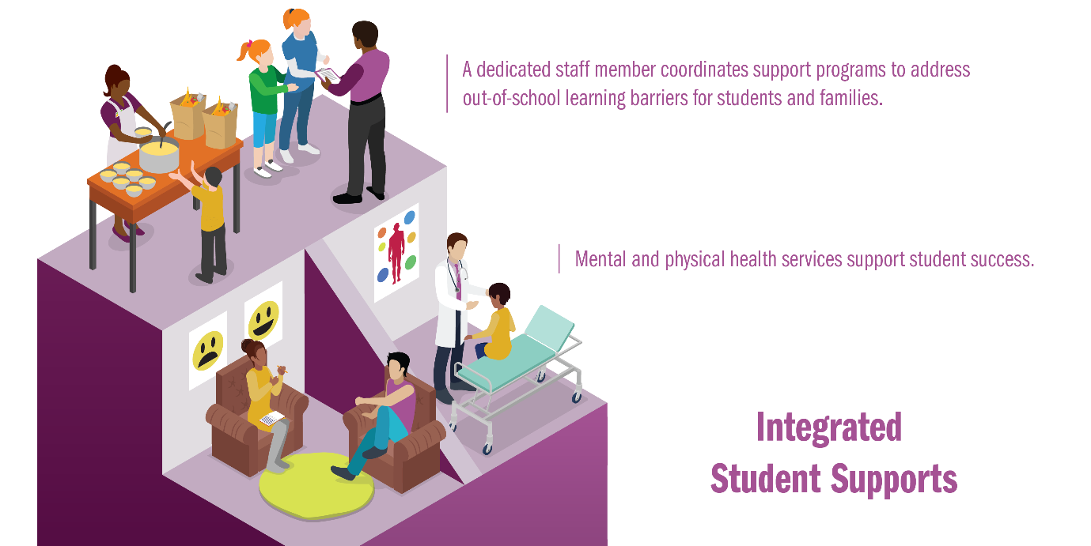

These supports address non-academic and out-of-school barriers to learning through partnerships with social and health services agencies and providers that may include school-based or school-linked health care, case management services, and family stability supports that are coordinated by a community school coordinator who is **culturally and linguistically responsive.**

Selection of the intervention(s) must relate back to the school(s) needs assessment, asset map, vision, and input from the community through listening sessions and data collection.

Describe how each eligible public school will address ISS. Please discuss any evidence drawn from existing research, as described in evidence-based interventions included in the ESSA, from local data, or research associated with your community school planning or implementation work. Examples of evidence-based integrated student supports can be found [here](https://learningpolicyinstitute.org/sites/default/files/product-files/Community_Schools_Effective_REPORT.pdf).

(ISS 1) Reflecting on the last three implementation years, describe what you have learned towards achieving the desired outcomes, how you engaged community partners, and what you plan to do differently to overcome the challenges that you have encountered in the ISS pillar.

|  |
| --- |
|  |

(ISS 2) Describe how this renewal grant will help the community school in sustaining the ISS pillar (i.e., what ISS components are still missing in the community school that you are planning to complete this coming year to get closer to the transformation goal?).

|  |
| --- |
|  |

Expanded and Enriched Learning Time and Opportunities **(EELTO)**

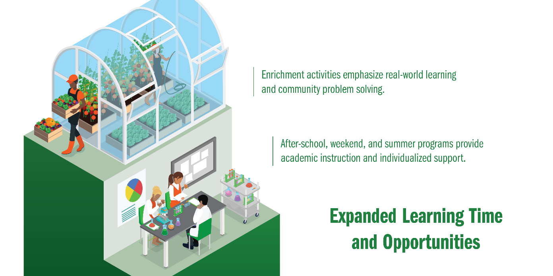EELTO opportunities include before-school, after-school, weekend, summer, and year-round programs that provide additional academic support, enrichment activities, and other programs that may be offered in partnership with **community-based organizations** to enhance academic learning, social skills, emotional skills, and life skills aligned with the school’s curriculum. Partnerships can also include institutions of higher education, health-care providers, businesses, and other community-based organizations.

Selection of the intervention(s) must relate back to the school(s) needs assessment, asset map, vision and input from the community through listening sessions and data collection.

Describe how each eligible public school will address Expanded Learning Time and Opportunities. Please discuss any evidence drawn from existing research, as described in evidence-based interventions included in the ESSA, from local data, or research associated with your community school planning or implementation work. Examples of evidence-based, expanded and enriched learning time and opportunities can be found [here](https://learningpolicyinstitute.org/sites/default/files/product-files/Community_Schools_Effective_REPORT.pdf).

(EELTO 1) Reflecting on the last three implementation years, describe what you have learned towards achieving the desired outcomes, how you engaged community partners, and what you plan to do differently to overcome the challenges that you have encountered in the EELTO pillar.

|  |
| --- |
|  |

(EELTO 2) Describe how this renewal grant will help the community school in sustaining the EELTO pillar (e.g., what EELTO components are still missing in the community school that you are planning to complete this coming year to get closer to the transformation goal?).

|  |
| --- |
|  |

Active Family and Community Engagement (AFCE)

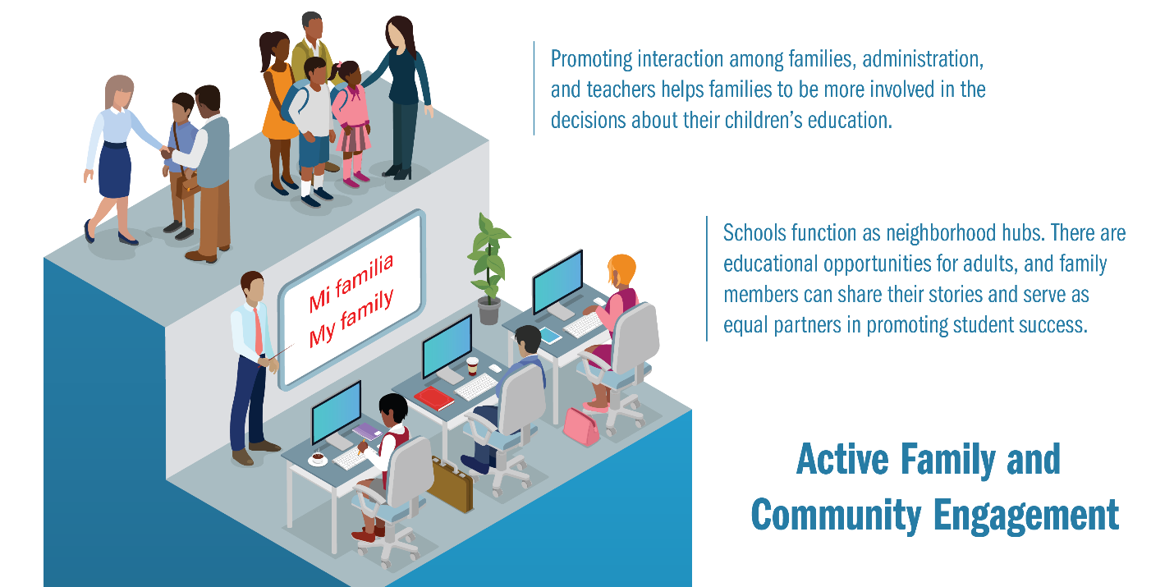

AFCE promotes the valuing of the experiences of people from diverse backgrounds. In community schools, diverse groups are encouraged to come together as empowered partners in decision-making. And it is from these partnerships with parents/caregivers that a vision for student success is developed and promoted. Courses, activities, and services are offered for parents, caregivers, and community members to provide them with opportunities to progress in areas of need and interest.

Selection of the intervention(s) to promote AFCE must relate back to the school(s) needs assessment, asset map, vision, and input from the community through listening sessions and data collection.

Describe how each eligible public school will address Active Family and Community Engagement. Please discuss any evidence drawn from existing research, as described in evidence-based interventions included in the ESSA, from local data, or from research associated with your community school planning or implementation work. Examples of evidence-based active and family community engagement can be found [here](https://learningpolicyinstitute.org/sites/default/files/product-files/Community_Schools_Effective_REPORT.pdf).

(AFCE 1) Reflecting on the last three implementation years, describe what you have learned towards achieving the desired outcomes, how you engaged community partners, and what you plan to do differently to overcome the challenges that you have encountered in the AFCE pillar.

|  |
| --- |
|  |

(AFCE 2) Describe how this renewal grant will help the community school in sustaining the AFCE pillar (e.g., what AFCE components are still missing in the community school that you are planning to complete this coming year to get closer to the transformation goal?).

|  |
| --- |
|  |

Collaborative Leadership and Practice (CLP)



CLP builds a culture of professional learning, collective trust, and responsibility using strategies that, at a minimum, include a site-based leadership and a community school coordinator.

Selection of the intervention(s) must relate back to the school(s) needs assessment, asset map, vision and input from the community through listening sessions and data collection.

Describe how each eligible public school will address Collaborative Leadership and Practice. Please discuss any evidence drawn from existing research, as described in evidence-based interventions included in the ESSA, or from local data or research associated with your prior community school work. Examples of evidence-based collaborative leadership and practice can be found [here](https://learningpolicyinstitute.org/sites/default/files/product-files/Community_Schools_Effective_REPORT.pdf).

**Note:** Be sure to include how the school’s community school plan will support its focus areas through NM DASH, if applicable.

(CLP 1) Describe how interdisciplinary and cross-sector community partners share responsibility and accountability for student and school success.

|  |
| --- |
|  |

(CLP 2) Describe how the SBLT prepare budgets with a view to helping sustain the community school and how community partners help generate funding for the programs and services at the community school.

|  |
| --- |
|  |

(CLP 3) Describe how this renewal grant will help the SBLT sustain the community school strategy.

|  |
| --- |
|  |

Additional Requirements (AR) for the Community Schools Plan

### United States Department of Agriculture (USDA) school meal and snack programs

Reimbursements will be provided for schools and school districts through the PED or CYFD for school meal and snack programs.

If the eligible community school provides an after-school program, at a minimum a USDA [afterschool snack program](https://www.fns.usda.gov/school-meals/afterschool-snacks) must be provided. After school meal programs are preferred and are available through the Children Youth and Families Department (CYFD) Child and Adult Care Food Program (CACFP), see [At-Risk Afterschool Meal Program](https://www.fns.usda.gov/cacfp/afterschool-programs).

If the eligible community school provides a summer program, the school must provide summer meals through the [Seamless Summer Option](https://www.fns.usda.gov/school-meals/opportunity-schools), operated by the school district or the [Summer Food Service Program](https://www.fns.usda.gov/sfsp/summer-food-service-program) operated by the Children Youth and Families Department CACFP.

1. For each eligible community school, state the type of meal or snack program the school will provide after school and during the summer.

|  |
| --- |
|  |

1. Reflecting on the last three implementation years, describe what you have learned in the provision of a school meal and snack program and what you plan to do differently to overcome the challenges that you have encountered.

|  |
| --- |
|  |

### High-Quality Professional Development

An evidence-based community schools initiative shall provide ongoing, high-quality professional development that aligns with the community school’s instructional program, facilitates effective teaching and learning, and supports the implementation of school reform strategies. The professional development plan must be created in conjunction with the site-based leadership team.

1. For each eligible public school, describe how your school will:
   1. Include and support the integration of community partners (existing and future) into your community school professional development plan.

|  |
| --- |
|  |

* 1. Provide leadership development and learning opportunities that empower families to support learning at home.

|  |
| --- |
|  |

### Evidence-based Evaluation System—Annual Assessment

An annual assessmentmust be completed. An evidence-based, community school initiative shall use a rigorous, transparent, equitable, and evidence-based evaluation system to assess the effectiveness of the implementation of the community school initiative. The annual assessment shall be conducted in the format required by the department and at a minimum shall include:

* Submission of community school data through the Student Teacher Accountability Reporting System (STARS) each reporting period.
* Completion of an annual progress report in the format required by the department within 30 calendar days after the state fiscal year ends that include solid evidence and satisfactory documentation that the national standards and the following focus areas have been developed:
  + Vision and strategic plan
  + Collaborative Leadership
  + Needs and asset assessments
  + Space and facilities
  + Research and evaluation
  + Sustainability
* Eligible public schools that receive an implementation grant for the 2022–23 school year will be required to collect data and information and participate authentically in the PED community schools certification process. This data and information must be collected, reviewed, and analyzed by the site-based leadership team and submitted in accordance with the PED’s guidelines and in a format required by the PED for the following indicators, among others:
  1. Community school culture and climate
  2. Student academic achievement
  3. Student attendance
  4. Student behavior
  5. Quality family engagement
  6. For high schools—graduation rates and readiness for college or a career
* Progress on the NM DASH focus areas that include the community school framework.

1. Describe the process each eligible public school will use to evaluate and assess the effectiveness of the community school’s progress on meeting the five or six indicators using data from STARS, data and information from the progress report, and any other measures utilized by the community school.

|  |
| --- |
|  |

## Optional Activities (OA) for the Community Schools Plan

The activities listed below are optional; however, they support the community school framework. Possible additional points may be assigned to schools that support these activities.

The community school framework may include:

Broader use of school facilities

School buildings become hubs for neighborhood events, activities, advocacy, and civic life.

1. Describe how each applicable eligible public school will broaden the use of the school spaces and facilities available for joint use and is open and accessible beyond the school day, including evenings and weekends.

|  |
| --- |
|  |

Community-Based Learning (CBL)

CBL is achieved through a community-based curriculum, in which the content of instruction is centered on local knowledge, service learning, and problem-solving around community issues.

1. Describe how each applicable eligible public school will sustain a community-based curriculum.

|  |
| --- |
|  |

Public pre-kindergarten and other federally funded early childhood services

These services

* support working families and help ensure that children come to kindergarten ready to learn
* provide students and working parents or caregivers with full-day and after-school child care
* provide high-quality pre-kindergarten programs that are aligned to early childhood professional and early learning standards
* provide health, vision, dental, and other supports and services to children before school age
* include strong partnerships and alignment with early learning centers and child care providers
  + may include transportation
  + may coordinate to meet the broader early childhood community needs

**Note:** The addition of pre-kindergarten and early childhood services should be a need identified through the eligible public school’s needs assessment. Partnerships with early learning centers should be noted in the eligible public school’s asset assessment or mapping.

1. Describe how each applicable eligible public school will continue providing a pre-kindergarten program or other early childhood services.

|  |
| --- |
|  |

### Funding Request (FR)

Each school granted an award will be entitled up to $75 thousand per year. Below are the allowable expenses for Community Schools, which follow the standard coding for the chart of accounts per [PSAB Supplement 3](https://webnew.ped.state.nm.us/wp-content/uploads/2020/04/16.-Supplement-3-ver-8.0-April-2020-1.pdf).

Use of the associated function code should describe the related activity for which the service or material object is acquired. Program and job codes are required, as appropriate.

Reference: <https://webnew.ped.state.nm.us/wp-content/uploads/2017/12/SBFAB_Manual-of-Procedures-PSAB_PSAB3-UCOA.pdf>

Align the student and community school needs to this funding request by completing the *Implementation Grant-Renewal Supplemental Application Budget Detail Worksheet*, located on the [NM PED Community Schools website](https://webnew.ped.state.nm.us/bureaus/community-schools/) and the Community Schools-*Resources* section of the [Community Schools & Extended Learning SharePoint site](https://eui.ped.state.nm.us/sites/stars/DocumentRepository/SitePages/Home.aspx). Please submit the required ***Implementation Grant-Renewal Supplemental Application Budget Detail Worksheet*** as an attachment to this application**.**

**Note:** The receipt of a grant award does not constitute an approval of the budget.

## Leveraging of Local, State, and Federal Funds (LEV)

The leveraging of different funding sources gives community schools the opportunity to maximize available resources to expand or enhance services for students in a sustainable way. In addition to seeking and obtaining local resources, community schools may utilize or apply for the following state and federal funds, including:

**Federal Funds**

* Title I, Part A, Rural and Low-Income School Program
* Title I, Part C Migrant Education Program
* Title IV, Part A Student Support and Academic Enrichment
* Title IV, Part B, 21st Century Community Learning Centers
* McKinney-Vento
* The Individuals with Disabilities Education Act, Part B

**State Funds**

* At-risk (State Equalization Guarantee)
* Extended learning time programs
* Family Income Index
* K–5 Plus
* Pre-kindergarten
* Science, Technology, Engineering, Arts, and Math (STEAM)

You can access the current PED’s Request for Proposal, Request for Information, and Request for Application via this [link](https://webnew.ped.state.nm.us/information/rfps-rfis-rfas/).

(LEV 1) Describe the types of funds (e.g. at-risk, extended learning, K–5 Plus) that will be leveraged for each community school and the evidence-based intervention, structure, program, and/or practice that will be implemented to support students. *For example, a school may use part of its Title I Part A funds to pay for a parent engagement coordinator.*

|  |  |  |
| --- | --- | --- |
| **Community School Interventions and Funding Source(s)** | | |
| **Evidence-Based Interventions, Structures, Programs, Practices** | | **Community Schools Pillar**  (ISS, EELTO, AFCE, CLP) |
| ***Example*** | *After-School programming for students experiencing homelessness.* | *EELTO* |
| **1** |  |  |
| **2** |  |  |
| **3** |  |  |
| **4** |  |  |
| **5** |  |  |
| **6** |  |  |
| **7** |  |  |
| **8** |  |  |
| **9** |  |  |
| **10** |  |  |

|  |  |  |  |  |
| --- | --- | --- | --- | --- |
| **item** | **Funding Source** | **Amount** | **District-Level Position:**  **% FTE Leveraged*∞** | **School-Level Position:**  **% FTE leveraged* ڄ** |
| ***Example*** | *Federal: Title I , Title IX & X-McKinney Vento grant, Hygiene grant; ESSER funds; State: At-Risk, FII, Local: NM Appleseed* | *$8,500; $4,000, $1,000, $50,000, $5,000* |  | *25% Title I, 25% ESSER, 25% At-risk, 25% FII* |
| **1** |  |  |  |  |
| **2** |  |  |  |  |
| **3** |  |  |  |  |
| **4** |  |  |  |  |
| **5** |  |  |  |  |
| **6** |  |  |  |  |
| **7** |  |  |  |  |
| **8** |  |  |  |  |
| **9** |  |  |  |  |
| **10** |  |  |  |  |

**Notes**

* Levels of effort cannot exceed 100 percent. Add rows as necessary.
* When including school district-level positions, include the percent of FTE dedicated specifically to the community school.
* When including school-level positions, include the percent of FTE dedicated specifically to the community school.

2. (LEV 2) List the organization, the type and amount of funds that are being leveraged to expand and sustain the community school, and the services and activities the funding supports. Add rows as needed*.*

|  |  |  |  |  |  |
| --- | --- | --- | --- | --- | --- |
| **Organization** | **Funding Source** | **Amount** | **Overall % FTE\*** | **Service Description∞** | **Activity Description ڄ** |
| *Example: NM Appleseed* | *Non-profit* | *$5,000* | 0% | *Provides cash vouchers to students experiencing homelessness* |  |
|  |  |  |  |  |  |
|  |  |  |  |  |  |
|  |  |  |  |  |  |
|  |  |  |  |  |  |
|  |  |  |  |  |  |
|  |  |  |  |  |  |
|  |  |  |  |  |  |
|  |  |  |  |  |  |
|  |  |  |  |  |  |
|  |  |  |  |  |  |

3. (LEV 3) Please describe the plan to sustain the community school strategy locally once this renewal grant ends.

## SY2022–23 Community School Sustainability Plan Summary

|  |  |  |  |  |
| --- | --- | --- | --- | --- |
| Describe your community school’s sustainability plan considering the main structures and practices of the community schools’ strategy and the 4P’s of sustainability: Provisions, People, Practice, and Policy. | | | | |
| Shared Vision | | | | |
|  | | | | |
| Strategic Goals | | | | |
|  | | | | |
| Community School System-Level Priorities | | | | |
|  | **Provisions** | **People** | **Practice** | **Policy** |
| Community-Wide Leadership Team |  |  |  |  |
| ISS Pillar |  |  |  |  |
| EELTO Pillar |  |  |  |  |
| AFCE Pillar |  |  |  |  |
| CLP Pillar |  |  |  |  |
| Community School -Level Priorities | | | | |
|  | **Provisions** | **People** | **Practice** | **Policy** |
| Community School Coordinator |  |  |  |  |
| Site-Based Leadership Team |  |  |  |  |
| Needs Assessment Process |  |  |  |  |
| ISS Pillar |  |  |  |  |
| EELTO Pillar |  |  |  |  |
| AFCE Pillar |  |  |  |  |
| CLP Pillar |  |  |  |  |
|  | | | | |

Reference: Please consider using the ECHO for Community Schools [recordings and materials](https://padlet.com/educationecho/yaf8cnwrbxc7uxck) on this topic to support you in completing this sustainability plan with your site-based leadership team.

# Assurances

Each eligible applicant must meet all of the assurances below. Check all of the applicable assurances.

|  |  |  |
| --- | --- | --- |
|  |  | The lead partner agency shall employ a full-time community school coordinator. |

|  |  |  |
| --- | --- | --- |
|  |  | The community school coordinator will work with the STARS coordinator and shall enter the required data into the Student Teacher Accountability Reporting System (STARS) each reporting period in accordance with 22-8-13, NMSA 1978. |

|  |  |  |
| --- | --- | --- |
|  |  | Each eligible public community school shall complete a Community Schools Progress Report on an annual basis and submit to the PED within 30 calendar days of the state fiscal year ending in the format specified by the department. |

|  |  |  |
| --- | --- | --- |
|  |  | The school district shall establish and maintain a community-wide leadership team. |

|  |  |  |
| --- | --- | --- |
|  | 5) | Each eligible public school shall establish and maintain a site-based leadership team. |

|  |  |  |
| --- | --- | --- |
|  | 6) | The school district shall bear any indirect costs associated with the establishment and implementation of a community school within the school district unless it receives federal funds. |

|  |  |  |
| --- | --- | --- |
|  | 7) | The school district or governing body shall give the community school sufficient operational flexibility in programming, curriculum, staffing, budgeting, and scheduling so that the community school can fully implement a comprehensive community school framework. |

|  |  |  |
| --- | --- | --- |
|  |  | If a grantee receives funding to implement the community schools initiative at three or more public school sites, the school district(s) of the funded community schools shall employ a community schools director or manager to oversee and coordinate implementation of the community school framework and ensure a community school coordinator is employed at each community school site. |

|  |  |  |
| --- | --- | --- |
|  |  | Eligible public schools will actively recruit students for community school programs who qualify for the migrant education program (Title I, Part C) and their families as well as students experiencing homelessness and their families. This includes community schools that operate pre-kindergarten and early childhood education programs. |
|  | 10) | Eligible public schools will participate in the certification process as determined by PED. |
|  | 11) | Applicants are strongly encouraged to attend all professional development opportunities offered by the PED, including the Student Teacher Accountability Reporting System (STARS) Conference, Community Schools Data Collection breakout session. Successful awardees must participate in the Community Schools ECHO Program and the New Mexico Community Schools Convening and the New Mexico Out-of-School Time (NMOST) annual conferences. Applicants must attend and participate in the Community Schools’ strand as appropriate. At a minimum, attendees should include the school’s community school coordinator, principal, and members of the site-based leadership team. |

**Additional Assurances**

### Needs Assessment and Asset Map

A needs assessment has been conducted for each eligible public school and is included with the application. The needs assessment analyzed student demographic data including the ESSA subgroups of students in the areas of academic proficiency and attendance.

An asset map has been conducted for each eligible public school and is included with the application.

### Partner Commitment Form

A supplemental Partner Commitment Form has been provided (and found in “Attachments” in this application packet). For each named partner in the application, include a signed completed form.

### Eligible Applicant Information and Signatures

In the section below, for each eligible public school, list the name(s) of the principal or charter school administrator, the name of the superintendent(s) or governing body leader(s), the name of the school or district business official(s), and the name of the chair or leader of the school’s leadership team.

The signatures below indicate that the signatories—representing their organization—will support the implementation of the community school framework, including the necessary ongoing professional development for the school principal and staff members, in order for the community school to be successful. The signatures also indicate agreement to support the needs assessment and asset mapping process for the eligible school’s implementation of the community school framework.

### Single School

Name and signature of eligible school’s principal or charter school administrator:

|  |  |  |  |
| --- | --- | --- | --- |
| Signature | |  | |
| Printed or Typed Name: | | |  |
| Title: |  | | |
| Date: |  | | |

Name and signature of eligible school’s superintendent or governing body chair:

|  |  |  |  |
| --- | --- | --- | --- |
| Signature | |  | |
| Printed or Typed Name: | | |  |
| Title: |  | | |
| Date: |  | | |

Name and signature of eligible school’s business manager or district business official:

|  |  |  |  |
| --- | --- | --- | --- |
| Signature | |  | |
| Printed or Typed Name: | | |  |
| Title: |  | | |
| Date: |  | | |

Name and signature of eligible school’s school site leadership team chair:

|  |  |  |  |
| --- | --- | --- | --- |
| Signature | |  | |
| Printed or Typed Name: | | |  |
| Title: |  | | |
| Date: |  | | |

|  |  |
| --- | --- |
| Consortium of Schools School District or REC for consortium |  |

Name of eligible schools’ superintendent or governing body leader or Regional Education

Cooperative Coordinating Council Chairperson in accordance with 22-2B-4, NMSA 1978:

|  |  |  |  |
| --- | --- | --- | --- |
| Signature | |  | |
| Printed or Typed Name: | | |  |
| Title: |  | | |
| Date: |  | | |

Names of eligible school principal or charter school administrator (School Name      ):

|  |  |  |  |
| --- | --- | --- | --- |
| Signature | |  | |
| Printed or Typed Name: | | |  |
| Title: |  | | |
| Date: |  | | |

Names of eligible school principal or charter school administrator (School Name      ):

|  |  |  |  |
| --- | --- | --- | --- |
| Signature | |  | |
| Printed or Typed Name: | | |  |
| Title: |  | | |
| Date: |  | | |

Name of each eligible school’s school or district business official (School Name      ):

|  |  |  |  |
| --- | --- | --- | --- |
| Signature | |  | |
| Printed or Typed Name: | | |  |
| Title: |  | | |
| Date: |  | | |

Name of each eligible school’s Leadership Team Chair or Leader (School Name      ):

|  |  |  |  |
| --- | --- | --- | --- |
| Signature | |  | |
| Printed or Typed Name: | | |  |
| Title: |  | | |
| Date: |  | | |

**Note:** Add lines as necessary

School District

Names of eligible school principal or charter school administrator (School Name      ):

|  |  |  |  |
| --- | --- | --- | --- |
| Signature | |  | |
| Printed or Typed Name: | | |  |
| Title: |  | | |
| Date: |  | | |

Names of eligible school principal or charter school administrator (School Name      ):

|  |  |  |  |
| --- | --- | --- | --- |
| Signature | |  | |
| Printed or Typed Name: | | |  |
| Title: |  | | |
| Date: |  | | |

Name of eligible school’s superintendent or governing body leader (School Name      ):

|  |  |  |  |
| --- | --- | --- | --- |
| Signature | |  | |
| Printed or Typed Name: | | |  |
| Title: |  | | |
| Date: |  | | |

Name of each eligible school’s school or district business official (School Name      ):

|  |  |  |  |
| --- | --- | --- | --- |
| Signature | |  | |
| Printed or Typed Name: | | |  |
| Title: |  | | |
| Date: |  | | |

Name of each eligible school’s Leadership Team Chair or Leader (School Name      ):

|  |  |  |  |
| --- | --- | --- | --- |
| Signature | |  | |
| Printed or Typed Name: | | |  |
| Title: |  | | |
| Date: |  | | |

**Note:** Add lines as necessary

# Attachments

## Partner Commitment Form

**Instructions to Applicant:** Please provide a copy of this form to **each** named partner in your application and submit all completed and signed forms as an attachment to your application.

**Applicant School District:**

**School for which this Form is Being Completed:**

**Instructions to Partner Organization:** The school and school district named above are submitting an application to the Public Education Department for a Community School (Planning/Implementation) grant. To evaluate the strength of each application’s existing and future partnerships, each applicant must submit this form for each named partner in the application. As a named partner, please complete the form below to the best of your ability.

**Name of Individual Completing Form:**

**Title and Organization:**

**Phone Number:**       | **E-mail Address:**

**Your Role (check all that apply):**

Community-wide Leadership Team

Site-based Leadership Team

Unsure

**Questions** (Please use as much space as needed to answer each question completely.)

1. What role, if any, has your organization played in the development of the community school named above?
2. What role, if any, did your organization play in helping to shape this community school grant application?
3. If this grant application is funded, how will your organization support this community school? Please include both financial, in-kind, and other resources that your organization has committed or will commit to support the identified priorities of the community school.
4. Are there any additional comments you would like to provide?

Signature:___________________________________

1. Emboldened words and phrases found in the body of this document as text are further defined in the glossary.