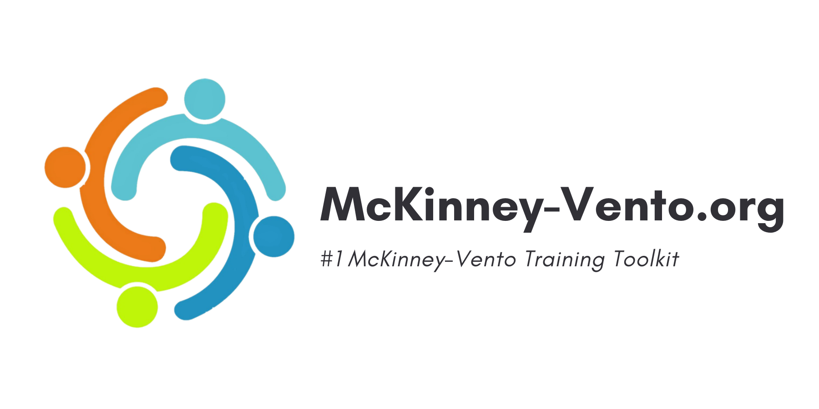
ESSENTIAL STAFF WELCOME LETTER

Hello everyone,

My name is ______ and I am the designated homeless liaison for our school district. This is a federally mandated position, with specific requirements that are aimed to ensure that we identify and support our students who are experiencing homelessness.

One of my many federally mandated requirements is to deliver training to all staff within our school district on the laws related to homelessness and ways to properly identify these students. This training is not only required, but it is also very important as we aim to increase the identification of homeless students in our district, impacting Local Educational Agency (LEA) funding for students experiencing homelessness and for Homeless Education Programs.

Given our limited resources and time to deliver this training in person, we have teamed up with Mckinney-Vento.org to provide an online alternative that is faster, easier, and more cost-effective. It should take you LESS THAN 15 minutes to complete.

Please review your login instructions on the next page, and I would respectfully request that you complete this training no later than [DATE].

LOGIN INSTRUCTIONS
Reminder: This training is mandated under the Every Student Succeeds Act – your district’s Homeless Liaison is required to educate all essential staff about homelessness.
- To register, click the link Register – McKinney-Vento.
- Fill out your name and school email address
- Select “I am NOT a liaison.”
- Select your state, county, district, school, and role(s) in the registration form and then select “Create Account”.
- You will receive an email at your provided email address with instructions on creating your account password. Please be sure to check your spam/junk folders for this email if it seems you have not received it.
- Once you have created your password, you will be able to log in and start taking your course(s). If you don’t see your course(s), click the Learn tab on the top right of the page.
If you need help with your account or you encounter any technical issues, please email your support team at support@mckinney-vento.org for a fast response! Thank you for taking the time to learn about this important topic!

