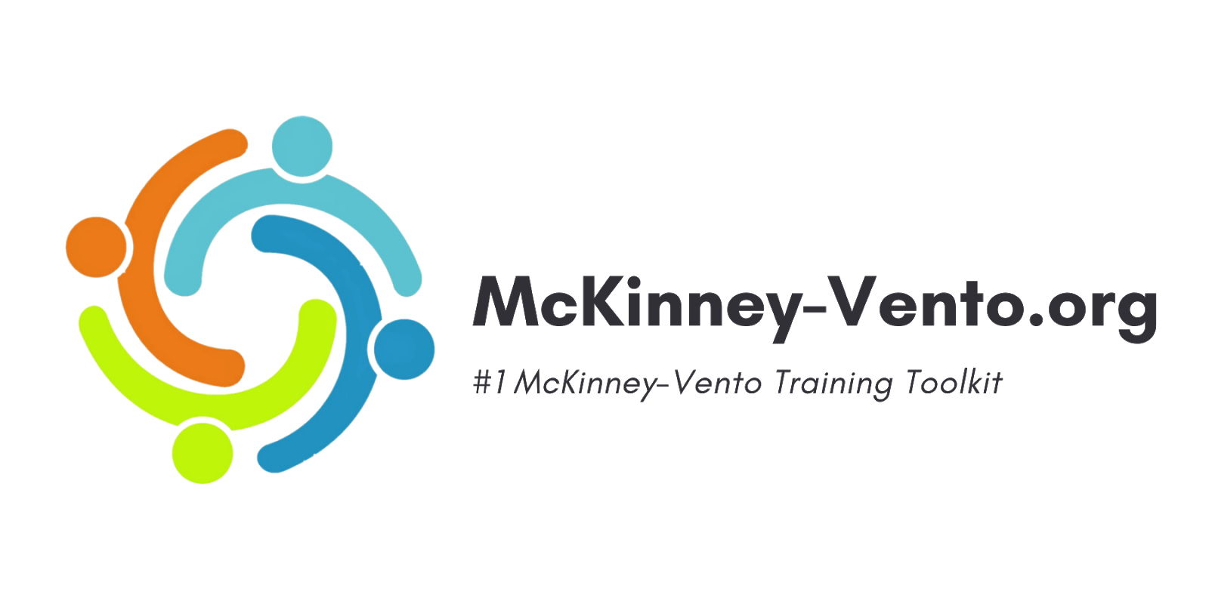
Hello, Liaisons!
Your state has provided you with McKinney-Vento.org trainings for homeless liaisons. In order to register for your training, take the following steps:
- To register, click the link Register – McKinney-Vento.
- Fill in your name and school email address
- Select “I am a Liaison.”
- Select your state, county, and district in the registration form.
- If you are the liaison for your entire LEA, select “Liaison for this entire district.” If you are the liaison for a specific school, select your school from the dropdown.
- Select “Create Account”.
- After submitting your registration, a member of our staff will approve you as the LEA or school liaison within one business day and will send an email notification of your approval. Please be sure to check your spam/junk folders for this email if it seems you have not received it.
- In your approval email, click the provided link to create your account password.
- Once your password is created, you can log in and begin your training courses at mckinney-vento.org/login. If you do not see your courses, click the Learn tab on the top right.
Please plan for approximately 5-8 hours to complete this training (depending on your experience as a liaison).
If you need help with your account or you encounter any technical issues, please email your support team at support@mckinney-vento.org. For SEA-related inquiries or credentials-related concerns, you can contact ______<Coordinator name and email address>.

Thank you!

