New Mexico Public Education Commission

2022 Charter School Renewal Application
Part C: Financial Statement

Charter Schools Division
Public Education Department
300 Don Gaspar Ave.
Santa Fe, NM 87501
(505) 827-6909
charter.schools@state.nm.us

Approved by the Public Education Commission: March 18, 2022

Table of Contents

Instructions 1
School Information 1
Financial Statement Narrative 1
Operational Expenditures Tables 2
Operational Expenditures Chart 6

Instructions
Please read the entire Charter School Renewal Application Kit before preparing documents. In an effort to help applicants understand the requirements of the Renewal Application, the CSD will hold a minimum of two technical assistance workshops. Applicants will be notified of the dates, times, and locations of the workshops.
Enter applicant responses in boxes below. Answer all questions unless the question indicates that applicants should answer only under certain conditions (e.g., rating on a Performance Framework indicator requires explanation, etc.). Narrative responses should be verifiable through documents submitted or observable evidence at the renewal site visit.

School Information
Name of School:
Current Charter Term:

Financial Statement Narrative
The school must provide a financial statement that discloses the costs of administration, instruction, and other spending categories for the charter school. The financial statement must be understandable to the general public and must allow comparison of costs to other schools or comparable organizations. The school must use the templates included within Part C of the renewal kit for the financial report. For schools that were identified in the lowest 25% of all schools in the NM System of Support and Accountability for SY2018-19 or SY2021-22, the report should specifically address how the school has prioritized resources toward proven programs and methods linked to improved student achievement.
Enter applicant response in box below:
School response:

Operational Expenditures Tables
For each fiscal year of the school’s current charter contract (Year 1 to Year 4 for a 5-year contract), complete the table specific to the school’s operational actual expenses and actual operational funding. Schools with contract terms shorter than five years may delete extra tables.
Year 1: FY ___ Operational Funds/General Funds – 11000
Function | Function Name | Example of Expenditures by Fund | Amount (in whole dollars) | Percentage (%)
1000 | Direct Instruction | Teachers, EAs, Instructional Coaches, etc.
2100 | Student Support | Attendance, Social Workers, Counseling, Ancillary Services, etc.
2200 | Instructional Support | Library/Media Services, Instructional-Related Technology, Academic Student Assessment, etc.
2300 | Central Administration | Governance Council, Executive Administration/School Head Administrator, Community Relations, etc.
2400 | School Administration | Office of the Principal
2500 | Central Services | Business Manager, Human Resources, Printing, Technology Services, etc.
2600 | Maintenance and Operations | Maintenance and Operations of Buildings, Upkeep of Grounds and Vehicles, Security, Safety, etc.
2700-5999 | All Other Function Codes | PED Grant Initiatives, PreK, state grants, Next Gen, CTE, digital technology, extended learning and K5+
Grand Total Operational/General Funds 11000 |  |  |  | 100%
Total Operational Funding Revenue 11000 |  |  |  | N/A

Year 2: FY ___ Operational Funds/General Funds – 11000
Function | Function Name | Example of Expenditures by Fund | Amount (in whole dollars) | Percentage (%)
1000 | Direct Instruction | Teachers, EAs, Instructional Coaches, etc.
2100 | Student Support | Attendance, Social Workers, Counseling, Ancillary Services, etc.
2200 | Instructional Support | Library/Media Services, Instructional-Related Technology, Academic Student Assessment, etc.
2300 | Central Administration | Governance Council, Executive Administration/School Head Administrator, Community Relations, etc.
2400 | School Administration | Office of the Principal
2500 | Central Services | Business Manager, Human Resources, Printing, Technology Services, etc.
2600 | Maintenance and Operations | Maintenance and Operations of Buildings, Upkeep of Grounds and Vehicles, Security, Safety, etc.
2700-5999 | All Other Function Codes | PED Grant Initiatives, PreK, state grants, Next Gen, CTE, digital technology, extended learning and K5+
Grand Total Operational/General Funds 11000 |  |  |  | 100%
Total Operational Funding Revenue 11000 |  |  |  | N/A

Year 3: FY ___ Operational Funds/General Funds – 11000
Function | Function Name | Example of Expenditures by Fund | Amount (in whole dollars) | Percentage (%)
1000 | Direct Instruction | Teachers, EAs, Instructional Coaches, etc.
2100 | Student Support | Attendance, Social Workers, Counseling, Ancillary Services, etc.
2200 | Instructional Support | Library/Media Services, Instructional-Related Technology, Academic Student Assessment, etc.
2300 | Central Administration | Governance Council, Executive Administration/School Head Administrator, Community Relations, etc.
2400 | School Administration | Office of the Principal
2500 | Central Services | Business Manager, Human Resources, Printing, Technology Services, etc.
2600 | Maintenance and Operations | Maintenance and Operations of Buildings, Upkeep of Grounds and Vehicles, Security, Safety, etc.
2700-5999 | All Other Function Codes | PED Grant Initiatives, PreK, state grants, Next Gen, CTE, digital technology, extended learning and K5+
Grand Total Operational/General Funds 11000 |  |  |  | 100%
Total Operational Funding Revenue 11000 |  |  |  | N/A

Year 4: FY ___ Operational Funds/General Funds – 11000
Function | Function Name | Example of Expenditures by Fund | Amount (in whole dollars) | Percentage (%)
1000 | Direct Instruction | Teachers, EAs, Instructional Coaches, etc.
2100 | Student Support | Attendance, Social Workers, Counseling, Ancillary Services, etc.
2200 | Instructional Support | Library/Media Services, Instructional-Related Technology, Academic Student Assessment, etc.
2300 | Central Administration | Governance Council, Executive Administration/School Head Administrator, Community Relations, etc.
2400 | School Administration | Office of the Principal
2500 | Central Services | Business Manager, Human Resources, Printing, Technology Services, etc.
2600 | Maintenance and Operations | Maintenance and Operations of Buildings, Upkeep of Grounds and Vehicles, Security, Safety, etc.
2700-5999 | All Other Function Codes | PED Grant Initiatives, PreK, state grants, Next Gen, CTE, digital technology, extended learning and K5+
Grand Total Operational/General Funds 11000 |  |  |  | 100%
Total Operational Funding Revenue 11000 |  |  |  | N/A

Operational Expenditures Chart
Complete the Operational Expenses chart below. To edit the data, right click on the chart and an Excel table will appear (see screenshot below). Edit the data in the table, and the data in the chart will update automatically.

Menu that appears when right click on chart:
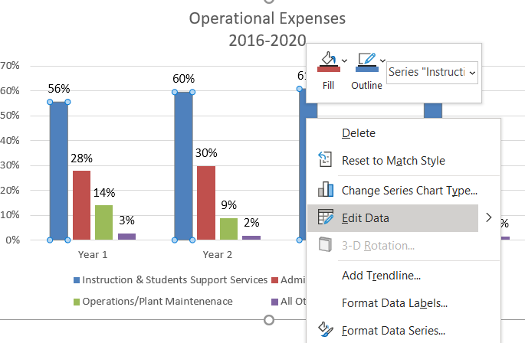

Table that appears when “Edit Data” is selected:
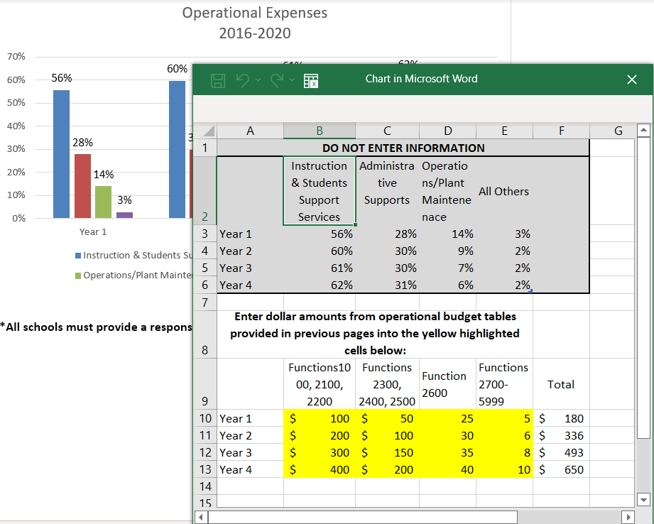
If the entire chart does not appear, drag to enlarge the window. Enter data in yellow-highlighted cells. Technical assistance will be provided as needed by CSD during Renewal Application training.

