New Mexico Public Education Commission

Charter School Renewal Application

Charter Schools Division
Public Education Department
300 Don Gaspar Ave.
Santa Fe, NM 87501
(505) 827-6909
charter.schools@ped.nm.gov

Approved by the Public Education Commission (PEC): February 17, 2023

Table of Contents

Overview of Renewal Application and Process 2
Process and Timeline 4
Evaluation Standards 5
Charter Renewal Application 6
Part B: Progress Report 6
Rubric 6
1. Academic Performance 7
1.a. Student Outcomes 7
1.b. Mission-specific or School-Specific Goals 7
2. Organizational Performance 8
2.a. Educational Program 8
2.b. Financial Compliance 8
2.c. Governance Responsibilities 8
2.d. Equity and Identity 8
2.e. Tribal Consultation 8
2.f. Other Performance Framework Indicators 9
Part C: Financial Statement 10
Part D: Petitions of Support 12
Part E: Facilities 14
Part F: Change in Authorizer 15
Appendices 15

Overview of Renewal Application and Process
By October of the last year of their contract term, charter schools must apply for renewal of their charter contract, either from their local chartering authority (district) or the Public Education Commission (PEC), which serves as the state chartering authority. In accordance with Section 6.80.4.13.A. of the New Mexico Administrative Code (NMAC), renewal applications must be submitted no later than the first business day of October of the year prior to the expiration of the school’s charter, and the chartering authority must rule on the renewal of the application in a public meeting no later than January 1 of the fiscal year in which the charter expires.
The Charter Schools Division (CSD) of the New Mexico Public Education Department (PED) provides staff support to the PEC and will review all renewal applications submitted to the PEC, conduct the renewal site visits, and provide an analysis and recommendation for renewal, non-renewal, or conditional renewal. The PEC makes the final decision regarding the renewal application after reading the application, the CSD preliminary analysis, the school’s response, and the CSD in final analysis and recommendation, and considering the school’s presentation at the renewal hearing.
The PEC developed this state charter renewal application kit to assist charter schools in the development of their renewal applications. The template for the state renewal charter application kit will be posted on the PEC website at https://webnew.ped.state.nm.us/bureaus/public-education-commission/policies-and-processes/. The CSD will provide technical assistance training that focuses on the state-authorization charter school renewal process. Schools intending to renew with a district authorizer should check with the district regarding their forms and processes.
The renewal application is divided into six parts, described below. These sections address the requirements of New Mexico Statutes Annotated (NMSA) 1978 §22-8B-12(J) and are intended to provide the PEC the information necessary to determine if the school’s past performance supports renewal of the charter.
Part A: Summary Data Report is provided by the CSD to the school in the summer before renewal, updated after the newest academic data is released, and provided to the PEC in October along with the rest of the school’s application. The school is asked to verify the information in Part A. The school should use the information to report on academic performance goals and other contractual requirements.
Part B: Progress Report offers schools the opportunity to provide information regarding their uniqueness, innovation, academic performance, financial compliance, and organizational, contractual and governance responsibilities and improvement actions over the term of their most current charter. This part of the application includes several sections, which are described in the Part B section below.
Part C: Financial Statement offers schools the opportunity to demonstrate the financial stewardship it has implemented over the term of the contract.
Part D: Petitions of Support offers the opportunity to demonstrate the community support for the continuation of the school. 1978 NMSA §22-8B-12 requires the school to provide petitions from school staff and households of students enrolled in the school.
Part E: Facilities requires the school to provide a description of the charter school facilities and assurances that the facilities are in compliance with the requirements of 1978 NMSA §22-8B-4.2. The documentation required is listed in the Charter Renewal Application section below.
Part F: New Authorizer is required only from district-authorized charter schools applying for renewal under the PEC. Part F consists of Appendices F-1 through F-8, which are listed in the Charter Renewal Application section below.
Upon receipt of the completed application, the CSD will review the application, verify data, and conduct a renewal site visit to verify information provided within the application. Afterwards, the CSD will write a preliminary analysis of the school’s renewal application and send a copy to the school and the PEC. The school will have an opportunity to respond to the analysis provided. After the CSD receives the school’s response, it will evaluate all information available and provide a final analysis for renewal, renewal with conditions, or non-renewal to the PEC and the school.
New Mexico law 1978, NMSA § 22-8B-12(K) provides that a charter may be not renewed by the chartering authority if the chartering authority determines that the charter school:
- committed a material violation of any of the conditions, standards or procedures set forth in the charter contract;
- failed to meet or make substantial progress toward achievement of the department's standards of excellence or student performance standards identified in the charter contract;
- failed to meet generally accepted standards of fiscal management;
- for a charter school located on tribal land, failed to comply with ongoing consultations pursuant to the Indian Education Act; or
- violated any provision of law from which the charter school was not specifically exempted.
Please contact charter.schools@ped.nm.gov, with any questions regarding the state charter renewal application kit.

Annual Process and Timeline

August 1 (may be delayed by data availability) | CSD to prioritize renewing school annual reports. PEC to review annual reports and send out notices of concerns.
Application Submission (September 15) | The Renewal Applications Due
Renewal Application Review (September 15 – October 31) | A CSD review team analyzes applications and schedules renewal site visits prior to completion of the Renewal Analysis. Site visit
Preliminary Analysis (November 1) | The CSD will send each renewal applicant and the PEC a Preliminary Renewal Analysis including a preliminary indication of the recommendation (renewal, non-renewal or renewal with conditions). This analysis will synthesize the strengths and weaknesses of the charter school in relation to the statutory reasons for non-renewal.
November PEC meeting (on or about November 7)  PEC letter goes to school (November 10) | PEC to identify schools that may be subject to a condition or non-renewal based on previous information and CSD preliminary renewal analysis. PEC to authorize Chair to send notice letters to school.
Response to Preliminary Analysis (November 15) | Renewal applicants may respond in writing to the Preliminary Renewal Analysis and provide a response to the preliminary recommendation of non-renewal or renewal condition. These responses must be uploaded to the school’s Google folder and will be included in the CSD final renewal analysis.
CSD Final Renewal Analysis to PEC (December 1) | The CSD will provide the PED with a final renewal analysis including a recommendation that the PEC renew, renew with conditions, or non-renew the charter. Renewal applicants will receive a copy of the final renewal analysis.
Final Authorization Meeting of PEC (within first three weeks of December) | The PEC will hold a public decision-making meeting to renew, renew with conditions, or non-renew the charter.  The school will be provided an opportunity to respond to the PEC notice of a possible non-renewal or renewal with conditions.  If, for the first time, a decision to renew with conditions or decision to non-renew is imposed by the PEC without prior notice, the school will be given an opportunity, prior to December 31, to ask for reconsideration of the condition or decision to non-renew at the January PEC meeting and provide a response at that time. The PEC could then decide to lessen or remove the condition or non-renewal decision made in December. The request for reconsideration would stay a notice of appeal until 15 days following the January meeting with the Secretary’s approval.

Evaluation Standards
Based on the completed Renewal Application Kit, the charter school site visits conducted during the charter term, the Renewal Analysis from the CSD staff, status reports provided by the PED’s divisions and bureaus, and, if applicable, the local school district, the CSD will make a recommendation to the PEC regarding renewal of a school’s charter. The following questions guide the CSD’s final analysis regarding renewal and are based upon the five reasons that a chartering authority must determine a charter school has violated in order to refuse to renew a charter pursuant to Subsection K of Section 22-8B-12 NMSA 1978.
Has the school committed a material violation of any of the conditions, standards, or procedures set forth in the charter?
The school’s performance contract defines the terms under which it proposes to operate and the Performance Framework (Attachment A to the contract) which defines the measurable goals that the school agreed to meet. The CSD will analyze the evidence presented in the application from the school during the renewal site visit, and from the monitoring conducted during the term of the contract, to provide a recommendation to the PEC regarding whether the school committed a material violation of any of the conditions, standards, or procedures set forth in the charter. Applicants that are currently authorized by a school district, and not the PEC, must provide these documents as well.
Has the school failed to meet or make substantial progress toward achievement of the PED’s minimum educational standards or student performance standards identified in the charter application?
The CSD will analyze and evaluate student achievement data on required state tests and on other measures set forth in the contract. The school must report data for school or mission specific goals both throughout the term of the contract and as part of the renewal application. The school’s own analysis and supporting data will both be considered.
Has the school and, if applicable, the school’s foundation failed to meet generally accepted standards of fiscal management?
The CSD will rely on documentary evidence based on the annual independent financial audits and reports from the School Budget and Finance Analysis Bureau and the Audit and Accounting Bureau with regard to whether the school has met generally accepted standards of fiscal management.
For a charter school located on tribal land, has the school failed to comply with ongoing consultations pursuant to the Indian Education Act?
The CSD will confirm by means of an interview with tribal officials that consultation took place in compliance with statute.
Has the school violated any provision of law from which the state-chartered charter school was not specifically exempted?
The CSD will rely on documentary evidence gathered by the PED or, if applicable, local district authorizer staff, during the term of the school’s charter contract to determine if the school has compiled a record of substantial compliance with applicable state and federal laws and regulations. Evidence will also be evaluated during the site including renewal site visit and from monitoring reports throughout the term of the contract.

Charter Renewal Application
Part A of the application will be completed by CSD. State-authorized schools must complete Parts B, C, D, and E of the application. District-authorized schools must also complete Part F. Parts B, C, and E should be completed using the forms in the Renewal Application Kit. Parts D and F consist only of appendices, which should be submitted as PDFs using the naming conventions indicated below.

Part B: Progress Report
Please submit the Progress Report using the Charter Renewal Application Part B document available on the Charter Renewal Application web page: https://webnew.ped.state.nm.us/bureaus/public-education-commission/policies-and-processes/renewal-application/.

Rubric
The following rubric will be used to evaluate the narratives in Part B:
Meets the Standards | - In each year of the contract term, the school has a demonstrated record of meeting all standards, which is supported by evidence.
Demonstrates  Substantial Progress | Demonstration Through Data | Demonstration Through Systemic Improvement
 | - The school does not have a demonstrated record of meeting all standards in each of the years in the contract term, however…  - An evaluation of all data and evidence (for academic narrative this includes all available academic performance data, including state assessment data) demonstrates at least two years of sustained improvement toward meeting the standard. | - The school does not have a demonstrated record of meeting all standards in each of the years in the contract term, however…  - The narrative describes specific adult (teacher, leader, board) actions taken to improve performance and outcomes by addressing the cause of the inadequate performance;  and  - The site visit team can verify the implementation of reported improvement actions by evaluating specific evidence at the school site that is observable, verifiable, and readily available;  and  - The narrative identifies measurable successes during the most recent year resulting from the improvement actions taken;  and  - An evaluation of the data and evidence supports the observable and reported successes.
Failing to  Demonstrate Progress | - The school does not have a demonstrated record of meeting all standards in each of the years of the contract term.  - An evaluation of data and evidence (for academic narrative this includes all available academic performance data, including state assessment data) does not demonstrate at least two years of sustained improvement toward meeting the standard.  and one or more of the following:  - The narrative is focused on describing circumstances connected to the poor performance and/or excuses for the poor performance (e.g., serving a disproportionately high rate of students with disabilities, serving a disproportionately high rate of “at-risk” students, a lack of funding, teacher/administrator turnover, etc.), and/or either does not describe specific adult improvement actions taken or describes minimal adult improvement actions taken;  or  - The site visit team is not able to verify implementation of the reported adult improvement actions because there is no observable, verifiable evidence presented during the site including renewal site visit;  or  - The narrative fails to identify any measurable successes during the most recent year, or evaluation of the data and evidence directly contradicts reported successes.

1. Academic Performance
The school reports on its academic performance during the term of the contract, including achieving its goals, student performance outcomes, state standards of excellence and accountability requirements set forth in the Assessment and Accountability Act.

1.a. Student Outcomes
1.a. How has the school measured student proficiency and growth, including action taken in the absence of state summative assessments in 2019-20 and 2020-21? Describe interim and formative assessments used, and the results of those assessments. Include a detailed narrative that addresses the actions taken to improve student outcomes, and the success of those actions. Schools may take the opportunity to include data in support of the narrative. If providing data to support the school’s narrative, provide it in Appendix A-1 Academic Data. Implementation of the described improvement actions should be verifiable through evidence at the renewal site visit.

1.b. Mission-specific or School-Specific Goals
Report on the school’s performance in relation to the school- or mission-specific goals in the negotiated performance framework. Performance reports related to school or mission specific goals should be supported by raw data (masked to protect PII) and provided in Appendix A-2 Mission Goal Data. The school should report on the performance in each year of the contract term.
Schools that have not met their school- or mission-specific goals in each year of the contract term should provide a narrative that addresses the improvement actions taken and the success of those actions. The purpose of the narrative is to demonstrate substantial progress toward meeting the school or mission specific goals and maintaining that performance level. Implementation of the described improvement actions should be verifiable through evidence at the renewal site visit.

2. Organizational Performance

2.a. Educational Program
How is the school implementing the distinctive educational program described in its contract (Performance Framework Indicator 1.a.)? The response should address the ways in which the school is implementing the family, teacher, and student-focused terms of its contract. Please discuss any innovations the school has implemented in support of its mission and educational program.

2.b. Financial Compliance
How is the school managing its finances (Performance Framework Indicators 2.a-f.)?
For each year in which the school had a significant deficiency, material weakness, or repeated finding(s) identified in the external audit, the school must provide a narrative explaining the improvement actions made to meet financial compliance requirements and the effectiveness of those actions in improving financial compliance. Success should be identified by specific changes in practice and changes in the audit findings in subsequent years. The purpose of the narrative is to demonstrate substantial progress toward achieving and maintaining financial compliance. Implementation of the described improvement actions should be verifiable through evidence at the site including renewal site visit.
If the school’s Board of Finance was suspended at any time during the term of the contract, the school must provide a narrative explaining the actions taken on the school’s own initiative to correct financial compliance and regain the Board of Finance Authority and the success of those actions. The school must also describe the current status of the Board of Finance and continuing actions to ensure the same financial challenges do not reoccur. Success should be identified by specific changes in practice. The narrative must be supported by evidence to be reviewed during the renewal site visit.

2.c. Governance Responsibilities
Describe how the school has met governance responsibilities during the term of the contract (Performance Framework Indicators 3.a.). Specifically, identify any time when membership on the governing body fell below the requirements in their by-laws or the statutory minimum of five members. Identify the amount of time any vacancies were open and identify any board members who did not complete required training hours in any year of the contract term. For any governance requirements the school was unable to meet, provide a narrative describing the improvement actions the school implemented to move toward full compliance. The purpose of the narrative is to demonstrate substantial progress toward meeting all governance requirements. The implementation of such actions must be verifiable through evidence during the renewal site visit.

2.d. Equity and Identity
How is the school complying with the requirements of the Indian Education Act (NMSA § 22-23A), the Hispanic Education Act (NMSA § 22-23B), and the Black Education Act NMSA § 22-23C)? What role does the school’s equity council play in protecting the rights of all students?

2.e. Tribal Consultation
Pursuant to the Indian Education Act, NMSA 22-23A-1 et. seq, and Subsections C and D of the Charter School Act, NMSA 22-8B-12.2, if the school is located on tribal land or serves a high percentage of Native American students, describe how the school complied with the requirements of ongoing consultations with tribal authorities.

2.f. Other Performance Framework Indicators
For any Performance Framework indicator for which a school received a “Does Not Meet Standard” or a repeated “Working to Meet Standard” rating over the term of the contract, the school should provide a narrative to address improvement actions it has made to correct those findings. The purpose of the narrative is to demonstrate substantial progress toward meeting organizational performance expectations. Implementation of the described improvement actions should be verifiable through evidence at the renewal site visit.
If the school has received any Office of Civil Rights (OCR) complaints, formal special education complaints or NM Attorney General complaints, the school must identify those, provide all communications (redacted to protect PII) related to those complaints in Appendix B-1 Complaint Communications, and describe the current status of the complaint process. If any of those complaints have been resolved and resulted in a finding that the school violated any law, the school must provide a narrative describing the required compensatory and corrective actions required and their status in implementing those actions. The implementation of such actions must be verifiable through evidence during the renewal site visit.

Part C: Financial Statement
The school must provide a financial statement that discloses the costs of administration, instruction, and other spending categories for the charter school. The financial statement must be understandable to the general public and must allow comparison of costs to other schools or comparable organizations. The school must use the templates included within Part C of the renewal kit for the financial report. For schools that were identified in the lowest 25% of all schools in the NM System of Support and Accountability for the most current year, the report should specifically address how the school has prioritized resources toward proven programs and methods linked to improved student achievement.
Please submit the Progress Report using the Charter Renewal Application Part B document available on the Charter Renewal Application web page: https://webnew.ped.state.nm.us/bureaus/public-education-commission/policies-and-processes/renewal-application/.
For each fiscal year of the school’s current charter contract (Year 1 to Year 4 for a 5-year contract), complete the table specific to the school’s operational actual expenses and actual operational funding.
FY ___ Operational Funds/General Funds – 11000
Function | Function Name | Example of Expenditures by Fund | Amount (in whole dollars) | Percentage (%)
1000 | Direct Instruction | Teachers, EAs, Instructional Coaches, etc.
2100 | Student Support | Attendance, Social Workers, Counseling, Ancillary Services, etc.
2200 | Instructional Support | Library/Media Services, Instructional-Related Technology, Academic Student Assessment, etc.
2300 | Central Administration | Governance Council, Executive Administration/School Head Administrator, Community Relations, etc.
2400 | School Administration | Office of the Principal
2500 | Central Services | Business Manager, Human Resources, Printing, Technology Services, etc.
2600 | Maintenance and Operations | Maintenance and Operations of Buildings, Upkeep of Grounds and Vehicles, Security, Safety, etc.
2700-5999 | All Other Function Codes | PED Grant Initiatives, PreK, state grants, Next Gen, CTE, digital technology, extended learning and K5+
Grand Total Operational/General Funds 11000 |  |  |  | 100%
Total Operational Funding Revenue 11000 |  |  |  | N/A

Complete the Operational Expenses chart below. To edit the data, right click on the chart and an Excel table will appear (see screenshot below). Edit the data in the table, and the data in the chart will update automatically.

Menu that appears when right click on chart:
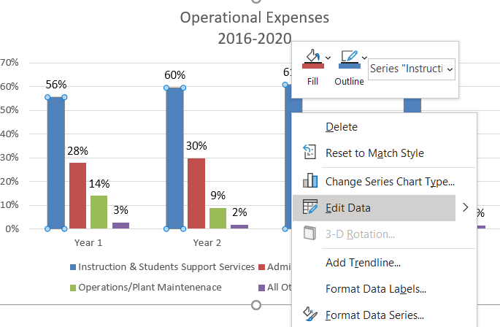

Table that appears when “Edit Data” is selected:
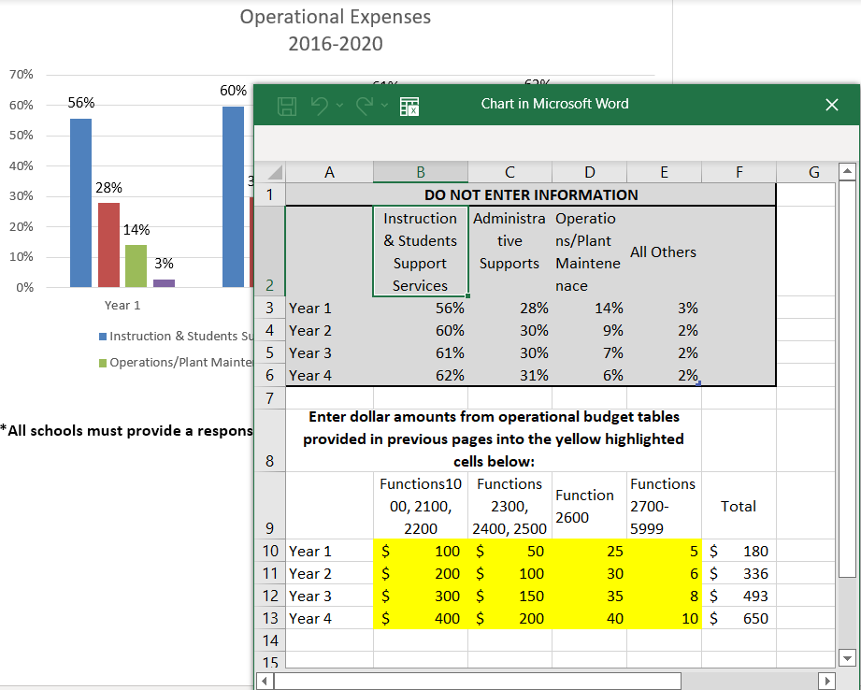
If the entire chart does not appear, drag to enlarge the window. Enter data in yellow-highlighted cells. Technical assistance will be provided as needed by CSD during Renewal Application training.

Part D: Petitions of Support
1978 NMSA §22-8B-12 requires the school to submit two petitions. Original signatures must be available for CSD review.
Appendix D-1 Employee Petition a petition in support of the charter school renewing its charter status signed by not less than sixty-five percent of the employees in the charter school during the year prior to the last year of the contract.
Signatures must be collected during the year prior to the last year of the contract, using the school’s employee information on the 120th day.
Following is a suggested form to certify the petition. This form may be attached to the petition. You MUST have original signatures.

I am the head administrator of the ______________ Charter School and hereby certify that: the attached petition in support of the Charter School renewing its charter was circulated to all employees of the ______________ Charter School. There are persons employed by the ______________ Charter School. The petition contains the signatures of employees which represents percent of the employees employed by the ______________ Charter School.

STATE OF NEW MEXICO)
ss.
COUNTY OF )

I, , being first duly sworn, upon oath state:

That I have read the contents of the attached Petition, and my statements herein are true and accurate to the best of my knowledge and belief.
Subscribed and sworn to before me this day of 20__.
Notary Public
My Commission Expires:

Appendix D-2 Household Petition a petition in support of the charter school renewing its charter status signed by at least seventy-five percent of the households whose children are enrolled in the charter school on the 120th day of the year prior to the last year of the contract.
Signatures must be collected during the year prior to the last year of the contract, using the school’s enrollment information on the 120th day. Students over the age of 18 and students acting as a head of household may provide the signature for the household. For students under the age of 18 living with a parent or guardian, the signature shall be the parent or guardian’s signature. Petitions may be signed electronically but must include the student name(s), parent name, email address, and date
Following is a suggested form to certify the petition. This form may be attached to the petition. You MUST have original signatures.

I am the head administrator of the ______________ Charter School and certify that: the attached petition in support of the Charter School renewing its charter was circulated to households whose children were enrolled in ______________ charter school. It contains the signatures of households which represents percent of the households whose children were enrolled in the ______________ Charter School.

STATE OF NEW MEXICO)
ss.
COUNTY OF )

I, , being first duly sworn, upon oath state:

That I have read the contents of the attached petition, and my statements herein are true and accurate to the best of my knowledge and belief.

Subscribed and sworn to before me this day of 20__.
Notary Public
My Commission Expires:

Part E: Facilities
The school must provide a description of the charter school facilities and assurances that the facilities are in compliance with the requirements of 1978 NMSA §22-8B-4.2. The documentation required in addition to the narrative is:
Appendix | Documentation
E-1 | E-Occupancy Certificate
E-2 | Public School Facilities Authority (PSFA) letter determining the New Mexico Condition Index (NMCI)
E-3 | A copy of the facility lease agreement, if applicable
E-4 | Facility Master Plan
E-5 | Assurances that the facilities are in compliance with the requirements of 1978 NMSA §22-8B-4.2, using Certificate A, B, or C

Part F: Change in Authorizer
District-authorized charter schools applying for renewal under the PEC must submit Appendices F-1 through F-8. Part F is not required for schools currently chartered by the PEC.
Appendix | Documentation
F-1 | Copies of the current charter contract, performance framework, and annual reports from the local authorizer
F-2 | Copies of all financial statements and audit findings for any audits performed within the current charter contract
F-3 | Membership figures for 80 day and 120 day reporting periods from STARS within the current charter contract
F-4 | Copies of 910-B5s within the current charter contract
F-5 | Copies of Site Visit Documents from within the current charter contract
F-6 | Copies of any Corrective Action Plans or Other Actions taken by the district or the PED
F-7 | Special Education Maintenance of Effort (MoE) Reports from within the current charter contract
F-8 | A Recent Cash Report submitted to the PED

Appendices
Please submit all documents as PDFs, using the following naming conventions. In place of “School Name” use a short form of the school’s name, with the same form used consistently for all appendices.
All Applicants
Appendix | File Name
A-1 | A-1 Academic Data School Name
A-2 | A-2 Mission Goal Data School Name
B-1 | B-1 Complaint Communications School Name
D-1 | D-1 Employee Petitions School Name
D-2 | D-2 Household Petitions School Name
E-1 | E-1 E-Occupancy School Name
E-2 | E-2 PSFA NMCI Score School Name
E-3 | E-3 Lease Agreement School Name
E-4 | E-4 Facility Master Plan School Name
E-5 | E-5 Facility Assurances Certificate School Name

District-chartered Schools Only
Appendix | File Name
F-1 | F-1 Contract School Name
F-2 | F-2 Financial Statements School Name
F-3 | F-3 Membership School Name
F-4 | F-4 910-B5s School Name
F-5 | F-5 Site Visits School Name
F-6 | F-6 CAPs School Name
F-7 | F-7 SPED MOE School Name
F-8 | F-8 Cash Report School Name

