Licensure Extension Request: Directions for LEA Administrators
This section must be completed by the Superintendent, Charter School Leader, or their designee.

Step One: Log into the licensure portal at this link: Professional Licensure Bureau – NMPED Licensure System (state.nm.us)

- Enter your email.
- Enter the password that was sent to your inbox or spam folder (this is the temporary password the system automatically sends you – you should be able to copy and paste this into the field. If the system doesn’t allow you to, please be careful entering as many characters may be misleading).
- Then click on the “I’m not a robot” and follow the captcha requirements (if applicable).
- You will enter the Security Access Code in the dialog box as seen below (6-digit number) that will arrive in your inbox or spam folder. **Please do not click yes if a dialog pops up asking if you want to save the password.**
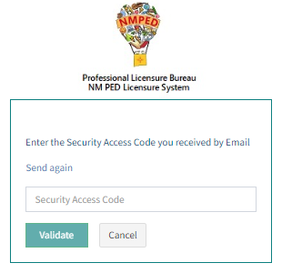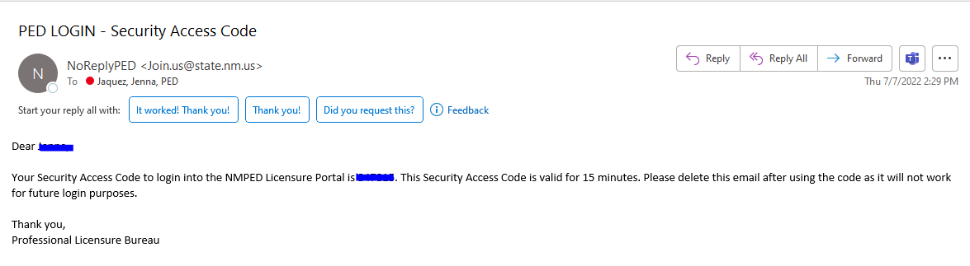

Step Two:
- Under PED applications select License application
- Under your role select District Administrator
- Click on Go

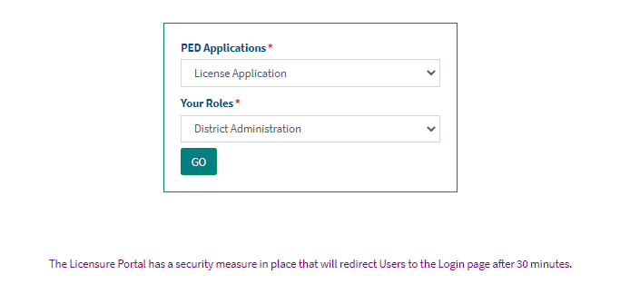

Step Three:
- Select Application Submission from the left hand menu
- Enter the license number of the educator
- Click on the SEARCH button

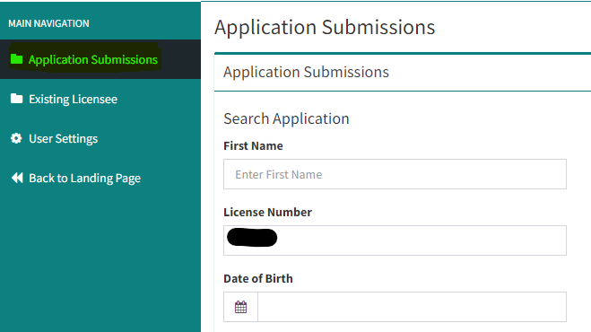

Step 5:
- Click on the ApplicationID number

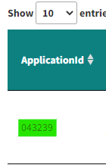

This will allow access to the application.

Step 6
- Scroll down and review the applicants narrative
- Complete the section title Superintendent Narrative
- Then hit submit

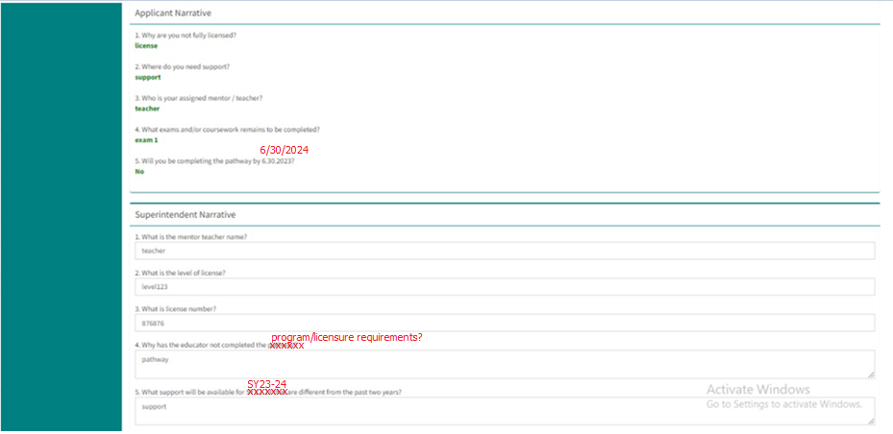

Once these steps are completed, the application will be assigned to a Licensure Consultant for review and approval.

