Licensure Extension Request: Directions for Educators

Step One: Log into the licensure portal at this link: Professional Licensure Bureau – NMPED Licensure System (state.nm.us)

- Enter your email.
- Enter the password that was sent to your inbox or spam folder (this is the temporary password the system automatically sends you – you should be able to copy and paste this into the field. If the system doesn’t allow you to, please be careful entering as many characters may be misleading).
- Then click on the “I’m not a robot” and follow the captcha requirements (if applicable).
- You will enter the Security Access Code in the dialog box as seen below (6-digit number) that will arrive in your inbox or spam folder. **Please do not click yes if a dialog pops up asking if you want to save the password.**
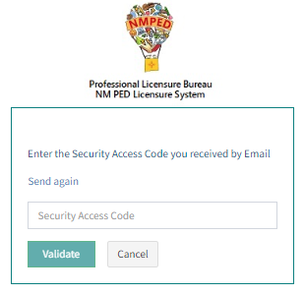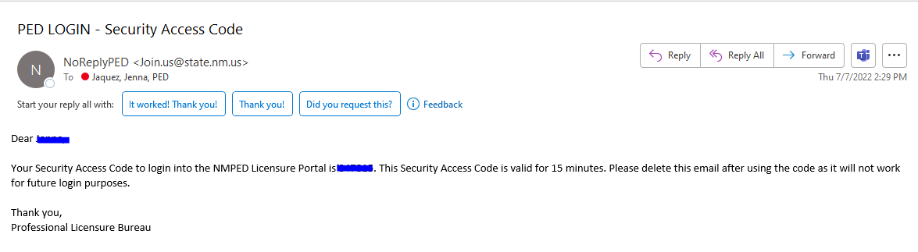

Step Two:
Select Licensure Application
Select Applicant as your role
Select your current district or charter school

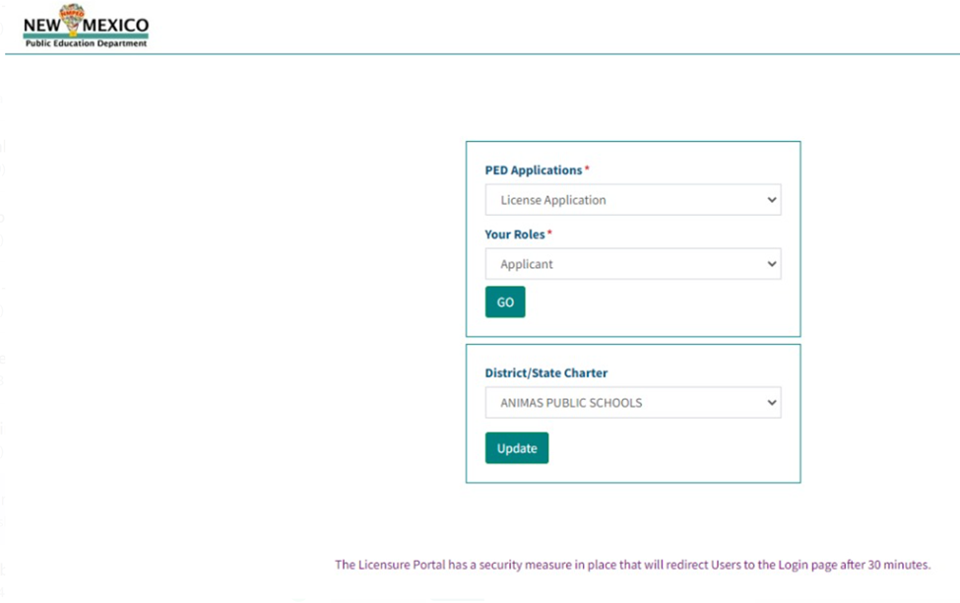

Step Three:
- Under application type select extension
- Under license category select teacher
- Under license type select the alternative license you hold
- Under pathway select OPAL, if you are completing the portfolio pathway, or EPP if you are attending a preparation program, or Dossier if you need time to submit your dossier, or Alternative Post-Secondary if you have not completed the required 160 days teaching on the license.
- Leave endorsement and License Level Code blank
- Click on the ADD LICENSE button
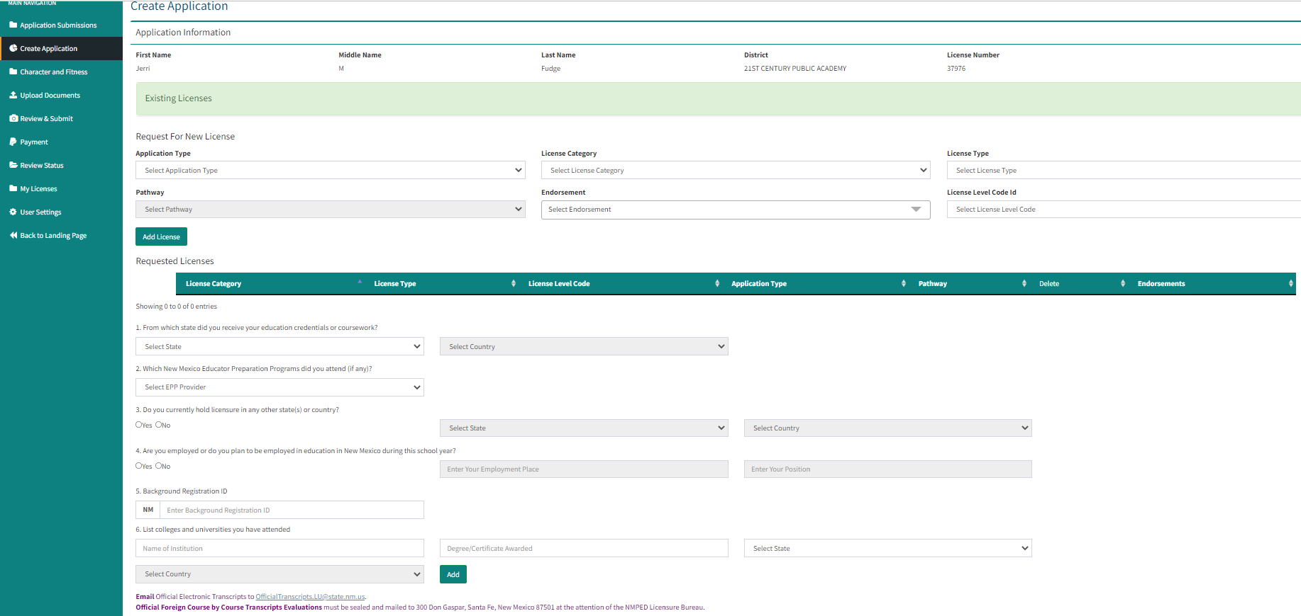

Step 4:
- Complete the Applicant narrative section of the application

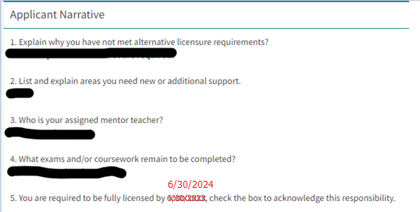

Step 5:
- Upload supporting documentation including test scores and unofficial transcripts
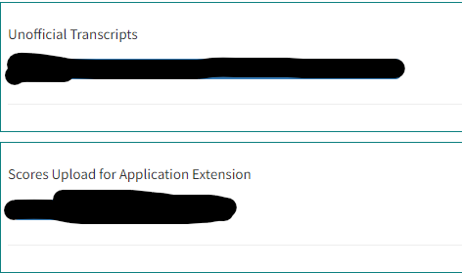

Step 6:
- Review submission, make any final edits, and submit for payment.
- There is a fee of $120.00, so you will be directed to the payment stage/section.

After the educator submits the application moves to the LEA for review and approval. Please notify your LEA’s HR office to complete the Superintendent Narrative section of the application. Once the LEA completes its section, the application moves to the PLB for review and approval.

