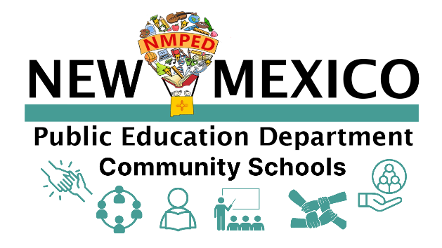

NMPED Community Schools Grant

MLSS Community Schools Reporting
CS Strategic Plan
TEMPLATE

May, 2023

Upload Instructions:
- Date (YYYY_MM_DD) CS School Name
- EXAMPLE: 2023_05_16 CS Apache ES
- Please no acronyms for school name
- Please upload as a PDF
- 5-10 pages

Name of School
Contents of NMPED Community Schools Strategic Plan Report
May, 2023

Collaborative Leadership, Shared Power and Voice (Key Practice 2) ………………………. p.
Key Practice 1: Powerful Student and Family Engagement ………………………. p.
Key Practice 3: Expanded, Culturally Enriched Learning Opportunities ………………………. p.
Key Practice 4: Rigorous, Community-Connected Classroom Instruction ………………………. p.
Key Practice 5: Culture of Belonging, Safety and Care ………………………. p.
Key Practice 6: Integrated Systems of Support ………………………. p.

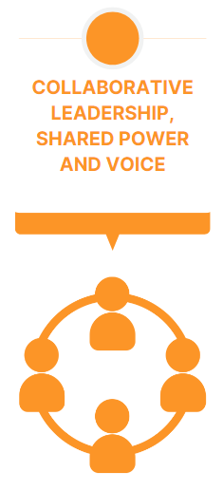
KEY PRACTICE 2
Collaborative leadership, shared power and voice is the inclusion of stakeholders in shared decision making about a CS shared vision, goals and creating participatory practices for distributing responsibilities and leveraging the collective expertise of all participants. This site based leadership team (SBLT) co-create a culture of professional learning, collective trust, and shared responsibility as they make decisions together. Collaborative leadership, shared power and voice provides the relational “glue” that connects and reinforces the other Key Practices, making it foundational and critical for the success of a community school strategy. Such collaborative efforts necessitate honest conversations around identity, power, and turf and can build pride and power among traditionally marginalized communities. Collaborative leadership creates sustainable and humane community school workplaces for CS students, staff and educators.
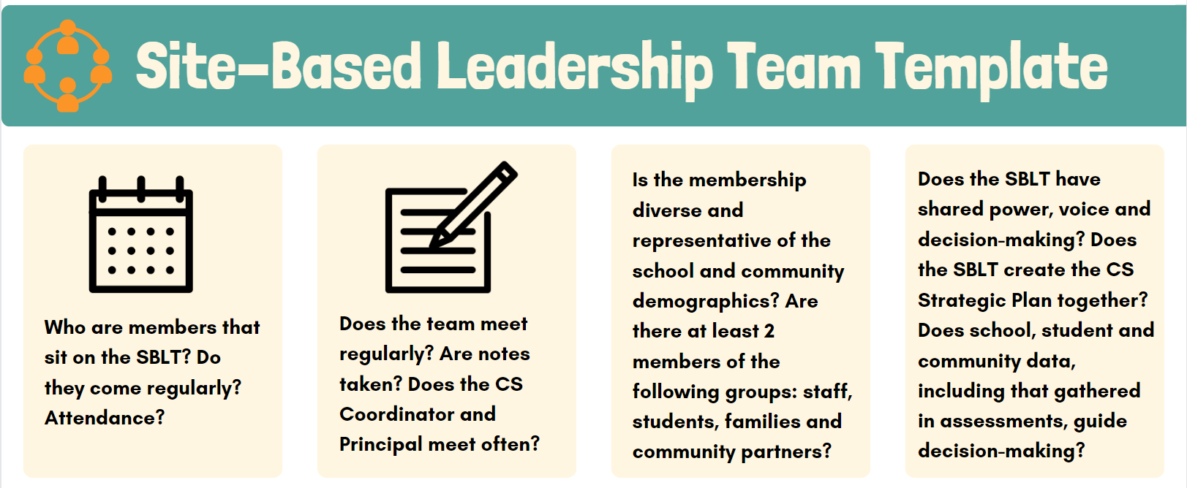

- For planning year, include the building of the SBLT (focusing on current beginning implementation and planning of these questions)
- For all other grant years, please answer all questions
- The SBLT and activities that take place at these collaborative meetings (such as needs assessment, root cause analysis, asset assessment, strategic plan) are necessary to implement effective initiatives in each key practice. If your school does not currently have community school key practice initiatives being implemented or an SBLT that is meeting regularly, please focus on Key Practice 2 (above) and include goals, timelines, plans and measurements to transition to a sustainable and centralized site-based leadership team at the school.

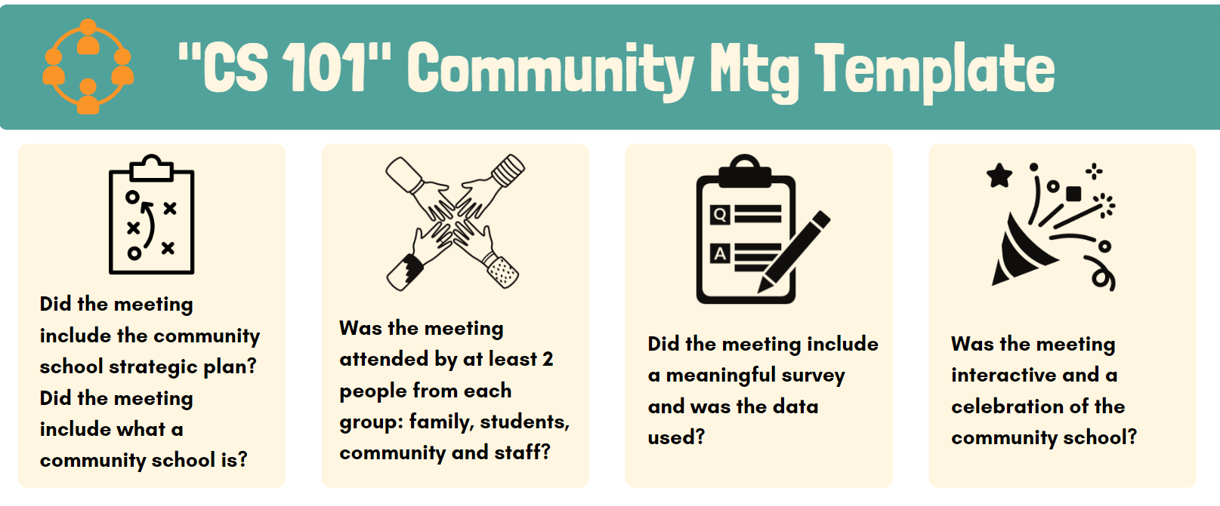

- The NMPED CS team understands this is not a required deliverable. If this mtg. has not occurred, skip this step.
- For all other CS that have had a CS 101 meeting, please answer all questions.

After completing the SBLT section (above), move forward to work on filling in each Key Practice. Each Key Practice will have initiatives.
Standards for Initiatives:
- “Initiative” is defined as a specific goal that the SBLT has identified based on the root cause analysis
- There should be at least one initiative in each key practice (Required: Key Practice 1, 3, 6; Optional: Key Practice 4 & 5).
- For initiatives that overlap in different key practices, choose one key practice to place that initiative
- Place all CS initiatives into each key practice; note there is no key practice 2 as that makes up the strategy within each key practice
See next page and use Key Practice 1 as the template information for all other Key Practices.
Please be honest in this entire report. For example, if your SBLT does not have data or a partner for a particular initiative, state as such and that the SBLT has set goals to ensure both of those gaps are filled. This report will not determine any funding or evaluation. This report is for self-assessment and NMPED required deliverables for the grant.

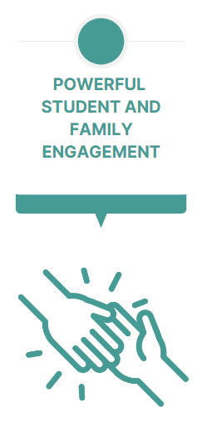
KEY PRACTICE 1
Students and families actively participate in the school community and are key partners in decision-making, shaping the school’s environment, priorities, and partnerships. Families’ lived wisdom and experience inform approaches to student success. As a result, schools become hubs providing opportunities for adults as well as young people. There are opportunities for deeper knowledge of children and greater alignment between home and school, build positive relationships and school climate, and improve student outcomes on many measures, including attendance, discipline, and academic achievement. The school gains important advocates, such as for deeper investments and partners, as families and community members understand and support strategic goals and see themselves as vital partners in schools’ success.
- For planning year, include all planned initiatives for Key Practice 1
- For all other grant years, please answer all questions for every initiative that falls into Key Practice 1
Initiative 1: NAME OF INITIATIVE
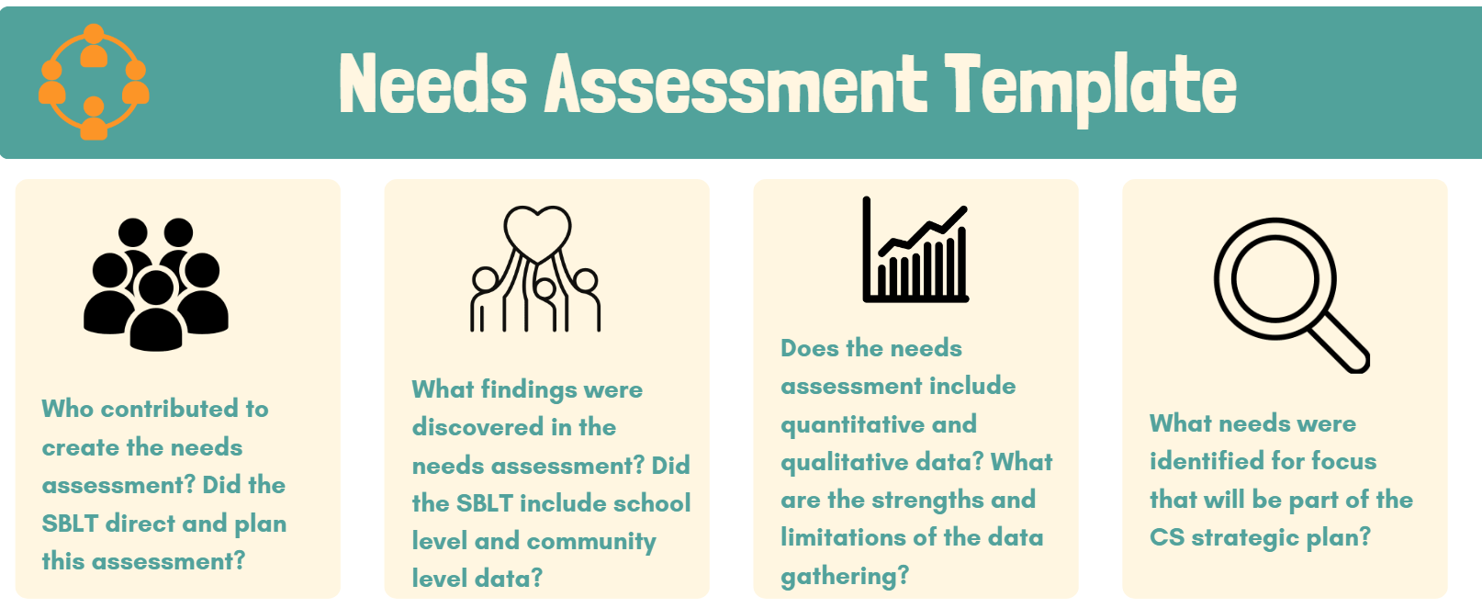
- Answer all of the above questions for the needs assessment SPECIFIC only to this particular initiative. You do NOT need to include the entire needs assessment.
  - Example: The needs assessment showed poor attendance for 3rd graders. Include the raw data of attendance for 3rd graders and how that data was gathered. Did the SBLT direct this section of the needs assessment? Did they see the data? Was there school level and community level data for this focus point? Was there quantitative and qualitative data around 3rd grades attendance? What are the strengthens and limitations of this data point?

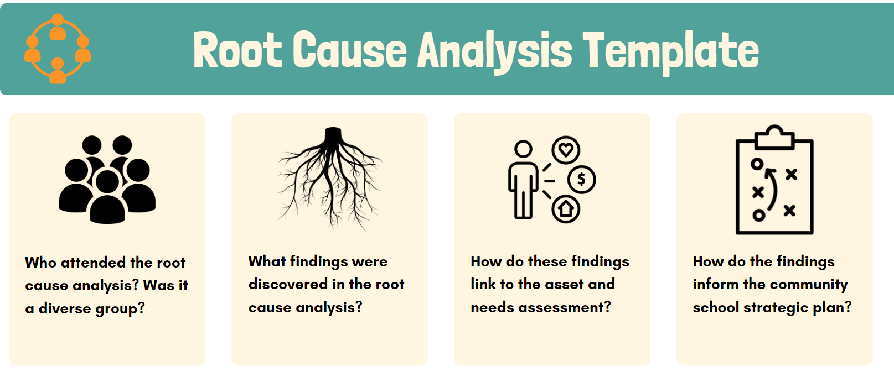

- NMPED CS team understands this is a new deliverable. If your community school has not conducted this yet, skip this step in the strategic plan. It will be required for next years deliverables.
- Answer all of the above questions for the root cause analysis SPECIFIC only to this particular initiative. You do NOT need to include the entire root cause analysis
  - Example: 3rd grade attendance root causes identified included difficulty of families getting their kids to school (executive functioning) and lack of reliable transportation. These root causes were found in a diverse SBLT meeting with XYZ in attendance. Assets and partners will be identified to collaborate on solutions for these root causes.

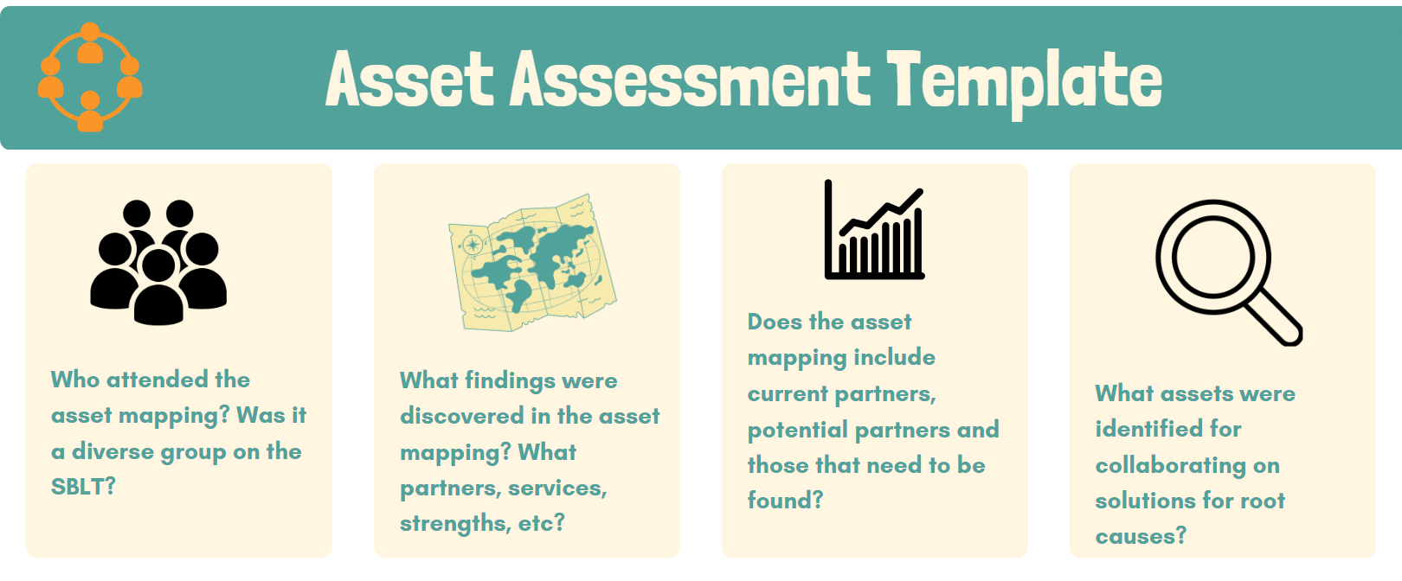

- Answer all of the above questions for the asset assessment SPECIFIC only to this particular initiative. You do NOT need to include the entire asset assessment.
  - Example: 3rd grade attendance root causes identified included difficulty of families getting their kids to school (executive functioning) and lack of reliable transportation. The asset mapping was completed by a diverse group on the SBLT using the XYZ data collection methods. Assets (community partners) identified are 1) Parenting classes with a focus on executive functioning and getting kids ready for school with non-profit XYZ and 2) Transportation solutions with Department of Transportation. Include exactly what the services will entail, who they will serve, when they will serve and how each partner will sit as a member on the SBLT. Identify potential future partners that may need to be found.

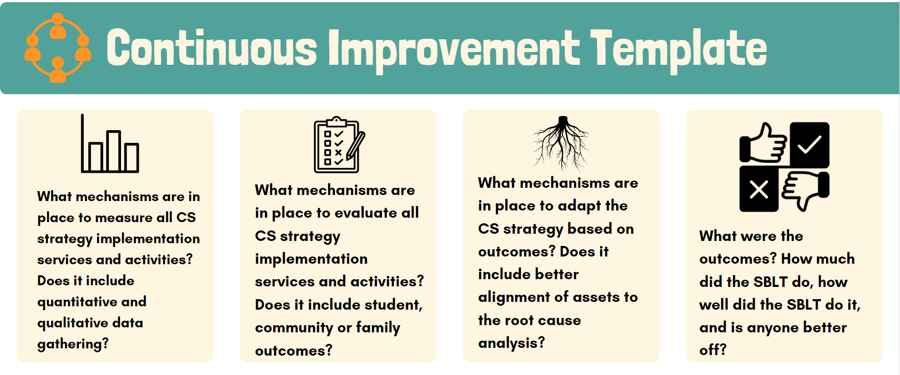

- Answer all of the above questions for continuous improvement SPECIFIC only to this particular initiative. You do NOT need to include the entire asset assessment.
- For planning year, only include planned continuous improvement of this initiative; no implementation should occur.
- For all other grant years, please answer all questions for every initiative that falls into Key Practice 1
  - Example: 3rd Grade Attendance partners (non-profit XYZ and Department of Transportation) report monthly to the SBLT on services, activities and plans. The SBLT ensures that quantitative data of participation and 3rd grade attendance are gathered and recorded regularly throughout the year. (Show this data briefly). Mechanisms used include school level and partner level data as well as surveys of students and parents impacted by the initiatives. The SBLT will adapt these measures to see progress on 3rd grade attendance. This may include another analysis of the needs assessment and root cause analysis findings. Outcomes are reporting at the end of the initiative. How well did the SBLT do in influencing 3rd grade attendance? Is anyone better off? What can be done better next time?

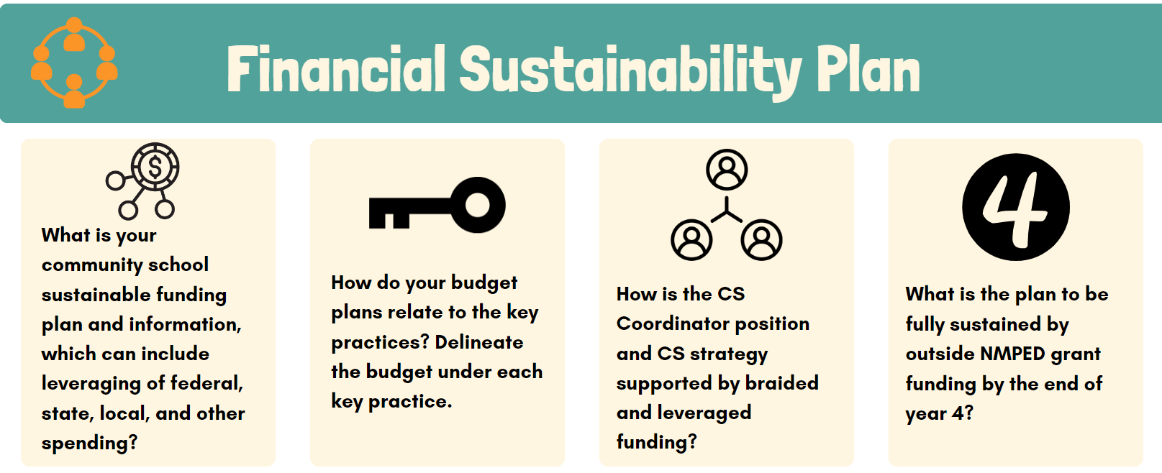

- Answer all of the above questions for the financial sustainability SPECIFIC only to this particular initiative. You do NOT need to include the entire financial sustainability plan.
- For planning year, only include planned financial sustainability of this initiative; no implementation should occur.
- For all other grant years, please answer all questions for every initiative that falls into Key Practice 1
  - Example: All 3rd grade attendance initiatives will be primarily sustained by community partners. These partners will contribute XZY donations, services and funding. Any extra costs (such as a stipend for the parenting classes) will be covered by the NMPED grant. For the future, our SBLT would like to see these funds supported by Title I or XYZ funds for sustainability of this initiative.
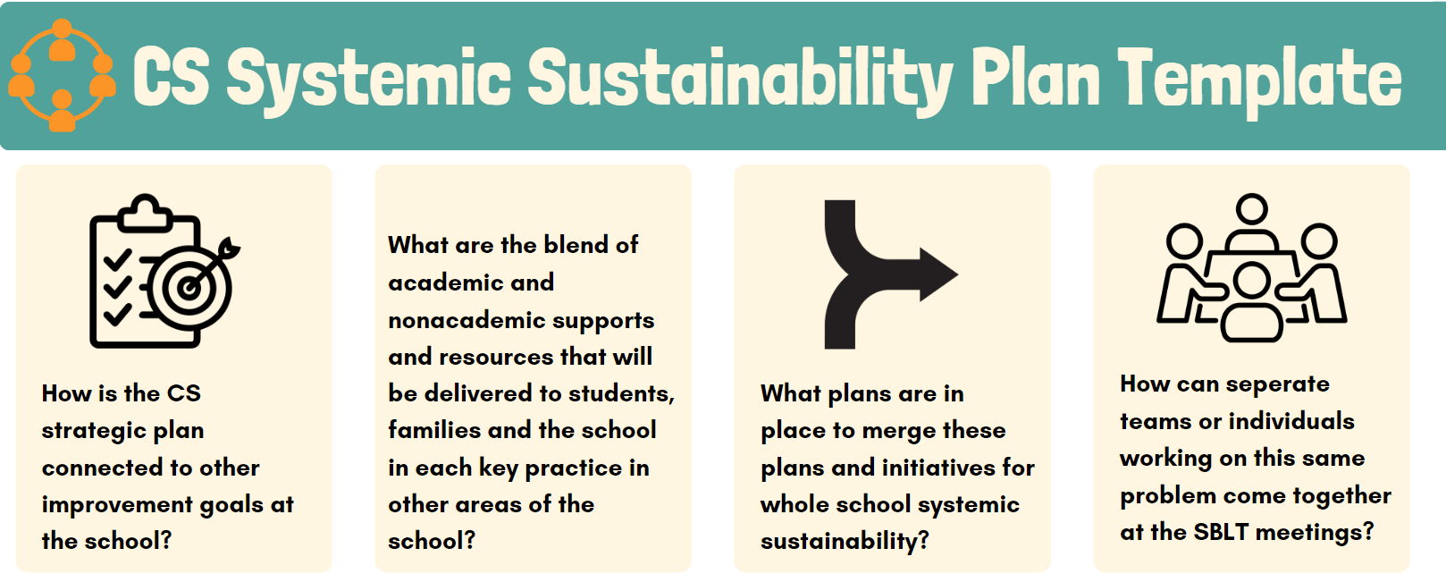

- Answer all of the above questions for the systemic sustainability SPECIFIC only to this particular initiative. You do NOT need to include the entire systemic sustainability plan.
- For planning year, only include planned systemic sustainability of this initiative; no implementation should occur.
- For all other grant years, please answer all questions for every initiative that falls into Key Practice 1
  - Example: 3rd grade attendance is also being targeted by the Attendance Team and the 3rd grade teacher’s cohort. The attendance team is working on initiatives such as incentives and contacting families. The 3rd grade teachers are focusing on student-voice lead curriculum and experiential learning. These groups have been invited to attend the SBLT and merge these plans with the CS strategic plan. Any gaps in needs assessment and root cause analysis for these other initiatives will take place the months of XYZ. Partners will come on board to help with contacting families, incentives and community partner experiential learning. An updated CS strategic plan is in the works.

Initiative 2: NAME OF INITIATIVE
Follow the above guidance for all initiatives in each key practice.

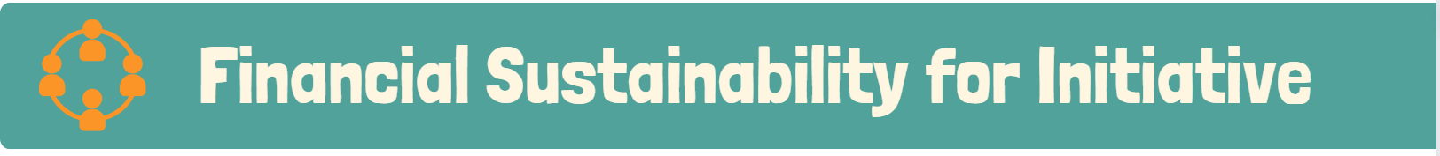

KEY PRACTICE 3
Expanded, culturally enriched learning time and opportunities encourages agency, taps into students’ strengths and interests, assists students in feeling safe, and promotes academic success. These opportunities are essential to schools’ capacity to support students’ academic growth, develop socially, emotionally and physically and explore their passions, dive deeper into the application of academic content and strengthen their knowledge and skills. These opportunities can accelerate learning and reduce opportunity gaps between what students from low-income families and their peers from middle- and upper-income families experience during out-of-school hours. Opportunities are more impactful when they incorporate deeper learning practices that engage youth in meaningful content that is culturally enriching and is connected to students’ lives outside of school.

Initiative 1: NAME OF INITIATIVE

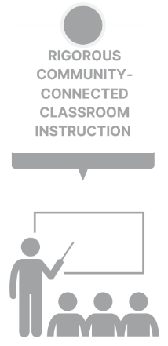
KEY PRACTICE 4
Rigorous community-connected classroom instruction is teaching and learning in the school that infuses high-level content and skills with real-world learning opportunities. The curriculum is deeply connected to the local community and students’ identities, cultures, and experiences, providing opportunities for students to engage in meaningful inquiry-based learning and problem solving. Embracing the link between learning and community, teachers and community school staff ensure that students and communities have opportunities to access rich, challenging, and culturally relevant curriculum and pedagogy, while accessing community resources and supports.

The NMPED CS team understands that this is a new key practice 4 and is not required for your CS strategic plan. If your school does have these initiatives, please include them.
Initiative 1: NAME OF INITIATIVE

KEY PRACTICE 5
A culture of belonging, safety and care is a school climate that is welcoming and fosters trust where members of the school community are valued for their rich diversity of experiences and are encouraged to share their views, knowledge and culture. The school becomes a place grounded in healthy relationships, in which members feel safe and comfortable navigating conflicts and taking risks. Students embrace the school community and contribute actively. This type of environment is Key Practice for student learning and development; it both buffers students from stress and adversity and provides safety and consistency, so that students can take risks, explore new experiences, and develop their identities
The NMPED CS team understands that this is a new key practice 5 and is not required for your CS strategic plan. If your school does have these initiatives, please include them.
Initiative 1: NAME OF INITIATIVE

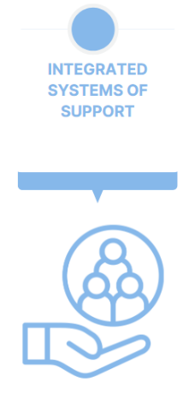
KEY PRACTICE 6
Integrated systems of support promote healthy learning and development and foster individual and collective well-being using an assets-based approach to nurture and strengthen students, families and the community. ISS provides a range of services and supports to overcome both academic and non-academic barriers to student’s educational and life success. ISS increase access to essential services and supports and provides preventative care. ISS help mitigate social determinants of health (SDOH), which have a major impact on people’s health, well-being, and quality of life. These impacts can be seen in classrooms and student outcomes. Students receiving support often show significant improvements in attendance (for example: students miss less school as they are healthier and do not miss the whole day of school for appointments), behavior, social well-being, and academic achievement.

Initiative 1: NAME OF INITIATIVE

