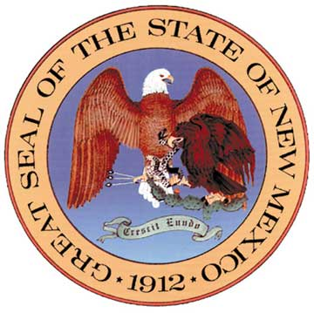

State of New Mexico
Public Education Department
CHANGE OF SCHOOL NAME, ADDRESS, and/or PHONE NUMBER NOTICE

REVISED: 06.26.2023

00/00/0000
PLEASE CHECK OFF THE BOX/ES OF CHANGE REQUEST/S: Date:
Include Full Eight-Digits
000000
School Name | School Address | School Phone No.
☐ | ☐ | ☐
STARS School Code (District Code & Location Code):
Include Full Six-Digits

I ___________________________ Superintendent/Head Administrator of ____________________________________________
(Enter Name) (Print Full Name of District or Charter School)

hereby notify the Public Education Department of a recent school name change:

Former School Name and Address  Please include city and zip code below |  | New School Name and Address  Please include city and zip code below
Name: |  | Name:
Address: |  | Address:
City & Zip: |  | City & Zip:

Former School Phone Number  Please include area code | New School Phone Number  Please include area code
505-000-0000 | 505-000-0000

Requestor’s Signature: _______________________________________

Please attach relevant board-approved board resolution and/or approved board minutes authorizing name change.

Return Form via Mail to: or Return Form via Email to:
NM Public Education Department Waivers.PED@state.nm.us
Attn: Waivers
300 Don Gaspar Ave.
Santa Fe, NM 87501

