Membership Projections Instructions
PUBLIC EDUCATION DEPARTMENT
School Budget Bureau
300 Don Gaspar Street
Santa Fe, NM 87501

In accordance with Section 22-8-12-1 NMSA 1978, the Membership Projection files and reports are due on or before October 15.

Technical Assistance
Please contact your assigned Budget Analyst.

PK Students
PK should only be reported with 3-Year-Old (3Y) and 4-Year-Old (4Y) Developmentally Delayed (DD) students. Every student shall be entered as “1”.

KF-12 Students
KF-12 should be reported with Basic MEM, C Level, and D Level students. Every student shall be entered as “1”.

Charter Schools
Charter school membership projections should be reported by each approved charter school and NOT by the district.

Adding Schools and Grades
To add new schools or grades, ensure that the reorganization process is complete, and that PED approval has been given to add/remove grades or schools before contacting your assigned Budget Analyst.

In accordance with NMAC 6.29.1.9

G. Organization of grade levels and establishing/closing schools. Any change in a school district or charter school's organizational pattern, including the establishment or closing of a school, shall have the secretary's approval prior to implementation. Requests for change shall be submitted using the department's organization of grade levels and establishing/closing school waiver request form. This form shall include: name of superintendent; district/school; mailing address; phone; fax; email address; name of a secondary contact person including the same information; date of submission; local board policy requirement and approval, if required; date of board approval; statement of applicable district or charter school policy and rationale for request. The waiver request shall outline the expected educational benefits.

Step 1 – Using a web browser, go to the Projected Membership website.
https://eui.ped.state.nm.us/sites/SchBudProjMem/SitePages/default.aspx
The Website address will also be on PED’s School Budget Bureau Web Page.

Step 2 – Sign in
This is your STARS/NOVA login information. The User Name is your email address.
If you have forgotten your password, please follow this link https://starspass.ped.state.nm.us/GetStarsPassword/

If you do not have a STARS/NOVA Login please submit a ticket here https://nmnova.freshdesk.com/support/tickets/new

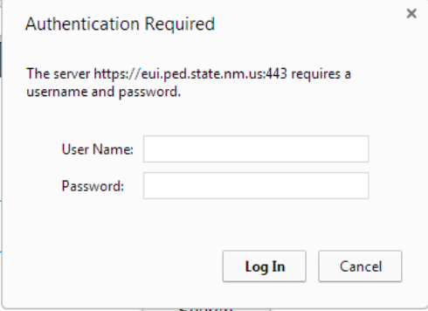

Step 3 – Click on the Edit Icon.

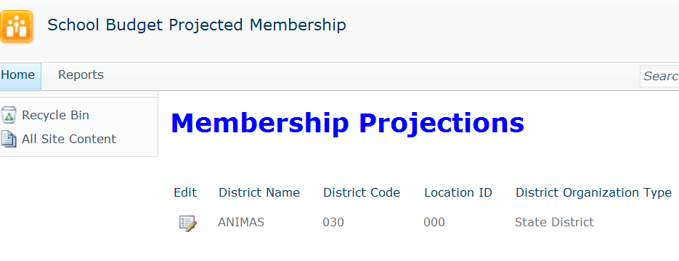

Step 4 – Enter your A/B MEM and Ancillary FTE.

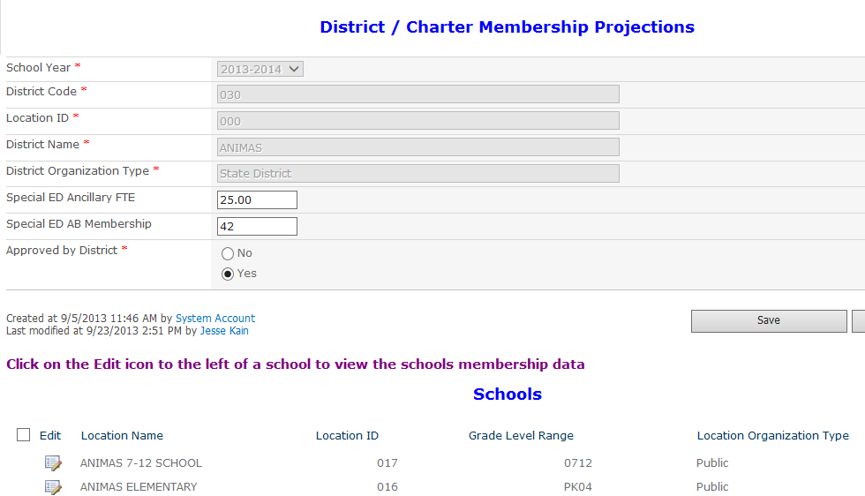

Step 5 – Click on the Edit Icon to select a school to enter Membership.

Step 6 – Select Grade.

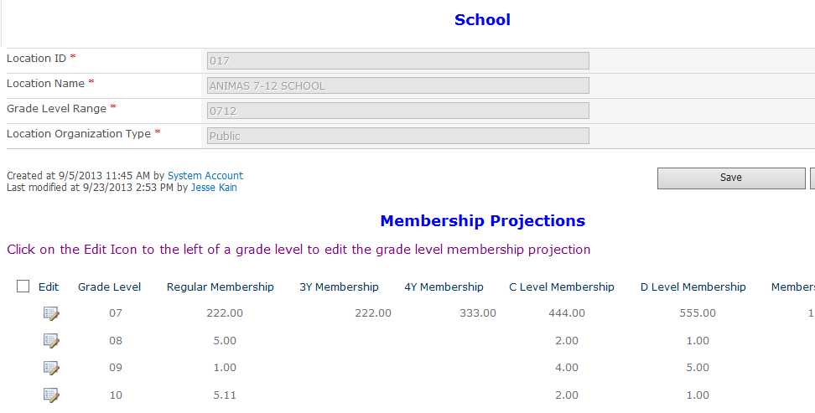

Step 7 – Enter Grade Membership.

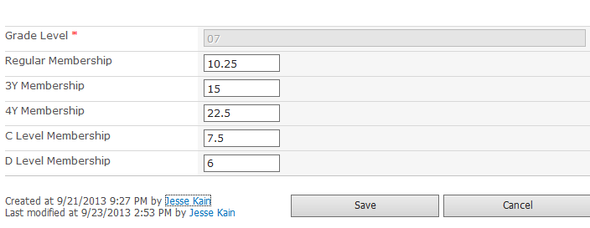

Click Save after entering the data.

Step 8 – Repeat steps 6 and 7 until all grades have been entered.

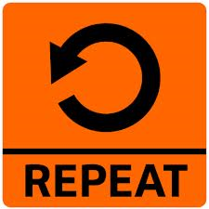

Step 9 - Click on Save to return to the list of schools.

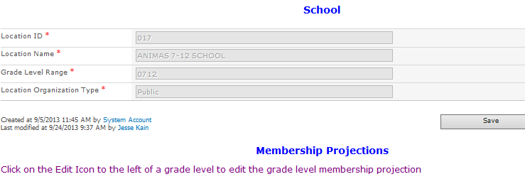

Step 10 – Repeat steps 5 thru 9 until all Schools have been entered.

Step 11 – Approve Projected Membership.

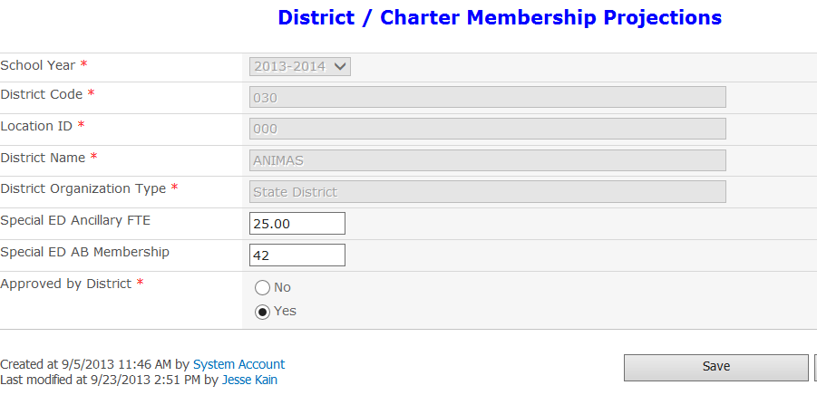

Step 12 – Save the Membership.

Step 13 – Go to the report menu. Click Site Contents at the top of the page.

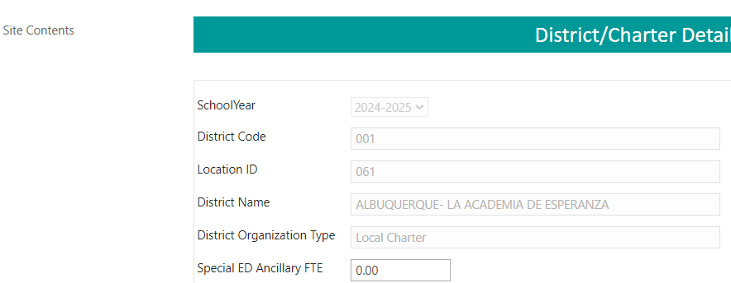

Then click Reports at the top of the page.
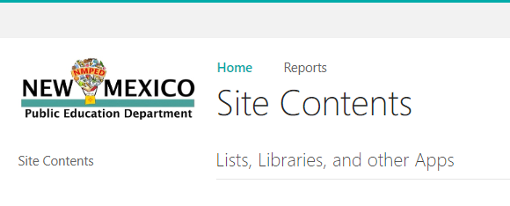

Step 14 –Click on the report name to run the report.

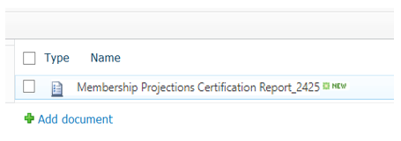

Step 15 – Select Year and District.

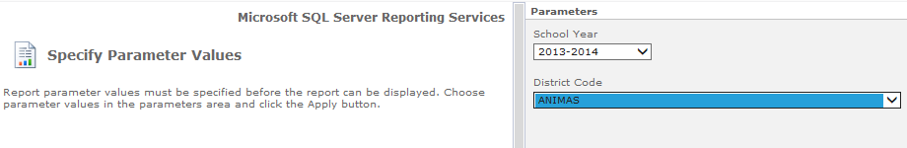

Step 16 – Click Apply to run the report.

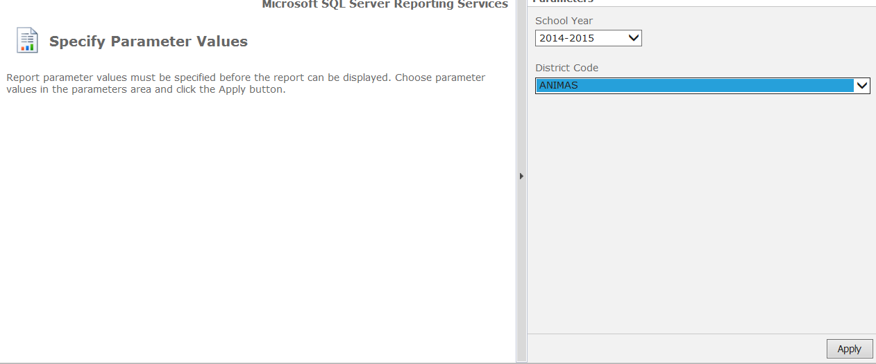

Step 17 – To print the report, first Click on Actions. Then select Export -> PDF.

Step 18 – Superintendent/Charter Representative signs via wet signature or electronic signature. PED will not accept a typed signature.

Step 19 – Upload the signed report into File Transfer Site in FY24 -> Membership folder with the naming convention “Entity Name-FY25 MEM Projections ###-###” (###-### is the PED Number).

