OBMS Audited Cash Guide

Contents
1. Introduction 2
2. On audit 3
2.1. To Upload Audited Actuals 3
2.1.1. Step 1 3
2.1.2. Step 2. 3
2.1.3. Step 3. 4
2.1.4. Step 4. 4
2.1.5. Step 5. 5
2.1.6. Step 6. 5
2.2. To Submit Audited Actuals (BM or SP) 7
2.2.7. Step 1. 7
2.2.8. Step 2. 7
2.2.9. Step 3 8
2.2.10. Step 4 8
3. Upload format 10
3.1. Audited Actuals Fixed Length Records 10
3.2. Audited Actual Fixed Field explanation 11
3.2.11. Examples 12
4. Audited Actuals CSV Records (for IT departments) 14

Introduction
Starting in Fiscal Year 2022, Audited Actuals must be submitted by all Budget entities similarly to Q1, Q2, Q3, and Q4 Actuals data. The difference between the quarterly and audit-reported data is that the audit-reported data will only be reported on the Fund, Function, and Object levels. This ensures that the submitted audit data in OBMS matches the Budget Entity’s audited data. It ensures consistency and accountability in calculating indirect costs and is required by the federal government. Therefore, the alternative to reconcile the submitted actual data with the audited data was dismissed as a much higher administrative burden.
PED offers two columns to upload - “Audit Data YTD” and “Cash Basis” columns.
Audit Data YTD:
The budget entity must submit in this column the same data on the Fund Function Object level it had submitted to its auditor.
Cash Basis:
The budget entity can submit in this column the data on a cash basis as it is on its general ledger.

PED recommends using the (likely Excel) file prepared for a budget entity’s auditor to create the OBMS audit upload file to ensure that the data the auditor reviews and PED receives are the same. PED will report to the federal government that all budget entities submit the audited data to PED, and PED uses the data to determine the indirect costs.

On audit

To Upload Audited Actuals

Step 1
From the OBMS home page, click the Actuals link.
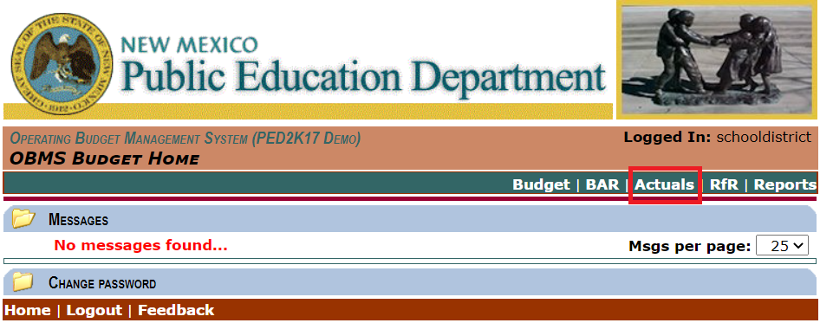

Step 2.
Click Actuals Audit.
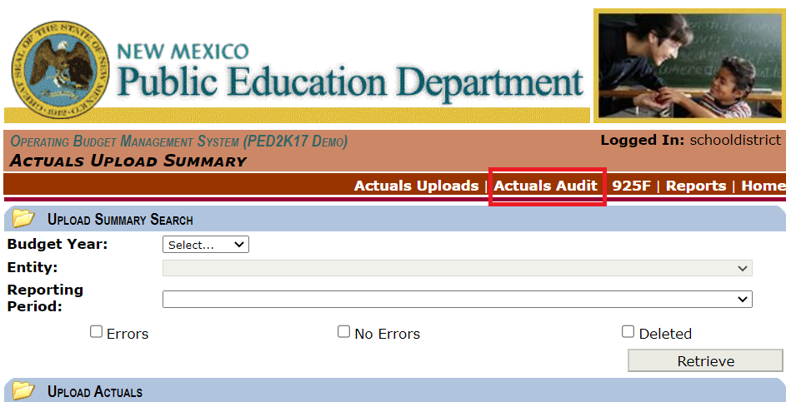

Step 3.
On the Actuals Audit screen, click Choose File.
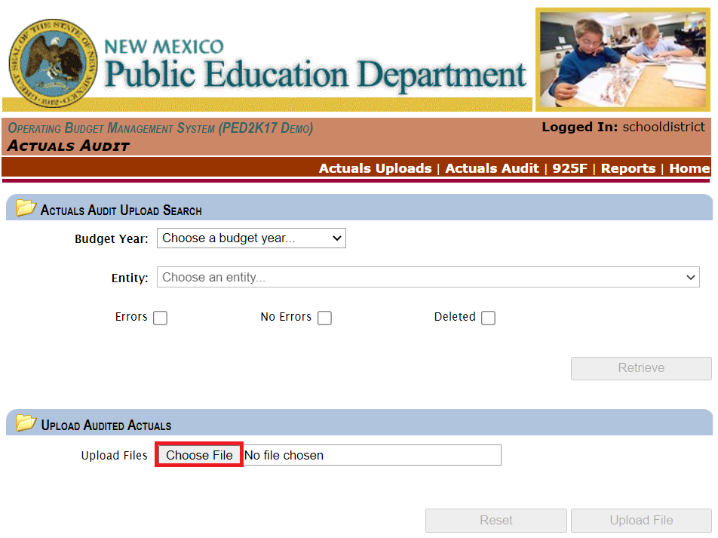

Step 4.
Select the file you wish to upload from your Windows File Explorer and click Open. In this example, we are using a .csv file.
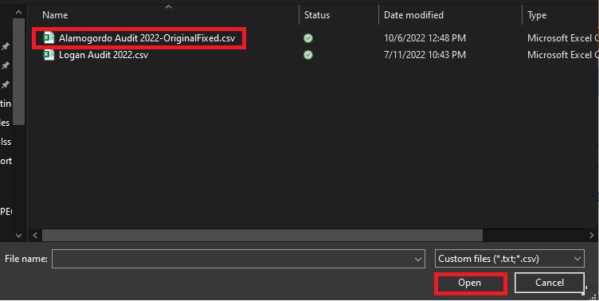

Step 5.
The name and file type selected now displays in multiple areas of the Upload Audited Actuals section. Click Upload file.
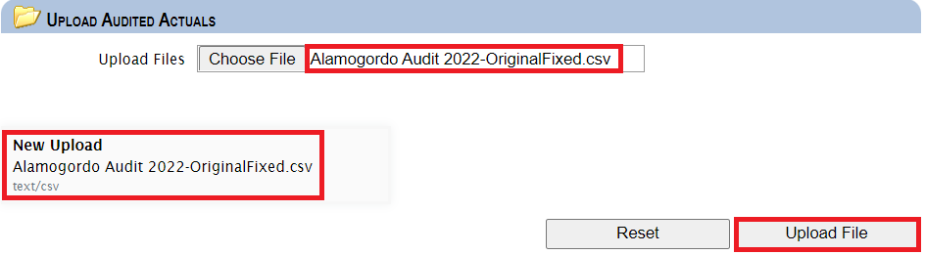
You will receive a message when your file is successfully uploaded.
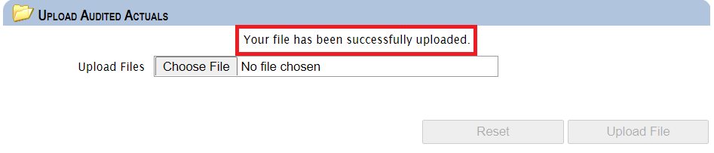

Step 6.
Return to the Actuals Audit screen and select the Budget Year and Entity for the Audited Actuals, then click Retrieve.
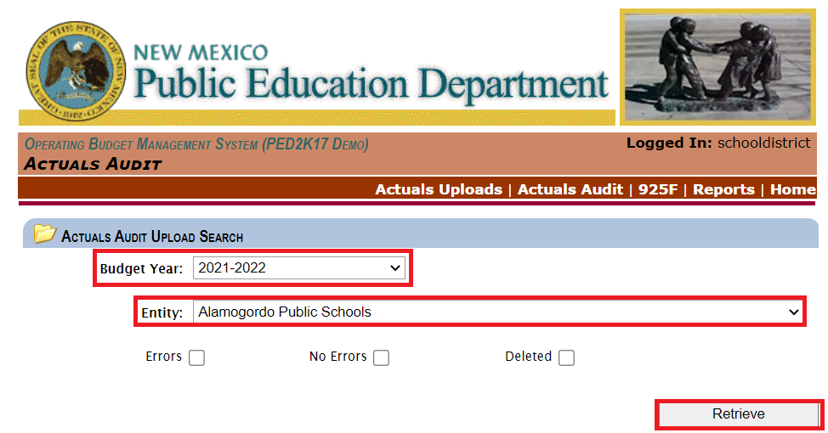
You can now see the details of the upload displayed. To see more information for each section,
click “” to expand or “” to collapse.
- Events: Displays the user’s actions, along with their LoginID and Date/Time modified.
- Files: Displays the Upload Date, File Name, Status, YTD Audit Revenue, YTD Audit Expenditure, Cash Basis Revenue, Cash Basis Expenditure, number of lines in the file, and number of lines with errors.
- File Events: Displays the stages the file has gone through during the upload along with the LoginID of the user who uploaded the file, as well as the Date/Time modified.
The file can also be deleted and re-uploaded if changes need to be made by clicking Delete File.
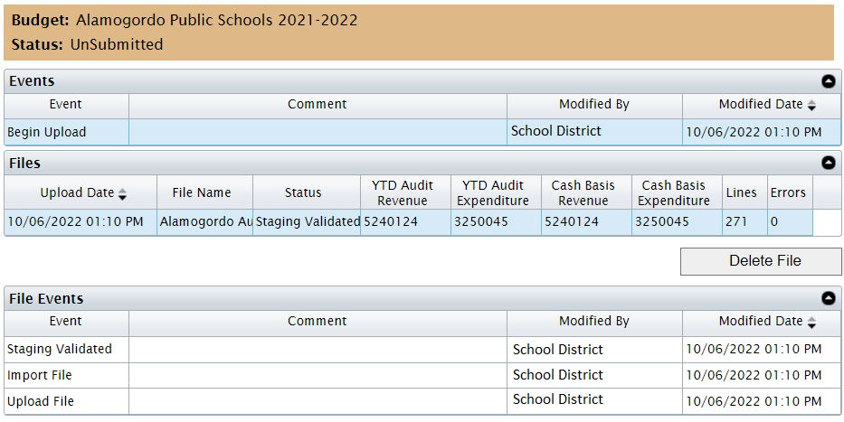
A Business Manager or Superintendent will submit the Audited Actuals if everything is correct.

To Submit Audited Actuals (BM or SP)
Logged in as a Business Manager or Superintendent, navigate to the Audited Actuals screen.

Step 1.
Click Actuals from the home page.
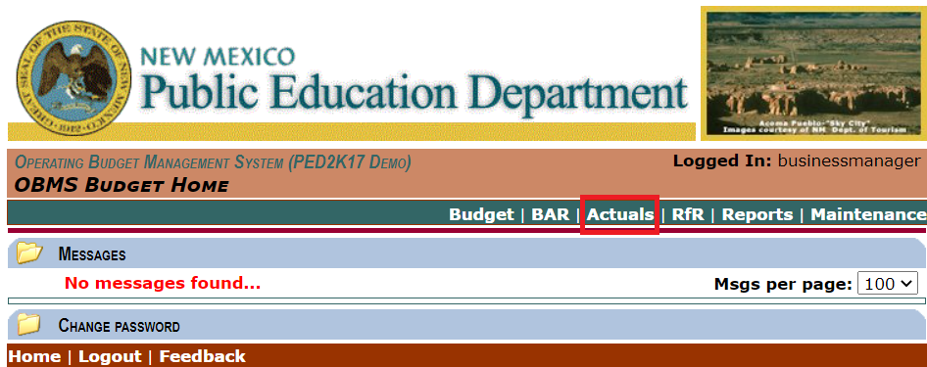

Step 2.
Click Actuals Audit.
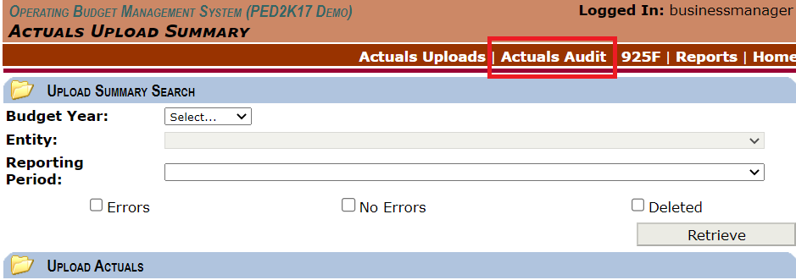

Step 3
Select the Budget Year and Entity, then click Retrieve.
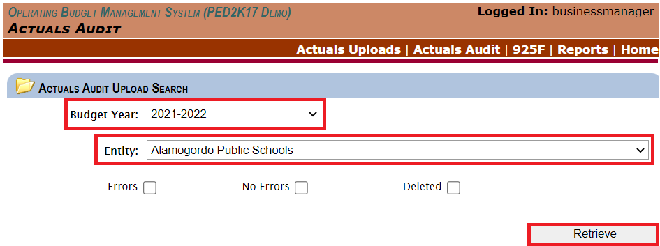

Step 4
Review the information shown below, and if everything looks good, click Submit.
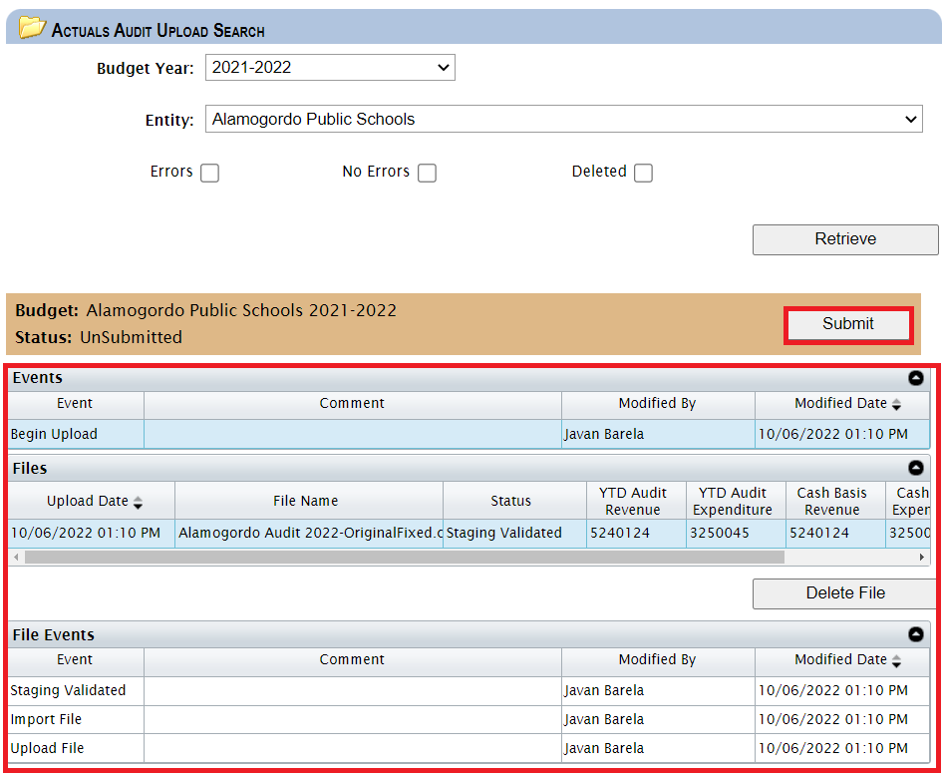
The system will prompt you to enter a comment, then click Submit once more.
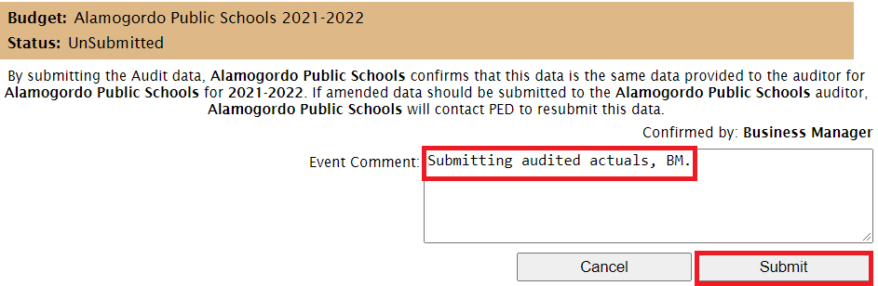
The system will auto-approve the Audited Actuals upon submission.
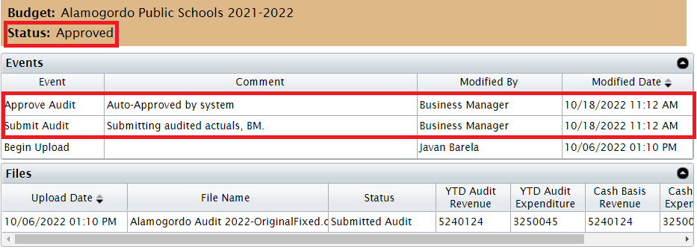

Upload format

Audited Actuals Fixed Length Records
The format shown in Table 18 is used to import audited actuals. Each record has a fixed length and is terminated with a carriage return <CR> and linefeed <LF> pair. Each record is composed of multiple fields that may or may not be valued depending upon the interface used. The first column is the starting position of the field within the record, and the second column is the field length. The third column is the field name. The record length is 55 (53 for the data plus 2 for the <CR><LF>).

Position | Length | Field Name
1 | 3 | Period Code
4 | 3 | Entity Code
7 | 3 | Location Code
10 | 4 | Budget Year
14 | 5 | COA Fund
19 | 4 | COA Function
23 | 5 | COA Object
28 | 14 | Audited YTD
42 | 14 | Cash Basis
Table 18 – Audited Actuals Fixed Length Record Format

Please remember, the column Cash Basis is OPTIONAL. All other columns are mandatory.

Audited Actual Fixed Field explanation
The field descriptions shown in Table 18 document what OBMS expects in each field of an actual audit import line record.
Field Name | Description | Characters Allowed
Period Code | The Audit is applied to the Year-To-Date period.  Note: The submission period must be ‘YTD’ for all lines in a file. | Upper case letters ‘YTD’.
Entity Code | The entity code is the unique numeric code used by PED to identify the parent entity. | Digits ‘0’ thru ‘9’.
Location Code | The location code is the unique numeric code PED uses to identify the child entity. | Digits ‘0’ thru ‘9’.
Budget Year | The budget’s fiscal year. | Digits ‘0’ thru ‘9’.
COA Fund | Valid fund codes from the Chart of Accounts (COA) for the Budget Year. | Digits ‘0’ thru ‘9’.
COA Function | Valid function codes from the Chart of Accounts (COA) for the Budget Year. | Digits ‘0’ thru ‘9’.
COA Object | Valid object codes from the Chart of Accounts (COA) for the Budget Year. | Digits ‘0’ thru ‘9’.
Audited YTD | The dollar amount for this chart line for the Audited YTD value. | Digits ‘0’ thru ‘9’, except for position 36, which must be a decimal point ‘.’. Position 25 can contain the “-“ sign if this is a negative number.
Cash Basis | The dollar amount for this chart line for the Cash Basis value. | Digits ‘0’ thru ‘9’, except for position 82, which must be a decimal point ‘.’. Position 39 can contain the “-“ sign if this is a negative number.
Table 19 – Audited Actuals Fixed Length Field Descriptions

Examples
The following is an example fixed length record file that may be supplied to the ‘Audited Actuals Upload’ interface in OBMS.
YTD02020221100010005110001452404760.21-3477929970.12
YTD020202211000100051100-0529580870.8900498461668.33
YTD02020221100010005110000117229630.3300616528912.29
The following is a different example for Excel; the file has to be saved as .csv to be up-loadable to OBMS.
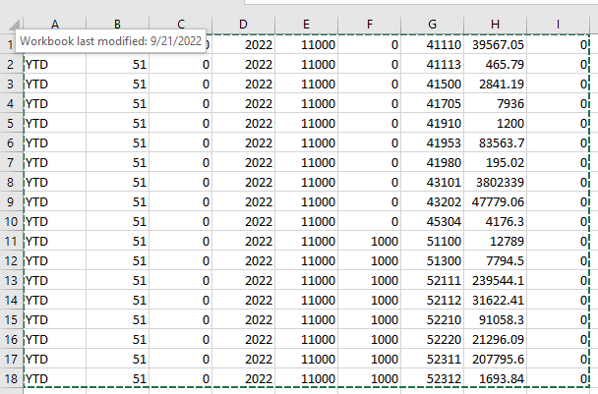

If we examine the file's first record (highlighted in color) more closely, Table 20 explains the record’s content.
Position | Length | Field Name | Value / Description
1 | 3 | Period Code | ‘YTD’ – Indicates Audited Actuals
4 | 3 | Entity Code | ‘020’ – Carlsbad
7 | 3 | Location Code | ‘000’ – District Office
10 | 4 | Budget Year | ‘2022’ – 2022 Fiscal Year (2021-2022 school year)
14 | 5 | COA Fund | ‘11000’ – Fund 11000:  Operational Sub-Fund
19 | 4 | COA Function | ‘1000’ – Function 1000:  Instruction
23 | 5 | COA Object | ‘51100’ – Object 51100:  Teachers - Grades 1-12
28 | 14 | Audited YTD | ‘01452404760.21’ – $1,452,404,760.21
42 | 14 | Cash Basis | ‘-3477929970.12’ –  -$3,477,929,970.12
Table 20 – Audited Actuals Fixed Length Record Example

In Excel, every field is one column.

Audited Actuals CSV Records (for IT departments)
The format shown in Table 21 is used to import audited actuals. Each record has a variable length and is terminated with a carriage return <CR> and linefeed <LF> pair. Each record is composed of multiple fields that may or may not be valued depending upon the interface used. The record length is variable, but each field must be separated from the next with a comma. In Table 15, the first column is the field number within the record. The second column is the field name. A dollar sign ‘$’ may precede the values for fields 7 and 8. If these fields contain a large numeric value, these fields may contain commas as long as the entire field is contained within double quotes. For example, either $123456789 or “$123,456,789” is acceptable.

Field | Field Name
1 | Period Code
2 | Entity Code
3 | Location Code
4 | Budget Year
5 | COA Fund
6 | COA Function
7 | COA Object
8 | Audited YTD
9 | Cash Basis
Table 21 – Audited Actuals CSV Record Format

The field descriptions shown in Table 22 document what OBMS expects in each field of an audited actuals import line record.

Field Name | Description | Characters Allowed
Period Code | The Audit is applied to the Year-To-Date period.  Note: The submission period must be ‘YTD’ for all lines in a file. | Upper case letters ‘YTD’.
Entity Code | The entity code is the unique numeric code used by PED to identify the parent entity. | 3 Digits ‘0’ thru ‘9’.
Location Code | The location code is the unique numeric code PED uses to identify the child entity. | 3 Digits ‘0’ thru ‘9’.
Budget Year | The budget’s fiscal year. | 4 Digits ‘0’ thru ‘9’.
COA Fund | Valid fund codes from the Chart of Accounts (COA) for the Budget Year. | 5 Digits ‘0’ thru ‘9’.
COA Function | Valid function codes from the Chart of Accounts (COA) for the Budget Year. | 4 Digits ‘0’ thru ‘9’.
COA Object | Valid object codes from the Chart of Accounts (COA) for the Budget Year. | 5 Digits ‘0’ thru ‘9’.
Audited YTD | The dollar amount for this chart line for the Audited YTD value. | 14 Digits ‘0’ thru ‘9’ and the special characters ‘-‘, ‘$’, and ‘,’.
Cash Basis | The dollar amount for this chart line for the Cash Basis value. | 14 Digits ‘0’ thru ‘9’ and the special characters ‘-‘, ‘$’, and ‘,’.
Table 22 – Audited Actuals CSV Field Descriptions

The following is an example CSV file that may be supplied to the ‘Audited Actuals Upload’ interface in OBMS.

YTD,20,2022,11000,1000,51100,”$145,240,476.00”,-612251159.33
YTD,020,2022,11000,1000,51100,-2958087.34,”$751984625.28”
YTD,20,2022,11000,1000,51100,1722963.67,”$995,948,621.64”

If we examine the file's first record (highlighted in color) more closely, Table 23 explains the record’s content.
Position | Field Name | Value / Description
1 | Period Code | ‘YTD’ – Indicates Audited Actuals
2 | Entity Code | ‘020’ – Carlsbad
3 | Location Code | ‘000’ – District Office
4 | Budget Year | ‘2022’ – 2022 Fiscal Year (2021-2022 school year)
5 | COA Fund | ‘11000’ – Fund 11000:  Operational Sub-Fund
6 | COA Function | ‘1000’ – Function 1000:  Instruction
7 | COA Object | ‘51100’ – Object 51100:  Salaries
8 | Audited YTD | ‘”$145,240,476.00”’ – $145,240,476.00
9 | Cash Basis | -612251159.33 –  -$612,251,159.33
Table 23 – Audited Actuals CSV Record Example

