OSE Data Webinar Meeting Notes

May 21, 2024

IT Data Collection

All data collection points should be located in the special education SharePoint folder.

To run a report: navigate to the special education folder. Click on the report to run. Select the server, and database. Settings in radio buttons will only change what is available in the dropdown menu. Then select the snapshot date, select district, then reporting period.

The only option that matters when pulling the report is the “Snapshot Date” dropdown.

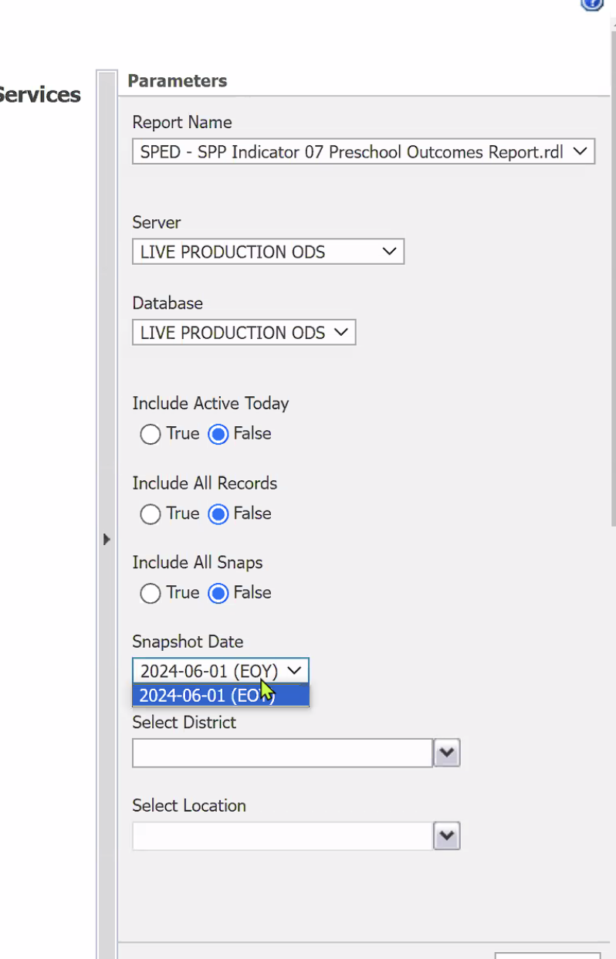

SPP Indicator Reports

- Some reports will come back blank if there is no data to report.

SPED Profile Report

- Much different than the former STARS SPED Profile Report.
- Big change is the B items. B items are on the bottom of the profile report. Will only display if there are “B Errors”. Will also show up in the DVD page.
- DVD page will categorize errors.
- Duplicate ID report is baked into the top of the profile report.

Child Count Location Error Report

- Not many changes from this repot from the former STARS report.

Questions:

- What is the diagnostic report?
- The report will generate a diagnostic report with additional information regarding the data collection. It can be used for data troubleshooting.

- Verification report, choosing “active today” is the best option when pulling EOY data. If active today does not work, please submit a ticket. https://nmnova.freshdesk.com/support/home

- When the report is pulled after the last day, there are errors. System wide issue. IT is aware and is working on the issue.

- When the duplicate ID report is pulled, there are errors. “All or SPED - Duplicate ID Report”. Issue is reported and IT will work to resolve the issue.

- Can reports be provided to export in CSV or Excel format?
- CSV is not available, but Excel is, and IT is working to improve the ability to clean up and edit the Excel File. The Profile Report will not be as easy to export due to the large amount of details within the report.

- Is there a list of reports that OSE will use to validate the data at EOY?
- Charlene Marcotte, director of data and finance OSE, will be communicating this plan later in the year.

- Who shall we speak to if we are continuing to get errors?
- If tickets have been filed, email Nicholas Keyes directly: nicholas.keyes@ped.nm.gov

- Issues with validating prek data with ECECD. IT will work to resolve the issue.

- As of today (5/21/24), if SPED Profile report is not loaded, this is due to the duplicate report being down. IT is working on this.

- Flat file and graduates. SPED seniors with exits. Do not make any changes on LEA dates. IT will communicate with LEAs if dates need to be changed.

- What exit date is to be used for graduates. Use the same you have always used. IT will communicate if dates need to be changed.

OSE Data Collection

EOY Reviews:

Data collected: Child Count Number, Validation (B Item) Errors, Missing Special Education Exit Events

Indicators: Indicator 7, Indicator 11, Indicator 12
All dates must be filled out for each student in indicator 11 and 12.

If you have errors, please correct errors before moving forward.

Indicator 14 Collection
Data collection process - Glenn Damian, REC4
Email: gdamian@nmhu.edu

Manual 40 Day Collection
Data due to US Dept. of Ed July 2024
Form due to NMPED OSE June 3, 2024
Collection will occur in cooperation with the School Budget Bureau
Form: 40 Day School-Age Data
Form collects data by school age, and preschool.

