SDRCS Data Report SY 2024-25:
Dr. Kommander
September 13, 2024
Background:
In the latter part of the 2022-23 academic year, WHCS administered assessment tests in Mathematics and English for students in Grades 6-8 utilizing the i-Ready diagnostic software. This platform underwent rigorous evaluation for validity and other critical parameters by WHCS during the same academic year. Moreover, the software aligns with Every Student Succeeds Act (ESSA) Tier 1 requirement and adheres to the What Works Clearinghouse standards for evidence-based interventions. Due to time constraints, students in Grades K-5 were not assessed. I-Ready software not only identifies a student’s overall grade-level placement in Math and English. The software can disaggregate the Math and English data into specific Domains. The Math Domains are 1) Numbers and Operations, 2) Algebra and Algebraic Thinking, 3) Measurement and Data and 4) Geometry. For English the Domains are 1) Phonological Awareness, 2) Phonics, 3) High-Frequency Words, 4) Vocabulary, 5) Comprehension Overall, 6) Literature and 8) Informational Text.
Previous Math assessment data of 9th Grade students entering WHCS for SY 2022-23 showed that students had entered high school >3 grades below their grade level, with a 4th grade median as determined by both the IXL and i-Ready platforms. New 10th grade students who entered WHCS in 10th grade showed similar results.
The analysis of these results was instrumental in shaping the SDRCS 3-year Strategic Plan. In September 2024, baseline data for all grades (K-8) in both English and Mathematics was collected using the i-Ready software. 1st Grade students will still be tested in Math. Initial ELA assessment data of 9th and 10th grade students entering WHCS for SY 2022-23 that all 9th and 10th grade students (including students on Individualized Learning Plans - IEP’s) had entered WHCS >4 grades below their ELA grade level, with a 4th -5th^{th} ELA grade median.
The SY 2024-25 Beginning of Year (BOY) results for English and Math for Grades K-8 are presented in the Figures 1-17 below. The data identifies the following trends:
- Significant Student Achievement Gaps in both English and Math exist not only in Middle School but extend to Elementary School and Kindergarten
- At Kindergarten and 1st Grade levels SDRCS students are 80-100% below 1 Grade level in Math and English.
- After 2nd Grade the Student Achievement Gap widens in both Math and English. In 2nd Grade Math, 100% of students have fallen behind two grade levels, in 3rd Grade Math 44 % of students have fallen below three or more grade levels. In 2nd Grade English 80% of students have fallen 2 grade levels behind, by 3rd Grade 40% of students are three or more Grades below grade level.
- The Student Achievement Gap does not improve in Middle School. The SY 2024-25 8th Grade data is comparable to the 9th Grade WHCS BOY data which shows that students are 3 or more Grade levels below Grade level.
- A pronounced heterogeneity in student performance across various domains is evident. This disparity not only highlights the differing achievement levels within a single class but also implies a potential deficiency or ineffectiveness in the implementation of interventions or strategies aimed at bridging learning gaps.

Math Results:

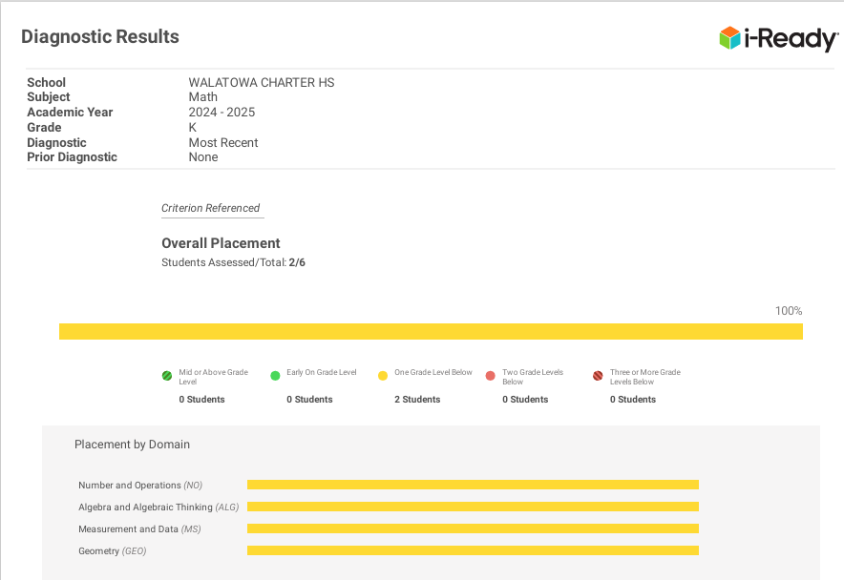
Figure 1: I-Ready Diagnostic Results for Kindergarten Grade Math students
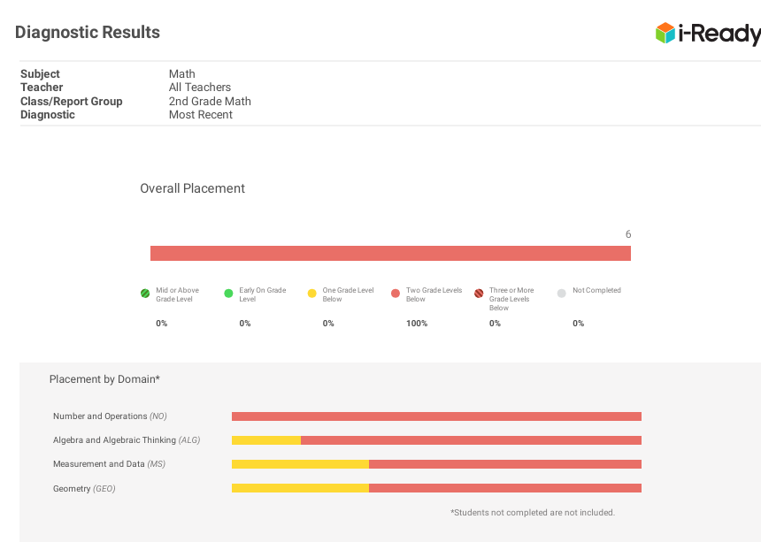
Figure 2: I-Ready Diagnostic Results for 2nd Grade Math students
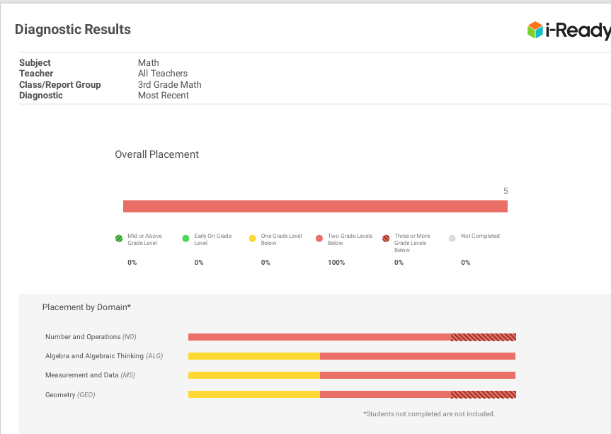
Figure 3: I-Ready Diagnostic Results for 3rd-Grade Math Students
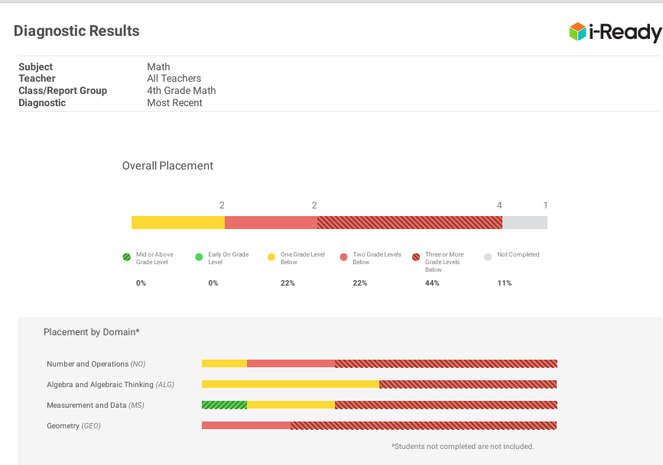
Figure 4: I-Ready Diagnostic Results for 4th-Grade Math Students
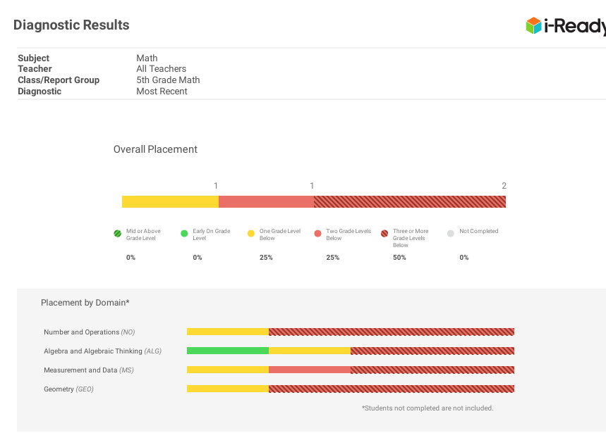
Figure 5: I-Ready Diagnostic Results for 5th-Grade Math Students
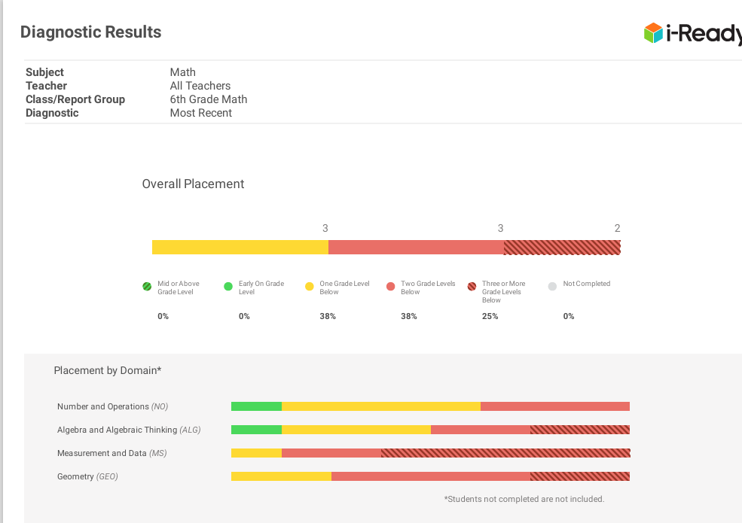
Figure 6: I-Ready Diagnostic Results for 6th-Grade Math Students
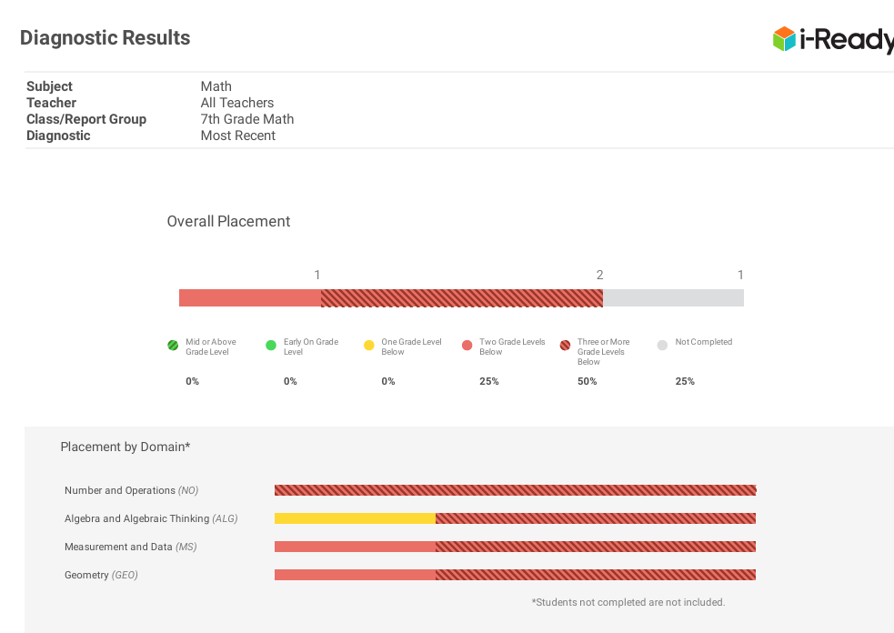
Figure 7: I-Ready Diagnostic Results for 7th-Grade Math Students
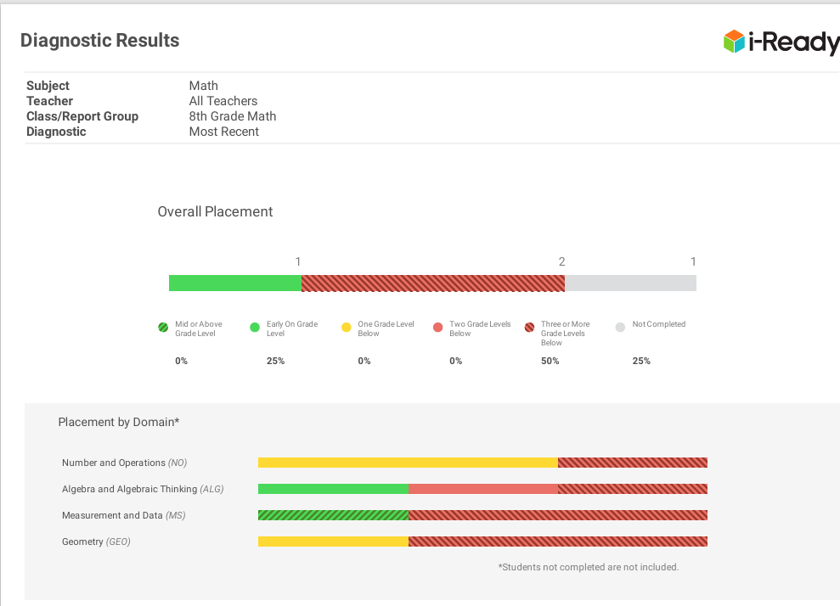
Figure 8: I-Ready Diagnostic Results for 9th-Grade Math Students (8th Grade data: 4 students, 1 student missing)

English Results:
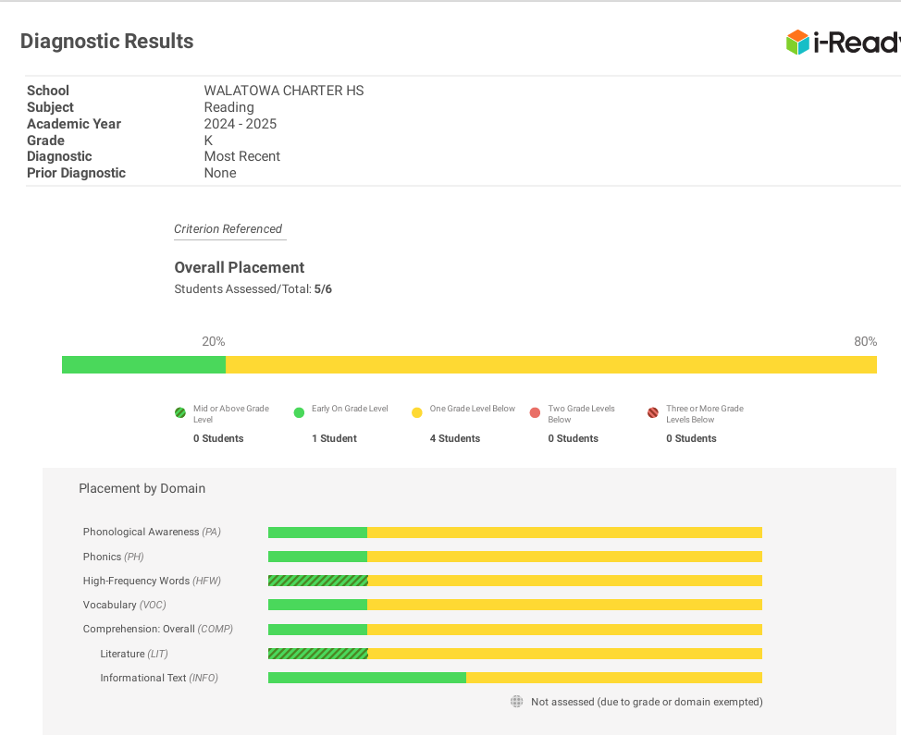
Figure 9: I-Ready Diagnostic Results for Kindergarten Grade English Students
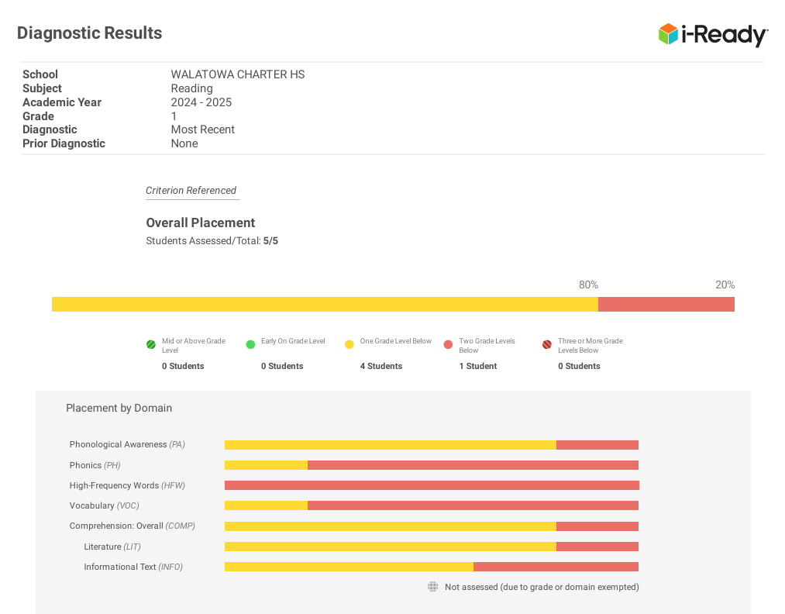
Figure 10: I-Ready Diagnostic Results for 1st -Grade English Students
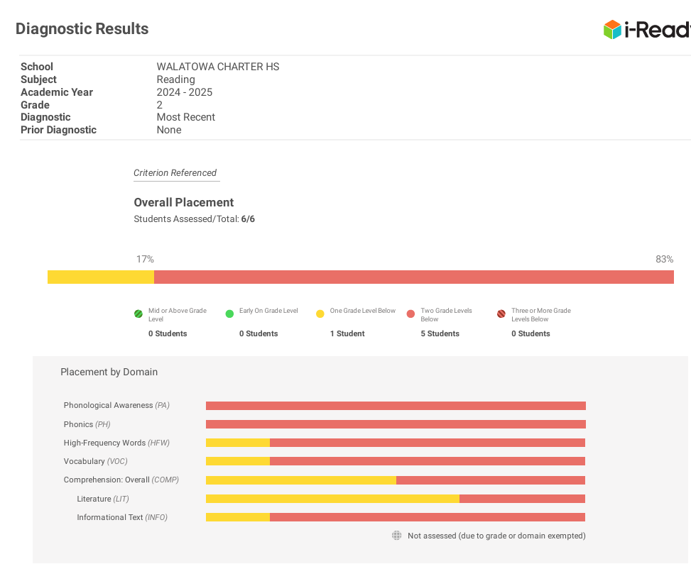
Figure 11: I-Ready Diagnostic Results for 2nd -Grade English Students

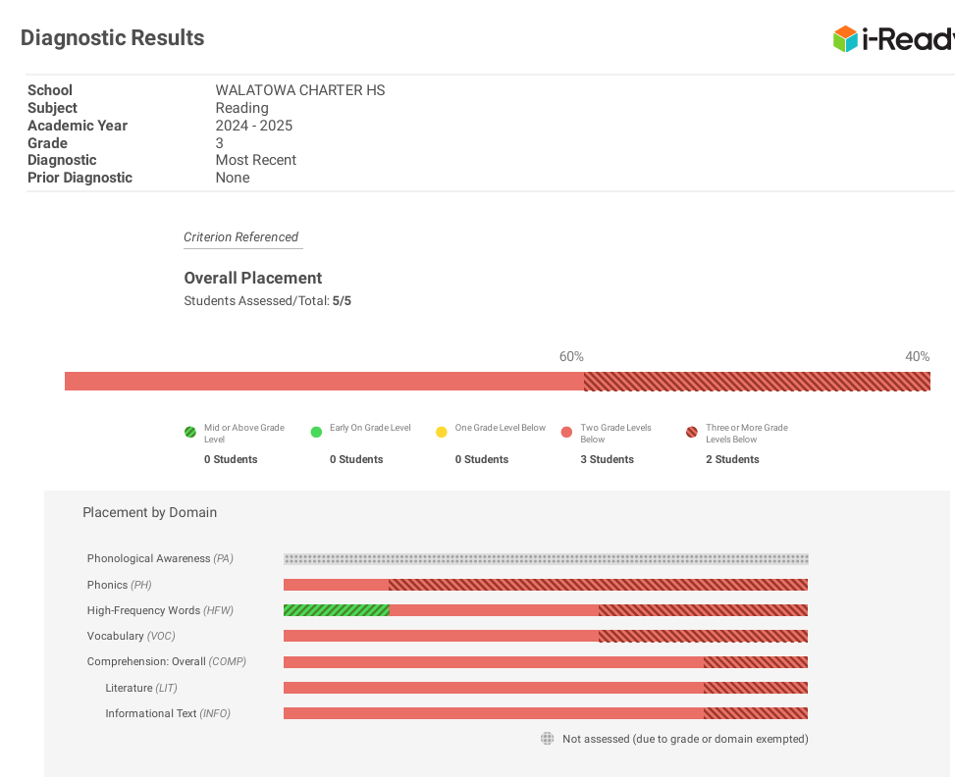
Figure 12: I-Ready Diagnostic Results for 3rd -Grade English Students

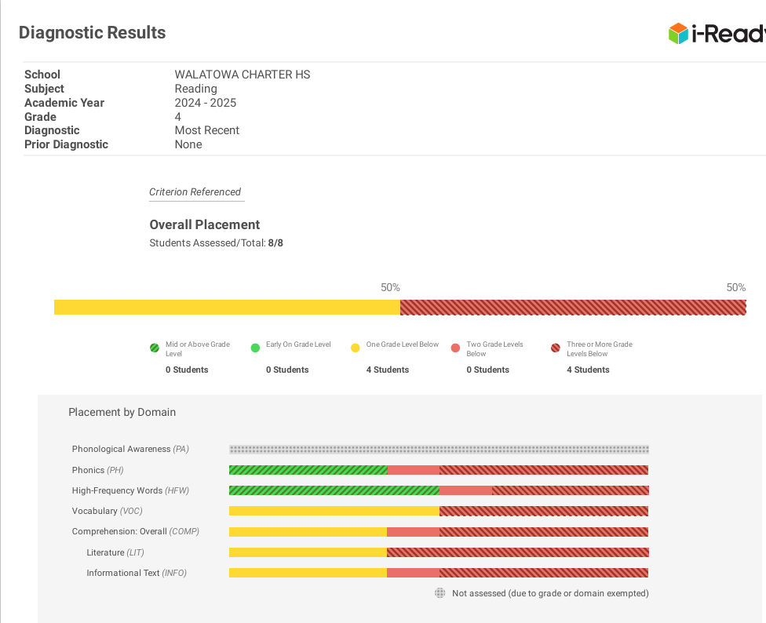
Figure 13: I-Ready Diagnostic Results for 4th -Grade English Students

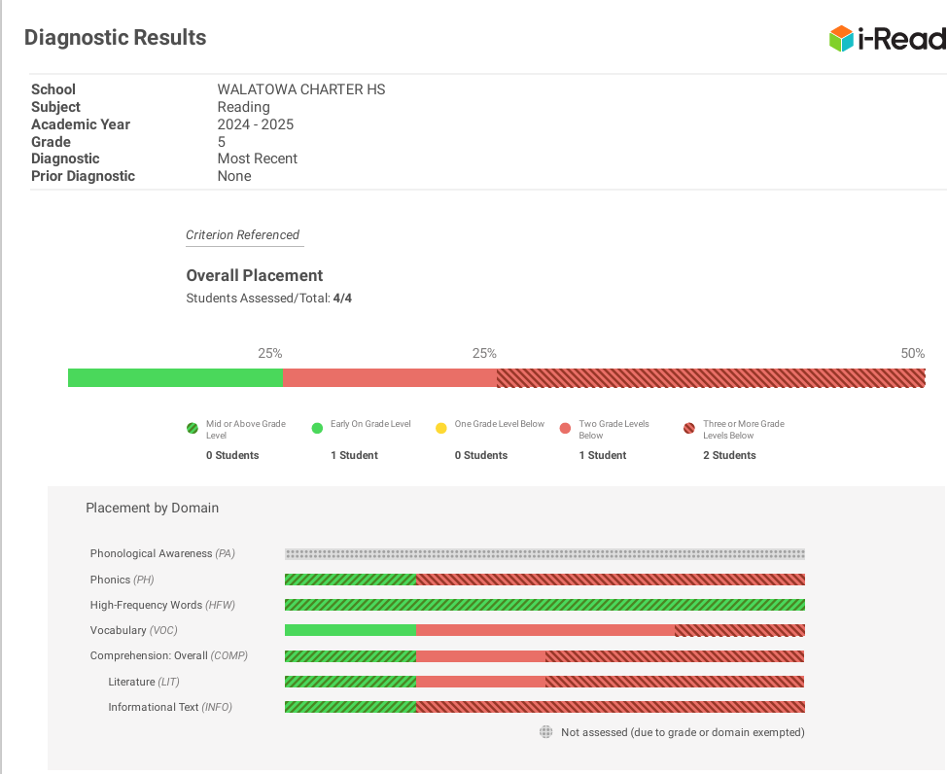
Figure 14: I-Ready Diagnostic Results for 5th -Grade English Students
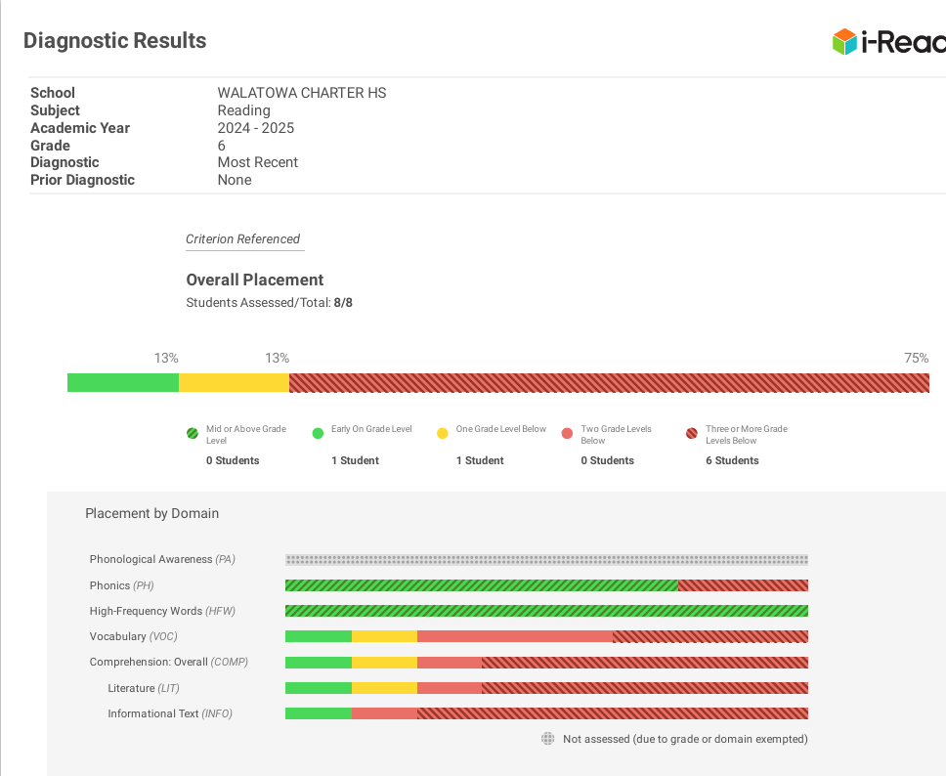
Figure 15: I-Ready Diagnostic Results for 6th -Grade English Students
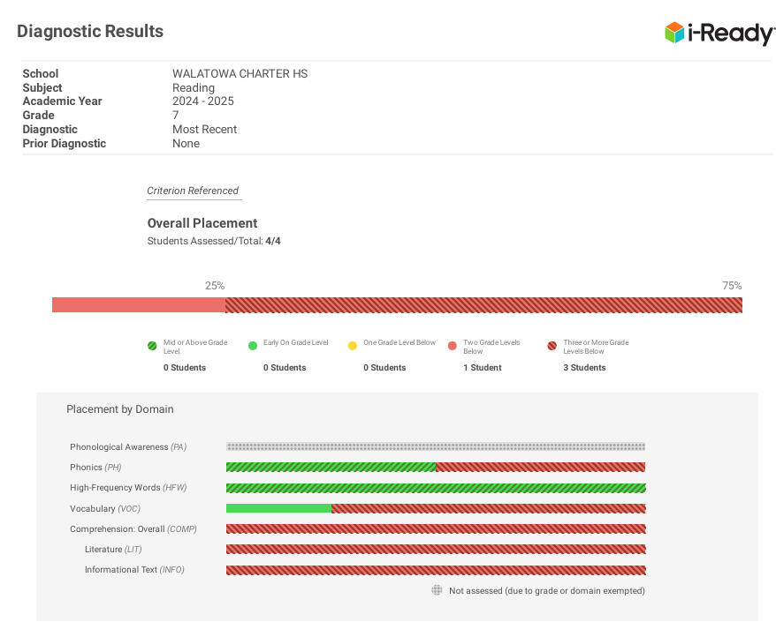
Figure 16: I-Ready Diagnostic Results for 7th -Grade English Students
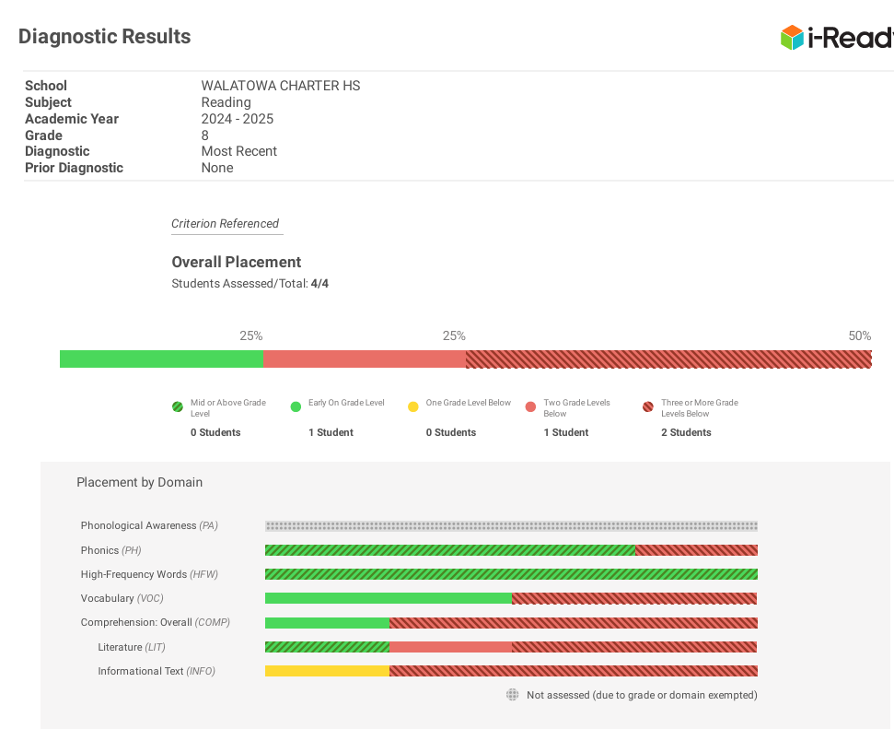
Figure 17: I-Ready Diagnostic Results for 7th -Grade English Students

Root Cause Analysis and Intervention Plan:
- Core Issue:
- Teachers lack training in new interventions.
- New teachers are not adequately trained in updated curricula.
- The departure of teachers skilled in specialized interventions, without proper succession planning, creates a substantial void.
Result:
- The school struggles with consistently implementing interventions and curricular resources as intended.

Action Plan:

- Collaborative PD for 2 English teachers in English at SDRCS and WHCS. PD will be provided for the following software:
4-8 Reading Plus

- Collaborative PD for 2 Math teachers in English at SDRCS and WHCS

K-5 Happy Numbers
K-8 Dreambox Math

- Monitoring the implementation of interventions (NMDASH Plan, MLSS Plan, Lesson Plans, NMElevate, Assessments)

Desired Outcome:

Collaborative PD between both schools according to the SDRCS Strategic Plan (Targeted comprehensive teacher PD and PLCs to support intentional learning experiences and drive DDI) will 1) provide sustainability of the intervention programs, 2) allow for streamlined intervention programs spanning from elementary to high school, 3) integrate comprehensive Layer 2 MLSS interventions at both schools.
- Core Issue:

- The majority of SDRCS students speak Towa, a Tanoan language of the Jemez Pueblo, which lacks a written form due to tribal rules. Transitioning from a Towa-immersion Head Start program to an all-English curriculum with Towa support is challenging. Upon entry, 90% of kindergarteners are ELL, 67% of first graders are at high risk for dyslexia, and all 4th and 5th graders read below grade level.
Action Plan:
- Implementing an early kindergarten program at SDRCS to prepare students for kindergarten and 1st Grade.

Desired Outcome:

This program would prepare students for language and literacy development as well as school-readiness skills.

