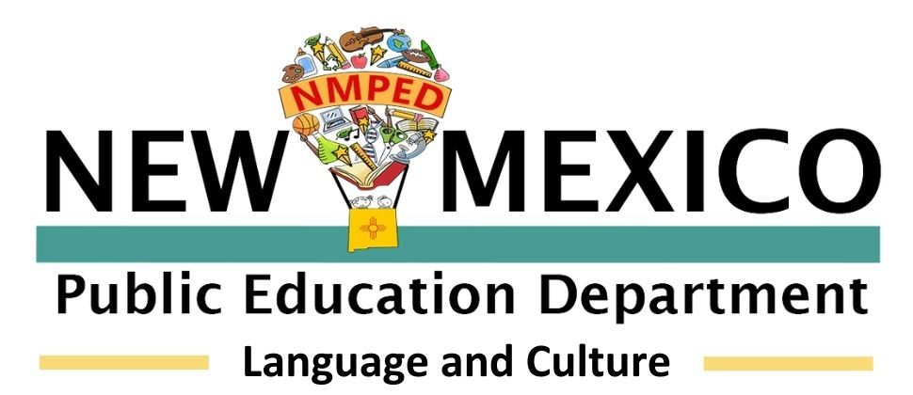
State Seal of Bilingualism-Biliteracy (SSBB) Monitoring Checklist
District
School
SSBB Coordinator
Date
Program Goals
6.32.3.6 NMAC This rule establishes the criteria for students to earn a state seal of bilingualism-biliteracy on a New Mexico diploma of excellence. The SSBB certifies that the recipient is proficient for meaningful use in college, a career or to meet a local community language need in a world language other than English.
There are four SSBB options: 1. certification by an individual tribe; 2. units of credit + assessment; 3. units of credit + alternative process portfolio; 4. assessment + alternative process portfolio
Item |  | Response
How many students earned the SSBB on the Diploma of Excellence last school year?
How many students will be earning the SSBB in the current school year?
How many students earned the seal per option? |  | 1. | 2. | 3. | 4.
Are all four SSBB options available to students? If not, please explain why some options are not available.
How does the school offer support toward obtaining the SSBB for interested candidates?
Has the school created a rubric and policies, around the alternative process portfolio?
Does the school provide coursework to support the SSBB?
How does the school, work to meet existing community member language needs?
Is there evidence that the school has an MOU with all nations, tribes, or pueblos whose languages have been or will be awarded an SSBB (if applicable)?
How does the district or charter school prepare to report annual SSBB end of year data accurately to Nova?
How are SSBB recipients celebrated by the school community?
Is there anything else the school would like to share (e.g. success stories, specific challenges, interesting data, etc.)?
Does the school wish to receive any specific support with the SSBB from the Language and Culture Division?

